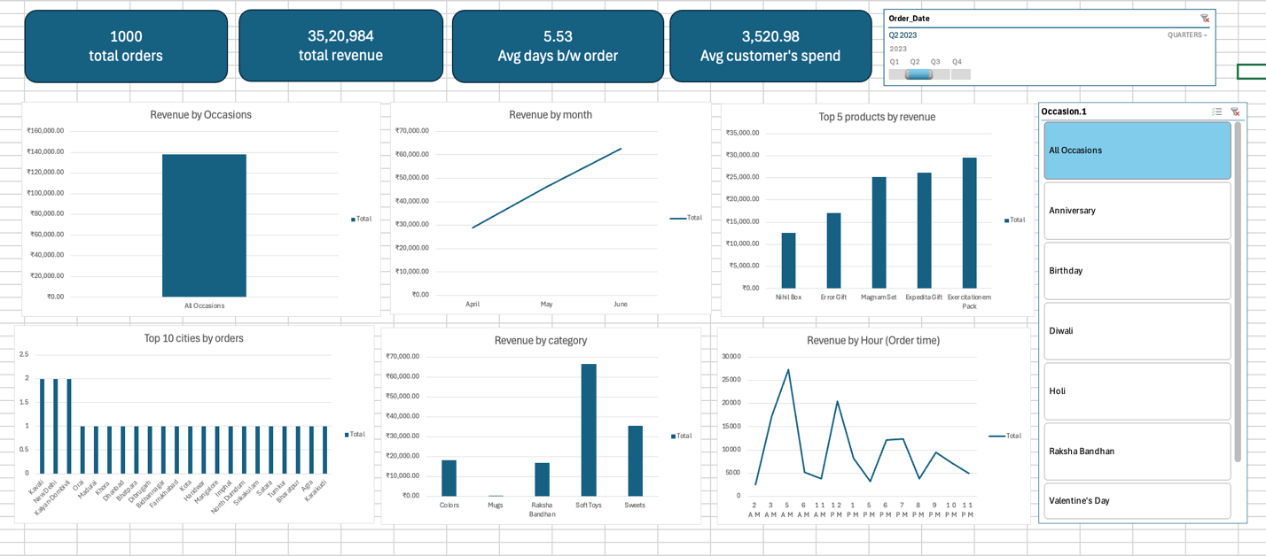

Developed an interactive Excel dashboard using Pivot Tables and charts to analyze sales performance. Tracked KPIs like revenue, orders, and customer spend while uncovering insights across time, product categories, locations, and order patterns using dynamic filters.

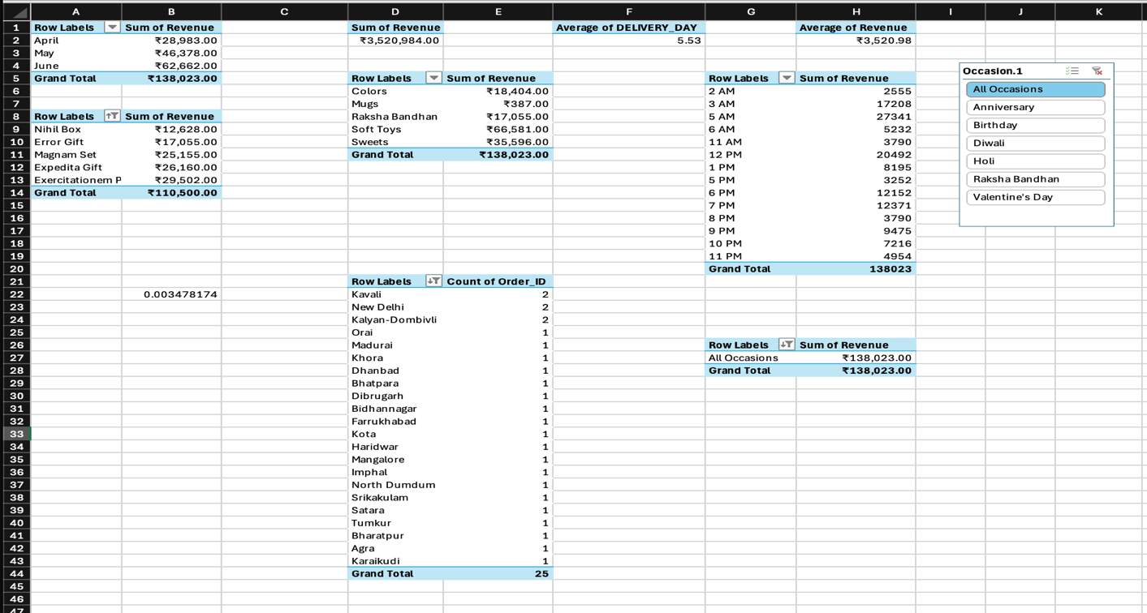
This image showcases the underlying data analysis performed using Excel Pivot Tables, forming the foundation of the dashboard. It organizes raw data into meaningful summaries across multiple dimensions:
- Monthly Revenue Breakdown (April–June) with a total of ₹1,38,023
- Product-wise Revenue Analysis identifying top-performing items
- Category-wise Revenue Distribution with Soft Toys contributing the highest share
- Time-based Revenue Analysis showing order distribution across different hours of the day
- City-wise Order Count highlighting demand spread across locations
- Average Metrics such as delivery time (5.53 days) and average revenue per order (₹3,520.98)

