**NAME: SUHAN MOHANTY SEC: CSE 29**

**ROLL NO: 22052337**   **DATE: 24.01.2025**

**GITHUB LINK: https://github.com/suhan395/AILAB4**

**AI LAB – Assignment 4**

**Logistic Regression**

**4) In this assignment, you need to classify the given dataset using logistic regression.**

**Database**

**Independent/Predictor Variable -**

**https://drive.google.com/file/d/1eEBjqnIMlViYOwoOBqZ11tMbn9cZLLEo/view?usp=drive_link**

**Dependent/Response Variable -**

**https://drive.google.com/file/d/1hnowuwHw_qgRl1a0LLa6y0eItyMU_lZ0/vi ew?usp=drive_link**

**Use the same cost function that we had discussed in class.**

**Answer the following questions based on your observations**

**1. Use logistic regression to find decision boundary For the given database. Set your learning rate to 0.1. What is the cost function value and learning parameter value after convergence?**

**OUTPUT:**

Theta after convergence: [ 0.32395465 2.38613663 -2.49462467]  
Final Cost: 0.22910833189006333

**2. Plot cost function v/s iteration graph for the model trained in question 1. Plot the line as shown here -**

**https://pythonguides.com/matplotlib-plot-a-line/#Matplotlib_pl ot_a_line_chart**

**Do not use scatter plots for this.**

**OUTPUT:**

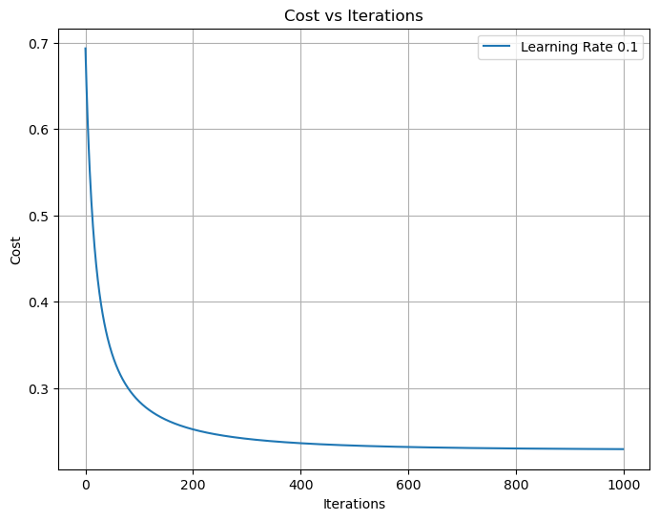

**3. Plot the given dataset on a graph, use different colours for different classes and also show the decision boundary you obtained in question 1. Do not use scatter plot.**

**OUTPUT:**

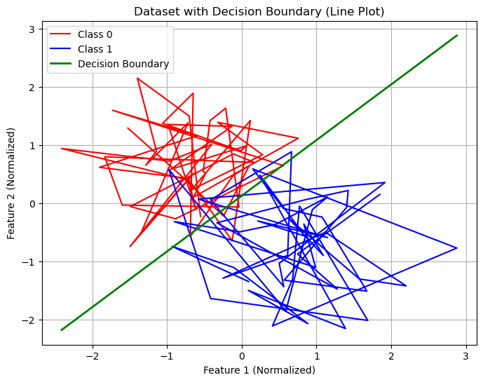

**4. Train your model with a learning rate of 0.1 and 5. Plot the cost-function v/s iteration curve for both learning rates on the same graph. For this task, only train your model for 100 iterations.**

**OUTPUT:**

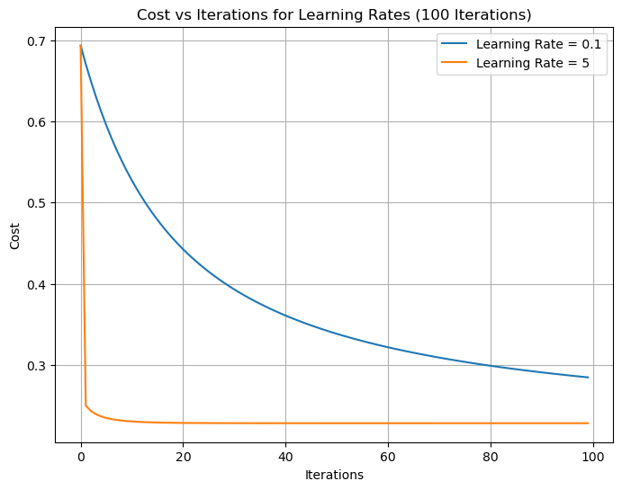

**5. Find the confusion matrix for your training dataset. Using the confusion matrix to calculate the accuracy, precision, recall, F1-score.**

**OUTPUT:**

Confusion Matrix:  
[[45 5]  
 [ 8 42]]  
Accuracy: 0.87  
Precision: 0.89  
Recall: 0.84  
F1-Score: 0.87