# **Lab 17 AI for Data Processing: Data Cleaning and Preprocessing Scripts**

**Name:** Suhana Rehan

**Enrollment Number**: 2503A51L36

**Task 1 :**

**Task :** Use AI to generate a Python script for cleaning an employee dataset

**Prompt:**Generate a Python script to clean an employee dataset by handling missing values, formatting joining_date, standardizing department names, and encoding categorical variables.

**Code:**

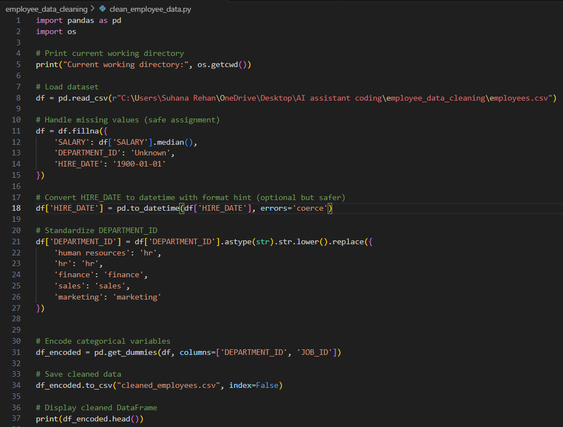

**Output:**



**Observations:**

The AI help me clean the the database and it handled all the missing value and made the database ready to use

**Task 2 :**

**Task:**Use AI to generate a script for preprocessing a sales transaction dataset

**Prompt:**

Preprocess a sales dataset by parsing dates, extracting Month-Year, removing invalid amounts, and normalizing values.

**Code:**

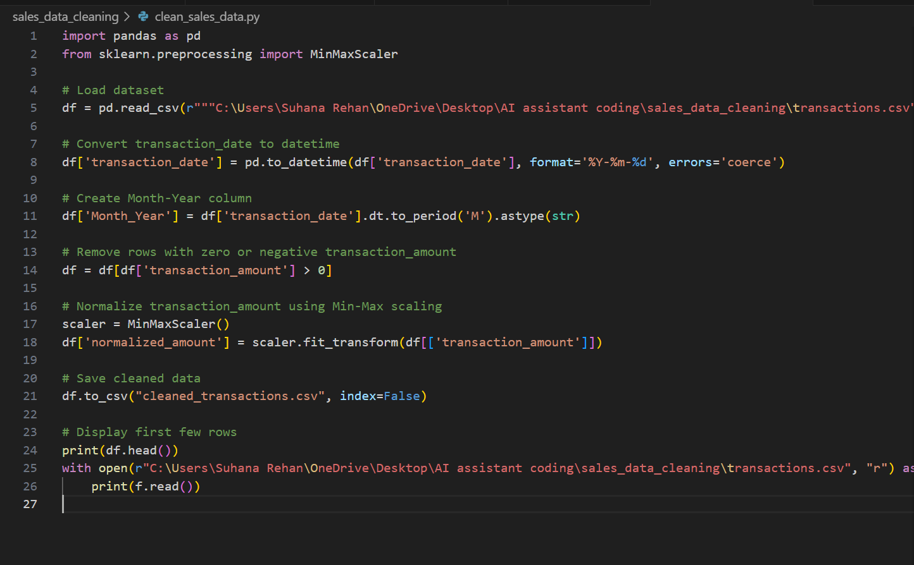

**Output:**

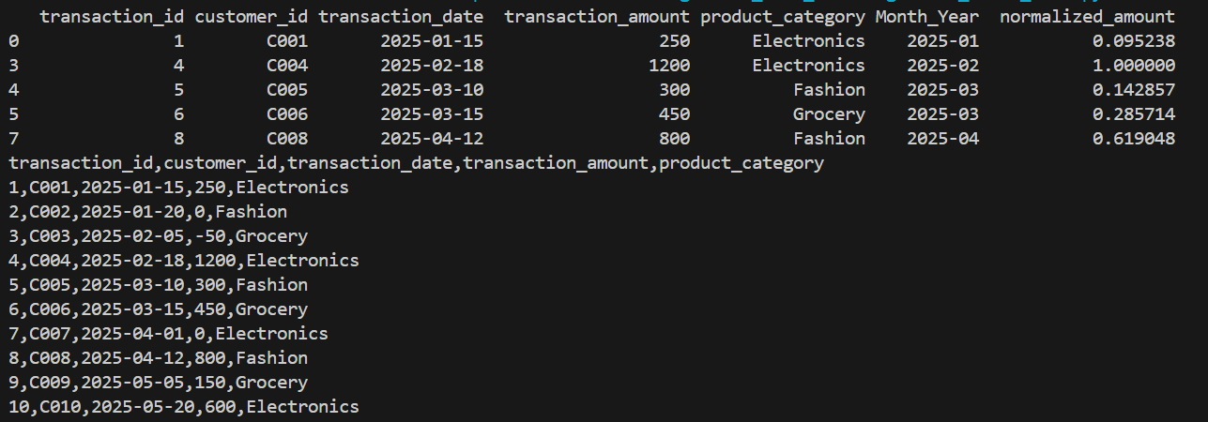

**Observation:**

* The AI helped me in cleaning the data, handle the missing value and irrelevant information in my database
* It made my database readable and ready to process

**Task 3**

**Task:**Use AI to generate a script for cleaning healthcare patient records**.**

**Prompt:**

Clean healthcare patient records by imputing numeric means, standardizing height units, fixing gender labels, and dropping IDs.

**Code:**

**Output:**

**Observation:**

**Task 4**

Use AI to write a script to preprocess a social media text dataset.

**Prompt:**

**Code:**

**Output:**

**Observation:**

**Task 5**

**Task:**  
Use AI to create a preprocessing script for a financial dataset

**Prompt:**

**Code:**

**Output:**

**Observation:**