AI Assisted Coding

Lab Test 3: Question paper T16

Roll No: 2503A51L36
Name: Suhana Rehan
Batch: 25BTCAICSB20
_______________________________________________________________________________
Set E10
Q1:
Scenario: In the domain of E-commerce, a company is facing a challenge related to
algorithms with ai assistance.
Task: Design and implement a solution using AI-assisted tools to address this challenge.
Include code, explanation of AI integration, and test results.
Prompt: Implement a solution for an E-commerce that is facing an algorithm challenge.
Code Generated:
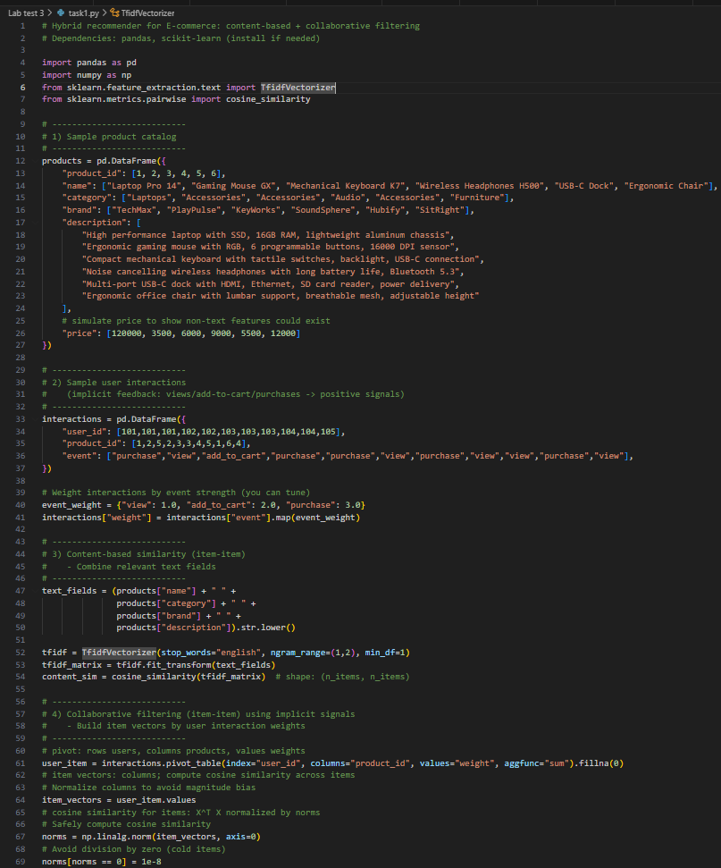
Output:
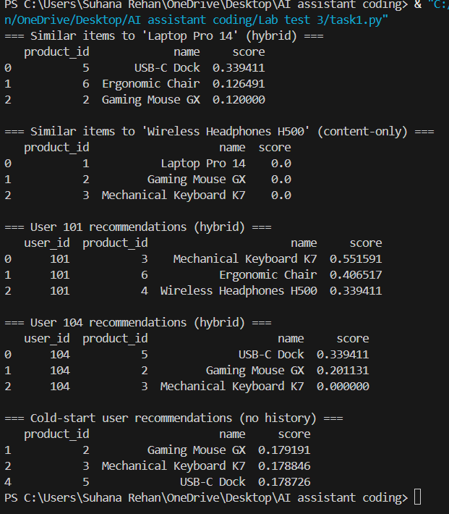
Observation:
- AI solved the algorithmic challenges faced by the e-commerce platform by using a Text Understanding approach to ensure that recommendations are accurate, personalized, and effective, even for new products or users.
- AI designed the code to personalize recommendations by observing user interactions and adapting accordingly.
_______________________________________________________________________________
Q2:
Scenario: In the domain of Finance, a company is facing a challenge related to code
refactoring.
Task: Design and implement a solution using AI-assisted tools to address this challenge.
Include code, explanation of AI integration, and test results.
Prompt: Implement the changes to resolve the challenges faced during code refactoring.
Original code with Issue:
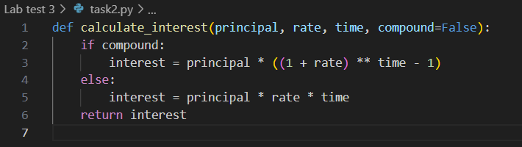
Code generated:
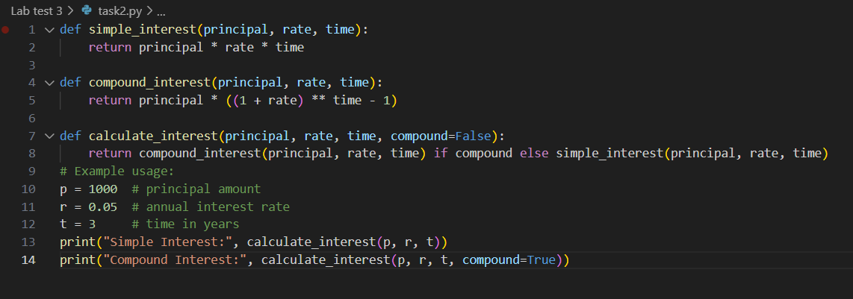
Output:

Observation:
- Here, the AI refactored the code by creating a completely new function instead of using multiple if-else loops, which improved the overall efficiency.
- The code now executes faster because it no longer checks every condition repeatedly in loops.
- This demonstrates how AI-driven optimization can intelligently redesign legacy code to improve both clarity and execution speed.

