**Assignment No:3**

Submitted To:___________________________________ Sir. Touseef

Submitted By:___________________________________ Sahwana ilyas

Registration No:_________________________________ SP24-BSSE-025

Subject :_______________________________________ ICT

**COMSATS University Islamabad**

**Vehari Campus**



Date:_______________24May,2024

**Exploring the convergence of cloud computing,IoT,and Augmented reality:**

**Objective:**

The objective of this assignment is to delve into the interplay between Cloud Computing, IoT,and Augmented reality, understanding their integration applications, and potential impact on various industries.

**Cloud Computing:**

* Fundamental Concepts about Cloud Computing:

Cloud computing is a paradigm that enables convenient, on-demand access to a shared pool of configurable computing resources (such as networks, servers, storage, applications, and services) that can be rapidly provisioned and released with minimal management effort or service provider interaction. Here are some fundamental concepts of cloud computing:

**On-Demand Self-Service**:

Cloud computing allows users to provision computing resources, such as server time and network storage, automatically without requiring human intervention from the service provider.

**Broad Network Access:**

Cloud services are accessible over the network and can be accessed through standard mechanisms, enabling use by heterogeneous client platforms such as mobile phones, tablets, laptops, and workstations.

**Resource Pooling**:

Cloud computing resources are pooled to serve multiple consumers using a multi-tenant model, with different physical and virtual resources dynamically assigned and reassigned according to demand. Users typically have no control or knowledge over the exact location of the resources but may be able to specify location at a higher level of abstraction (e.g., country, data center).

**Rapid Elasticity**:

Cloud computing services can rapidly scale out or in to accommodate changes in demand. Users can elastically provision resources as needed and release them when no longer required. This capability provides the illusion of unlimited resources to the user.

**Measured Service:**

Cloud computing systems automatically control and optimize resource usage by leveraging a metering capability at some level of abstraction appropriate to the type of service (e.g., storage, processing, bandwidth, and active user accounts). Resource usage can be monitored, controlled, and reported, providing transparency for both the provider and consumer of the service.

**Service Models:**

Cloud computing offers different service models:

**Infrastructure as a Service (IaaS)**: Provides virtualized computing resources over the internet. Users can provision and manage virtual machines, storage, and networking.

**Platform as a Service (PaaS):** Provides a platform allowing customers to develop, run, and manage applications without dealing with the underlying infrastructure complexities.

**Software as a Service (SaaS)**: Delivers software applications over the internet on a subscription basis. Users can access these applications through a web browser without needing to install or maintain the software locally.

**Deployment Models:** Cloud computing offers various deployment models:

**Public Cloud**: Services are offered over the public internet and are available to anyone who wants to purchase them.

**Private Cloud:** Services are maintained on a private network and are dedicated to a single organization. They can be managed by the organization itself or by a third party.

**Hybrid Cloud**: Combines public and private cloud services, allowing data and applications to be shared between them.

**Community Cloud**: Infrastructure shared by several organizations with common concerns (e.g., security, compliance).

**Describe the service model IaaS of Cloud Computing**:

Infrastructure as a Service (IaaS) is one of the fundamental service models of cloud computing. In IaaS, instead of owning physical hardware such as servers, storage, and networking components, users rent virtualized resources over the internet. IaaS providers offer a range of services, allowing customers to deploy and manage their own virtualized IT infrastructure on demand. Here's a detailed description of the IaaS service model:

**Virtualized Computing Resources:**

IaaS providers offer virtualized computing resources, including virtual machines (VMs), virtual CPU (vCPU) cores, memory, and storage. Users can create, manage, and run VMs on these resources according to their computing needs. This abstraction layer enables users to access and control computing resources without dealing with the underlying physical hardware.

**Scalability and Elasticity**:

One of the key features of IaaS is its scalability and elasticity. Users can rapidly scale their infrastructure up or down based on demand. This means they can easily add or remove computing resources such as VMs, storage, and networking components as needed, without the constraints of physical infrastructure.

**Self-Service Provisioning**:

IaaS platforms typically offer self-service interfaces, such as web-based portals or APIs (Application Programming Interfaces), that allow users to provision and manage their infrastructure autonomously. Users can deploy VMs, configure networking, allocate storage, and manage other resources without the need for manual intervention from the service provider.

**Pay-Per-Use Billing Model:**

IaaS providers typically employ a pay-per-use billing model, where users are charged based on their actual resource consumption. This model offers cost-effectiveness and flexibility, as users only pay for the resources they use, rather than investing in and maintaining expensive hardware infrastructure. Additionally, users can adjust their resource usage according to their budget and requirements.

**Infrastructure Management:**

While IaaS providers manage the underlying physical infrastructure, users are responsible for managing their virtualized resources and applications. This includes tasks such as installing and configuring operating systems, deploying software applications, managing security configurations, and monitoring performance. Users have full control over their virtualized environment, allowing them to customize it to suit their specific requirements.

**Geographic Reach**:

IaaS providers typically operate data centers in multiple geographic regions, allowing users to deploy their infrastructure in locations that are geographically closer to their target audience or comply with data residency requirements. This geographic reach enhances performance, reliability, and compliance for users' applications and services.

Example Use Cases: IaaS is suitable for a wide range of use cases, including:

Hosting websites and web applications

Development and testing environments

High-performance computing (HPC) and scientific research

Disaster recovery and backup solutions

Big data analytics and processing

Virtual desktop infrastructure (VDI)

Software development and deployment platforms

Overall, IaaS provides users with a flexible, scalable, and cost-effective solution for building and managing their IT infrastructure in the cloud.

**Describe the service model Paas of Cloud Computing:**

Platform as a Service (PaaS) is a cloud computing service model that provides a platform allowing customers to develop, run, and manage applications without the complexity of building and maintaining the underlying infrastructure. PaaS abstracts away the underlying hardware and software infrastructure, offering a complete development and deployment environment as a service. Here's a detailed description of the PaaS model:

**Development Environment:**

PaaS provides developers with a comprehensive development environment, including tools, libraries, and frameworks for building, testing, and deploying applications. These environments typically support multiple programming languages and development frameworks, allowing developers to choose the tools that best suit their needs.

**Middleware Services:**

PaaS platforms offer a range of middleware services to facilitate application development and integration. These services may include database management systems, messaging queues, caching services, identity management, and more. By leveraging these pre-built services, developers can focus on building application logic rather than dealing with infrastructure complexities.

**Deployment and Scaling:**

PaaS platforms streamline the deployment and scaling of applications by automating infrastructure provisioning and management tasks. Developers can deploy their applications with a few clicks or commands, and the platform takes care of allocating resources, managing dependencies, and scaling the application based on demand. This enables rapid iteration and deployment cycles, improving time-to-market for applications.

**Elasticity and Scalability:**

PaaS platforms offer elasticity and scalability, allowing applications to automatically scale up or down in response to changes in workload or demand. This ensures optimal performance and resource utilization without manual intervention from developers or administrators. PaaS platforms can dynamically adjust resources such as compute instances, storage, and networking to accommodate fluctuations in traffic and usage patterns.

**Managed Services**:

PaaS providers offer a variety of managed services to offload operational tasks from developers and administrators. These managed services include database as a service (DBaaS), messaging as a service (MaaS), analytics services, monitoring and logging, security services, and more. By outsourcing these responsibilities to the PaaS provider, organizations can focus on building and improving their applications without worrying about infrastructure management.

**Multi-Tenancy and Isolation**:

PaaS platforms typically support multi-tenancy, allowing multiple users or organizations to share the same underlying infrastructure while maintaining logical isolation between their applications and data. This enables efficient resource utilization and cost savings, as resources are pooled and shared among multiple users without compromising security or performance.

**Integration and Ecosystem:**

PaaS platforms often provide integration with third-party services, APIs, and development tools, allowing developers to extend the capabilities of their applications and integrate with external systems seamlessly. Additionally, PaaS ecosystems foster collaboration and innovation by providing access to a marketplace of pre-built components, libraries, and solutions developed by the community or third-party vendors.

Example Use Cases: PaaS is suitable for a wide range of use cases, including:

Web application development and hosting

Mobile application development and backend services

Internet of Things (IoT) application development and management

Enterprise application integration and development

DevOps and continuous integration/continuous deployment (CI/CD) pipelines

Data analytics and processing platforms

Overall, PaaS offers developers and organizations a flexible, efficient, and cost-effective platform for building, deploying, and managing applications in the cloud.

**Describe the service model SaaS of Cloud Computing**:

Software as a Service (SaaS) is one of the three main service models in cloud computing, alongside Infrastructure as a Service (IaaS) and Platform as a Service (PaaS). SaaS provides users with access to software applications hosted on cloud infrastructure, typically via the internet. Here's a breakdown of the SaaS model:

**Accessibility:**

SaaS applications are accessible over the internet through a web browser or a thin client interface. This eliminates the need for users to install and maintain software locally on their devices.

**Multi-tenancy**:

SaaS applications are usually designed to serve multiple users or organizations simultaneously. They leverage a multi-tenant architecture, where a single instance of the software serves multiple customers (tenants) while ensuring data isolation and security.

**Subscription-based pricing**:

SaaS offerings often follow a subscription-based pricing model, where users pay a recurring fee (monthly or annually) for access to the software. This model typically includes automatic updates, maintenance, and support services as part of the subscription package.

**Scalability and Flexibility**:

SaaS applications are designed to scale dynamically based on user demand. This scalability allows businesses to easily adjust their usage levels according to changing needs without worrying about infrastructure provisioning or capacity planning.

**Managed Infrastructure**:

With SaaS, the cloud provider manages all aspects of the underlying infrastructure, including hardware, networking, and data storage. Users are relieved of the burden of managing and maintaining hardware or software components, allowing them to focus on utilizing the software to achieve their business objectives.

**Customization and Integration:**

While SaaS applications offer standard functionality to cater to a broad user base, they also often provide customization options to meet specific user requirements. Additionally, SaaS applications can be integrated with other cloud services or on-premises systems, enabling seamless data exchange and workflow integration.

**Automatic Updates and Maintenance**:

SaaS providers handle software updates, patches, and maintenance tasks centrally, ensuring that users always have access to the latest features and security enhancements without any manual intervention.

**Describe the deployment model Public of Cloud Computing**:

The public cloud deployment model involves hosting cloud services and infrastructure resources on hardware owned and managed by third-party cloud service providers. Here are the key characteristics of the public cloud deployment model:

**Shared Infrastructure**:

In the public cloud, multiple tenants share the same underlying physical infrastructure, including servers, storage, and networking resources. This multi-tenant architecture allows cloud providers to achieve economies of scale, driving down costs for users.

**Accessibility**:

Public cloud services are accessible to users over the internet on a pay-per-use basis. Users can provision and access computing resources, such as virtual machines, storage, databases, and application services, through web-based portals or APIs provided by the cloud provider.

**Scalability**:

Public cloud services are highly scalable, allowing users to rapidly scale resources up or down based on demand. This elasticity enables businesses to handle fluctuating workloads efficiently, without over-provisioning or underutilizing resources.

**Resource Pooling**:

Public cloud providers pool together computing resources from multiple physical servers and data centers to create a vast pool of resources that can be dynamically allocated to users as needed. This pooling of resources enables efficient utilization and optimization of hardware infrastructure.

**Self-Service Provisioning**:

Users can self-provision and manage cloud resources without requiring extensive interaction with the cloud provider. Through self-service portals or APIs, users can easily deploy, configure, and manage virtual machines, storage volumes, databases, and other services.

**Pay-Per-Use Billing**:

Public cloud services typically follow a pay-as-you-go pricing model, where users are billed based on their actual usage of resources, such as compute time, storage space, data transfer, and additional services consumed. This utility-based pricing model allows businesses to align their costs with actual usage and avoid upfront capital expenditures.

**Global Reach**:

Public cloud providers operate data centers in multiple geographical regions around the world, allowing users to deploy and access cloud services from locations that are geographically closer to their end-users. This global reach enables low-latency access, high availability, and compliance with data sovereignty regulations.

**Security and Compliance:**

Public cloud providers implement robust security measures to protect data and infrastructure against unauthorized access, data breaches, and other security threats. Additionally, cloud providers often undergo third-party certifications and compliance audits to demonstrate adherence to industry standards and regulatory requirements.

Overall the public employment organization provides the easy approach and access to the computer resources.

**Describe the Private Deployment of Cloud Computing:**

A private cloud deployment model involves hosting cloud infrastructure resources exclusively for a single organization. Unlike the public cloud, where resources are shared among multiple tenants, in a private cloud, the infrastructure is dedicated to a specific organization or user group. Here are the key characteristics of the private cloud deployment model:

**Dedicated Infrastructure:**

In a private cloud, the hardware infrastructure, including servers, storage, and networking resources, is owned, and operated solely by the organization or a third-party provider exclusively serving that organization.

**Isolation:**

Private clouds provide a higher level of isolation compared to public clouds. The organization has exclusive control over the resources, ensuring that sensitive data and workloads are isolated from other organizations and users.

**Customization**:

Private cloud environments can be tailored to meet the specific requirements and preferences of the organization. This customization may include hardware configurations, network architectures, security policies, and management tools, allowing organizations to optimize the cloud infrastructure to suit their unique needs.

**Control and Security:**

Private clouds offer greater control and visibility over data, security, and compliance compared to public clouds. Organizations have full control over access permissions, encryption mechanisms, and security policies, enabling them to implement stringent security measures to protect sensitive data and ensure regulatory compliance.

**Scalability:** While private clouds offer scalability similar to public clouds, the process may be more complex and less elastic due to the dedicated nature of the **infrastructure.**

Organizations need to carefully plan and provision resources to accommodate fluctuating workloads and scalability requirements.

**Cost Considerations:**

Private cloud deployments typically involve higher upfront costs compared to public clouds due to the investment required in hardware infrastructure and data center facilities. However, over the long term, private clouds may offer cost savings for organizations with predictable workloads or stringent security and compliance requirements.

**Hybrid and Multi-Cloud Integration:**

Many organizations adopt a hybrid or multi-cloud strategy, combining private cloud resources with public cloud services or other cloud deployment models. This approach allows organizations to leverage the benefits of both private and public clouds, optimizing cost, performance, and flexibility based on workload requirements.

**Service-Level Agreements (SLAs)**:

In a private cloud deployment, organizations can define and enforce service-level agreements (SLAs) tailored to their specific needs and performance requirements. This enables organizations to guarantee high availability, reliability, and performance for critical workloads and applications.

Overall, the private cloud deployment model offers organizations greater control, customization.

**Describe the hybrid Deployment Computing Cloud:**

A hybrid cloud deployment model combines elements of both public and private cloud environments, allowing organizations to leverage the benefits of both deployment models to meet their specific business requirements. Here are the key characteristics of the hybrid cloud deployment model:

**Integration of Public and Private Clouds:**

In a hybrid cloud deployment, organizations integrate resources and workloads across both public and private cloud environments. This integration enables seamless data and application portability between the two environments, allowing organizations to dynamically allocate resources based on workload requirements, cost considerations, and performance needs.

**Flexibility and Scalability:**

Hybrid clouds offer organizations greater flexibility and scalability compared to relying solely on either public or private clouds. Organizations can leverage the scalability and on-demand resources of the public cloud for bursty workloads or unpredictable demand, while maintaining control over sensitive data and mission-critical applications in the private cloud.

**Data and Application Portability:**

One of the key advantages of hybrid cloud is the ability to move data and applications between public and private cloud environments as needed. Organizations can deploy workloads in the environment that best suits their requirements at any given time, whether it's for performance optimization, regulatory compliance, or cost savings.

**Cost Optimization:**

Hybrid cloud deployments enable organizations to optimize costs by leveraging the cost-effective, pay-per-use model of the public cloud for non-sensitive workloads or temporary projects, while keeping sensitive data and critical applications on-premises or in a private cloud environment to minimize ongoing operational expenses.

**Disaster Recovery and Business Continuity:**

Hybrid clouds are well-suited for implementing disaster recovery (DR) and business continuity (BC) strategies. Organizations can replicate critical data and applications between public and private cloud environments to ensure data redundancy, fault tolerance, and rapid recovery in the event of a disaster or outage.

**Security and Compliance:**

Hybrid cloud deployments allow organizations to maintain control over sensitive data and comply with regulatory requirements by keeping certain workloads and data on-premises or in a private cloud environment, while still benefiting from the security measures and certifications offered by public cloud providers.

**Hybrid Management Tools**:

Managing a hybrid cloud environment requires specialized management tools and platforms that provide visibility, control, and automation across both public and private cloud environments. These tools enable organizations to monitor performance, enforce policies, and optimize resource utilization seamlessly.

**Hybrid Cloud Use Cases:**

Hybrid cloud deployments are commonly used for a variety of use cases, including data analytics, DevOps, development and testing, IoT applications, and customer-facing web applications. By leveraging the strengths of both public and private clouds, organizations can achieve greater agility, scalability, and innovation while maintaining control over their IT infrastructure.

Overall, the hybrid cloud deployment model offers organizations a flexible, scalable, and cost-effective approach to cloud computing, enabling them to balance the benefits of public and private clouds to meet their specific business needs

**Write the components of IoT (Internet of Things)**:

The Internet of Things (IoT) encompasses a vast ecosystem of interconnected devices, sensors, networks, and platforms that enable the exchange of data and communication between physical objects and the digital world. Here are the key components of IoT:

**Sensors and Actuators**:

Sensors are devices that detect and measure physical parameters such as temperature, humidity, light, motion, and proximity. Actuators, on the other hand, are devices that can control or manipulate physical systems based on input received from sensors. These components form the foundation of IoT by collecting real-world data and enabling actions to be taken in response.

Connectivity: Connectivity technologies enable devices to communicate with each other and with cloud-based platforms over networks such as Wi-Fi, cellular, Bluetooth, Zigbee, LoRaWAN, and others. The choice of connectivity technology depends on factors such as range, bandwidth, power consumption, and deployment environment.

**Edge Computing**:

Edge computing involves processing data locally on IoT devices or gateways, closer to the data source, rather than sending it to centralized cloud servers for analysis. Edge computing enhances real-time processing, reduces latency, and conserves bandwidth by filtering and analyzing data at the edge of the network before transmitting relevant information to the cloud.

**IoT Platforms**:

IoT platforms provide the infrastructure and tools for managing, monitoring, and analyzing IoT devices and data. These platforms typically include features such as device management, data ingestion, storage, analytics, security, and integration with other enterprise systems. Examples of IoT platforms include AWS IoT, Azure IoT Hub, Google Cloud IoT Core, and IBM Watson IoT Platform.

**Cloud Services**:

Cloud services play a crucial role in IoT by providing scalable computing resources, storage, and analytics capabilities for processing and storing large volumes of IoT data. Cloud services enable organizations to leverage the flexibility, scalability, and cost-effectiveness of cloud computing for IoT deployments.

**Security:**

Security is a critical component of IoT to protect against unauthorized access, data breaches, and cyber-attacks. Security measures include encryption, authentication, access control, secure boot, firmware updates, and intrusion detection systems. Security protocols and standards such as TLS, DTLS, MQTT, and OAuth are commonly used to secure IoT communication.

**Data Analytics and Machine Learning:**

IoT generates vast amounts of data that can be analyzed to extract insights, detect patterns, and make data-driven decisions. Data analytics techniques such as descriptive, diagnostic, predictive, and prescriptive analytics are applied to IoT data to derive actionable insights. Machine learning algorithms are used for tasks such as anomaly detection, predictive maintenance, and intelligent automation.

**Applications and Use Cases**:

IoT applications span a wide range of industries and use cases, including smart homes, smart cities, industrial automation, healthcare, agriculture, transportation, and environmental monitoring. These applications leverage IoT technology to improve efficiency, productivity, safety, and sustainability across various domains.

By integrating these components, IoT enables the creation of interconnected ecosystems .

**Applications of IoT**:

The applications of IoT span various industries and domains, revolutionizing how businesses and individuals interact with the physical world. Here are some of the key applications of IoT:

**Smart Home:**

IoT enables the creation of smart home systems that connect devices and appliances to the internet, allowing homeowners to remotely control and automate tasks such as lighting, heating, cooling, security cameras, door locks, and kitchen appliances. Smart home systems enhance convenience, energy efficiency, and security.

**Industrial IoT (IIoT):**

In the industrial sector, IoT is used for monitoring and optimizing processes, improving operational efficiency, and reducing downtime. IIoT applications include predictive maintenance, asset tracking, supply chain management, remote monitoring of equipment, and real-time quality control in manufacturing plants.

**Healthcare:**

IoT technologies are transforming healthcare delivery by enabling remote patient monitoring, telemedicine, wearable health trackers, and smart medical devices. IoT devices collect and transmit patient data in real-time, allowing healthcare providers to monitor health metrics, detect abnormalities, and deliver personalized care.

**Smart Cities:**

IoT is instrumental in building smart cities by deploying connected sensors and devices to monitor and manage urban infrastructure and services. Smart city applications include smart lighting, traffic management, waste management, air quality monitoring, water management, public safety, and intelligent transportation systems.

**Agriculture**:

IoT solutions are revolutionizing agriculture by providing farmers with real-time data and insights to optimize crop cultivation, irrigation, fertilization, and pest control. IoT-enabled precision agriculture techniques improve crop yields, conserve water and resources, and enhance sustainability in farming practices.

Retail: In the retail industry, IoT is used to enhance the shopping experience, optimize inventory management, and personalize marketing campaigns. IoT devices such as RFID tags, beacons, and smart shelves enable retailers to track merchandise, analyze customer behavior, and deliver targeted promotions and recommendations.

**Logistics and Supply Chain Management**:

IoT plays a crucial role in logistics and supply chain management by providing real-time visibility and tracking of goods throughout the supply chain. IoT-enabled solutions optimize inventory management, reduce shipping delays, improve route optimization, and enhance overall supply chain efficiency.

**Environmental Monitoring:**

IoT sensors are deployed to monitor environmental parameters such as air quality, water quality, soil moisture, and pollution levels. Environmental monitoring IoT applications help governments, organizations, and communities to track environmental changes, mitigate pollution, and protect natural resources.

**Energy Management:**

IoT is used for smart energy management and conservation by monitoring and controlling energy consumption in buildings, factories, and utilities. IoT-enabled energy management systems optimize energy usage, identify energy inefficiencies, and enable demand response programs to reduce energy costs and carbon emissions.

**Connected Vehicles:**

IoT technology is transforming the automotive industry with connected vehicles equipped with sensors, telematics, and communication systems. Connected car applications include vehicle tracking, predictive maintenance, remote diagnostics, driver assistance systems, and in-car infotainment services.

**Describe the Future trends about IoT**:

The future of IoT holds promising trends that are poised to shape the evolution of technology and its impact on society. Here are some key future trends in IoT:

**Edge Computing**:

As IoT deployments continue to grow and generate massive amounts of data, edge computing will become increasingly important. Edge computing involves processing data closer to the source, at the network edge, rather than in centralized cloud data centers. This trend will reduce latency, bandwidth usage, and reliance on cloud infrastructure, making IoT systems more responsive and efficient.

**5G Connectivity:**

The rollout of 5G networks will revolutionize IoT by providing faster data speeds, lower latency, and greater network capacity. 5G connectivity will enable new IoT applications and use cases that require high-bandwidth, real-time communication, such as autonomous vehicles, augmented reality, and industrial automation.

**AI and Machine Learning Integration:**

The integration of artificial intelligence (AI) and machine learning (ML) with IoT will enable intelligent data analytics, predictive insights, and autonomous decision-making in IoT systems. AI-powered IoT applications will optimize resource allocation, detect anomalies, and enable proactive maintenance, leading to greater efficiency and productivity across various industries.

**Blockchain for IoT Security:**

Blockchain technology will play a vital role in enhancing security and trust in IoT ecosystems. Blockchain can provide secure, decentralized ledgers for recording and verifying transactions, identities, and data exchanges between IoT devices. Blockchain-based solutions will ensure data integrity, authentication, and tamper-proof audit trails, addressing security concerns in IoT deployments.

**Interoperability and Standards:**

As the IoT landscape continues to expand, interoperability and standards will become critical to ensure seamless integration and communication between diverse IoT devices and platforms. Industry consortia, standards bodies, and open-source initiatives will drive the development of common protocols, data formats, and interoperability frameworks for IoT interoperability.

**Sustainable IoT Solutions:**

Sustainability will emerge as a key focus area for IoT deployments, with a growing emphasis on energy efficiency, environmental impact, and resource optimization. IoT solutions will enable smart energy management, waste reduction, water conservation, and sustainable agriculture practices, contributing to a more sustainable and eco-friendly future.

**Privacy and Data Ethics**:

With the proliferation of IoT devices and the collection of vast amounts of personal data, privacy concerns and data ethics will become increasingly important. Regulations such as the GDPR (General Data Protection Regulation) and evolving privacy frameworks will drive greater transparency, consent, and accountability in IoT data collection, storage, and usage practices.

**Autonomous IoT Ecosystems:**

The convergence of IoT with other emerging technologies such as robotics, drones, and autonomous systems will lead to the development of autonomous IoT ecosystems. These ecosystems will enable autonomous decision-making, coordination, and collaboration between interconnected devices and intelligent agents, opening up new possibilities for automation, efficiency, and innovation.

**Augmented Reality**

**Discuss the AR technologies**:

Augmented Reality (AR) technologies blend digital content with the physical world, enhancing real-world environments with virtual elements. Here are some key AR technologies:

**Marker-based AR:**

Marker-based AR relies on predefined markers or images in the physical environment to trigger the display of virtual content. When a device's camera detects a marker, the associated virtual content is superimposed onto the marker's position. Marker-based AR is commonly used in applications like interactive advertising, educational content, and gaming.

**Markerless AR:**

Markerless AR, also known as location-based AR or SLAM (Simultaneous Localization and Mapping) AR, uses sensors such as GPS, accelerometers, gyroscopes, and cameras to overlay virtual content onto real-world scenes without the need for markers. Markerless AR is used in applications like navigation, tourism, interior design, and industrial maintenance.

**Projection-based AR:**

Projection-based AR projects virtual content onto physical surfaces, such as walls, floors, or objects, using projectors. This technology creates immersive experiences by overlaying dynamic content onto real-world surfaces, enabling interactive storytelling, product demonstrations, and artistic installations.

**Wearable AR Devices:**

Wearable AR devices, such as smart glasses and headsets, enable users to experience AR content hands-free. These devices typically feature transparent displays or projection systems that overlay digital content onto the user's field of view. Wearable AR devices are used in various industries, including manufacturing, healthcare, field service, and entertainment.

**AR SDKs and Frameworks**:

Augmented Reality Software Development Kits (SDKs) and frameworks provide developers with tools, libraries, and APIs to create AR applications for different platforms and devices. Popular AR SDKs include ARKit (iOS), ARCore (Android), Vuforia, Unity AR Foundation, and Wikitude. These SDKs enable developers to integrate AR features such as 3D object tracking, image recognition, plane detection, and spatial mapping into their apps.

**Spatial Computing:**

Spatial computing combines AR, VR (Virtual Reality), and MR (Mixed Reality) technologies to create immersive, interactive experiences that blend physical and digital worlds seamlessly. Spatial computing enables users to interact with virtual objects in real-world environments, facilitating applications like immersive training simulations, remote collaboration, and architectural visualization.

**WebAR:**

WebAR allows users to access AR experiences directly from web browsers without the need for native apps or downloads. WebAR leverages technologies such as WebXR, WebGL, and WebAssembly to deliver AR content through standard web browsers on smartphones, tablets, and desktops. WebAR enables frictionless access to AR content and expands the reach of AR experiences across different devices and platforms.

**Cloud-based AR:**

Cloud-based AR platforms leverage cloud computing resources to offload processing-intensive tasks, such as 3D rendering, computer vision, and content delivery, to remote servers. This approach enables lightweight AR applications that can run on a wide range of devices, including smartphones and wearables, without requiring powerful hardware. Cloud-based AR platforms also facilitate real-time collaboration, content sharing, and updates for AR experience.

**Platforms of AR :**

Certainly! Here are some of the leading platforms for developing augmented reality (AR) applications:

**ARKit (Apple):**

ARKit is Apple's augmented reality development framework for iOS devices.

It provides a suite of tools and APIs for building AR experiences, including scene understanding, motion tracking, and lighting estimation.

ARKit supports features like plane detection, object occlusion, and face tracking, enabling developers to create immersive AR apps for iPhones and iPads.

Developers can use ARKit with programming languages like Swift or Objective-C within Xcode, Apple's integrated development environment (IDE).

**ARCore (Google):**

ARCore is Google's platform for building augmented reality apps on Android devices.

It offers features such as motion tracking, environmental understanding, and light estimation to enable AR experiences on a wide range of Android smartphones and tablets.

ARCore supports capabilities like plane detection, object recognition, and cloud anchors for multi-user experiences.

Developers can use ARCore with popular development tools like Unity and Android Studio to create AR apps using Java, Kotlin, or C#.

**Vuforia (PTC):**

Vuforia is an augmented reality platform that offers tools and SDKs for building AR applications across various industries.

It provides features like image recognition, object tracking, and spatial mapping to create interactive AR experiences.

Vuforia supports multiple development platforms, including iOS, Android, Unity, and UWP (Universal Windows Platform).

Developers can leverage Vuforia's computer vision algorithms and cloud services to create marker-based, markerless, and location-based AR applications.

**Unity AR Foundation:**

Unity AR Foundation is a cross-platform framework for creating AR apps using the Unity game engine.

It abstracts the underlying AR technologies (ARKit, ARCore, and others) into a unified API, simplifying the development process for building AR experiences that run on both iOS and Android devices.

**Hardware of AR**:

The hardware required for augmented reality (AR) can vary depending on the specific application and use case. However, here are some common hardware components used in AR systems:

**Display Devices:**

**Smartphones and Tablets**: Many AR applications run on smartphones and tablets, leveraging their built-in cameras, sensors, and processing power to deliver AR experiences.

**Head-Mounted Displays (HMDs)**: AR headsets, such as Microsoft HoloLens, Magic Leap One, and Google Glass Enterprise Edition, provide immersive AR experiences by overlaying digital content onto the user's field of view.

**Sensors:**

**Camera**: Cameras capture real-world images and videos, which are used as input for AR applications to detect features, track objects, and overlay virtual content.

**Depth Sensors**: Depth sensors, such as structured light sensors and time-of-flight (ToF) sensors, measure the distance to objects in the environment, enabling more accurate scene understanding and depth perception in AR.

**IMU (Inertial Measurement Unit):** IMUs include accelerometers, gyroscopes, and magnetometers to track the device's orientation, movement, and rotation in 3D space, facilitating motion tracking and gesture recognition in AR.

**Processors:**

**CPU (Central Processing Unit):** The CPU handles the computational tasks required for running AR applications, including image processing, sensor data fusion, and rendering virtual content.

**GPU (Graphics Processing Unit):** The GPU accelerates graphics rendering and visualization, allowing AR applications to display realistic virtual objects and environments with smooth animations and high frame rates.

**AI Accelerators:** Some AR devices may include dedicated hardware accelerators for machine learning and artificial intelligence tasks, enabling advanced features like real-time object recognition, scene understanding, and gesture tracking.

**Optical Components:**

**Optical Displays:** Optical displays, such as waveguides, lenses, and mirrors, project virtual images onto the user's field of view in AR headsets, creating the illusion of digital content seamlessly integrated with the physical environment.

**Lighting Systems:** Lighting systems, including LED arrays and diffractive optical elements, control the illumination of virtual objects in AR, ensuring consistent lighting conditions and realistic shading effects.

**Connectivity:**

**Wireless Communication:** Wireless connectivity technologies, such as Wi-Fi, Bluetooth, and 5G, enable AR devices to communicate with other devices, cloud services, and the internet for data exchange, content streaming, and remote control.

**Sensors and Interfaces:** AR devices may include additional sensors and interfaces, such as GPS, NFC, and USB ports, to enable location-based services, contactless interactions, and peripheral connectivity.

**Power Supply:**

**Batteries:** AR devices are typically powered by rechargeable batteries, providing the necessary energy for prolonged use without requiring tethering to external power sources.

**Power Management:** Efficient power management systems optimize energy consumption and extend battery life in AR devices, ensuring uninterrupted operation during extended AR session.

**Applications**:

Certainly! Augmented Reality (AR) has a wide range of applications across various industries and domains. Here are some of the key applications of AR:

**Gaming and Entertainment:**

AR gaming apps overlay virtual characters, objects, and environments onto the real world, creating immersive gaming experiences. Examples include Pokémon GO, which lets players catch virtual Pokémon in real-world locations, and Minecraft Earth, which allows players to build and explore virtual structures in their surroundings.

**Retail and E-Commerce:**

AR enhances the shopping experience by enabling virtual try-on of clothing, accessories, and cosmetics. Retailers use AR apps to showcase products in 3D, visualize furniture in home settings, and provide interactive product demonstrations. Examples include IKEA Place, which lets users preview furniture in their homes, and Warby Parker's virtual try-on for glasses.

**Education and Training:**

AR applications in education provide interactive and immersive learning experiences. Students can explore virtual models of complex concepts, such as anatomy or astronomy, visualize historical events through augmented reality tours, and engage in hands-on simulations and experiments. Examples include AR textbooks, anatomy apps like Human Anatomy Atlas, and language learning apps like MondlyAR.

**Healthcare and Medicine:**

AR technology is used in healthcare for medical training, surgical planning, and patient education. Surgeons can visualize patient anatomy in 3D during pre-operative planning and use AR guidance systems for precise navigation during procedures. AR apps also help patients understand their conditions and treatment options through interactive visualizations. Examples include AccuVein, which uses AR to visualize veins for easier IV insertion, and Proximie, a surgical AR platform.

**Manufacturing and Maintenance:**

AR improves efficiency and accuracy in manufacturing processes by providing real-time guidance and visualizations to workers. AR-enabled smart glasses and mobile apps help technicians perform equipment maintenance, assembly, and quality inspections by overlaying instructions, diagrams, and sensor data onto their field of view. Examples include Boeing's use of AR for aircraft assembly and Siemens' AR-guided maintenance solutions.

**Architecture and Construction**:

AR is used in architecture and construction for design visualization, project planning, and on-site collaboration. Architects and engineers can overlay virtual building models onto real-world environments, visualize design changes in real time, and identify potential conflicts or errors before construction begins. Examples include Trimble's SketchUp Viewer for AR and Autodesk's BIM 360 for construction project management.

**Tourism and Cultural Heritage:**

AR enhances tourism experiences by providing interactive guided tours, historical reconstructions, and augmented reality exhibits at museums and heritage sites. Tourists can use AR apps to explore landmarks, learn about local history and culture, and view virtual reconstructions of ancient ruins or historical events.

**Future Trends**:

Certainly! Here are some anticipated future trends in the field of Augmented Reality (AR):

**Widespread Adoption:** As AR technology continues to mature and become more accessible, we can expect to see widespread adoption across various industries and domains. Businesses will increasingly integrate AR into their operations for purposes such as training, remote assistance, marketing, and customer engagement.

**Enterprise AR:** The adoption of AR in enterprise settings is expected to grow significantly. Industries such as manufacturing, healthcare, retail, and logistics will leverage AR for tasks such as equipment maintenance, remote assistance, product visualization, and inventory management. Enterprise AR solutions will focus on improving efficiency, productivity, and collaboration among workers.

**AR Cloud**: The development of AR cloud infrastructure will enable persistent and shared AR experiences across multiple devices and users. AR cloud platforms will provide real-time spatial mapping, localization, and synchronization capabilities, allowing virtual content to be anchored to specific locations and accessible by multiple users simultaneously. This will open up new possibilities for social AR, multiplayer gaming, and collaborative AR applications.

**Wearable AR Devices:** Wearable AR devices, such as smart glasses and headsets, will become more prevalent and sophisticated. Advances in hardware miniaturization, display technology, and battery life will lead to lighter, more comfortable, and more immersive AR wearables. These devices will enable hands-free AR experiences in various contexts, from work and education to entertainment and everyday life.

**AR in Healthcare:** AR technology will play an increasingly important role in healthcare for purposes such as medical training, surgical navigation, patient education, and telemedicine. Surgeons will use AR guidance systems for precise visualization and navigation during procedures, while patients will benefit from AR-based rehabilitation exercises and remote consultations with healthcare providers.

**AR in Education:** AR will revolutionize education by providing immersive and interactive learning experiences. Students will use AR apps to visualize complex concepts, conduct virtual experiments, and explore historical events in 3D. AR-enabled textbooks, educational games, and virtual field trips will enhance student engagement and comprehension across diverse subjects and grade levels.

**Spatial Computing:** The convergence of AR, VR (Virtual Reality), and MR (Mixed Reality) technologies will lead to the development of spatial computing platforms. These platforms will enable seamless interaction between virtual and physical environments, blurring the lines between the digital and real worlds. Spatial computing will empower users to interact with virtual objects and information in intuitive ways, revolutionizing how we work, learn, and play.

**AR Cloud Gaming:** AR cloud gaming will emerge as a popular entertainment trend, allowing gamers to experience immersive AR experiences in outdoor and indoor environments. AR cloud gaming platforms will offer location-based games, multiplayer experiences, and interactive storytelling adventures that leverage real-world surroundings as the backdrop for gameplay.

**Diagram of Cloud Computing**

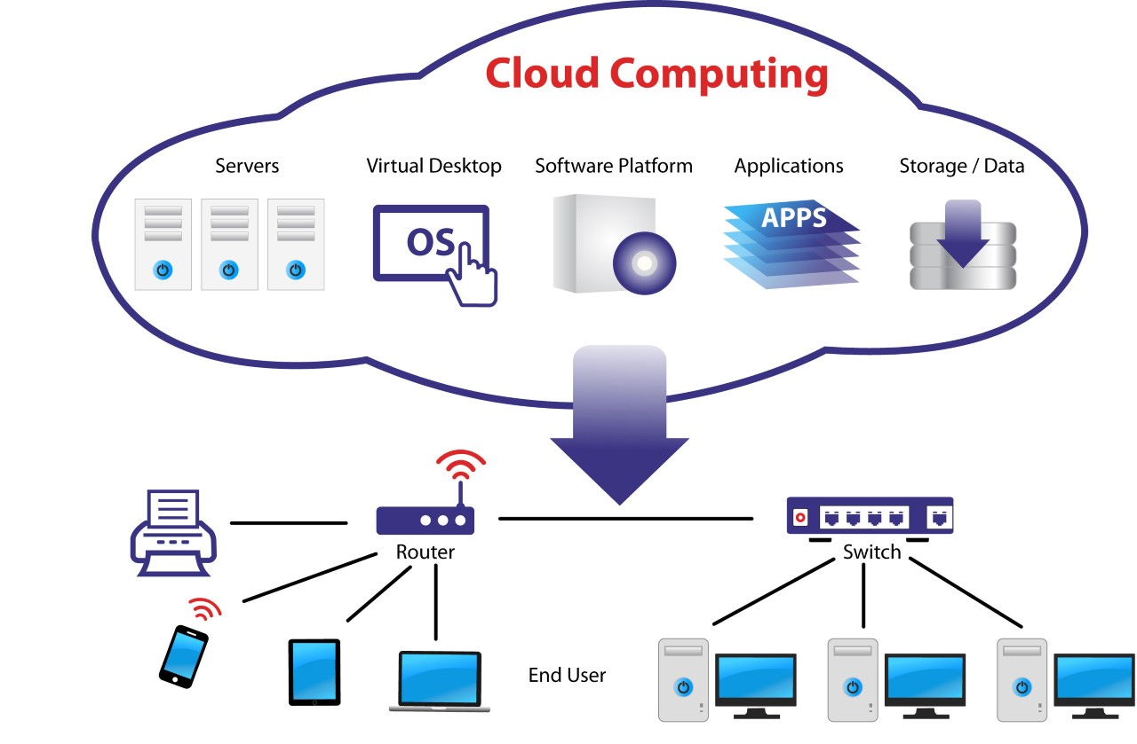

**Diagram of IoT**

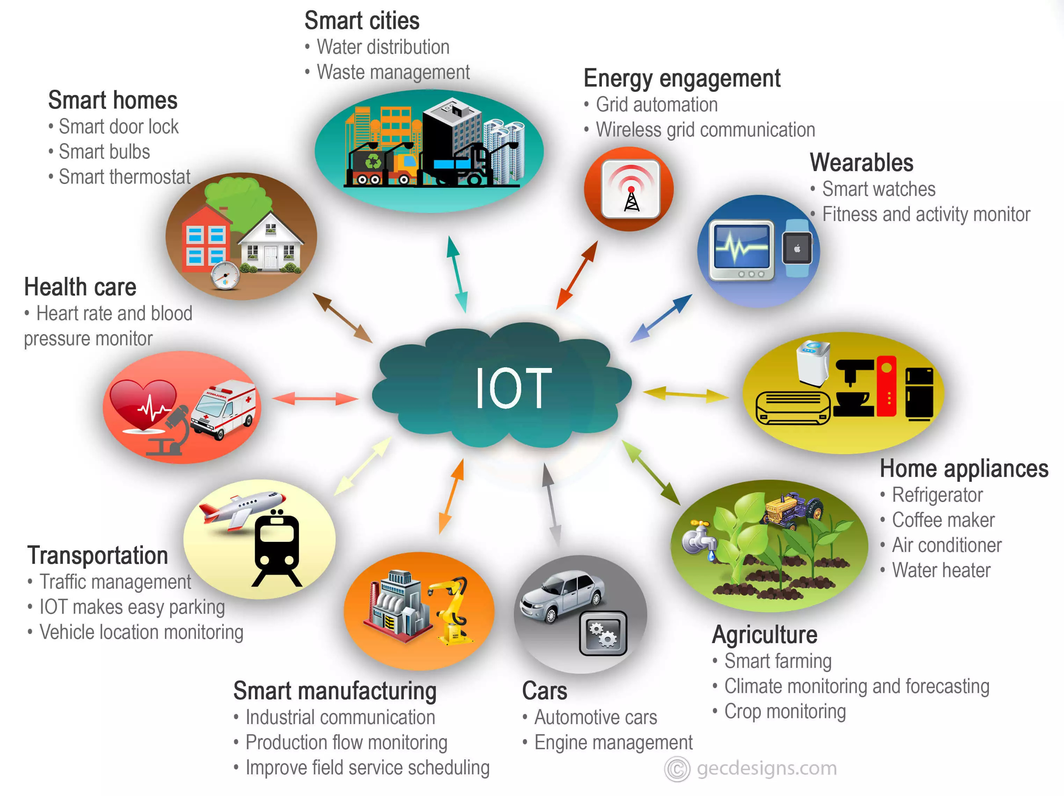

**Diagram of Augmented Reality**

