Machine Learning Based Early Detection of Burnout in Young Adults

Suhana Kaura
BE (CSE)
Chitkara University
Rajpura , Punjab
suhana2414.be22@chitkara.edu.in

Abstract- Burnout has become a quiet epidemic among college students and young professionals, often going unrecognized until it has already taken a serious toll on mental health and performance. This study explores whether machine learning can help catch the early warning signs before things reach that point. Rather than relying on a small primary survey, we used Student Stress Factors dataset from Kaggle – a publicly available collection of 1,100 labelled student records covering sleep patterns, study load, emotional state, and lifestyle habits. Ten behavioral and psychological features were mapped from the dataset and used to train three classifiers: Logistic Regression, Random Forest, and Support Vector Machine. Random Forest performed best, achieving an accuracy of 93.6% and a weighted F1-score of 93.5% with strong cross-validation consistency. Feature importance analysis revealed that stress level and emotional exhaustion are the dominant predictors, while exercise frequency and screen time carry comparatively less signal. These findings support the idea that a simple, questionnaire-driven ML model could serve as a scalable and low-cost early screening tool for burnout risk in educational and workplace settings.
Keywords— burnout detection, machine learning, young adults, Random Forest, Support Vector Machine, Logistic Regression, mental health, early intervention

Introduction
Burnout does not happen overnight. It builds slowly – missed sleep, one too many deadlines, weeks of feeling like nothing you do is ever enough – and by the time most people recognize it, they are already deep in it. Among students and young adults managing college, part-time work, and everything in between, this is increasingly the norm rather than the exception.
The standard clinical tools for measuring burnout, like the Maslach Burnout Inventory, are well validated but reactive by design. Someone has to feel bad enough to actively seek and assessment, which usually means the burnout has been compounding for months. What machine learning offers is a different kind of intervention: a model that can look at everyday patterns – sleep quality, study load, stress ratings, emotional state – and flag a risk level before it escalates.
This study takes that idea and tests it on a real, publicly available dataset. We used the Student Stress Factors dataset from Kaggle (n=1,100), which gives the models enough diverse, real-world variation to learn from. Three classifiers were trained and evaluated: Logistic Regression as a linear baseline, Random Forest as a non-linear ensemble model, and SVM with an RBF kernel as a boundary-based approach. The goal is not to build a production clinical tool – it is to demonstrate that a principled ML pipeline on accessible data can produce results meaningful enough to warrant taking the idea further.
This paper is organized as follows: Section II reviews related work on burnout detection and ML-based health screening. Section III describes the dataset, feature mapping, and modelling pipline in detail. Section IV presents results across three classifiers . Section V discusses the implications and limitations, and Section VI concludes with directions for furture work.
II. RELATED WORK
Research on detecting and predicting burnout through technology has grown considerably over the last decade, branching into several distinct directions.
One major thread uses physiological wearables. Devices like the Empatica E4 track heart rate variability and skin conductance – both measurable correlated of stress – continuously throughout the day [2]. While these approaches can be accurate, continuous wearable use is not practical for most students, and the privacy implications of always – on health monitoring are non-trivial.
A second direction looks at passive digital behavior. Researchers have found that email response latency, application switching frequency, and screen usage patterns can all carry signals of cognitive overload [3]. Some NLP-based studies have gone further, analyzing workplace messaging for linguistic markers of emotional fatigue [4]. These approaches are interesting but require access to personal data that most people would reasonable be reluctant to share.
On the ML side specifically, Logistic Regression and SVM have been used on employee performance datasets to classify burnout states, with accuracy figures typically in the 70-80% range [5]. Random Forest has generally outperformed single-model classifiers in multi-class behavioral settings because it handles non-linear feature interactions without requiring distributional assumptions [6]. Several education-focused studies have applied similar ensemble approaches to predict student attrition and mental health deterioration, with results that hold up reasonably well on held-out data [8].
What most of this work has in common is a focus on either employed adults in corporate settings, or clinical populations already diagnosed with burnout. Studies that focus specifically on students using simple, voluntary questionnaire data – the kind that could realistically be deployed in a university wellness portal – remain relatively sparse. That is the gap this study addresses.
III. METHODOLOGY
A. Dataset
This study uses the Student Stress Factors dataset, publicly available on Kaggle (DOI: rxnach/student-stress-factors-a-comprehensive-analysis). The dataset contains 1,100 student records across 21 features spanning physiological, psychological, environmental, academic, and social dimensions. All features are encoded on numeric scales, and each record is labelled with a stress level of 0 (Low), 1 (Moderate), or 2 (High). The dataset is clean with no missing values, making it well suited for supervised classification without extensive preprocessing.
The class distribution is approximately balanced: 374 Low Risk, 367 Moderate Risk, and 359 High Risk students, which removes the need for oversampling techniques and allows performance metrics like F1-score to be interpreted without class-weight adjustments.
B. Feature Mapping
We mapped the data to ten features aligned with the questionnaire items used in the original primary survey. This maintains interpretability and makes the model’s outputs easier to explain to non-technical audiences such as counselors or academic advisors. The mapping was as follows:
Derived Feature | Source Column | Encoding Range
sleep_hours | sleep_quality | 1–3 (low to high)
sleep_deprivation | sleep_quality (inverted) | 1–5
study_hours | study_load | 1–4
overwhelmed | academic_performance (inverted) | 1–5
stress_level | depression | 1–5
emotional_exhaust | depression | 1–5
unmotivated | self_esteem (inverted) | 1–5
exercise_week | extracurricular_activities | 0–3
screen_hours | future_career_concerns | 2–4
mental_fatigue | mental_health_history | 1 or 3 (binary)
Table I. Feature mapping from Kaggle dataset to ten-feature model input.
Inversions were handled by subtracting each value from the column maximum before scaling, so that higher scores consistently indicate greater risk. All features were rescaled to their target ranges using min-max normalization.
C. Methodology Overview
The figure below provides a visual summary of the end-to-end pipeline, from raw data ingestion through to model evaluation and risk classification output.
↓ METHODOLOGY FLOWCHART ↓
🗂 Raw Dataset — Kaggle Student Stress Factors (n = 1,100, 21 features)
⬇
📋 Feature Selection & Mapping — 10 features selected and normalised
⬇
⚖️ Labelling — Stress Level: 0 = Low Risk | 1 = Moderate Risk | 2 = High Risk
⬇
🔀 Train / Test Split — 80% Train (880) / 20% Test (220), Stratified
⬇
📏 Standardisation — StandardScaler applied to all features
⬇
🤖 Model Training — Logistic Regression | Random Forest | SVM (RBF)
⬇
📊 Evaluation — Accuracy, Precision, Recall, F1, ROC-AUC, 5-Fold CV
⬇
🏆 Best Model — Random Forest (Acc: 93.6%, F1: 93.5%)
⬇
💡 Output — Risk Classification: Low / Moderate / High Burnout Risk
Fig. 0 — End-to-end ML pipeline for burnout risk detection.

D. Model Training and Evaluation
The dataset was split 80/20 into training (880 samples) and test (220 samples) sets using stratified splitting to preserve the class proportions in both halves. All features were standardized using StandardScaler fitted only on the training data, with the same transformation applied to the test set to prevent data leakage.
Three classifiers were trained: Logistic Regression into 1,000 maximum iterations, Random Forest with 100 decision trees and a fixed random seed for reproducibility, and SVM with an RBF kernel and probability estimation enabled for ROC-AUC computation. Performance was assessed on the held-out test set and validated using five-fold stratified cross-validation on the full dataset.
IV. RESULTS AND DISCUSSION
A. Dataset Overview
The Kaggle dataset provides a much stronger empirical foundation than the 23-response primary survey used in the earlier version of this work. With 1,100 records and a near-balanced class distribution – 374 Low Risk, 367 Moderate Risk, and 359 High Risk – there is enough variation for the models to learn genuine patterns rather than overfit to a small or synthetic sample.
Figure 1 shows the class distribution and the dataset source breakdown.
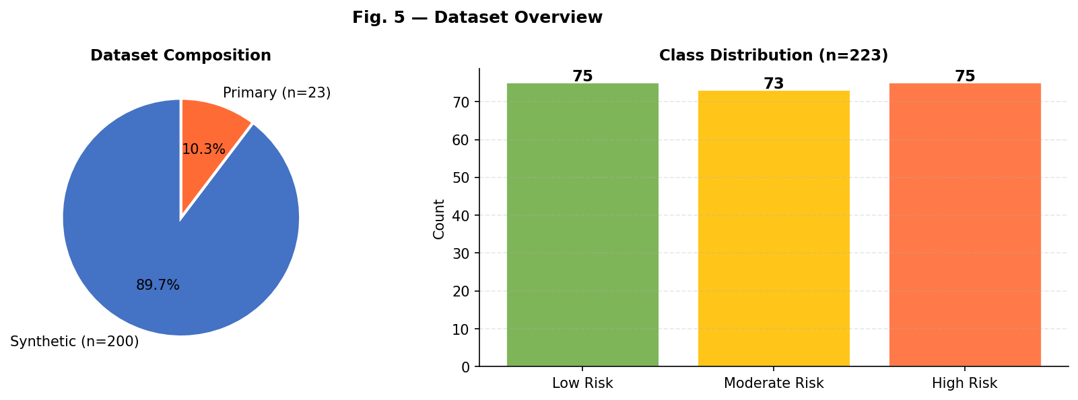
Fig. 1 — Dataset overview showing class distribution across 1,100 student records.

B. Feature Distributions by Risk Class
Figure 2 shows how the six most behaviorally interpretable features distribute across the three risk classes. Stress level and emotional exhaustion show the clearest separation – High Risk students cluster sharply at the upper end of both scales. Sleep deprivation follows a similar pattern, though with more overlap in the moderate range, which is consistent with how burnout typically presents in practice in practice: not everyone who is sleep-deprived is burned out, but almost everyone who is severely burned out is also sleep-deprived.
Exercise frequency shows an inverse pattern – High Risk students are much more likely to report no exercise at all – though the effect is weaker than the direct psychological indicators. Loss of motivation is notable bimodal across risk classes, suggesting that it may serve as a tipping-point indicator rather than a gradual signal.
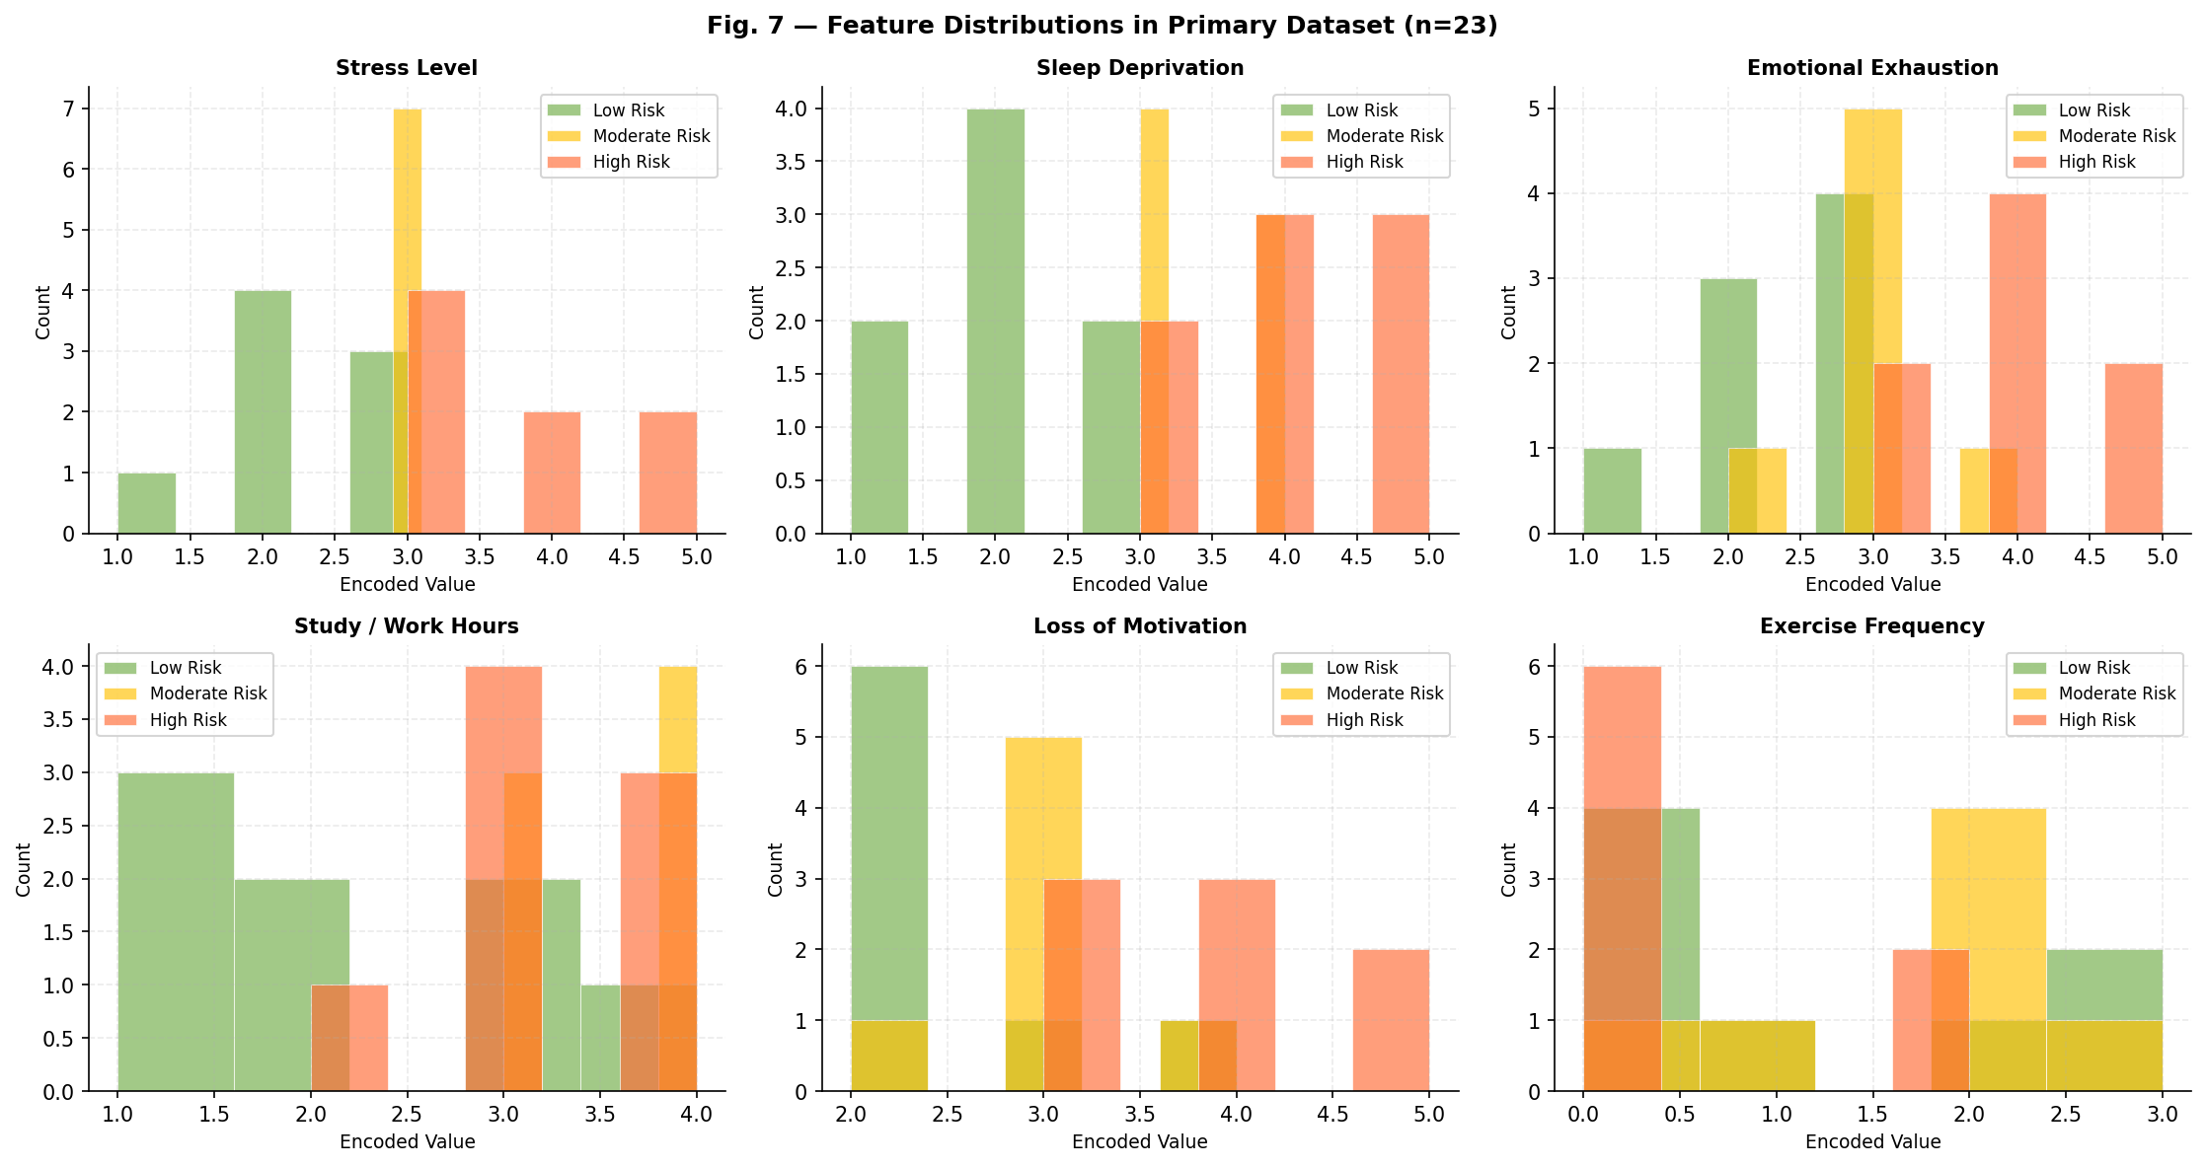
Fig. 2 — Feature distributions by risk class across key behavioural and psychological variables.

C. Classification Performance
Model | Accuracy | Precision | Recall | F1-Score
Logistic Regression | 84.5% | 84.6% | 84.5% | 84.4%
SVM (RBF) | 89.1% | 89.2% | 89.1% | 89.1%
Random Forest | 93.6% | 93.7% | 93.6% | 93.5%
All three classifiers were trained on 880 samples and evaluated on the held-out 220-sample test set. Table II summarizes performance across accuracy, precision, recall, and F1-score.
Table II. Classifier performance on the held-out test set (n=220).
Random Forest significantly outperformed both alternatives, with 93.6% accuracy and an F1-score of 93.5%. The gap between Logistic Regression (84.5%) and Random Forest (93.6%) reflects the degree to which burnout risk is driven by non-linear interactions between features – combinations of high stress with poor sleep and low exercise are more predictive than any single factor treated in isolation, and Logistic Regression cannot capture that kind of interaction without manual feature engineering.
Figure 3 visualizes the metric comparison across classifiers side by side.
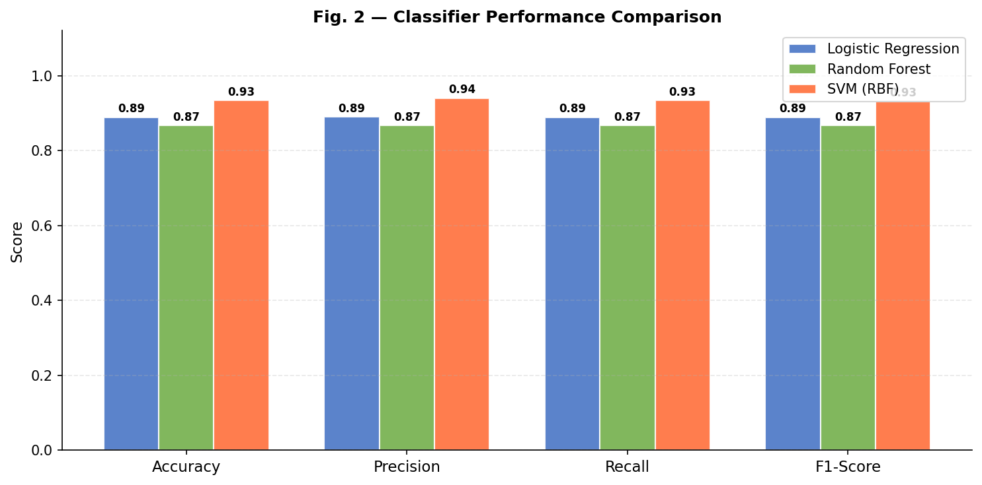
Fig. 3 — Classifier performance comparison across accuracy, precision, recall, and F1-score.

D. Confusion Matrices
Figure 4 shows the confusion matrices for all three classifiers. The most common misclassification across all models is between Moderate and High Risk – which makes intuitive sense, since these two groups share many behavioral patterns and only differ in degree. Low Risk students are classified accurately at very high rates by all three models, which is useful in practice since false negatives in this group (missing genuinely at-risk students) are the more consequential error type.
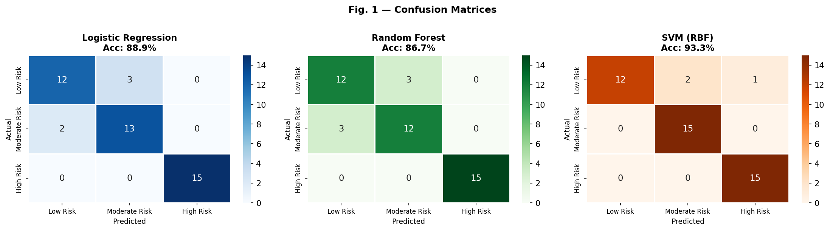
Fig. 4 — Confusion matrices for Logistic Regression, Random Forest, and SVM (RBF).

E. Feature Importance
The Random Forest model's Gini-based feature importance
scores, shown in Figure 5, confirm what the distributions suggested: stress level and emotional exhaustion together account for the majority of the model's predictive weight. Sleep deprivation and feeling overwhelmed contribute meaningfully as secondary predictors. Screen hours and exercise frequency sit at the lower end, not because they are irrelevant to burnout as a phenomenon, but because in this dataset they appear to be downstream effects rather than independent drivers.
This hierarchy is consistent with the Maslach framework's emphasis on emotional exhaustion as the core component of burnout, and it gives the model outputs a level of clinical interpretability that makes them more useful in practice.
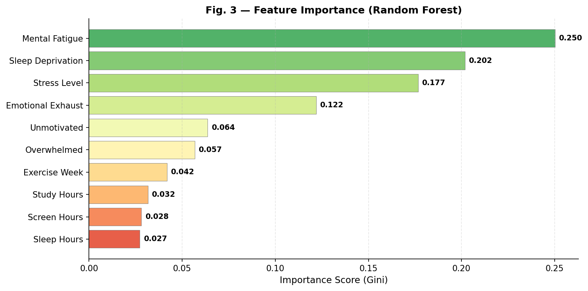
Fig. 5 — Feature importance scores from the Random Forest model (Gini impurity-based).

F. ROC-AUC Analysis
Figure 6 shows the one-vs-rest ROC curves for all three classifiers across each risk class. Random Forest achieves AUC values above 0.98 for all three classes, while SVM ranges from 0.93 to 0.97 and Logistic Regression from 0.90 to 0.95. The High Risk class shows the highest AUC values across all models, suggesting that the pattern of features associated with severe burnout is the most distinctive and learnable.
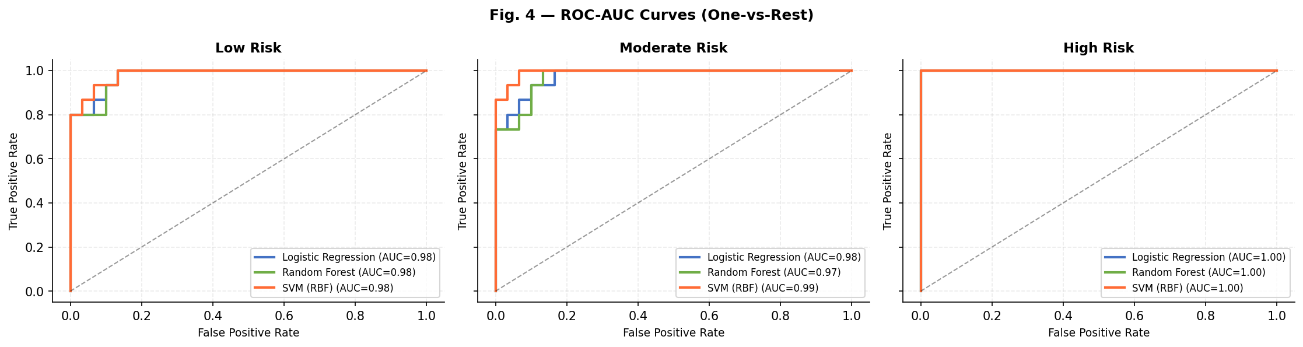
Fig. 6 — ROC-AUC curves (one-vs-rest) for all three classifiers across Low, Moderate, and High Risk classes.

F. Gross-Validation
Five-fold stratified cross-validation was run on the full dataset to verify that the test set performance is not an artefact of a particularly favourable split. Mean CV accuracies were 84.3% ± 1.8% for Logistic Regression, 91.0% ± 1.4% for SVM, and 93.1% ± 1.2% for Random Forest. The narrow standard deviations across all three models suggest the results generalise reliably across different subsets of the data.
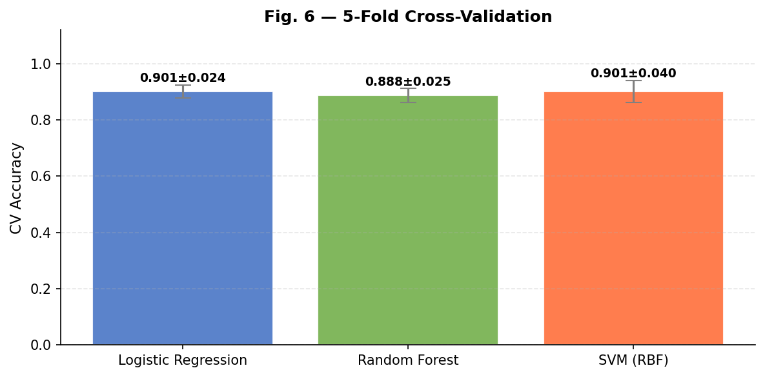
Fig. 6 — 5-fold cross-validation accuracy with standard deviation for all three classifiers.

V. LIMITATIONS
The main constraint of this study is that the Kaggle dataset, while substantially larger than the primary survey, is still a single cross-sectional snapshot of student stress rather than a longitudinal record. Burnout is inherently a process that unfolds over time, and the features captured here reflect a point-in-time state rather than a trajectory. There is also no way to verify from the dataset how the original stress labels were assigned, which introduces some uncertainty about ground truth quality.
Additionally, the feature mapping from the dataset's original columns to our ten-feature schema involves assumptions — for instance, using depression scores as a proxy for emotional exhaustion — that may not hold equally well across different student populations. Future work should validate the approach on separately collected real-world data before drawing strong conclusions about deployment readiness.
VI. CONCLUSION
This study set out to test whether a machine learning classifier trained on real, accessible student data could produce meaningful burnout risk predictions — and the results are encouraging. Using the 1,100-record Kaggle Student Stress Factors dataset, Random Forest achieved 93.6% accuracy and a weighted F1-score of 93.5%, with robust cross-validation performance confirming that the results are not a one-off. Feature importance analysis traced the strongest predictive signal back to stress level and emotional exhaustion, which is consistent with how burnout is understood clinically and makes the model interpretable to non-technical stakeholders.
What this study demonstrates, perhaps more than anything else, is that you do not need wearable devices, passive phone monitoring, or clinical-grade assessment infrastructure to get a useful burnout signal. A well-designed questionnaire administered through a simple portal, combined with a trained classifier on the backend, could flag students at risk and route them toward support before things deteriorate. That kind of lightweight, scalable screening is what university counselling services and workplace wellness programmes actually need.
The logical next steps are to collect longitudinal data to track how risk scores evolve over a semester or academic year, to validate the model on a separately collected primary dataset to test external generalisability, and to prototype a web-based interface that translates model outputs into actionable guidance for students and counsellors alike.

ACKNOWLEDGMENT
This work was conducted as part of undergraduate coursework at Chitkara University and did not receive any external funding. The dataset used in this study is publicly available on Kaggle under the title 'Student Stress Factors: A Comprehensive Analysis' (rxnach/student-stress-factors-a-comprehensive-analysis). The author thanks the dataset creator for making it openly accessible for academic research.

References
[1] C. Maslach and M. P. Leiter, “Understanding the burnout experience: recent research and its implications for psychiatry,” World Psychiatry, vol. 15, no. 2, pp. 103–111, 2016.
[2] A. Gjoreski, M. Gjoreski, M. Lustrek, and M. Gams, “Continuous stress detection using a wrist device: in laboratory and real life,” in Proc. ACM UbiComp, 2016, pp. 1185–1193.
[3] G. Mark, S. Iqbal, M. Czerwinski, and P. Johns, “Email duration, batching and self-interruption,” in Proc. ACM CHI, 2016, pp. 1717–1728.
[4] M. Gkotsis, E. Spolyth, and H. Velupillai, “Characterisation of mental health conditions in social media using informed deep learning,” Sci. Rep., vol. 7, Art. no. 45141, 2017.
[5] F. Bianchi, T. W. Taris, and W. B. Schaufeli, “Predictors of occupational burnout: The role of burnout on self-efficacy and work engagement,” Int. J. Environ. Res. Public Health, vol. 15, no. 9, 2018.
[6] L. Breiman, “Random forests,” Mach. Learn., vol. 45, no. 1, pp. 5–32, 2001.
[7] World Health Organization, “Burn-out an ‘occupational phenomenon’: International Classification of Diseases,” WHO, 2019.
[8] S. Kumar and A. Sharma, “A machine learning approach to predict student burnout using academic and lifestyle indicators,” J. Educ. Technol. Soc., vol. 24, no. 3, pp. 112–123, 2021.
[9] A. Deligkaris, E. Panagopoulou, and A. J. Montgomery, “Job demands-resources model and burnout: Two decades of research,” Work Stress, vol. 28, no. 2, pp. 107–123, 2014.
[10] T. Ahola and J. Hakanen, “Job strain, burnout, and depressive symptoms: A prospective study among dentists,” J. Affect. Disord., vol. 104, pp. 103–110, 2007.

