INTERNSHIP REPORT
ON
COMMUNITY SERVICE AND SOCIAL DEVELOPMENT AT NEEV SHAKTI SANSTHA
Submitted To
School of Computer Science and Engineering
IILM University, Greater Noida, U.P.
In partial fulfilment of the requirement of the degree of
B.Tech CSE – AI & ML with IBM

By
Roll Number of Student: 25SCS1003001384
Name of Student: SUHANA KUMAR
Batch: 2026-27

CANDIDATE'S DECLARATION
I, Suhana Kumar, a student of B.Tech CSE – AI & ML with IBM at IILM University, do hereby declare that the internship report titled “Community Service and Social Development at Neev Shakti Sanstha” has been completed by me to fulfil the requirement for the award of the degree of Bachelor of Technology in CSE. All the references have been quoted and I have not taken as such any material from any other source. I affirm that this report is my own original account of the work and learning undertaken by me during the internship period, and has not been submitted to any other institute for any degree/diploma requirement, and I shall be solely responsible for any kind of copyright violation in this regard.
Signature
Student Name: Suhana Kumar
Enrollment No.: 25SCS1003001384
University: IILM University

ACKNOWLEDGEMENT
I would like to express my sincere gratitude to IILM University for providing me the opportunity to undertake this internship as part of my academic curriculum, and to the faculty for their guidance and support throughout this period.
I am equally thankful to Neev Shakti Sanstha for welcoming me into their team and giving me the opportunity to be a part of their meaningful work. My sincere thanks go to the staff and mentors at the NGO who patiently guided me, shared their knowledge, and helped me understand the practical aspects of community service and social development.
I am also grateful to the beneficiaries and community members who welcomed me during various activities and made this internship a truly enriching and humbling experience. This internship has been a valuable step in my personal and professional growth. I express my gratitude to my parents for their blessings.
Signature
Student Name: Suhana Kumar
Enrollment No.: 25SCS1003001384

INTERNSHIP COMPLETION CERTIFICATE
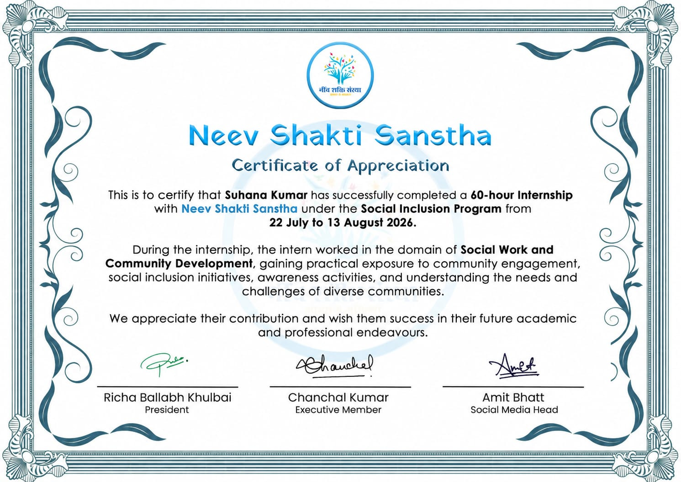
Certificate of Appreciation issued by Neev Shakti Sanstha certifying successful completion of the 60-hour internship (22 July 2026 – 13 August 2026).

TABLE OF CONTENTS
Chapter No. | Chapter Name | Page No.
 | Cover Page | —
1. | Candidate's Declaration | i
2. | Acknowledgement | ii
3. | Internship Completion Certificate | iii
4. | Project Description
 | 4.1 Introduction | 1
 | 4.2 Organization Profile | 1
 | 4.3 Problem Statement | 2
 | 4.4 Project Objectives | 3
 | 4.5 Scope of the Project | 3
 | 4.6 Technologies and Tools Used | 4
 | 4.7 System Architecture (Working Model) | 5
 | 4.8 Methodology | 5
 | 4.9 Expected Outcomes | 10
 | 4.10 Certificates of Completion and Communication Proof | 12
5. | Bibliography / References | 13

4. PROJECT DESCRIPTION

4.1 Introduction
This report presents an account of the internship undertaken by Suhana Kumar, a B.Tech CSE – AI & ML with IBM student (2nd Year, 3rd Semester) at IILM University, at Neev Shakti Sanstha in the capacity of a Community Service Intern. The internship was carried out over a duration of 22 July 2026 to 13 August 2026, amounting to a total of 60 hours of engagement with the organisation.
The internship provided practical exposure to community service, disability inclusion, and the functioning of a non-governmental organisation, and aimed to bridge the gap between theoretical academic knowledge and real-world social work through direct interaction with beneficiaries and participation in the NGO's ongoing initiatives.
The internship began with an orientation into the NGO's mission and day-to-day operations, followed by direct interaction with beneficiaries during educational and recreational sessions. As the internship progressed, the intern participated in awareness campaigns and creative activities such as the Best Out of Waste initiative and poster-making sessions, took part in a community cleanliness drive, and supported outreach events organised with the local administration. In the final phase, the intern accompanied the NGO team on a beneficiary field visit and assisted in organising and analysing household survey data, gaining exposure to documentation and evidence-based social work. Throughout the internship, practical skills in communication, teamwork, leadership, problem-solving, data organisation, and community engagement were developed, alongside a strengthened sense of empathy and understanding of the importance of an inclusive society.

4.2 Organization Profile
Neev Shakti Sanstha is a non-governmental organisation (NGO) dedicated to empowering persons with disabilities by promoting inclusion, equal opportunities, and independent living. The organisation works towards improving the quality of life of its beneficiaries through education, skill development, awareness programs, community participation, and support in accessing government welfare schemes. During the internship, the intern had the opportunity to observe the NGO's efforts in creating a more inclusive and supportive society.

Key Areas of Work
- Empowering persons with disabilities through education and skill development.
- Creating awareness about disability rights and social inclusion.
- Assisting beneficiaries in obtaining UDID Cards, Aadhaar Cards, disability certificates, pensions, and other government welfare benefits.
- Organising educational, recreational, and community engagement activities.
- Conducting awareness campaigns, cleanliness drives, and environmental initiatives.
- Promoting sustainable practices through activities such as Best Out of Waste.
- Conducting household surveys and data analysis to identify community needs and improve welfare services.
- Encouraging self-employment and livelihood opportunities for beneficiaries.
- Supporting rehabilitation, accessibility, and equal participation in society.
- Working with volunteers, students, and community members to create a positive social impact.
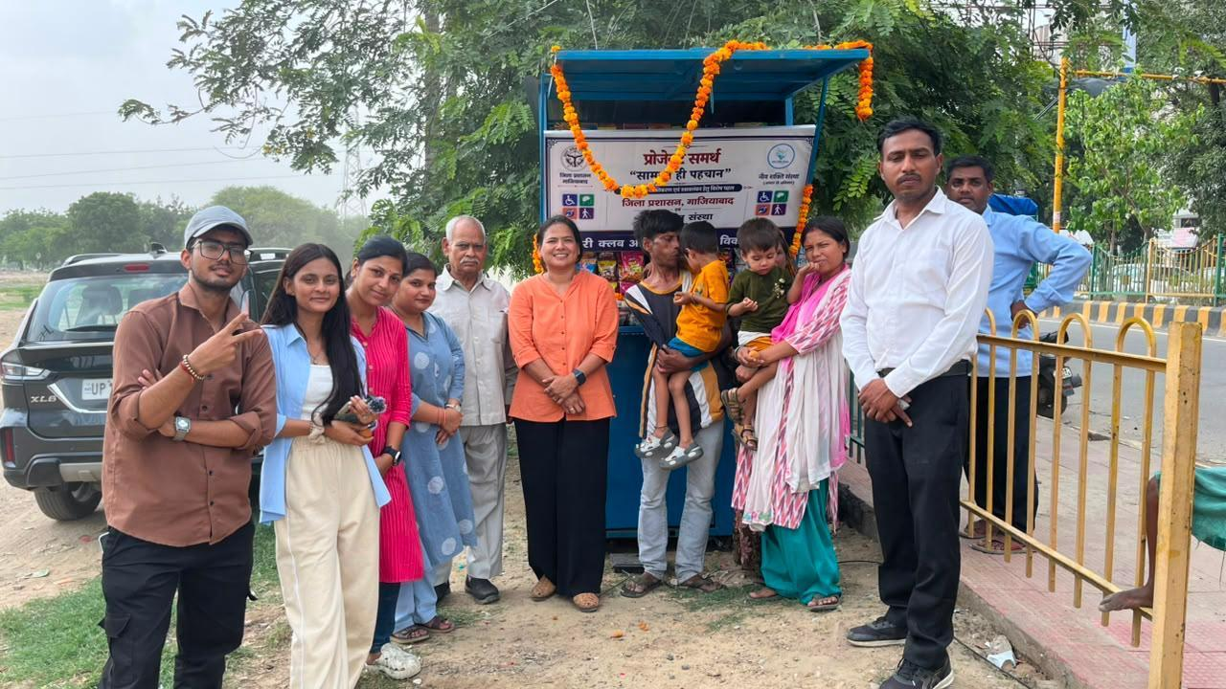
Figure 4.1: A Neev Shakti Sanstha community outreach stall organised with the district administration to promote disability inclusion and welfare access.

4.3 Problem Statement
Persons with disabilities continue to face significant barriers in accessing education, government welfare schemes, healthcare, and livelihood opportunities, which limits their independence and equal participation in society. Many beneficiaries served by Neev Shakti Sanstha lack access to essential documentation such as UDID Cards, Aadhaar Cards, and disability certificates, without which they are unable to avail pensions and other welfare benefits to which they are entitled.
Furthermore, there exists a wider gap between the theoretical understanding of disability inclusion and community welfare taught in academic settings and its practical, ground-level implementation. The internship was undertaken to address this gap by engaging directly with the NGO's efforts to identify community needs through household surveys, spread awareness, and support beneficiaries in overcoming social and administrative barriers to inclusion.

4.4 Project Objectives
The internship at Neev Shakti Sanstha was undertaken with the objective of gaining practical exposure to community service, disability inclusion, and the functioning of a non-governmental organisation. It aimed to bridge the gap between theoretical knowledge and real-world social work through direct interaction with beneficiaries and participation in the NGO's ongoing initiatives. The specific objectives were as follows:
- To understand the mission and working model of Neev Shakti Sanstha.
- To gain practical knowledge of disability inclusion and community welfare.
- To interact with beneficiaries and understand their social and economic needs.
- To participate in awareness campaigns and community outreach activities.
- To support educational, recreational, and skill-development activities.
- To contribute to environmental initiatives such as cleanliness drives and sustainable practices.
- To support survey data organisation, analysis, and report preparation.
- To develop communication, teamwork, leadership, and problem-solving skills.
- To understand the importance of empathy, inclusion, and social responsibility in community development.

4.5 Scope of the Project
As a Community Service Intern, the intern's role primarily involved supporting the NGO's ongoing community development activities rather than any technical work. The key responsibilities within the scope of this internship included:
- Assisting NGO staff during orientation, awareness sessions, and outreach programs.
- Interacting with beneficiaries and supporting educational and recreational sessions.
- Participating in awareness campaigns, poster-making, and the Best Out of Waste activity.
- Taking part in a community cleanliness drive and related environmental activities.
- Accompanying the NGO team on a beneficiary field visit.
- Assisting in organising and reviewing household survey data collected by the NGO.
- Supporting basic documentation and preparation of activity-related reports.
The scope of the internship was limited to community service and social development activities and did not involve the design or development of any software or technical system.

4.6 Technologies and Tools Used
As this was a community service and social development internship rather than a software development project, no programming languages, frameworks, or technical development tools were used. The work instead relied on the following methods and materials:
- Household survey forms and records used by the NGO to collect information on Aadhaar availability, UDID cards, disability status, pension benefits, and employment.
- Basic documentation and record-organisation methods for sorting and reviewing survey responses and preparing summaries.
- Creative and awareness materials, including recyclable items (paper, cardboard, and plastic bottles) used for the Best Out of Waste activity, and materials used for poster-making on themes of inclusion, cleanliness, and environmental responsibility.
- Standard office and reporting tools used for preparing activity-related documentation.
Although no software tools were developed or used, the intern noted that the discipline of data organisation, verification, and analysis applied to the household survey data is directly transferable to the analytical and documentation skills required in a technical, CSE-based field of study.

4.7 System Architecture (Working Model of Service Delivery)
As the internship did not involve the design of a software or hardware system, this section instead describes the working model / process flow through which the NGO's community engagement activities — and the intern's participation in them — progressed over the internship period. The overall flow of engagement is summarised below:
- Orientation → Introduction to the NGO's mission, ongoing projects, and day-to-day operations.
- Beneficiary Interaction → Direct engagement with beneficiaries during educational and recreational sessions.
- Awareness & Creative Activities → Participation in awareness campaigns, poster-making, and the Best Out of Waste initiative.
- Environmental & Community Engagement → Involvement in a cleanliness drive and a community outreach event with local administration.
- Field Visit & Data Analysis → Accompanying beneficiary field visits, and organising, reviewing, and summarising household survey data.
- Documentation & Reporting → Preparation of activity-related summaries and this internship report.
This sequential model reflects how the NGO builds from awareness and direct beneficiary contact towards data-driven, evidence-based welfare planning — a structure that the internship schedule (detailed week-by-week in the Methodology section) closely followed.

4.8 Methodology
The internship was carried out over four weeks, with each week focused on a distinct set of activities that progressively built the intern's exposure to the NGO's work. The methodology followed during each week, along with the observations, skills developed, and reflections, is detailed below.

Week 1 – Orientation and NGO Immersion (22 July 2026 – 26 July 2026)
The first week of the internship at Neev Shakti Sanstha was dedicated to orientation and becoming familiar with the organisation's day-to-day operations. The intern was welcomed by the NGO team and given an overview of its mission, ongoing projects, and its commitment to improving the lives of persons with disabilities. This included attending an orientation session covering the NGO's history and the various services it provides, and visiting different sections of the NGO to observe how staff coordinate educational support, counselling, and welfare services.
One of the most meaningful parts of the week was interacting directly with beneficiaries and assisting them during learning sessions and recreational activities, including encouraging participation in simple exercises and games, which gave a first-hand view of how such activities build confidence, communication, and social interaction among beneficiaries.
It was observed that every beneficiary was treated with patience, respect, and dignity by the staff, who focused on building confidence and independence rather than offering only basic assistance. Through these interactions, the value of empathy, active listening, and effective communication was learned, along with a much better understanding of disability inclusion and community engagement than could be gained from theoretical study alone.
Skills Developed: Communication and Interpersonal Skills; Observation and Analytical Thinking; Teamwork and Adaptability; Empathy and Compassion.
Weekly Reflection: Week 1 laid a strong foundation for the rest of the internship. Interacting directly with beneficiaries changed the understanding of what true inclusion means — not just providing services, but ensuring respect, equal opportunity, and independence for every individual.
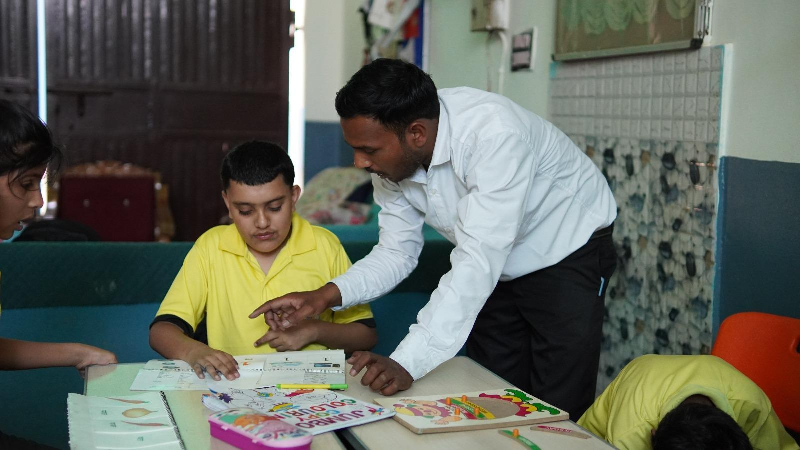 | 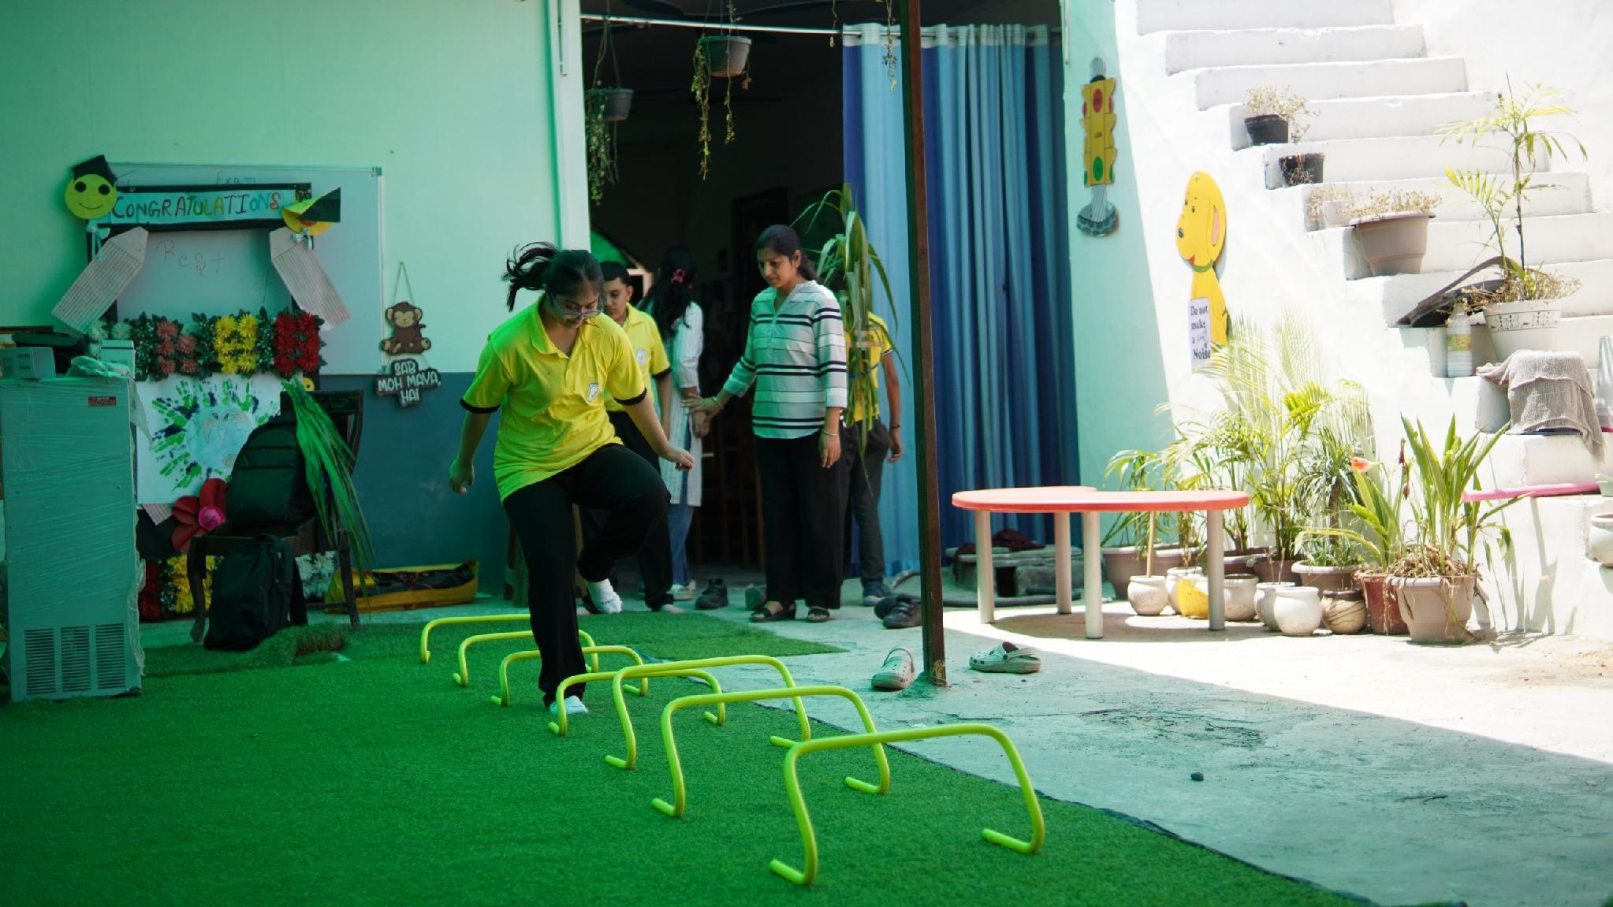
Figure 4.2: Supporting an educational activity, and assisting a beneficiary during a recreational exercise session.

Week 2 – Awareness, Creative Activities and Environmental Sustainability (28 July 2026 – 1 August 2026)
The second week focused on awareness and sensitisation activities, environmental sustainability, and creative learning. The intern took part in sessions highlighting the importance of disability inclusion, education, and environmental conservation, and contributed to the Best Out of Waste activity, where recyclable materials such as paper, cardboard, and plastic bottles were reused to create useful items. The intern also helped design awareness posters on themes such as inclusion, cleanliness, and environmental responsibility, and supported beneficiaries during a creative session focused on Earth Day awareness.
It was observed that creative activities are highly effective in conveying important social messages, and that beneficiaries showed great enthusiasm while participating in poster-making and art sessions. This week strengthened the understanding of how environmental sustainability and disability inclusion can be promoted together through interactive, community-based activities, and improved organisational, communication, and teamwork skills.
Skills Developed: Creativity and Innovation; Communication and Coordination; Environmental Awareness; Teamwork and Collaboration.
Weekly Reflection: This week reinforced the belief that meaningful change begins with awareness and active participation, and that even simple, creative initiatives can encourage people to adopt more sustainable and inclusive practices.
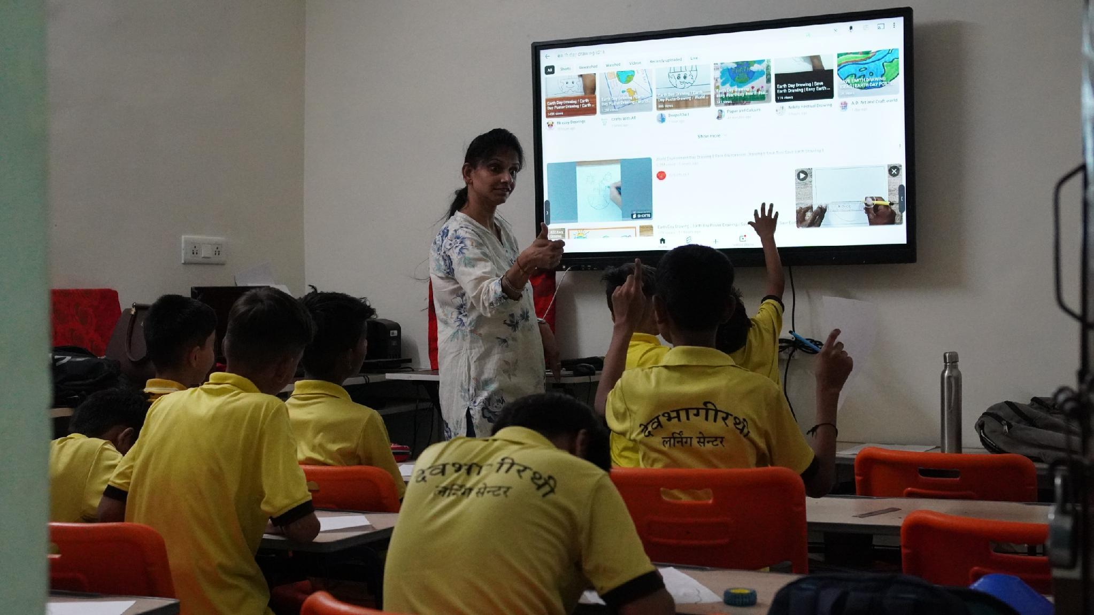 | 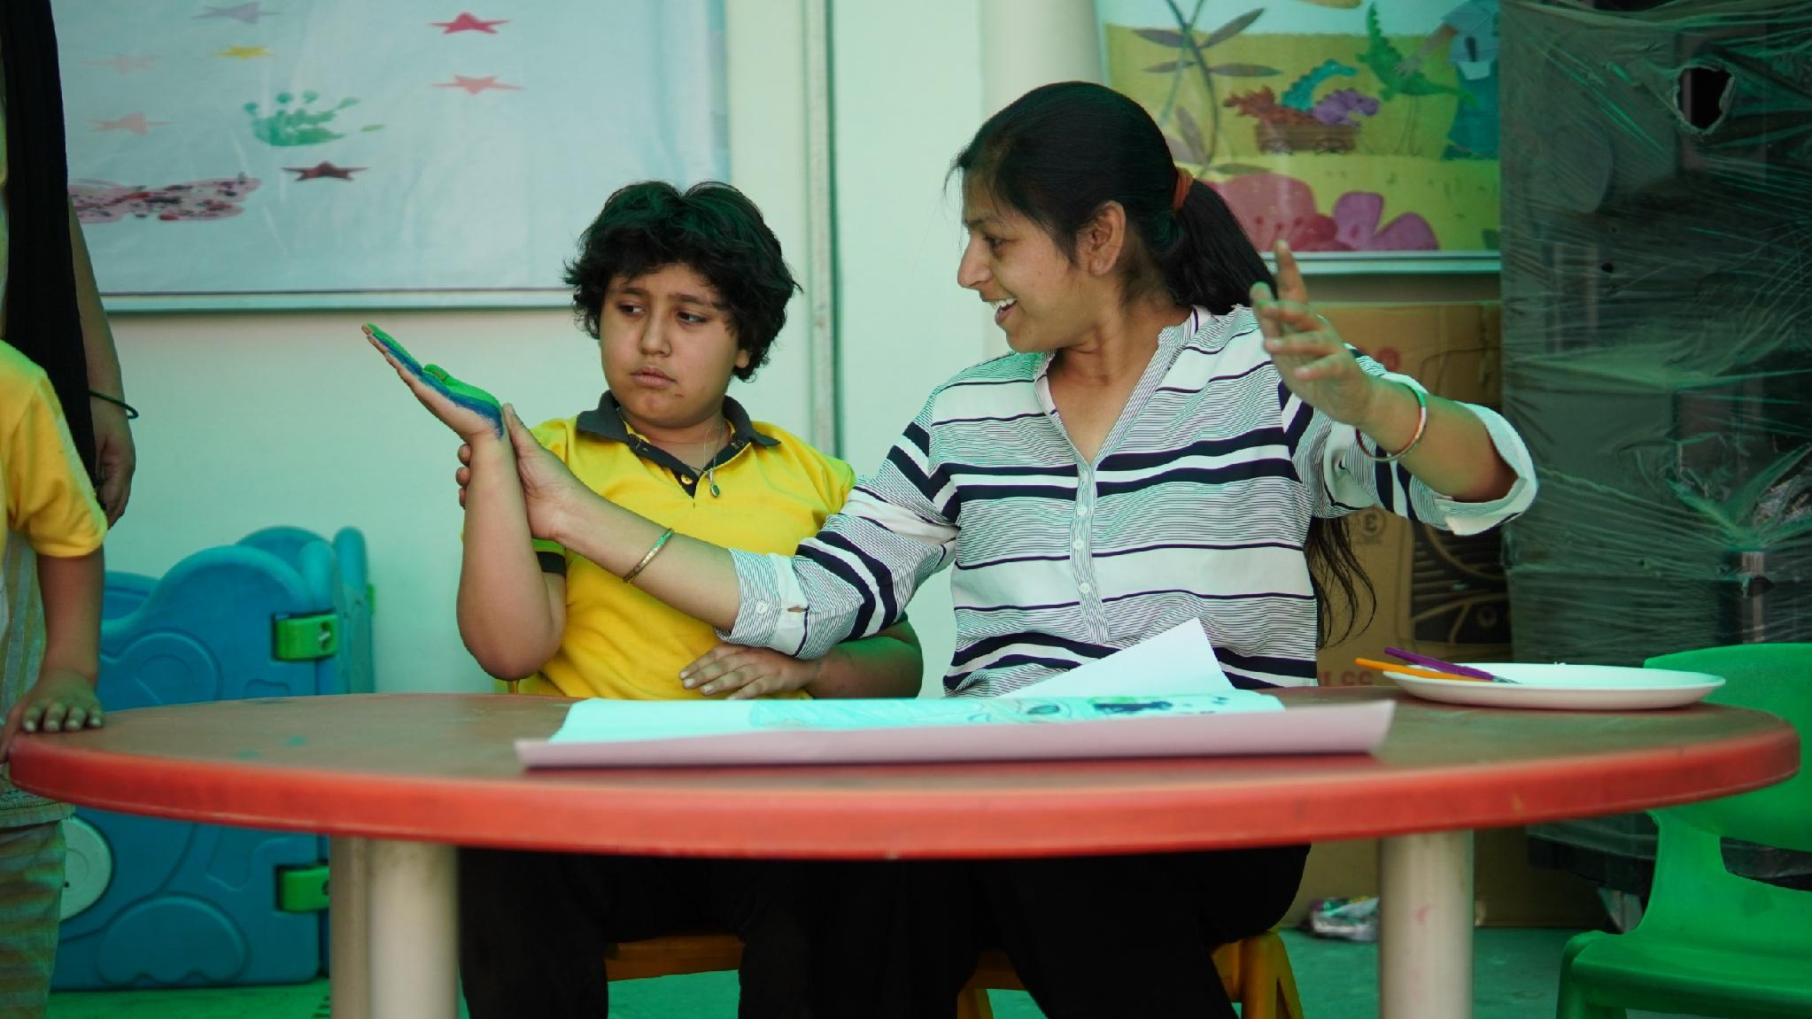
Figure 4.3: Participation in an environmental awareness and creative activity session with beneficiaries.

Week 3 – Cleanliness Drive and Community Engagement (3 August 2026 – 7 August 2026)
The third week focused on community service and environmental responsibility. The intern took part in a cleanliness drive organised by the NGO to promote hygiene and public participation, working alongside fellow volunteers to collect litter and encourage responsible waste disposal in the local area. Alongside this, the intern continued visiting the NGO and participated in a community outreach event conducted in coordination with the local administration, interacting with beneficiaries and community members and observing how such events support disability inclusion at the community level.
This week demonstrated that maintaining a clean environment is a shared responsibility, and that even small collective efforts by volunteers can make a real difference. Continued interaction with beneficiaries and community members further strengthened communication skills and deepened understanding of accessibility, inclusion, and equal opportunity.
Skills Developed: Communication Skills; Teamwork and Collaboration; Environmental Awareness; Social Responsibility.
Weekly Reflection: Participating in the cleanliness drive and community engagement activities highlighted that protecting the environment and supporting inclusion both begin with individual responsibility and consistent, collective action.
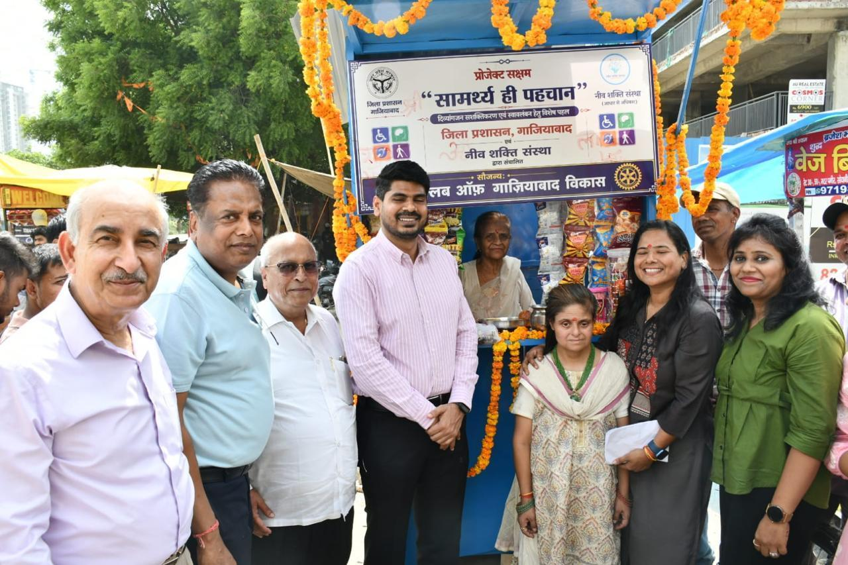
Figure 4.4: Participation in a community outreach and engagement event organised with local administration support.

Week 4 – Beneficiary Visit, Survey Data Analysis and Report Preparation (8 August 2026 – 13 August 2026)
The final week focused on economic empowerment and evidence-based social work. The intern accompanied the NGO team on a field visit to interact with beneficiaries and understand the NGO's efforts in supporting livelihood and self-employment opportunities for persons with disabilities, which highlighted the importance of empowering beneficiaries through independence rather than assistance alone.
The intern also assisted in organising and reviewing household survey data collected by Neev Shakti Sanstha, which included information related to Aadhaar availability, UDID cards, disability status, pension benefits, and employment. This work involved sorting responses, checking records for completeness, and helping prepare a summary of key observations for the NGO's survey report. As a B.Tech CSE – AI & ML student, this exercise was found particularly valuable in appreciating how data organisation, analysis, and documentation support evidence-based decision-making — skills that are directly transferable to a technical field, even though this task itself was carried out manually and did not involve developing any software or technical tool.
This week deepened the understanding of the relationship between fieldwork and data analysis in community development, highlighting that accurate data collection and systematic analysis are essential for NGOs to identify community needs and plan effective welfare interventions.
Skills Developed: Data Organisation and Analytical Thinking; Documentation and Report Preparation; Observation and Critical Thinking; Community Engagement.
Weekly Reflection: This week combined field exposure with analytical work and strengthened an appreciation for research-based social work, showing how field observations and organised data together contribute to effective welfare programmes.
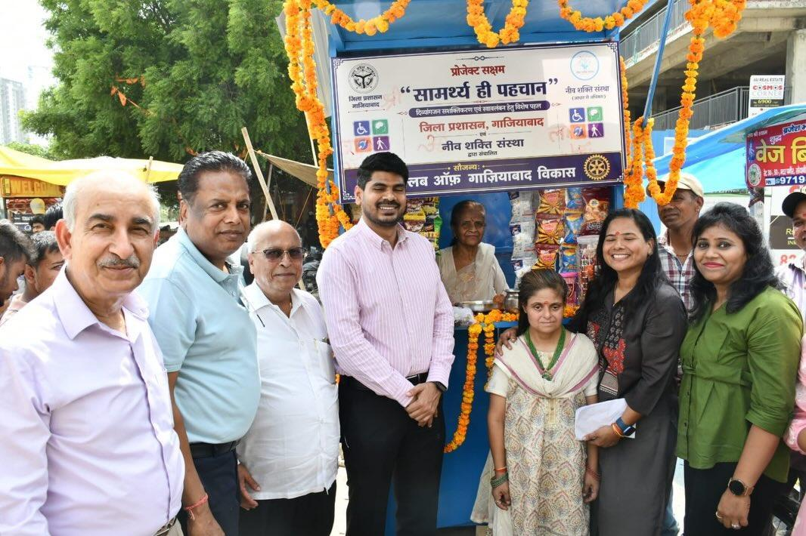
Figure 4.5: Accompanying the NGO team during a community and beneficiary field visit.

Challenges Faced
During the internship, a few challenges were encountered that contributed to overall growth. Communicating effectively with beneficiaries having different needs required patience and careful, sensitive interaction, especially in the initial days. Understanding welfare-related information and helping organise survey data required close attention to detail, as errors or inconsistencies could easily be introduced while handling large amounts of information. Coordinating community activities such as the cleanliness drive and awareness sessions also required good time management and teamwork.
With guidance from the NGO staff and through consistent practice, these challenges were overcome over the course of the internship, which in turn strengthened confidence, communication, and problem-solving abilities.

4.9 Expected Outcomes

Skills Acquired
- Communication
- Teamwork and Collaboration
- Leadership
- Problem-Solving
- Time Management
- Observation
- Analytical Thinking
- Data Organisation
- Report Writing and Documentation
- Community Engagement
- Creativity
- Environmental Awareness
- Empathy and Social Responsibility
- Adaptability

Key Learning Outcomes
This internship provided practical exposure to community service and disability inclusion that went well beyond what could be learned from theory. Interacting with beneficiaries taught the importance of patience, empathy, and effective communication, while participating in awareness, environmental, and cleanliness activities demonstrated how collective, community-driven effort can create meaningful social change.
Working with survey data during the final week helped in understanding how evidence-based approaches strengthen social work, and reinforced the value of organisation, accuracy, and clear documentation — skills that will benefit both personal development and technical studies. Overall, the internship strengthened a sense of social responsibility and provided a much deeper appreciation of the role NGOs play in building an inclusive and supportive society.

Conclusion
The internship at Neev Shakti Sanstha was a valuable and enriching learning experience that allowed for an understanding of the real-world importance of community service, disability inclusion, and social responsibility. Through direct engagement with beneficiaries, participation in awareness and environmental activities, and exposure to survey-based social research, insights were gained that go well beyond classroom learning.
The experience helped develop essential skills such as communication, teamwork, leadership, and analytical thinking, while also strengthening confidence and empathy towards persons with disabilities. Overall, this internship has been a meaningful step in both personal and professional development, and has inspired continued positive contribution towards community welfare in the future. Sincere gratitude is due to Neev Shakti Sanstha and to IILM University for providing this opportunity to learn, serve, and make a positive contribution to the community.

4.10 Certificates of Completion and Communication Proof
The Internship Completion Certificate issued by Neev Shakti Sanstha, certifying successful completion of the 60-hour internship undertaken from 22 July 2026 to 13 August 2026 under the Social Inclusion Programme, has been enclosed in this report as Chapter 3 (Internship Completion Certificate). No additional email or written communication proof was provided by the organisation beyond this certificate.

5. BIBLIOGRAPHY / REFERENCES
This report is primarily based on first-hand experience, observations, and notes recorded during the internship, together with information and materials provided by the host organisation. The sources referred to in the preparation of this report are as follows:
1. Neev Shakti Sanstha – Organisational information, mission, and areas of work, as shared by the NGO during the internship orientation and ongoing interactions (22 July 2026 – 13 August 2026).
2. Neev Shakti Sanstha – Certificate of Appreciation issued on completion of the 60-hour internship under the Social Inclusion Programme.
3. Personal field notes, observations, and weekly reflections recorded by the intern during the course of the internship.

