TROY: SIEGE
Working Design Document — v0.3
Prepared for Sheetal · July 24, 2026

1. Concept Overview
Troy: Siege is a large-scale, 50-versus-50 asymmetric objective mode set during the Trojan War, drawing on the Iliad. One team defends the fortified city of Troy; the other must break in and destroy it before time runs out.
Note: despite the "battle royale" framing in early notes, the design — persistent respawns, a fixed 15-minute round, and a single team objective rather than last-player-standing — places this closer to a large-scale siege/objective mode (in the vein of Battlefield's Conquest or Rush) than a classic battle royale. Worth keeping in mind for how the game is marketed.
Scope decision: the game draws only on the Iliad / siege of Troy. Odyssey material (gods, monsters, the sea voyage) is intentionally excluded from this mode to keep the systems approachable for new players.

2. Teams & Heroes

Defense — "For Troy"
Defends the homeland. Two hero kits, mapped to Trojan figures from the myth:
- Hector — frontline melee tank. Troy's greatest defender.
- Paris — ranged archer, primary counter to attackers exposed at walls or dynamite plants.
(A third class, Medic, was cut to keep the defense roster tight and balanced against the attack side's two kits.)

Attack — "Against Troy"
Must infiltrate and destroy Troy. Two hero kits, mapped to Greek figures from the myth:
- Achilles — engages directly, escorts dynamite carriers, and pushes the wall breach. The Greeks' greatest warrior.
- Odysseus — builds and uses secret tunnels to enter undetected. The myth's master of cunning and infiltration — fittingly also the mind behind the Trojan Horse.
Attackers are given a higher base HP pool than defenders, to offset the natural disadvantage of closing distance against ranged archers.
Roadmap note: Ajax is reserved as a future third attack-side hero or alternate kit, once the base roster is validated in playtesting.

3. The Objective: The Idol
A large idol stands at the center of Troy, clearly visible from anywhere inside the walls so infiltrators always know where to go.
- HP pool: the idol has its own health bar. Interacting with it (channeling) deals damage over time; there is no separate "decapitation" action — depleting its HP is the win condition.
- No regeneration: idol HP never regenerates. Chip damage from an early, unsuccessful push persists for the rest of the round, so partial progress is never wasted.
- Multi-channel: any number of attackers can channel the idol simultaneously, and damage scales with how many are channeling — a coordinated final push is meaningfully faster than a lone attempt.
- Defender interrupt: defenders can stop a channel at any time by killing the channeling attacker(s), via arrows or melee.

4. Respawns
Attackers respawn freely for most of the round. Respawns are permanently cut off once the idol has taken 5 HP of cumulative damage — not on first contact/touch.
This threshold (rather than an instant on-touch cutoff) exists specifically to prevent a lone or griefing attacker from prematurely locking the rest of the 50-player attack team out of respawns before the team is actually in position to capitalize on the opening.

5. Infiltration Methods
Attackers have three distinct ways into Troy, each with a different risk/reward and counterplay profile:

5.1 Wall Breach
Troy's walls have their own independent HP pool, separate from the idol.
- Attackers place dynamite by holding a button (e.g. E) at the wall.
- Only one charge can be active at a time — a new charge cannot be placed adjacent to one that hasn't detonated yet.
- Each charge takes ~15 seconds to arm/detonate before the next can be placed, pacing out the breach rather than allowing a single simultaneous burst.
- Each detonation chips away a portion of the wall's HP independently of the idol.
- Counterplay: there is no defuse mechanic. Defenders' only counter is killing the attacker before they finish planting — archer (Paris) fire is the primary deterrent, making the wall the loudest, most exposed, most heavily contested entry point.

5.2 Secret Tunnels
Attackers playing Odysseus can build tunnels underground to bypass the walls entirely.
- Every Odysseus player is equipped with a shovel, used to dig.
- Tunnels cannot be detected by archers by default — the stealth option, trading time investment for safety.
- Digging faster/louder increases the chance of detection once defense has purchased a Listening Post (see Section 6) — a risk/reward trade between dig speed and stealth.
- On reaching the space beneath Troy, the digging player gets an "Entering Troy" notification so they know when to surface.

5.3 The Trojan Horse
A single random event per match, referencing the iconic myth directly:
- Triggers once, at an unpredictable point in the round.
- 3–4 riders are randomly selected from the entire attack team over a ~5 second window — a player can be grabbed mid-fight.
- A cutscene shows the horse dropping into Troy from above.
- Selected riders spawn at random locations inside the walls — a genuine surprise-entry wildcard, not a guaranteed safe insertion.

6. Defense Economy — The Armor Shop
Defenders earn tokens by killing attackers, spent on permanent upgrades.
- The shop is not open continuously — it opens for a window every 3 minutes across the 15-minute round (roughly 5 windows per match).
- This periodic-window design (rather than an always-open shop) is intended to curb snowballing: without it, an early kill streak could buy overwhelming armor immediately and compound for the rest of the round.
- Listening Post — a purchasable, upgradeable structure that lets defense hear digging activity underground, and increases the odds of detecting a tunnel the faster/noisier an attacker digs. The direct counter to the otherwise-undetectable tunnel (Section 5.2).

7. Signature Hero Moments
The Trojan Horse gives attackers a rare, high-variance highlight moment. To keep this from feeling one-sided, defense gets a mirrored, equally rare, skill-gated moment of its own — both drawn directly from the same myth, so no new lore or systems (like gods or monsters) are needed.

7.1 Achilles' Heel (Defense payoff)
Achilles has a small, very difficult-to-hit weak point — his heel. Landing a precise shot there as Paris is an instant kill regardless of Achilles' current HP or armor. Rare, high-skill, and a direct callback to how Achilles dies in the myth.

7.2 Hector's Flaw (Attack payoff)
Mirroring the above: Hector has one exposed gap in his armor (echoing how Achilles kills Hector in the Iliad, exploiting a gap in armor Hector had taken from Patroclus). An attacker — most fittingly Achilles — who lands a precise strike on that gap gets an instant kill regardless of Hector's current HP or armor.
Together, these give each side one iconic, rare, skill-based "clutch moment" mirroring the other, rather than a raw power advantage for either side.

8. Art Direction
Grounded Bronze Age historical-fantasy rather than stylized mythology — closer to Ryse: Son of Rome and Total War Saga: Troy for scale and armor grounding, God of War (2018) for weighty combat framing and color grading, and For Honor for readable asymmetric class silhouettes across a chaotic 50v50 fight. Because Odyssey material (gods, monsters) is out of scope, the visual language stays plausible-historical: bronze, leather, and sun-bleached stone, with no glowing magic effects.
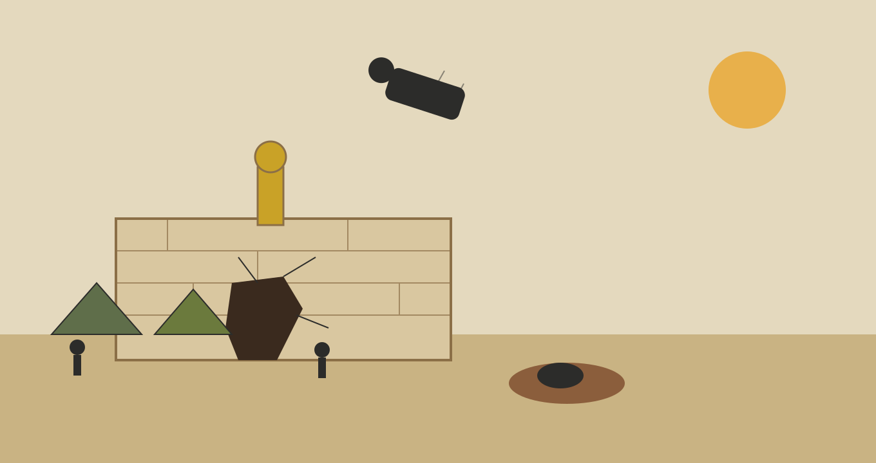
Concept sketch: siege scene — wall breach, tunnel mound, the idol visible above the ramparts, the horse mid-drop
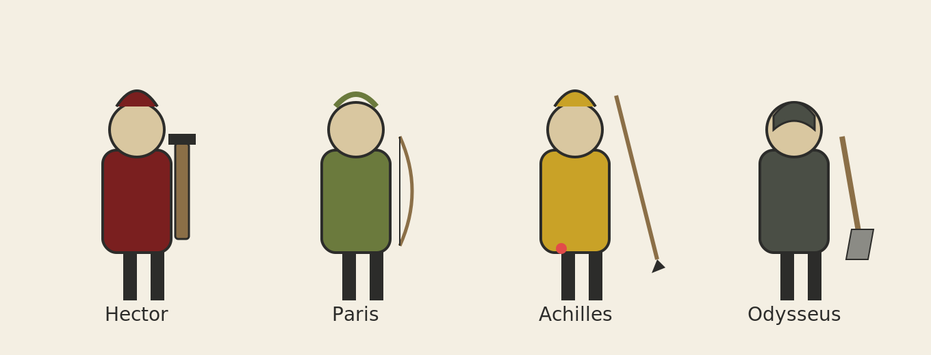
Concept sketch: hero silhouettes — Hector, Paris, Achilles, Odysseus
The wall's damage state doubles as a readable HP indicator — cracks and a growing breach accumulate as dynamite chips away at it, so players can gauge progress without checking a UI bar:
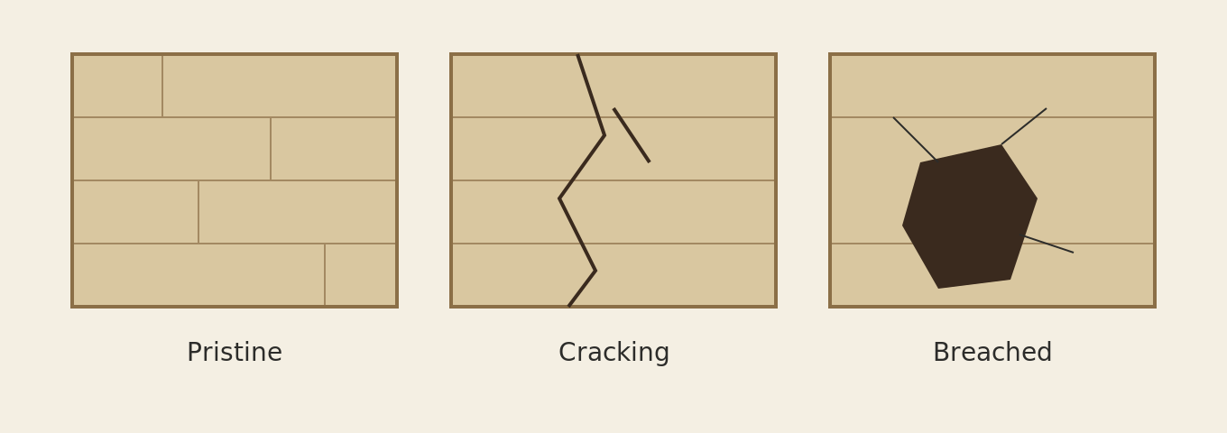
Wall HP states: pristine, cracking, breached
Armor shop UI direction — parchment and bronze tones, laurel/Greek-key motifs rather than a modern sci-fi HUD, keeping menus in period with the 3D art:
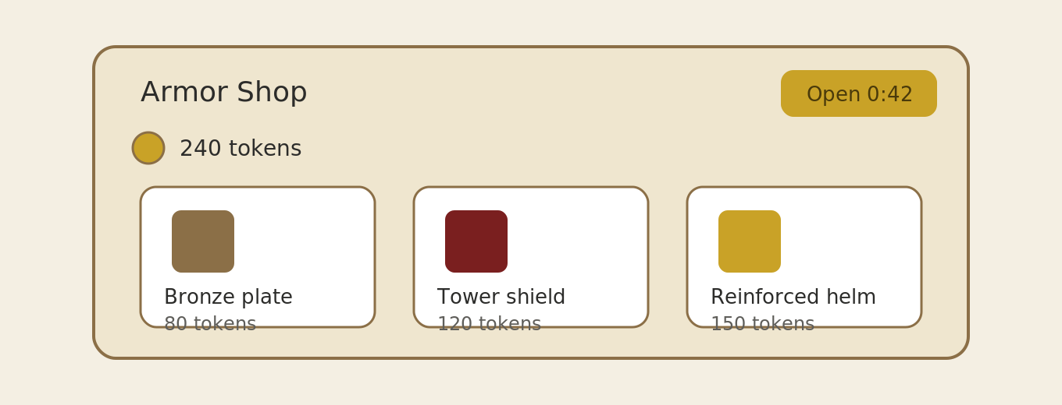
Armor shop mockup: token balance, countdown to next open window, purchasable upgrades

9. Win / Lose Conditions & Rewards
Outcome | Trigger
Attack wins | Idol HP reaches zero before the 15-minute round timer expires.
Defense wins | Idol survives (HP remains above zero) when the round timer expires.
Reward | The winning team earns a medal each round, which contributes to an account-level level/progression system.

10. Platforms & Matchmaking
Targeting PC, console, and mobile.
- Matchmaking pools are kept separate per platform by default, to avoid mixing control schemes (mouse/keyboard, controller, touch) within the same match.
- Cross-platform play is available only via party invites — friends on different platforms can group up and queue into the same match together.

11. Future Roadmap (Not Being Designed Yet)
Ideas raised during discussion that are intentionally deferred, to keep the initial scope focused:
- Ajax as a third attack-side hero or alternate kit, once the base four-hero roster is validated.
- Divine Intervention — limited-use, god-themed effects (e.g. environmental/battlefield-altering abilities). If pursued, likely positioned as a future paid feature rather than a core mechanic, and out of scope for the current design pass.
- Ongoing map/scenario variety and live-ops balance tuning (wall HP, idol HP, shop cadence, horse frequency) post-launch, to keep the mode from feeling repetitive over time.

12. Open Questions & Playtesting Priorities
Items flagged during design discussion that are decided in direction but need numbers or playtesting to finalize:
- Wall HP tuning: how many dynamite cycles (at ~15 sec each) should a full breach take, relative to how exposed that leaves attackers to archer fire?
- Idol channel scaling: does damage scale linearly with the number of channelers, or is there a soft cap so a 10-person zerg doesn't trivialize the final push?
- Trojan Horse fairness: with zero warning before the drop, does a lucky/unlucky horse landing feel like it decides rounds too often? Worth testing whether any minimal telegraph (sound, brief sky effect) preserves surprise while giving defense a sliver of reaction time.
- Armor shop cost curve: should upgrade costs scale up per tier (beyond just the 3-minute window gating) to further flatten snowball potential?
- Listening Post tuning: how directly should it reveal tunnel location vs. just general "digging nearby" alerts, so it counters tunnels without fully negating the stealth fantasy?
- Tunnel dig time/risk: how long should digging take relative to the wall-breach and horse paths, so all three infiltration routes stay competitive with each other?
- Achilles' Heel / Hector's Flaw tuning: instant-kill or heavy-damage-only? How telegraphed should the weak point be, and should there be a cooldown so it can't be spammed into a routine kill rather than a rare moment?
- Mobile control parity: touch-aim vs. mouse/controller precision for Paris/archer play in particular — may need aim-assist tuning specific to mobile.
- Marketing framing: given the mechanics resemble a large-scale siege/objective mode more than a classic battle royale, decide how the mode is described to players to set correct expectations.

