AMAZON SALES DATA INDIA
Sales Performance & Business Insights Report
Analysis period: 01 Jan 2024 – 30 Aug 2026
Dataset: 10,000 rows | 10,000 unique orders
Prepared from the provided Excel workbook. Monetary values are reported in Indian rupees (INR).

1. Executive Summary
The dataset contains 10,000 unique orders and 24,926 units across 5 product categories. Recorded sales total ₹155,789,893.89, with recorded profit of ₹33,167,008.49 and an overall profit margin of 21.29%. The average order value is ₹15,578.99. Electronics & Mobiles is the leading category, contributing 79.32% of total sales. Maharashtra is the highest-sales shipping state.
Total Orders: 10,000 | Total Sales: ₹155,789,893.89
Total Profit: ₹33,167,008.49 | Profit Margin: 21.29%
Average Order Value: ₹15,578.99 | Units Sold: 24,926
Calculation notes: Total sales and profit are sums of the dataset's Total_Sales_INR and Profit_INR columns. Average order value (AOV) = total sales ÷ unique Order_ID count. Profit margin = total profit ÷ total sales.

2. Overall Sales and Profit Performance
The recorded profit margin is 21.29%, meaning the dataset records about ₹21.29 profit per ₹100 of sales. Average quantity per order is 2.49 units. The average listed discount is 8.56%.
Business interpretation:
- Use profit margin alongside sales volume when evaluating products and categories; the highest revenue item is not automatically the most efficient.
- Review discounting by category and product to understand whether discounts are supporting order volume without unnecessarily reducing margin.
- Track monthly sales and profit together so that revenue growth can be checked against profitability.

3. Category and Product Performance
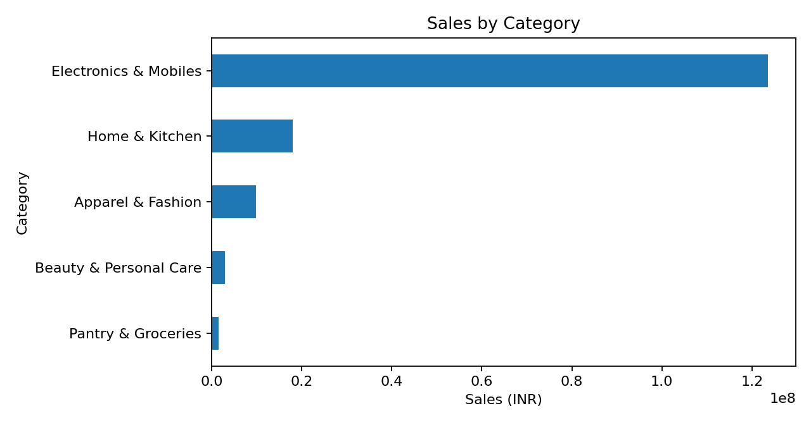
Electronics & Mobiles leads sales with ₹123,569,507.07 (79.32% of total sales). This category is a major driver of business performance and should be monitored for stock availability, pricing, and profitability.
Category | Orders | Sales | Profit | Margin
Electronics & Mobiles | 3,045 | ₹123,569,507.07 | ₹26,310,257.24 | 21.29%
Home & Kitchen | 1,888 | ₹17,973,218.93 | ₹3,837,268.36 | 21.35%
Apparel & Fashion | 2,580 | ₹9,831,025.09 | ₹2,085,354.00 | 21.21%
Beauty & Personal Care | 1,499 | ₹2,889,178.50 | ₹604,390.41 | 20.92%
Pantry & Groceries | 988 | ₹1,526,964.30 | ₹329,738.48 | 21.59%

Top products by sales
Product | Orders | Sales | Profit
Laptop Backpack | 652 | ₹26,529,187.41 | ₹5,628,644.03
Power Bank 20000mAh | 634 | ₹25,548,449.07 | ₹5,496,680.51
5G Smartphone | 596 | ₹24,330,766.23 | ₹5,109,132.92
Wireless Earbuds | 603 | ₹23,848,640.89 | ₹5,204,191.90
Smartwatch | 560 | ₹23,312,463.47 | ₹4,871,607.88
The highest-sales product is Laptop Backpack at ₹26,529,187.41. The top five products are useful candidates for inventory planning, promotional campaigns, and supplier review.

4. Order Status and Potential Revenue Exposure
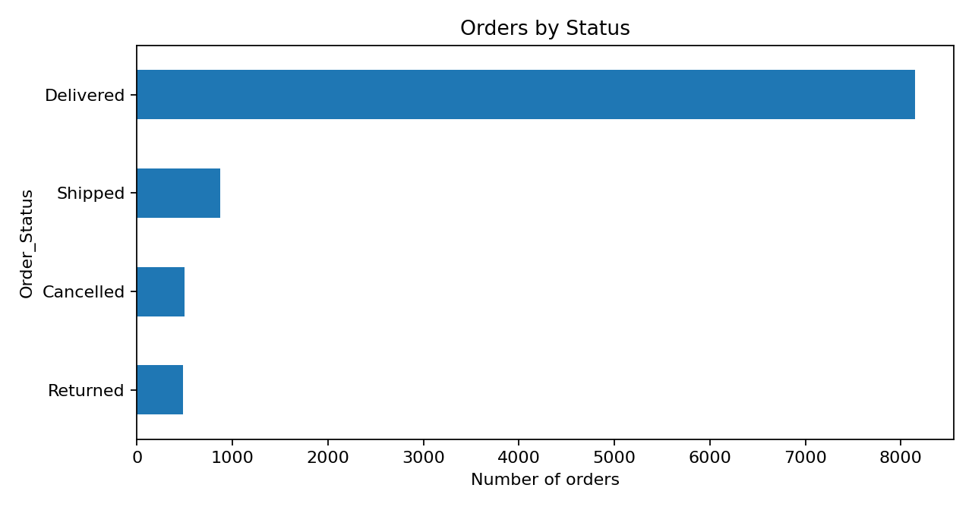
Order status breakdown: 8,147 delivered (81.47%), 868 shipped (8.68%), 500 cancelled (5.00%), and 485 returned (4.85%). Cancelled and returned orders together account for 985 orders (9.85%).
Status | Orders | Order Share | Recorded Sales | Recorded Profit
Delivered | 8,147 | 81.47% | ₹125,894,209.85 | ₹29,697,472.88
Shipped | 868 | 8.68% | ₹14,246,941.40 | ₹3,469,535.61
Cancelled | 500 | 5.00% | ₹7,688,159.19 | ₹0.00
Returned | 485 | 4.85% | ₹7,960,583.45 | ₹0.00
Important data caveat: cancelled and returned records have sales values but show zero recorded profit in this file. Their sales totals should be treated as status-associated amounts, not automatically as confirmed revenue loss or refunds. Validate the business rules for cancellations, returns, refunds, and profit recognition before reporting a definitive loss figure.

5. Payment Method Performance
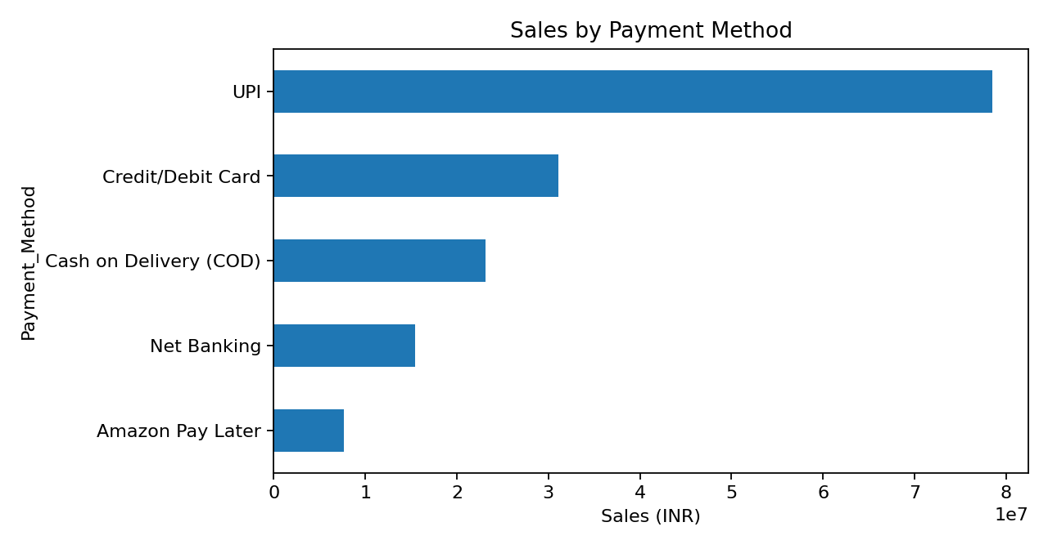
Payment Method | Orders | Sales | Profit | Sales Share
UPI | 4,972 | ₹78,515,436.26 | ₹16,653,494.14 | 50.40%
Credit/Debit Card | 2,074 | ₹31,069,230.90 | ₹6,525,646.17 | 19.94%
Cash on Delivery (COD) | 1,458 | ₹23,101,583.64 | ₹5,008,107.37 | 14.83%
Net Banking | 1,024 | ₹15,419,486.46 | ₹3,292,296.82 | 9.90%
Amazon Pay Later | 472 | ₹7,684,156.63 | ₹1,687,463.99 | 4.93%
UPI is the largest payment method by sales, contributing 50.40% of total sales. Keep payment options reliable and compare payment-method conversion, failure, and cancellation rates where those data are available.

6. Fulfillment Performance
Fulfillment Method | Orders | Sales | Profit | Margin
Amazon (FBA) | 7,054 | ₹107,528,288.07 | ₹22,882,414.52 | 21.28%
Seller Flex | 1,966 | ₹31,198,391.98 | ₹6,815,054.52 | 21.84%
Merchant (FBM) | 980 | ₹17,063,213.84 | ₹3,469,539.45 | 20.33%
Amazon (FBA) handles the largest order volume (7,054 orders) and contributes 69.02% of sales. Compare delivery speed, cancellation/return rates, and margin across fulfillment types before shifting volume.

7. Geographic Performance
Shipping State | Orders | Sales | Profit | Sales Share
Maharashtra | 1,840 | ₹29,554,237.21 | ₹6,301,731.56 | 18.97%
Karnataka | 1,515 | ₹24,415,704.16 | ₹5,273,235.35 | 15.67%
Delhi | 1,444 | ₹22,361,687.04 | ₹4,699,095.38 | 14.35%
Tamil Nadu | 1,109 | ₹17,889,855.25 | ₹3,856,864.11 | 11.48%
Uttar Pradesh | 991 | ₹14,140,675.36 | ₹2,978,266.81 | 9.08%
Telangana | 906 | ₹13,961,458.53 | ₹2,944,127.16 | 8.96%
West Bengal | 665 | ₹10,864,550.51 | ₹2,344,788.08 | 6.97%
Gujarat | 591 | ₹9,369,304.18 | ₹2,008,021.80 | 6.01%
Rajasthan | 456 | ₹6,620,697.25 | ₹1,383,028.68 | 4.25%
Kerala | 483 | ₹6,611,724.40 | ₹1,377,849.56 | 4.24%
Maharashtra is the leading state by sales with ₹29,554,237.21, followed by Karnataka at ₹24,415,704.16. These high-performing states may be priorities for inventory availability and targeted campaigns, while lower-sales states can be examined for delivery coverage, demand, and conversion barriers.

8. Monthly Sales Trend
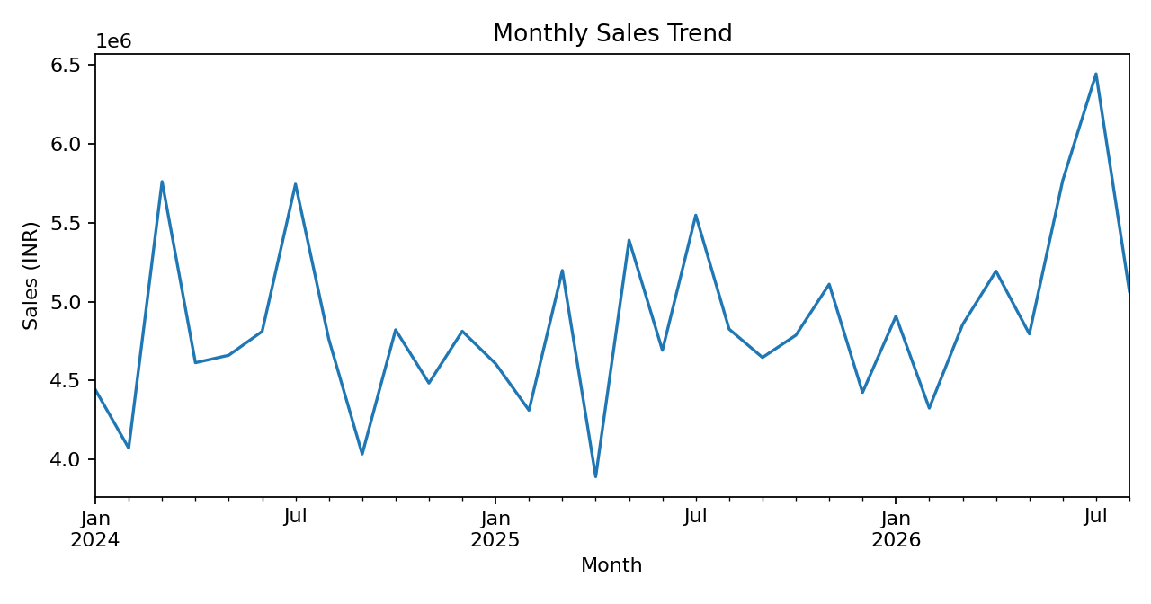
The highest-sales month in the dataset is Jul 2026, with sales of ₹6,443,679.00 and profit of ₹1,329,442.03. Monthly totals vary, so campaign planning should use seasonality and order volume rather than a single month alone. The dataset spans calendar months from {date_min:%b %Y} through {date_max:%b %Y}; the final month may be partial depending on the source data.

9. Key Findings
- Scale: 10,000 unique orders and 24,926 units are recorded in the dataset.
- Profitability: total recorded profit is ₹33,167,008.49, with a 21.29% overall margin.
- Category concentration: Electronics & Mobiles contributes 79.32% of sales.
- Order completion: delivered orders account for 81.47% of all orders.
- Cancelled/returned volume: 985 orders, or 9.85%, are marked cancelled or returned.
- Payment preference: UPI is the leading payment method by sales.
- Geography: Maharashtra is the largest shipping-state market by sales.

10. Recommendations
- Protect profitable growth: Review sales, profit, and margin together by category and product; set margin thresholds for promotions.
- Reduce avoidable cancellations and returns: Investigate reasons by product, state, fulfillment method, and payment method. Add reason codes if not already captured.
- Optimize inventory: Prioritize stock availability for the top-selling products and the highest-performing categories, while monitoring slow-moving inventory.
- Improve monthly planning: Compare month-over-month sales, profit, and orders; annotate campaign periods, holidays, and stockouts to explain peaks and dips.
- Use regional targeting: Maintain strong service in Maharashtra and Karnataka and evaluate opportunities in other states based on demand and fulfillment cost.
- Strengthen data quality: Confirm whether cancelled/returned sales should be excluded, reversed, or retained; reconcile the dataset with refunds and accounting records.

11. Data Scope and Limitations
- The analysis uses the Sheet1 transaction-level table with 10,000 rows and 15 columns.
- The report assumes one unique Order_ID represents one order; the dataset contains 10,000 unique Order_ID values.
- Profit and sales are reported exactly as supplied in the source columns and have not been reconciled to external accounting records.
- Cancelled and returned records have zero recorded profit but non-zero sales; interpretation depends on the source system's accounting logic.
- No shipping cost, advertising spend, refund amount, customer identifier, or return reason field was available in the analyzed table, limiting causal analysis.

12. Conclusion
The dataset shows ₹155,789,893.89 in recorded sales and ₹33,167,008.49 in recorded profit across 10,000 orders. Electronics & Mobiles is the main sales engine, UPI leads payment-method sales, and Maharashtra is the leading state. The strongest next steps are to protect margins in high-volume categories, investigate cancellations and returns, and use monthly and state-level trends to guide inventory and marketing decisions.
Report generated from the user-provided Excel workbook.

