Supermart Grocery Sales Report-1
Retail Analytics Report | Data period: 2015–2018
Prepared from the supplied Excel workbook. Amounts are shown in the dataset’s original units; no currency symbol was specified.

1. Executive Summary
The dataset contains 9,994 sales records covering 03 Jan 2015 to 30 Dec 2018. Total recorded sales were 14,956,982, with total profit of 3,747,121.20 and an overall profit margin of 25.05%. The strongest year by both sales and profit was 2018, while the West region generated the largest regional sales and profit totals.
Key metric | Result
Sales records | 9,994
Total sales | 14,956,982
Total profit | 3,747,121.20
Overall profit margin | 25.05%
Unique order IDs | 9,994
Unique customer names | 50
Average sales per record | 1,496.60
Average discount value | 0.227

2. Yearly Performance
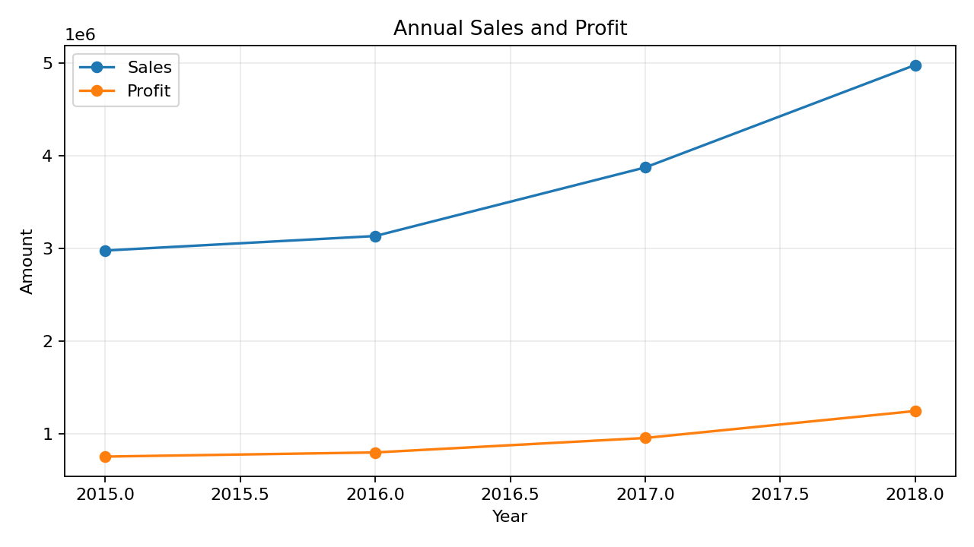
Sales increased from 2,975,599 in 2015 to 4,977,512 in 2018, a rise of 67.3%. Profit also rose from 752,529.11 to 1,244,182.88. The 2018 sales total was the highest in the period.
Year | Sales | Profit | Records
2015 | 2,975,599 | 752,529.11 | 1,993
2016 | 3,131,959 | 797,192.99 | 2,102
2017 | 3,871,912 | 953,216.22 | 2,587
2018 | 4,977,512 | 1,244,182.88 | 3,312

3. Category Performance
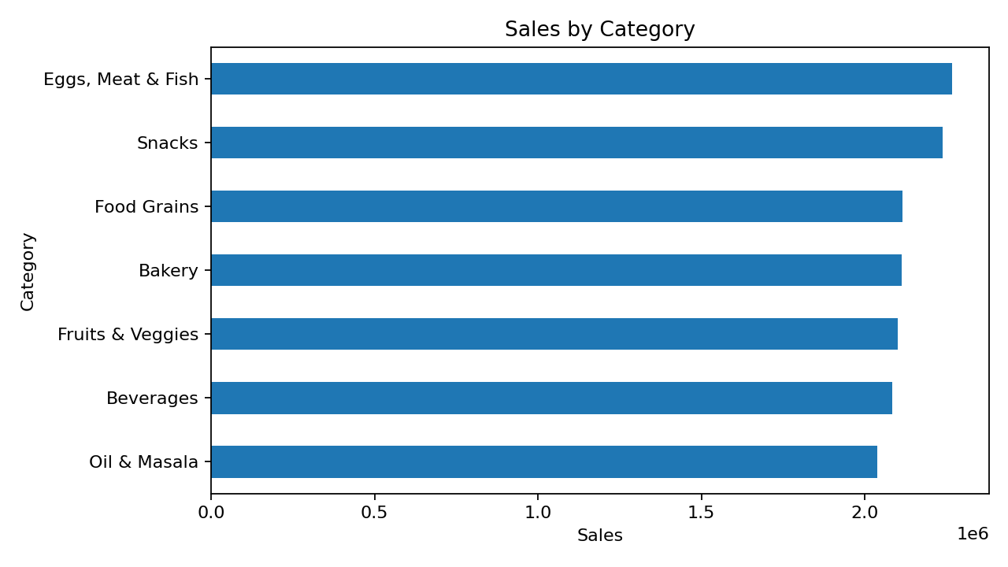
Eggs, Meat & Fish recorded the highest category sales (2,267,401). Snacks generated the highest category profit (568,178.85). Snacks had the strongest category profit margin (25.39%), while Oil & Masala had the lowest (24.43%). Category margins are relatively close overall, so comparing absolute profit alongside margin is useful.
Category | Sales | Profit | Margin %
Eggs, Meat & Fish | 2,267,401 | 567,357.22 | 25.02%
Snacks | 2,237,546 | 568,178.85 | 25.39%
Food Grains | 2,115,272 | 529,162.64 | 25.02%
Bakery | 2,112,281 | 528,521.06 | 25.02%
Fruits & Veggies | 2,100,727 | 530,400.38 | 25.25%
Beverages | 2,085,313 | 525,605.76 | 25.21%
Oil & Masala | 2,038,442 | 497,895.29 | 24.43%

4. Regional Performance
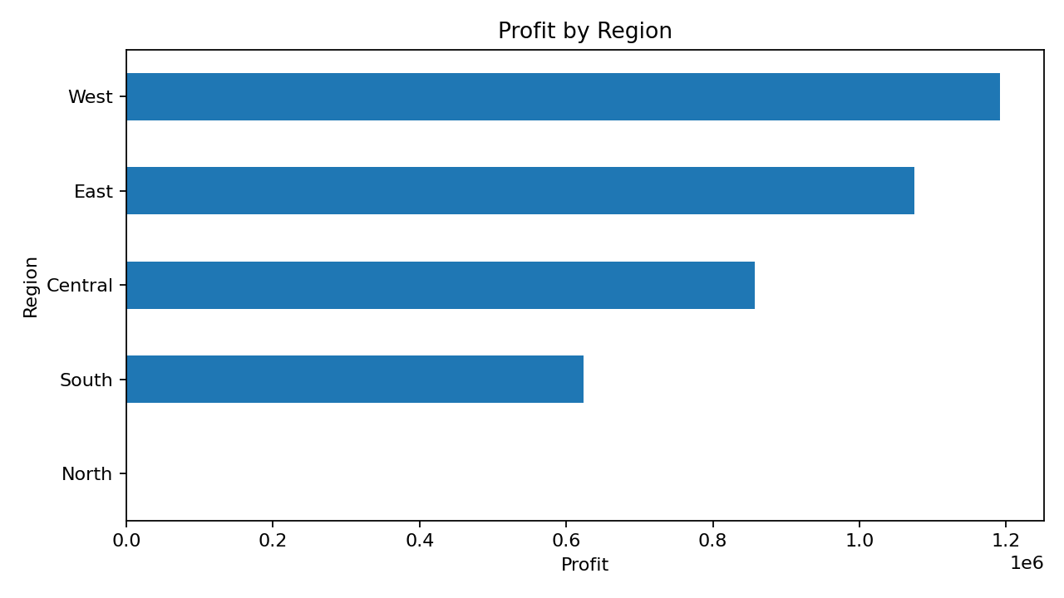
The West region led with sales of 4,798,743 and profit of 1,192,004.61. Among the major regions, North showed the highest profit margin at 32.00%. The North region contains only one record and should not be compared directly with the other regions without checking the source data.
Region | Sales | Profit | Margin %
West | 4,798,743 | 1,192,004.61 | 24.84%
East | 4,248,368 | 1,074,345.58 | 25.29%
Central | 3,468,156 | 856,806.84 | 24.70%
South | 2,440,461 | 623,562.89 | 25.55%
North | 1,254 | 401.28 | 32.00%

5. Location and Product Highlights
Among cities, Kanyakumari had the highest sales (706,764). Vellore generated the highest city-level profit (174,073.01). Tenkasi had the lowest city profit margin (24.27%), making it a candidate for further investigation—but a low margin alone does not prove poor performance.
At sub-category level, Health Drinks had the highest sales (1,051,439) and Health Drinks had the highest profit (267,469.79).

6. Discount and Profit: Interpretation
The Pearson correlation between the Discount and Profit columns is 0.0000. This indicates a positive linear relationship, with strength assessed by how close the value is to -1 or +1. Correlation does not prove that discounts cause profit changes. Check the meaning and scale of the Discount field and compare profit margin across discount bands before making pricing decisions.

7. Data Quality and Limitations
The main sheet has 9,994 rows and 12 columns, with no blank values detected in the loaded columns. There are 1 distinct state value(s) and 5 region labels; validate whether these fields reflect the intended geographic coverage. The North region has just one row, which can distort regional comparisons. The dataset has 9,994 unique Order IDs, so the row count appears to match the order-ID count; confirm whether each row represents a complete order or an individual transaction before using order-level averages.

8. Recommendations
- Investigate the 2018 growth drivers by comparing category, sub-category, city and monthly performance against earlier years.
- Protect the West region’s strong contribution while reviewing whether its 24.84% margin can be improved through pricing, sourcing or discount controls.
- Review Oil & Masala’s category margin (24.43%) to identify cost, price or promotion opportunities.
- Compare profit margin and order volume across discount bands; avoid judging discount effectiveness from correlation alone.
- Prioritize cities with high sales but below-average margin for a deeper product-mix and discount review.
- Validate the single-record North region and geographic fields before using them for strategic conclusions.

9. Conclusion
The business recorded 14,956,982 in sales and 3,747,121.20 in profit across 2015–2018, with an overall profit margin of 25.05%. Results show growth over time, a strong West region contribution and modest differences in category margins. The next analysis should focus on monthly trends, discount bands, and high-sales/low-margin cities to turn these findings into specific actions.
***************************************************************************************************

