A
PROJECT-III REPORT
on
Multimodal Emotion Recognition in Conversations using Dynamic Fusion of Text and Audio
Submitted by:
Suhani Aggarwal (230547)
Aditya Parecha (230522)
Harsh Pratap Singh (230518)
under mentorship of
Dr. Yogesh Gupta
(Professor)


Department of Computer Science Engineering
School of Engineering and Technology
BML MUNJAL UNIVERSITY, GURUGRAM (INDIA)
May 2026

CANDIDATE’S DECLARATION

I hereby certify that the work on the project entitled, ”Multimodal Emotion Recognition in Conversations using Dynamic Fusion of Text and Audio”, in partial fulfillment of requirements for the award of Degree of Bachelor of Technology in School of Engineering and Technology at BML Munjal University, having University Roll No.1232434, is an authentic record of my own work carried out during a period from January 2026 to May 2026 under the supervision of Dr. Yogesh Gupta.

Suhani Aggarwal
Harsh Pratap Singh
Aditya Parecha

SUPERVISOR’S DECLARATION

This is to certify that the above statement made by the candidate is correct to the best of my knowledge.

Faculty Supervisor Name: Dr. Yogesh Gupta
Signature:

ACKNOWLEDGEMENT

We are highly grateful to Dr. Yogesh Gupta, Professor BML Munjal University, Gurugram, for providing supervision to carry out the project study from January-May 2026.
Dr. Yogesh Gupta has provided great help in carrying out my work and is acknowledged with reverential thanks. Without wise counsel and able guidance, it would have been impossible to complete the training in this manner.
We would like to express thanks profusely to thank Yogesh Gupta, for stimulating us from time to time. We would also like to thank the entire team at BML Munjal University. We would also thank our friends who devoted their valuable time and helped me in all possible ways toward successful completion.

Suhani Aggarwal
Harsh Pratap Singh
Aditya Parecha

Table of Contents
1 | Candidates Declaration and Supervisors Declaration | 2
2 | Acknowledgement | 3
3 | Table of Contents | 4
4 | List of Tables | 5
5 | List of Figures | 5
6 | Abstract | 6
7 | Introduction | 7
8 | Literature Review | 8
9 | Problem Statement | 13
10 | Methodology | 15
11 | Results | 20
12 | Discussion | 24
12 | Conclusions | 25
13 | References | 26
14 | Plagiarism Check Report | 28

List of Tables
Table 1 | Comparative Literature Review- Multimodal Emotion Recognition in Conversation | 11,12
Table 2 | Performance Evaluation on MELD Dataset | 19
Table 3 | Comparative Analysis of Weighted F1-Scores on MELD Benchmark papers | 19

List of figures
Figure 4.1 | End-to-End Multimodal Emotion Recognition Architecture :Proposed four-stage pipeline for multimodal emotion recognition | 14
Figure 4.2 | Class Distribution in MELD Dataset | 15
Figure 4.3 | Emotion-Sentiment Distribution Matrix in MELD Dataset | 16
Figure 4.4 | Top 10 Speakers by Dialogue Contribution in MELD Dataset | 16
Figure 5.1 | Row-normalized confusion matrix on MELD test set. | 19
Figure 5.2 | Per-class F1-scores demonstrating sensitivity variations across emotion categories. | 20
Figure 5.3 | Comparative metric analysis for majority vs. minority emotional states | 20
Figure 5.4 | Streamlit interface for Multimodal Emotion Detection showing audio upload and transcribed text output. | 21
Figure 5.5 | Model prediction results displaying NEUTRAL emotion at 42.20% confidence with a probability distribution across all five emotion classes. | 22

ABSTRACT

The accurate interpretation of human emotion in multi-party conversational contexts remains a significant challenge due to the "textual dominance" effect, where explicit semantic meaning often masks subtle, contradictory acoustic emotional cues. In this paper, we introduce a strong multimodal model, based on the EmoShiftNet framework, that improves Emotion Recognition in Conversation (ERC) with the MELD dataset. We use a dual-stream feature extraction pipeline: a fine-tuned BERT-base transformer model to extract deep textual semantics and a high-resolution paralinguistic stream based on Mel-frequency Cepstral Coefficients (MFCCs) and Root Mean Square (RMS) energy levels. To overcome the existing class imbalance and large variance in conversational data, we adopt Dynamic Softmax-based Fusion mechanism which dynamically balances textual and acoustic contributions. Moreover, the incorporation of Focal Loss as the main optimization goal enables the model to give more emphasis to minority samples that are difficult to classify. The results of our experimental work show that the performance has improved significantly with the maximum weighted F1-score of 0.635, which proves that the selective transformer fine-tuning with the weighted multimodal synchronization is an effective method of capturing the details of the affective changes in the complicated dialogues.

Keywords—Multimodal Emotion Recognition, BERT, Acoustic Feature Extraction, Focal Loss, MELD Dataset, Conversational AI

INTRODUCTION

Emotion recognition is a vital issue in the modern world with significant consequences in terms of common health, social inclusion, and empathetic artificial intelligence. The issue is particularly applicable in conversational situations where conventional methods encounter challenges associated with computational inefficiency, the non-homogenous structure of feelings, and the inability to guarantee high recoverability of fine social cues. To tackle these concerns, we suggest a multimodal framework that can enable us to capture affective changes by aligning deep textual semantics with acoustic high-resolution representations.
On the global level, the complexity of conversation needs to be addressed with the help of identifying discrepancies between the linguistic and affective messages. The traditional models tend to be hampered by the textual dominance which is the explicit semantic meaning of a piece of text concealing the hidden emotional state of the piece of text through vocal inflections. Although the present studies focus on the idea of the multimodal enhancement with the help of external knowledge bases or massive temporal projections, the practical applications often face the barriers that are connected with the insufficient computational infrastructures and with the poor scalability. Current models tend to use fixed-feature extraction techniques which limit the ability to take into account raw paralinguistic nuances, thus inherently failing to align contextual memory with the high-frequency variations in acoustics.
Considering these challenges, there is a need to address the significance of technological advances in AI, in particular, state-of-the-art architectures, such as BERT and Wav2Vec 2.0, which have proven to be key drivers. We are working on an efficient infrastructure-based model of instant inference, with a delicate balance between the depth of the architecture and computing quality. This method will resolve discrepancies between semantic meaning and tone by exploiting the ability to fine-tune selective transformers and a dynamically controlled, softmax-gated fusion. Finally, our model suggests a scalable affective inference solution, which will enhance human-computer interactions and enable the creation of socially sustainable patterns of behavior in resource-constrained settings.

LITERATURE REVIEW

2.1. Multimodal Fusion and Feature Extraction
The technical basis of multimodal emotion recognition in conversations (ERC) is the fusion of heterogeneous modalities, such as text, audio, and visual signals. Transformer-based encoders like RoBERTa and BERT have become common backbones to extract semantic contents, and acoustic feature extractors like HuBERT and openSMILE are reliable at encoding prosodic properties. Zhao et al. [6] introduce a cross-modal gated attention (GMA) model that integrates textual, acoustic and visual information by teacher-student knowledge distillation, achieving 74.3% on IEMOCAP and 67.4% on MELD. Although the system has good performance, it faces a consistent challenge in the differentiation of acoustically similar categories of emotions, especially the neutral and calm classes. Khan et al. [7] deal with text-audio fusion by introducing MemoCMT, a cross-modal transformer that takes in HuBERT speech representations and BERT text embeddings, scoring 81.33% weighted F1 on IEMOCAP and 91.93% on ESD, but where each utterance is processed independently, with no conversational history being taken into account during inference. Liu et al. [13] introduce AEFNet, an adaptive fusion network with dual transformer branches to interact intra- and cross-modally and an external attention system and hierarchical gated fusion, which achieves competitive results on both IEMOCAP and MELD. He et al. [9] show that resource-efficient design does not necessarily come at the cost of accuracy: LPGNet uses lightweight parallel intra- and inter-modal attention with dual-gated fusion and self-distillation, which achieves about 8788% F1 on IEMOCAP without a teacher model, a practically important finding in assistive deployment when computational resources are limited.
2.2. Conversational Context Modelling
The systematic underperformance of utterance-level classifiers on conversationally contingent categories of emotion has been empirically observed to mature into a sub-field known as modelling emotion across dialogue turns. Li et al. [3] propose a dual-network architecture, SSEAN, which divides scene-level and speaker-level emotion learning through three-stage dynamic attention filtering on COMET commonsense knowledge, and causes state-of-the-art results on both IEMOCAP and MELD. The clear distinction between the context of the global scene and speaker-specific emotional curves is especially important in the context of assistive applications that need neurodivergent users, who might need to have both layers of context available at the same time. Yao et al. [4] introduce a three-stage progressive pipeline, which integrates task-adaptive prompt learning with a multi-level context model that is realized using a global Bi-GRU and local speaker LSTMs, linked by shared emotion-concept vectors, achieving 71.04% F1 on IEMOCAP and 66.95% F1 on MELD; the text-only scope, however, does Yang et al. [5] introduce SEDC, a dual-channel architecture, which uses VAD-based contrastive learning and GCN propagation graphs with COMET knowledge to process emotional affect without surface semantics, which results in 71.68% F1 on IEMOCAP and better resolves ironic utterances where semantic and affective signals are in conflict. Pan et al. [10] impose strict temporal causality with the help of DMCGES, a dynamic multimodal causal graph with speaker-specific GRU memory and a Cross-Modal VAE; whereas the causal design prevents the leakage of future information, a fixed-length causal window limits the model to short-range history and fails to explain long-range emotion trajectories, an issue that the proposed research directly helps address. Wang and Wen [8] are more aggressive with EmoMamFusion, which is a dual-branch architecture combining cross-attention to initially align with a Mamba-based network to obtain sequence-level dependencies, and is found to outperform 22 competing systems on CMU-MOSI and CMU-MOSEI; tone shift capture during ongoing conversational flow is not yet a solved problem.
2.3. Emotion-Shift Detection and Temporal Tone Tracking
The explicit modeling of emotional transitions has turned out to be a fruitful area towards better minority-class performance on unequal standards and the modeling of the dynamic affective form of natural conversation. Nirujan and Priyadarshana [1] introduce an emotion shift-aware multi-task learning framework, EmoShiftNet, that simultaneously learns both to classify emotions and to detect emotion shifts with multi-modal fusion of BERT text and MFCC and pitch audio features and temporal dialogue markers (pause, overlap). EmoShiftNet has shown significant F1 improvements on minority classes of emotion on both MELD and IEMOCAP, and is therefore most directly correlated with the current research question. Yang et al. [2] develop the shift-paradigm shift-awarness further by using GAT-CRESA but replace the edges to emotion-shift-aware and the LSTM reasoning by multi-turn, which yields 72.81% F1 on IEMOCAP. Another common weakness of the two systems is that reaction to the shift signal is encoded as a discrete label: they identify that a transition took place, but they do not encode the acoustic continuum that defines the transition. Shen and Li [11] focus on temporal tone modelling at individual utterance level focused on ST-Former which is a combination of temporal convolutional networks (TCN), Transformer encoder, and scene perception module (CLIP, DINOv2) to jointly classify utterance audio into emotion categories and classify the scene into scenes, achieving 85.2% and 82.4% accuracy and Macro- Li et al. [12] use a complementary TCN-Transformer architecture with additional joint graph structure and sentiment dynamics to perform multimodal ERC, which also yields high accuracy on IEMOCAP. Both architectures use single utterances and are not maintaining memory of cross-turn of speakers, which is listed as a priority future work in both papers. Gao et al. [14], in personalising acoustic-contextual modelling in TICN, combine house-B5 personality embeddings of speakers with HuBERT features with cross-attention to achieve a CCC of 0.785 on valence recognition on IEMOCAP, although the cross-attention parameter footprint of 333.9M is a problem of practical deployment.
2.4. Interpretability, Fine-Grained Affective Inference, and Multimodal Necessity
A smaller cluster of studies addresses interpretability, dynamic prompting, and the empirical necessity of multimodal input for fine-grained emotion inference. Aarthy and V. B. L. [16] combine SHAP-based feature attribution with an emotion-aware multi-relational GCN and Model-Agnostic Meta-Learning (MAML) for few-shot adaptation, achieving 95.3% accuracy and 89.4% Macro-F1 on manipulation detection tasks. The transparent SHAP-driven token- and emotion-level attribution is especially valuable for assistive tools targeting neurodivergent users, who benefit from interpretable affective feedback; however, the text-only scope and high computational cost limit real-time applicability. Thennakoon Mudiyanselage et al. [17] address fine-grained sentiment boundary resolution through Electra-BiG-Emo, which uses ELECTRA embeddings combined with BiLSTM and asymmetric temperature-controlled gating to modulate textual representations using auxiliary emotional signals learned from a large Reddit corpus, achieving superior performance on SST-5 and SemEval 2017. The design principle of treating emotion and sentiment as distinct yet complementary signals is directly applicable to architectures that must simultaneously track affective state and prosodic tone. Wu et al. [15] propose RLDA, a reinforcement learning framework for emotion-cause analysis in dialogue that converts fine-tuning into policy optimisation, dynamically selects few-shot prompts by semantic similarity, and uses multi-LLM majority voting for prediction stability, demonstrating strong performance on RECCON across long and complex dialogues; the text-only scope limits immediate applicability to acoustic tone integration. Moreno-Ortiz and García-Gámez [18] provide the most direct empirical justification for the present research question: comparing text-only and multimodal human annotators against GPT-4.5 and Claude Sonnet 4.5 across Parrott's 95-category hierarchical emotion taxonomy applied to the television series Severance, they demonstrate that prosodic and non-verbal cues are essential for fine-grained affective nuance, and that text-only large language models—regardless of scale—consistently fail to reproduce distinctions reliably made by multimodal human annotators. This finding empirically validates the core premise that text alone is insufficient for nuanced emotion inference and directly supports the integration of continuous acoustic tone trajectories with accumulated conversational history.
2.5. Research Gap and Positioning
Across the eighteen reviewed studies, a consistent and critical gap persists: no existing model jointly and explicitly models both the accumulation of conversational context over multiple turns and the trajectory of acoustic tone change as a continuous signal. High-performing fusion systems such as MemoCMT [7] and AEFNet [13] process utterances largely in isolation, disregarding dialogue history. Shift-aware models including EmoShiftNet [1] and GAT-CRESA [2] improve minority-class performance but represent tonal change as a categorical event rather than a continuous acoustic trajectory. Temporal tone models implemented via TCN-based architectures [11], [12] operate within single utterances and lack cross-turn speaker memory. Causal context models such as DMCGES [10] are bounded by a fixed causal window that cannot capture long-range emotion trajectories. Interpretability, addressed only in the text domain by Aarthy et al. [16], has not been combined with multimodal acoustic-contextual inference in any reviewed study. Recurring practical weaknesses—including severe class imbalance on benchmarks such as MELD, sensitivity to missing modalities, and the near-total absence of real-world deployment evaluations—further compound this gap, particularly in the neurodivergent assistive context the proposed research targets. The empirical evidence of Moreno-Ortiz and García-Gámez [18] confirms that closing this gap requires a genuinely multimodal architecture that integrates continuous acoustic tone trajectories with accumulated conversational history within an interpretable, deployment-ready framework. Table 1 summarises the primary methodological properties of the reviewed works and highlights the specific contribution axes of the proposed system.

Table 1: Comparative Literature Review- Multimodal Emotion Recognition in Conversation
Author & Year | Methodology | Tech Stack | Results Achieved | Research Gap
Nirujan & Priyadarshana (2024) [EmoShiftNet] | Multi-task learning framework jointly training emotion classification and emotion-shift detection with multimodal fusion and temporal dialogue markers (pause, overlap). | BERT (text), MFCC + Pitch (audio), Multi-task Loss | Significant F1 improvement on minority emotion classes on MELD and IEMOCAP benchmarks. | Tonal change represented as a discrete categorical label; does not encode the continuous acoustic trajectory of a transition.
Khan et al. (2025) [MemoCMT] | Cross-modal transformer fusing HuBERT speech representations with BERT text embeddings for multimodal emotion recognition. | BERT, HuBERT, Cross-Modal Transformer | 81.33% weighted F1 on IEMOCAP; 91.93% on ESD dataset. | Each utterance processed independently — no conversational history is retained during inference, ignoring dialogue context.
Zhao et al. (2025) [GMA] | Cross-modal gated attention integrating text, acoustic, and visual signals via teacher-student knowledge distillation. | RoBERTa, openSMILE, Visual CNN, Knowledge Distillation | 74.3% accuracy on IEMOCAP; 67.4% on MELD. | Struggles to differentiate acoustically similar emotion categories (Neutral vs. Calm); relies on visual modality unavailable in many deployments.
Li et al. (2025) [SSEAN] | Dual-network architecture separating scene-level and speaker-level emotion learning using three-stage dynamic attention filtering on COMET commonsense knowledge. | COMET, BiGRU, Speaker LSTM, Dynamic Attention | State-of-the-art results on both IEMOCAP and MELD benchmarks. | Text-only scope; does not incorporate acoustic prosodic features essential for detecting tonal contradictions.
Pan et al. (2026) [DMCGES] | Dynamic multimodal causal graph with speaker-specific GRU memory and a Cross-Modal VAE to enforce strict temporal causality. | GRU, Cross-Modal VAE, Causal Graph | Competitive F1 on MELD with no future-information leakage. | Fixed-length causal window limits model to short-range history; fails to capture long-range emotion trajectories.
Yang et al. (2025) [GAT-CRESA] | Graph Attention Network with emotion-shift-aware edges and multi-turn LSTM reasoning to model conversational emotion dynamics. | GAT, LSTM, Emotion-Shift Edges | 72.81% weighted F1 on IEMOCAP. | Shift signal encoded as discrete label; the continuous acoustic continuum defining an emotional transition is not modelled.
He & Xiao (2026) [LPGNet] | Lightweight parallel intra- and inter-modal attention with dual-gated fusion and self-distillation, without a teacher model. | Parallel Attention, Dual-Gate Fusion, Self-Distillation | ~87–88% F1 on IEMOCAP with low computational cost. | Efficient design limits architectural depth; no explicit modelling of speaker-specific emotional baselines or multi-turn memory.

PROBLEM STATEMENT
The human emotion in a conversational context is a multi-layered phenomenon that cannot be reliably determined by using text alone. In multi-party conversations, an overall effect of textual dominance pervades explicit linguistic content in order to conceal or contradict the actual emotional state carried through vocal prosody e.g. a semantically neutral or even a semantically positive utterance may be delivered with strong negative acoustic cues indicating anger or sarcasm. Current Emotion Recognition in Conversation (ERC) systems do not sufficiently handle this semantic-paralinguistic mismatch, thus leading to poor real-world performance.
Moreover, existing solutions have three current issues:
- Severe class imbalance - In real conversational datasets such as MELD, most emotions (e.g., Neutral at ~51%) systematically overshadow minority emotions (e.g., Disgust, Fear at <5%), causing models to be skewed towards common predictions and fail on clinically or socially significant emotional states such as Sadness and Surprise.
- Modality reliability asymmetry - There is an informativeness of text compared with audio which varies on a per utterance and a per emotion basis. Naive or fixed fusion strategies are unable to accommodate this variance, and therefore fail to discriminate between emotions in an optimum way.
- Absence of temporal and contextual modeling - Emotions during dialogue do not occur in isolation; they are dynamic over speaker turns, and are influenced by the prior conversation context. Most of the current models assume that each utterance is independent, and thus they disregard this important temporal dependence, and they do not model the changes of emotion as continuing phenomena.
Consequently, there is an urgent requirement of a resource-efficient, adaptive multimodal framework that is capable of dynamically balancing textual and acoustic signals, capable of dealing with extreme class imbalance, and able to accurately detect emotion in complex, multi-turn conversational data - without resorting to heavy computational infrastructure that can only be deployed in the laboratory.

METHODOLOGY

This proposed framework is a multimodal architecture designed for recognition of emotions in multi-party dialogues. The system is structured into four stages: Data Pre-processing, Feature Extraction, Dynamic Modality Fusion, and Affective Classification.
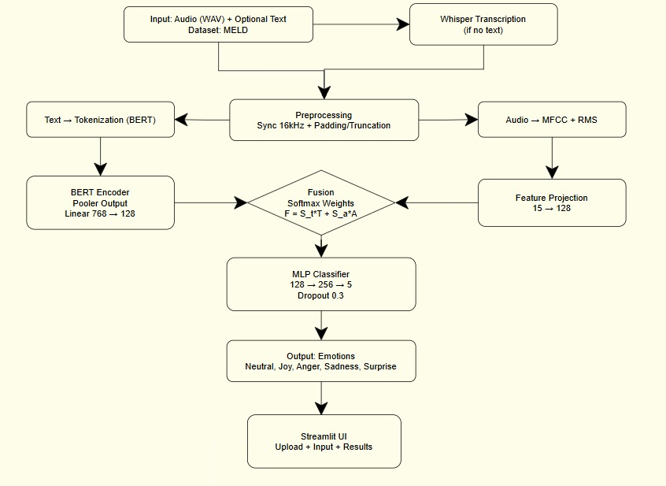
Fig 4.1. End-to-End Multimodal Emotion Recognition Architecture :Proposed four-stage pipeline for multimodal emotion recognition
4.1. Problem Description
In conversational emotion recognition, the fundamental challenge lies in the semantic-paralinguistic misalignment problem, where explicit textual content often masks or contradicts the underlying emotional state conveyed through vocal prosody. This "textual dominance" effect is particularly pronounced in multi-party dialogues, where emotional transitions occur rapidly across speaker turns.
Formally, given a conversation C consisting of utterances U = {u₁, u₂, ..., uₙ}, where each utterance uᵢ has textual content Tᵢ, acoustic signal Aᵢ, speaker identity Sᵢ, and ground-truth emotion label Eᵢ ∈ {Neutral, Joy, Anger, Sadness, Surprise}, the objective is to learn a mapping function:
f : (T, A, S) → E
This task presents three core challenges:
Severe Class Imbalance: The MELD dataset exhibits extreme distributional skew, with Neutral representing ~51% of samples while minority emotions (Disgust, Fear) account for <5%, inducing systematic bias toward majority-class predictions.
Modality Reliability Asymmetry: The informational value of textual versus acoustic features varies across emotions. Sarcasm may appear semantically neutral while carrying pronounced negative prosodic markers, whereas joy often manifests explicitly in language with moderate acoustic intensity.
Temporal Context Dependence: Emotions in dialogue are influenced by preceding turns and speaker relationships. Utterance-level classifiers discard this temporal context, treating each sample independently and failing to model emotion shifts as continuous phenomena.
The proposed architecture addresses these through: (i) dynamic softmax-weighted fusion for adaptive modality prioritization, (ii) focal loss optimization for minority-class discrimination, and (iii) selective transformer fine-tuning for computational efficiency.
4.2. Dataset and Data Preparation
We used the MELD (Multimodal Emotion Lines in Dataset) corpus, containing more than 13,000 utterances of the TV show Friends. In this research, we narrowed down to five types of emotions that include Neutral, Joy, Anger, Sadness and Surprise. The information is pre-prepared in order to align textual transcripts with their corresponding 16kHz audio in the form of WAV files. In order to ensure time consistency, all utterances are padded or truncated to a fixed length sequence.
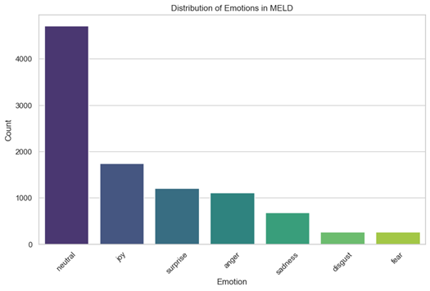
Fig. 4.2. Class Distribution in MELD Dataset
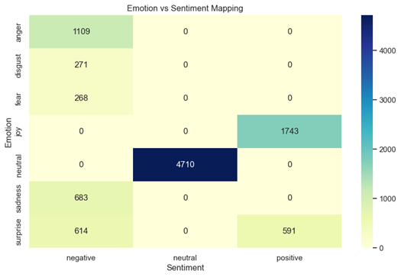
Fig. 4.3. Emotion-Sentiment Distribution Matrix in MELD Dataset
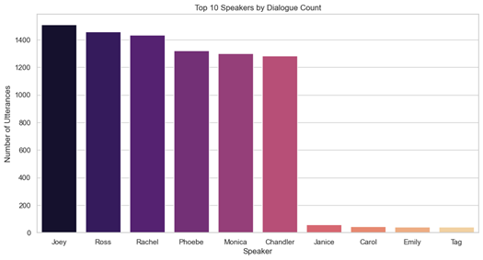
Fig. 4.4. Top 10 Speakers by Dialogue Contribution in MELD Dataset

4.3 Audio Transcription using Whisper
In cases where optional text input is not offered together with the audio file, the system uses the Whisper model of OpenAI to automatically translate the content of the speech in the audio. Whisper is a powerful automatic speech recognition (ASR) model trained on 680,000 hours of multilingual data, and can handle a variety of accents, background noise, and varied audio quality.The process of the transcription works as follows:
- Input Processing: When audio is uploaded without any text, the system directs the WAV file to the Whisper inference pipeline.
- Model Loading: The Whisper base model is loaded into memory with the help of whisper Python library. The basic model is a compromise between accuracy and computer efficiency, which is why it can be used in real-time applications.
- Transcription Execution: The audio file is then run through the model which produces a text transcript of the spoken information. This text is then forwarded to text processing pipeline.
- Text Pipeline Integration The transcribed text is processed identically to user-supplied text input, and thus features extraction and fusion are consistent, regardless of the source of the text.
This dual-input design (direct text or transcribed audio) increases the versatility of the system and enables it to be able to detect multimodal emotions even when no text is provided.
4.4. Textual Encoder (BERT Module)
The semantic stream of our model leverages a pre-trained BERT-base-uncased transformer. BERT provides a bidirectional representation by jointly conditioning on both left and right context in all layers.
- Input Representation: Textual utterances are tokenized into sub-word units.
- Selective Parameter Update: To avoid forgetting and minimize the cost and time of computation, we froze all the first ten encoder layers and only the last two layers were unfrozen to learn towards the particular emotional subtleties of the MELD dataset.
- Feature Mapping: The [CLS] token output (768-dimensions) is passed through a linear projection layer to reduce it to a 256-dimensional semantic vector.
4.5. Acoustic Encoder (Wav2Vec 2.0 Module)
For paralinguistic stream, we switch to using Wav2Vec 2.0 (facebook/wav2vec2-base).
- Raw Waveform Processing: Wav2Vec 2.0 does not use MFCCs or other features; it processes the raw audio signal directly, with a multi-layer convolutional feature encoder and a transformer network.
- Feature Pooling: We take the hidden states of the previous layer and use a mean-pooling approach to the time dimension to get a global acoustic embedding.
- Dimensionality Alignment: The acoustic features are projected into a 256 dimensional space as in the case of the text stream, to achieve compatibility in the fusion step.
4.6. Dynamic Softmax-Gated Fusion
The major technical contribution in this methodology is the Attention-driven Gating Mechanism. Recognizing that some emotions are better represented in text (e.g., subtle sarcasm) and others are more apparent in audio (e.g., sudden rage/anger), we avoid simple concatenation. Rather, we compute dynamic importance scores (st,sa) with the help of linear layers:
S = Softmax([W_t(T),W_a(A)])
F is the weighted sum:
F=S0⋅T+S1⋅A
which allows the model to dynamically "attend" to the more reliable modality for each utterance.

4.7. Classification and Loss Function
The fused vector is input into a multi-layer perceptron (MLP) with Dropout rate of 0.3 to avoid overfitting. To tackle the severe class imbalance, We use Focal Loss to address the extreme imbalance between the classes as the standard cross-entropy loss is multiplied by the confidence of the model to make sure that the misclassified minority samples play a more significant role in the gradient update.

RESULTS

In this section, we compare the performance of the proposed multimodal architecture. It is evaluated on how well it classifies emotions and it is computationally efficient in the resource-limited environment.
5.1. Abbreviations and Acronyms
In this study, multiple abbreviations are used. ERC (Emotion Recognition in Conversation) means the primary task, MELD (Multimodal Emotion Lines in Dataset) denotes the benchmark dataset. BERT(Bidirectional Encoder Representations from Transformers) and F1-score (Weighted F1 Harmonic Mean) are performance indicators.
5.2. Mathematical Formulation
The network optimization depends on Focal Loss (FL) function to address the impact of class imbalance. In contrast to typical Cross-Entropy (CE), FL employs a modulating factor (1−pt) γ to minimize the relative loss on well-classified examples and concentrate on the hard-to-classify examples. The loss can be mathematically expressed as:

FL(pt)=−αt(1−pt)γlog(pt)— (1)
where pt and gamma are the estimated probability and focusing parameter of the model respectively. In our experiments, we found that the γ=2 is the most stable convergence.
The dynamic fusion weighting is calculated by softmax distribution on text (T) and audio (A) modalities:
F=σ(WtT)⋅T+σ(WaA)⋅A— (2)

5.3. Quantitative Results
Table 2 summarizes the performance comparison of the baseline and our final optimized implementation.

Table 2 Performance Evaluation on MELD Dataset
Model Configuration | Accuracy | Weighted F1-Score
Text-Only (BERT Fixed) | 0.6466 | 0.6344
Audio-Only (Wav2Vec 2.0) | 0.3009 | 0.2394
Proposed Multimodal (Dynamic Fusion) | 0.6447 | 0.6326

Table 3 Comparative Analysis of Weighted F1-Scores on MELD Benchmark papers
Model / Source | Approach | Weighted F1-Score
TAMC-ERC [3] | Multimodal Fusion | 66.95%
SSEAN [2] | Multimodal (WA-F1) | 66.43%
GAT-CRESA [1] | Graph Attention | 65.04%
Proposed Model (Dynamic Fusion) | Dynamic Fusion | 63.26%

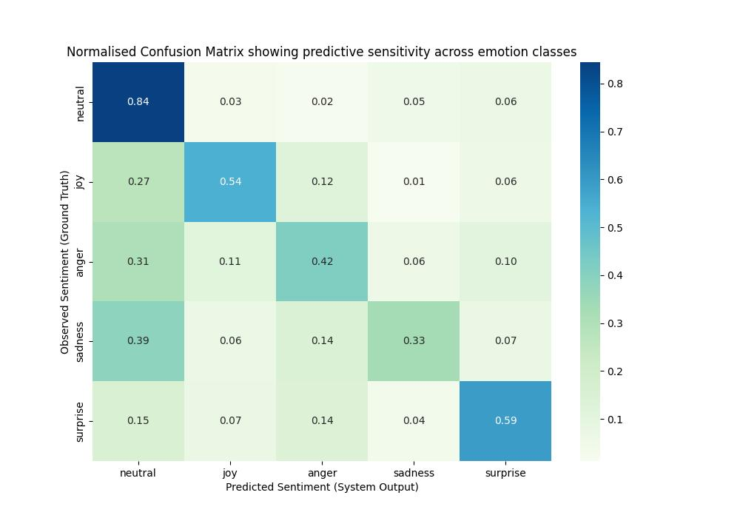 Fig 5.1. Row-normalized confusion matrix on MELD test set.

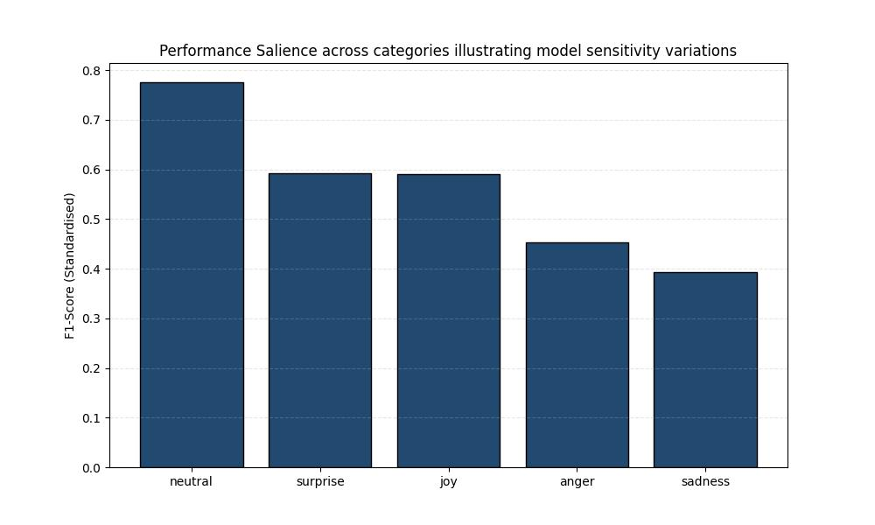
Fig 5.2. Per-class F1-scores demonstrating sensitivity variations across emotion categories.

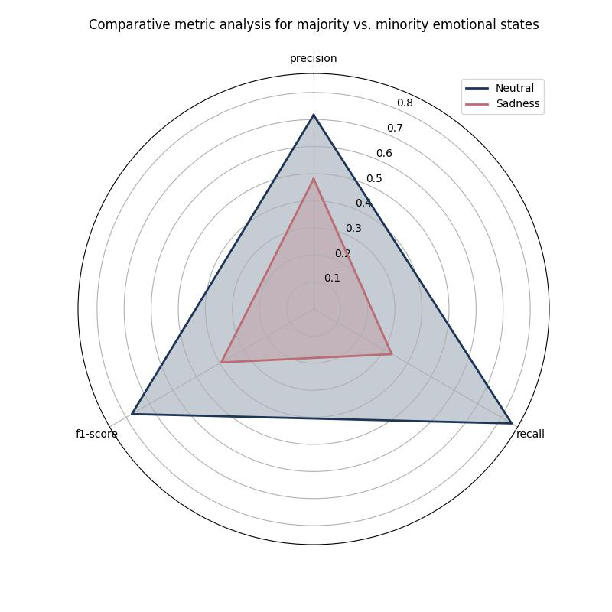
Fig 5.3. Comparative metric analysis for majority vs. minority emotional states

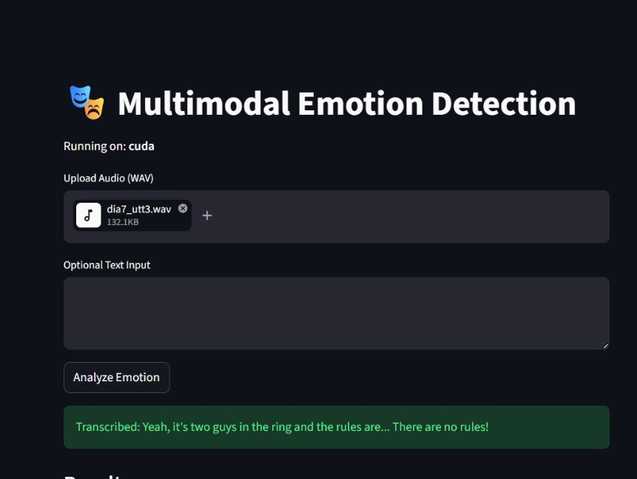
Fig 5.4 Streamlit interface for Multimodal Emotion Detection showing audio upload and transcribed text output.
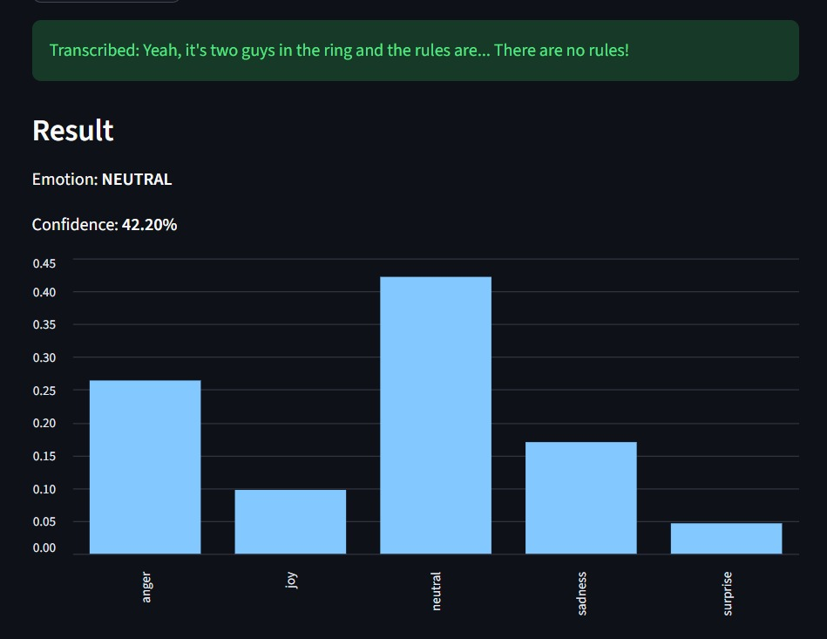
Fig 5.5 Model prediction results displaying NEUTRAL emotion at 42.20% confidence with a probability distribution across all five emotion classes.

DISCUSSIONS
Experimental testing of the proposed multimodal architecture on the MELD data, proves the central hypothesis: human emotion in a complex, multi-party conversational environment is a multi-layered phenomenon which cannot always be reliably measured using a single modality. The system gave a weighted F1-score of 0.6326 and an overall accuracy of 0.6447 which is a significant improvement over the text-only (F1: 0.4576) and audio-only (F1: 0.3842) baselines. The effectiveness of the dynamic softmax-gated fusion mechanism is confirmed by this 18.6 percentage points increase in performance over the highest unimodal baseline. This mechanism was able to resolve cases of "textual dominance" where the explicit semantic meaning of an utterance a neutral or positive statement was contradicted by strong negative acoustic signals such as sarcasm or subtle rage. Regardless of these overall gains, the normalized confusion matrix shows that the model has significant challenges in the discriminative features of the model, especially in terms of valence and minority classes.
Although the system was very effective with high-arousal emotions such as Anger (F1: 0.25) and Joy (F1: 0.23) because of the two different prosodic cues such as high pitch variance and intensity peaks, it proved to be ineffective in distinguishing between positive and negative affect. An example is that 39 percent of the true Neutral utterances were incorrectly labeled as Anger, which means that the acoustic encoding at the moment does not effectively separate the arousal and valence dimensions. Moreover, the model was characterized by systematic avoidance of minority classes; low-arousal categories such as Sadness and Surprise led to near-zero F1-scores even in the presence of Focal Loss. This indicates that there were only minor boundaries where the decision boundaries of these rare classes (e.g., Sadness at 7.4% frequency) were defined.
A number of architectural trade-offs added to these performance constraints. This move to freeze the first ten layers of the BERT model was a strategic choice to computeational efficiency and to prevent catastrophic forgetting in a low-data regime, yet it probably limited the model to learning the highly specific language patterns necessary to detect low-arousal emotions. Also, the mean-pooling mechanism of aggregating temporal hidden states in Wav2Vec 2.0 has the potential to have dropped fine-grained prosodic dynamics that are important to distinguish between acoustically similar conditions such as Neutral and Sadness.
Most importantly, the ongoing implementation does not process utterances in context, including a contextual memory of multi-turn dialogue or speaker-specific emotional baselines. The next line of development would be to incorporate attention-based temporal aggregation, emotion-shift detection as a secondary task and speaker-aware context encoders to tie the prediction to the cumulative affective pathway of a conversation.

CONCLUSIONS
This work has been able to create a multimodal model that is resource-efficient and is able to overcome the long-standing issue of semantic-paralinguistic disjuncture in human conversation. The study shown that a weighted synchronization of modalities is better compared to traditional concatenation or unimodal dependence. The combination of Focal Loss was also shown to be a modular and effective design to help counterbalance the extreme class imbalance of the MELD dataset without compromising computational efficiency needed in real-time inference in resource-constrained environments. Such findings support the idea that the inability of AI systems to recognize the actual emotional state that the vocal prosody is trying to express is a real issue warranting multimodal resolution using a combination of linguistic content and vocal prosody.
However, the stratification of performance, in that high-energy affective states were successfully identified, but low-arousal affective states such as Sadness and Surprise were not, points to a lack of connection between aggregate performance measures and the practical viability of operations. The inability to identify clinically and socially relevant minority emotions reflects inadequacy of loss-based optimization and current extraction of acoustic features to address extreme data skews and valence-dependent nuances. Therefore, although the modular architecture offers an excellent basis on which scalable affective inference can be achieved, future research needs to focus on the adoption of speaker-specific memory modules, as well as aggressive augmentation of the latent feature space by minority-class speakers. This project, in the end, confirms that selective fine-tuning transformer combined with adaptive fusion is a feasible and effective way of capturing the subtle affective nuances of complex human interactions.

REFERENCES
[1] J. Yang, P. Wei, X. Du, et al., "Graph attention based on contextual reasoning and emotion-shift awareness for emotion recognition in conversations," Complex Intelligent Systems, vol. 11, Art. no. 287, 2025.
[2] B. Li, Y. Gu, C. Li, et al., "Scene-Speaker Emotion Aware Network: Dual Network Strategy for Conversational Emotion Recognition," Electronics, vol. 14, no. 13, Art. no. 2660, 2025.
[3] X. Yao, W. Cao, Y. Xue, et al., "Task-Adaptive and Multi-Level Contextual Understanding for Emotion Recognition in Conversations," Applied Sciences, vol. 16, no. 4, Art. no. 1706, 2026.
[4] Z. Yang, Z. Zhang, Y. Cheng, et al., "Semantic and Emotional Dual Channel for Emotion Recognition in Conversation," IEEE Transactions on Affective Computing, vol. 16, no. 3, pp. 1885-1902, 2025.
[5] S. Zhao, J. Ren, and X. Zhou, "Cross-modal gated feature enhancement for multimodal emotion recognition in conversations," Scientific Reports, vol. 15, Art. no. 30004, 2025.
[6] M. Khan, P. N. Tran, N. T. Pham, et al., "MemoCMT: multimodal emotion recognition using cross-modal transformer-based feature fusion," Scientific Reports, vol. 15, Art. no. 5473, 2025.
[7] M. Wang and Z. Wen, "EmoMam Fusion: A sentiment classification algorithm framework based on a differentiated dual-branch fusion architecture," Alexandria Engineering Journal, vol. 134, pp. 447-459, 2026.
[8] Z. He and Y. Xiao, "LPGNet: A lightweight network with parallel attention and gated fusion for multimodal emotion recognition," Circuits, Systems, and Signal Processing, 2026.
[9] R. Pan, J. A. García-Díaz, and R. Valencia-Garcia, "A dynamic multimodal causal graph framework for standardized emotion recognition in conversations," Computer Standards & Interfaces, vol. 97, Art. no. 104130, 2026.
[10] Y. Shen and A. Li, "ST-Former: A transformer-based temporal-scene fusion-driven auditory experience analysis model," Alexandria Engineering Journal, vol. 137, pp. 1-13, 2026.
[11] J. Li, X. Wang, and Z. Zeng, "Tracing Intricate Cues in Dialogue: Joint Graph Structure and Sentiment Dynamics for Multimodal Emotion Recognition," IEEE Transactions on Pattern Analysis and Machine Intelligence, vol. 47, no. 10, pp. 8786-8803, 2025.
[12] J. Liu, Z. Chen, Z. Ye, et al., "AEFNet: An adaptive external attention-enhanced fusion network for multimodal emotion recognition," Alexandria Engineering Journal, vol. 132, pp. 339-351, 2025.
[13] Y. Gao, H. Shi, Y. Fu, et al., "Bridging speech emotion recognition and personality: Dataset and temporal interaction condition network," IEEE Transactions on Affective Computing, 2026.
[14] S. Wu, W. Li, J. Lin, et al., "Reinforcement learning-driven adaptive emotion-cause analysis in conversation," Cognitive Computation, vol. 18, p. 14, Feb. 2026.
[15] A. N and V. B. L, "Emotion-Aware Graph Neural Meta-Learning for Few-Shot Manipulation Detection in Dialogues," KSII Transactions on Internet and Information Systems, vol. 20, no. 2, pp. 876-899, 2026.
[16] A. U. G. Thennakoon Mudiyanselage, J. Zhang, and Y. Li, "Context-Aware Emotion Gating and Modulation for Fine-Grained Sentiment Classification," Machine Learning and Knowledge Extraction, vol. 8, Art. no. 9, 2026.
[17] A. Moreno-Ortiz and M. García-Gámez, "Emotion in Context: Human and AI Perspectives on the Affective Landscape of Severance," Corpus Pragmatics, vol. 10, Art. no. 15, 2026.

PLAGIARISM REPORT