## **Week 3 – Spring Data JPA with Spring Boot, Hibernate**

HandsOn 2 - Difference between JPA, Hibernate and Spring Data JPA

**1**.**JPA (Java Persistence API)**

• **JPA is a specification** (JSR 338) for accessing, persisting, and managing data between Java objects and relational databases.

• It defines **standard annotations** and interfaces to perform ORM (Object Relational Mapping).

• **Does not have an implementation** – it's just a set of guidelines.

Example:

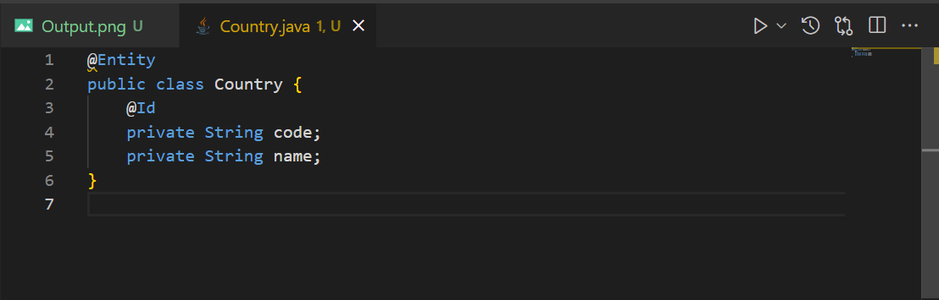

**2.Hibernate**

• Hibernate is an **implementation of JPA**.

• It is a full-fledged ORM (Object-Relational Mapping) tool.

• It implements the JPA interfaces and provides additional features like:

-Caching(Stores frequently accessed data in memory to reduce database hits.)

-Lazy loading(Loads related entities only when they're accessed, not when the parent is loaded.)

-Dirty checking(Automatically detects changes to entities and updates only modified fields in the database.)

-HQL (Hibernate Query Language)( An object-oriented query language similar to SQL but works with entity objects instead of tables.)

Example:

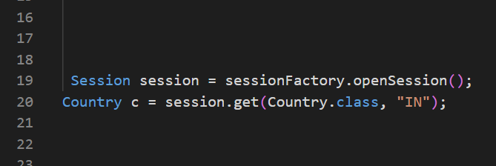

**3.Spring Data JPA**

• Spring Data JPA is a Spring module that acts as a wrapper over JPA (and Hibernate).

• It reduces boilerplate code by automatically implementing repositories, queries, etc.

• Great for rapid development of JPA-based data access layers.

Example:

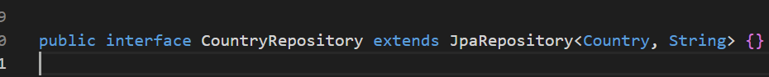

There’s no need to write SQL or HQL – Spring Data JPA handles it.