

PBL Mini Project Report
On
Credential Stuffing and Account Takeover Detection System

Submitted by

Suhani Shah(1262242212)
Shreya Pandey (1262242081)
Sneha Kunnummal(1262242233)
Anil Neerati (1262243623)

Under the Guidance of
Dr. Madhuri Bhalekar | Dr. Dipali Baviskar

Department of Computer Engineering and Technology
MIT World Peace University, Kothrud,
Pune 411 038, Maharashtra - India

2024-2025



DEPARTMENT OF COMPUTER ENGINEERING AND TECHNOLOGY

C E R T I F I C A T E

This is to certify that Suhani Shah, Shreya Pandey, Sneha Kunnummal and Anil Neerati of SYBTech. (CSF) have completed their project titled Credential Stuffing and Account Takeover Detection System and have submitted a Mini Project Report under the course PBL II (Project Based Learning) for the academic year 2025-2026.

Dr. Madhuri Bhalekar
Subject Faculty
Department of CET
MIT World Peace University, Pune

Dr. Dipali Baviskar
Subject Faculty
Department of CET
MIT World Peace University, Pune

Date: ___________

Acknowledgement
We express our sincere gratitude to Dr. Dipali Baviskar for guiding us throughout the PBL mini project. Her valuable suggestions, constant encouragement, and insightful feedback played a crucial role in shaping this work and helped us complete the project successfully.

We are also thankful to the Department of Computer Engineering and Technology, MIT-WPU, for providing us with the necessary resources, infrastructure, and academic environment required for the successful completion of this project.

Finally, we would like to thank our classmates and peers for their constructive discussions, suggestions, and moral support, which greatly contributed to the successful completion of this project.

Name of the Students

Suhani Shah
Shreya Pandey
Sneha Kunnummal
Anil Neerati

Abstract
This project develops a Python-based Adaptive Cybersecurity Intelligence System designed to automate multi-domain security monitoring. Leveraging the Flask micro-framework, the system integrates a backend engine that performs real-time data processing and behavioral risk assessment. Unlike static systems, this platform utilizes SQLAlchemy for sophisticated Object-Relational Mapping (ORM) and Pandas for high-speed data manipulation of security logs. The implementation includes a responsive Admin Dashboard that visualizes forensic data and generates automated security insights through algorithmic analysis of login patterns. Key features include asynchronous API handling, secure reverse tunneling for remote auditing, and a custom logic engine that identifies account anomalies and cross-platform intrusions.

List of Figures
Figure No. | Title | Page No.
6.1 | Police Terminal Login Interface | 23
6.2 | Threat Origin Distribution Dashboard | 23
6.3 | Infrastructure Load Analysis | 24
6.4 | High-Risk User Activity Trail | 24
6.5 | Network Node Investigation Interface | 25
6.6 | Active Connections and Reputation Score Monitor | 25
6.7 | Master Forensic Audit Trail | 26
6.8 | Forensic Threat Intelligence Panel | 26
6.9 | Portal Login - User Sign In Interface | 27
6.10 | Create Account - New User Registration Form | 27

Content

Chapter 1: Introduction 7
1.1 Motivation 7
1.2 Objectives 7
1.3 Problem Definition 7
Chapter 2: Tools and Technologies Used
2.1 Backend Technologies
2.2 Frontend & Visualization 10
2.3 Essential Python Libraries 3
2.4 Deployment & Networking tools
Chapter 3: Dataset Overview 11
Chapter 4: Algorithm & Flowchart 17
4.1 Algorithm 17
4.2 Flowchart 34
Chapter 5: Data Preprocessing & Analysis 6
5.1 Data Cleaning 6
5.2 Feature Engineering 6
5.3 Statistical Analysis
Chapter 6 : Data Visualization
Chapter 7 : Application Implementation & Web Integration
7.1 Backend Logic & Database Mapping
7.2 Dynamic UI Rendering & Remote Access 18
Chapter 7: Frontend GUI Screenshots 23
Chapter 8: Conclusion 28
Chapter 9: References 29

Chapter 1: Introduction
In the current landscape of digital transformation, cybersecurity stands as the most critical pillar for protecting data integrity across global networks. Traditional security frameworks that rely on static authentication are increasingly bypassed by sophisticated automated attacks. This project addresses these vulnerabilities by developing an Adaptive Cybersecurity Intelligence System. Built using the Python Flask framework, the system moves beyond simple password verification to implement real-time behavioral analysis and risk scoring, providing a proactive defense mechanism against modern cyber threats.

1.1 Motivation
The drive behind this project stems from the rapid evolution of cyber-criminality. Standard security measures often fail to distinguish between a legitimate user and a bot performing a credential-stuffing attack. The primary motivations for this development include:
- The Vulnerability of Static Credentials: Recognizing that passwords alone are no longer a sufficient deterrent for brute-force tactics.
- The Need for Algorithmic Detection: Utilizing Python’s logical processing power to identify patterns that manual monitoring would miss.
- Real-Time Forensic Requirements: The necessity for immediate data visualization and risk assessment through an automated Admin Dashboard.
- Scalability in Cloud Environments: Building a system that can be deployed and monitored remotely using secure tunneling protocols.

1.2 Objectives
The core objective of this project is to bridge the gap between backend data management and front-end security visualization. The specific technical goals include:
- Developing a Robust Flask Backend: To create a modular application capable of handling security requests across multiple web domains.
- Implementing Automated Risk Scoring: To design a Python-based logic engine that evaluates login attempts based on IP reputation and frequency.
- Integrating Object-Relational Mapping (ORM): Utilizing SQLAlchemy to ensure seamless and secure communication between the Python application and the MySQL database.
- Ensuring Remote Accessibility: Implementing secure reverse tunneling to enable mobile forensic auditing.
- Providing Data-Driven Insights: Using Pandas and Jinja2 to transform raw security logs into actionable intelligence for administrators.

1.3 Problem Definition
The objective of this project is to develop a database-driven system capable of detecting and preventing unauthorized login attempts by analyzing user behavior and maintaining detailed activity logs. The system should identify anomalies such as unusual login locations or repeated failed attempts and generate alerts for administrative action.

Credential stuffing is a type of cyberattack in which stolen account credentials — typically lists of usernames and/or email addresses and the corresponding passwords — are used to gain unauthorized access to user accounts through large-scale automated login requests. Unlike brute force attacks, credential stuffing exploits the fact that many people reuse the same username and password combination across multiple services.

Account Takeover (ATO) is a form of identity theft where a malicious actor successfully takes control of a legitimate user's account. This is often the end goal of credential stuffing, and can lead to unauthorized transactions, data theft, or further spread of compromised credentials.

The need for a system that can automatically detect, flag, and prevent such attacks in real time is the core motivation behind this project. The system must be adaptive, capable of identifying evolving attack patterns, and must maintain comprehensive audit trails to support forensic investigation.

Chapter 2: Tools and Technologies Used
The successful implementation of the Adaptive Cybersecurity Intelligence System requires a seamless integration of diverse technologies. By leveraging Python’s modular ecosystem, the system bridges the gap between structured data storage and dynamic web visualization.

2.1 Backend Technologies
- Python 3.x: Serving as the core programming language, Python handles the logic engine, data processing, and security algorithms.
- Flask Framework: A robust micro-framework utilized to build the application’s backend. It manages URL routing, session handling, and acts as the bridge between the database and the user interface.
- SQLAlchemy (ORM): An advanced Object-Relational Mapper that allows the system to interact with the database using Pythonic classes rather than raw SQL, enhancing security against SQL injection.
- MySQL: The primary Relational Database Management System (RDBMS). It is used to store complex datasets including IP reputation scores, multi-domain login logs, and forensic detection rules. It ensures ACID compliance and high-speed data retrieval.

2.2 Frontend & Visualization
- HTML5: Used for creating the semantic structure of the Admin Dashboard and forensic login portals.
- CSS3: Employed to design a responsive and professional layout, ensuring the dashboard is readable across multiple screen sizes.
- Jinja2 Templating: A Python-based engine used to dynamically inject backend forensic data into the HTML frontend in real-time.

2.3 Essential Python Libraries
- Pandas: A powerful data analysis library used to convert SQL result sets into structured DataFrames for security auditing and report generation.
- mysql-connector-python: The specialized driver that establishes a high-performance connection between the Python environment and the MySQL server.
- Requests: Utilized to interact with external Geolocation APIs, allowing the system to map incoming IP addresses to physical geographic locations.
- Datetime & Time: Essential for performing temporal analysis on login attempts, such as calculating the frequency of attacks within a specific time window.

2.4 Deployment & Networking Tools
- Localhost.run / SSH Tunneling: A critical component used for secure reverse tunneling. It allows the locally hosted Python application to be accessed via a public HTTPS URL for remote forensic monitoring.

Chapter 3: Dataset Overview
A well-structured database design is essential for maintaining data integrity and ensuring efficient operations. This project follows proper database design principles, including Entity-Relationship (ER) modeling and normalization.
The following tables describe the attributes of each entity in the database, including their data types and purpose within the system.

Site Table : SiteId (INT (PK, AUTO_INCREMENT)), SiteName (VARCHAR(100)), Domain (VARCHAR(100)), URL (VARCHAR(255))
Stores details of the four supported portal types in the system.

User Table : UserId (INT (PK, AUTO_INCREMENT)), EMail (VARCHAR(100)), PasswordHash (VARCHAR(255)), SiteId (INT (FK)), Status (VARCHAR(20)), CreatedAt (DATETIME)
Stores information about registered users across all portals.

IPAddress Table : IPId (INT (PK, AUTO_INCREMENT)), IPAddres (VARCHAR(45)), IsBlacklisted (BOOLEAN), CountryCode (CHAR(2)), RepScore (INT)
Stores information about IP addresses observed during login attempts.

DetectionRule Table : RuleId (INT (PK, AUTO_INCREMENT)), RuleName (VARCHAR(100)) , ThresholdValue (INT), TimeWindowMin (INT), Description (TEXT), Scope (VARCHAR(20))
Defines the rules used by the security audit system to detect suspicious patterns.

LoginAttempt Table : AttemptId (INT (PK, AUTO_INCREMENT)), TimeStamp (DATETIME), Success (BOOLEAN), FailureReason (VARCHAR(100)), UserId (INT (FK)), SiteId (INT (FK)), IPId (INT (FK)), AttemptCount (INT)
The central table recording every login attempt made on any portal.

SusAct (Suspicious Activity) Table : AlertId (INT (PK, AUTO_INCREMENT)), DetectedAt (DATETIME), RuleId (INT (FK)), IPId (INT (FK)), UniqueUsers (INT), SecurityLevel (VARCHAR(20)), ActionTaken (VARCHAR(50)), TotalAttempts (INT)
Logs all suspicious activities detected by the security audit procedures and triggers.

Chapter 5: Data Preprocessing & Analysis
Data preprocessing and analysis form the core intelligence of the Adaptive Cybersecurity System. While the MySQL database serves as a storage repository, the Python backend serves as the analytical engine that transforms raw logs into actionable forensic intelligence.

5.1 Data Preprocessing & Cleaning
Raw data retrieved from database logs is often unformatted or contains noise that can hinder real-time monitoring. The system utilizes the Pandas library to perform the following preprocessing steps:
- Handling Incomplete Records: The Python logic checks for null values in the IPAddress and FailureReason fields to prevent application crashes during dashboard rendering.
- Temporal Standardization: Raw SQL timestamps are converted into user-friendly formats using the datetime library. This allows the administrator to see the exact time difference between consecutive attack attempts.
- Data Type Normalization: The system ensures that numerical reputation scores and boolean flags (like IsBlacklisted) are correctly cast into Python integers and booleans for accurate logical comparisons.
- Feature Scaling: Reputation scores are mapped onto a consistent 0–100 scale, allowing for uniform risk assessment across different security domains.

5.2 Behavioral Analysis & Risk Scoring
Once the data is cleaned, the system performs behavioral analysis to identify potential threats. This move from "Data" to "Intelligence" involves the following logic:
- Threshold-Based Detection: The system analyzes the frequency of login failures. If the number of attempts from a single IP exceeds the ThresholdValue defined in the DetectionRule table within the specified TimeWindow, the Python engine flags the activity as a "Brute Force" attempt.
- Cross-Domain Correlation: The analysis logic checks if a specific IP address is appearing across multiple sites (e.g., SocialConnect and Global Trust Bank). High cross-domain activity triggers a "Credential Stuffing" alert.
- Risk Categorization: Based on the analysis, each activity is assigned a risk level:
  - CRITICAL (Score < 30): Immediate threat; IP is automatically considered for blacklisting.
  - WARNING (Score 30–70): Suspicious behavior; requires administrative monitoring.
  - SAFE (Score > 70): Standard user activity with no anomalies detected.
- Geographic Contextualization: Using the requests library, the system performs a lookup of the IP address to identify geographic origin. An unexpected login attempt from a foreign country is programmatically flagged as a "Geographic Anomaly."

5.3 Statistical Summary of Security Events
By leveraging Pandas DataFrames, the system generates a statistical summary of the security landscape. This includes calculating the percentage of successful vs. failed logins and identifying the "Top 5 Attacking IPs." This high-level analysis is what allows the Forensic Intelligence Hub to provide a "Police-eye view" of the entire network's security health.

Chapter 6: Data Visualization
Data visualization in this project serves as the primary interface for forensic intelligence, transforming complex security logs into a clear, actionable dashboard. By leveraging the Pandas library alongside the Jinja2 templating engine, the system achieves a dynamic representation of threat levels. Instead of viewing raw database rows, the administrator is presented with color-coded alerts where risk levels are programmatically determined.
For instance, the Python backend analyzes the RepScore of each IP address; scores below a certain threshold are dynamically assigned a "Critical" CSS class, rendering them in red to signify immediate danger. This visual hierarchy ensures that brute-force patterns and unauthorized access attempts are instantly recognizable. Furthermore, the integration of geographic data allows for a localized view of threats, providing a comprehensive "Security Heatmap" that enhances the decision-making process for forensic auditors.

Chapter 7: Application Implementation & Web Integration
The implementation phase involves the integration of the Python-based logic engine with a responsive web interface. This chapter details the technical execution of the backend services and the communication protocols that enable remote forensic monitoring.

7.1 Backend Logic & Database Mapping
The core of the application is built using the Flask micro-framework, which serves as the central hub for managing security requests. A critical component of this implementation is the use of SQLAlchemy (ORM) and Pandas to create a high-level abstraction over the MySQL database.
- Routing & Session Management: Python decorators like @app.route are used to define secure endpoints for the Admin Dashboard. These routes ensure that forensic data is only accessible to authorized personnel.
- Data Retrieval & Transformation: When a request is made to the dashboard, the backend executes complex join queries via the SQLAlchemy engine. The resulting raw data is processed into Pandas DataFrames, allowing the system to perform real-time sorting and filtering by "Risk Level" before passing the data to the frontend.
- Middleware Security: By utilizing Parameterized Queries through the database connector, the system implements a robust defense against SQL Injection attacks, ensuring that malicious inputs from attackers cannot compromise the underlying database schema.

7.2 Dynamic UI Rendering & Remote Access
To transform the processed forensic data into a visual "Intelligence Hub," the system utilizes the Jinja2 templating engine and secure networking protocols.
- Jinja2 Integration: The Python backend passes processed lists and dictionaries to the HTML frontend. Using Jinja2’s logical loops ({% for item in logs %}), the system dynamically generates table rows, color-coding them based on the Risk Score (e.g., highlighting "Critical" threats in red). This ensures the dashboard remains dynamic and updates without requiring manual HTML changes.
- Secure Reverse Tunneling: Since the application is hosted on a local development server, an SSH Reverse Tunnel (via localhost.run) is implemented to expose the app to the public internet securely.
- Global Accessibility: By configuring the Flask app to listen on host='0.0.0.0', the tunnel creates a bridge that allows the Forensic Intelligence Hub to be accessed on any mobile device via an encrypted HTTPS URL. This ensures that forensic auditors can monitor login anomalies and IP reputations in real-time from any geographic location, bypassing local firewall restrictions and hostel/college network limitations.

Chapter 8 : Frontend GUI Screenshots
This chapter showcases the graphical user interface of the system, demonstrating the admin and user-facing dashboards built using HTML and CSS with Flask as the backend. The screenshots correspond to the various functional modules of the application.

6.1 Police Terminal Login Interface
The admin section of the system is accessed through a dedicated Police Terminal login screen, providing authorized personnel secure access to the forensic monitoring dashboards.

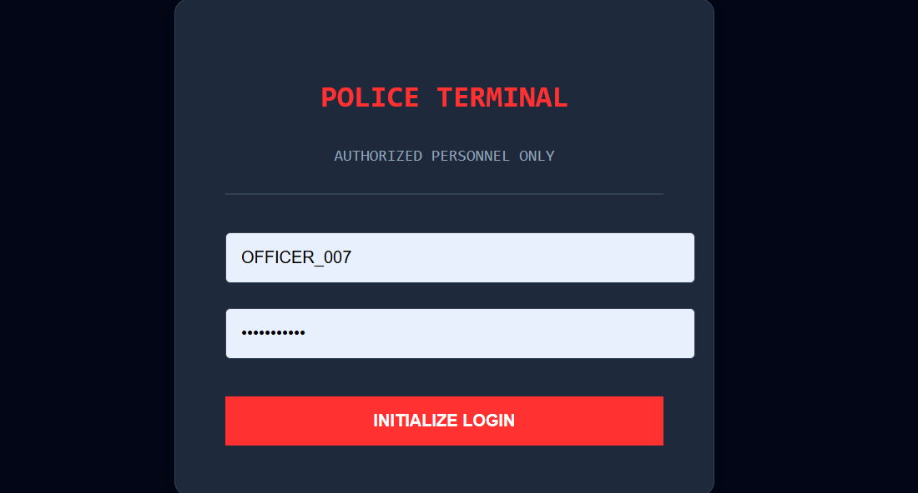
Figure 6.1: Police Terminal Login Interface

6.2 Global Intelligence
This dashboard presents a pie chart of the geographic distribution of threat origins, powered by AI forensic insights that automatically analyze high-density traffic patterns and recommend the action to be taken. If the major threat country is India, it recommends Rate Limiting rather than Geo Fencing.

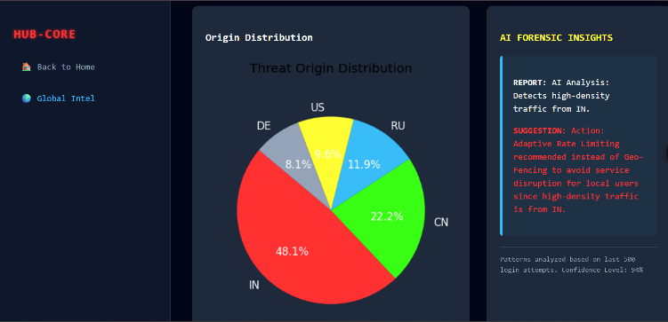
Figure 6.2: Threat Origin Distribution Dashboard

6.3 Site Pressure
The Infrastructure Load Analysis dashboard displays endpoint pressure levels across all four portals (Bank, Edu, Shop, Social) as a bar chart, with an AI report identifying the highest-traffic site and recommending rate-limiting actions or giving the option of enable MFA on the site(s). It also allows the officer to export the data in csv format.

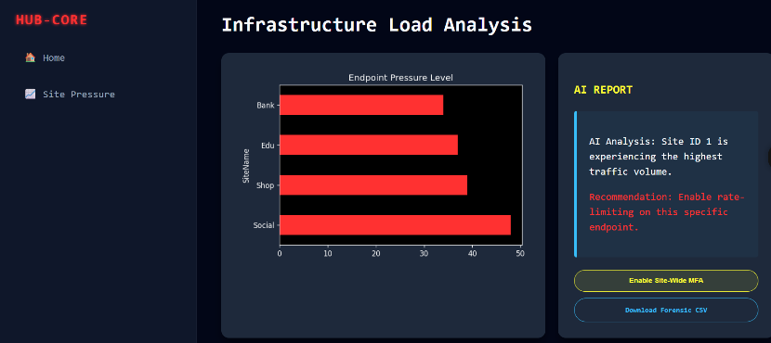
Figure 6.3: Infrastructure Load Analysis

6.4 User Risk Analysis
The High-Risk User Activity Trail filters the audit log to display only flagged high-risk events, showing User Email, Site Access, IP Source, and available actions (Freeze Account / Account Frozen) for rapid administrative intervention.

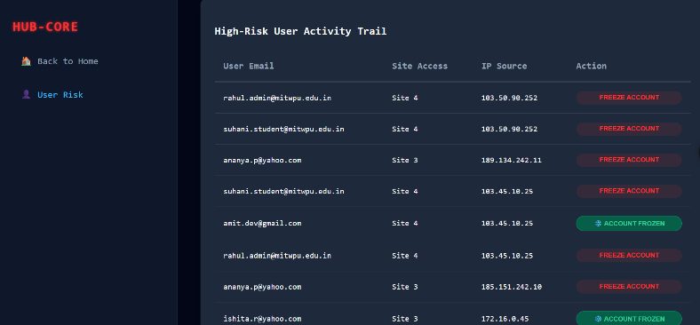
Figure 6.4: High-Risk User Activity Trail

6.5 IP Reputation - I
The Network Node Investigation Interface provides AI-driven analysis of individual IP nodes, detecting multiple connections from high-risk proxies and known botnet exit nodes, displaying the count of suspicious IPs active in the last 60 seconds.

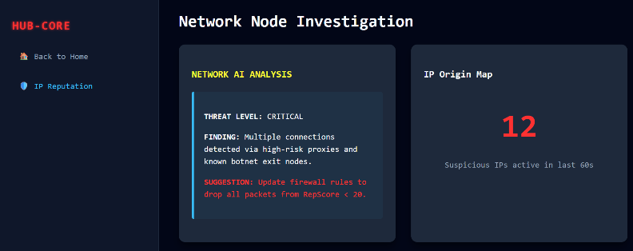
Figure 6.5: Network Node Investigation Interface

6.6 IP Reputation - II
This monitor lists all currently active IP connections along with their country of origin and real-time reputation score. IPs with low scores are highlighted and automatically marked as blacklisted, enabling immediate threat response.

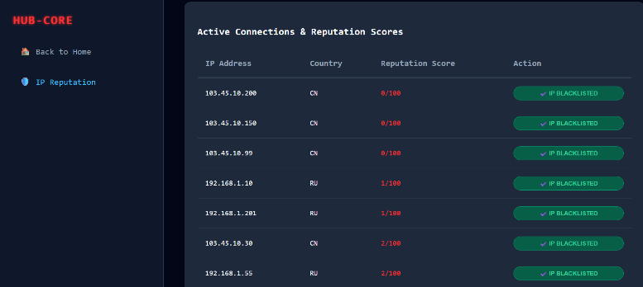
Figure 6.6: Active Connections and Reputation Score Monitor

6.7 Raw Audit Logs
The Master Forensic Audit Trail provides a comprehensive, tamper-evident chronological record of all login events, including Attempt ID, User Email, IP Address, Site, Status, and Timestamp — with download functionality for offline forensic analysis.

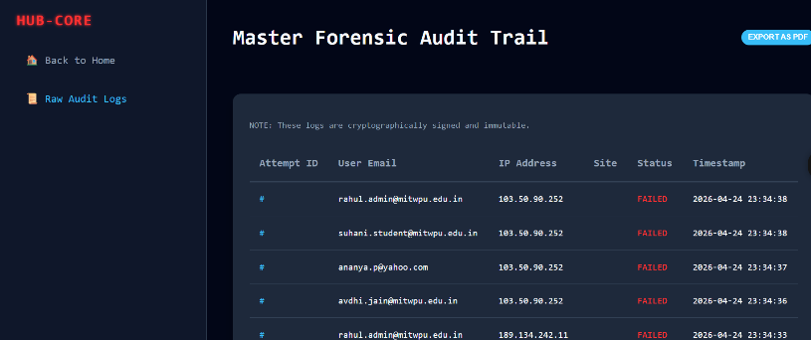
Figure 6.7: Master Forensic Audit Trail

6.8 Security Alerts
This panel runs the stored audit procedures in real time, scanning logs to identify brute force and site probing patterns. It reports the number of suspicious patterns flagged in the current window alongside audit engine analysis and recommended actions.

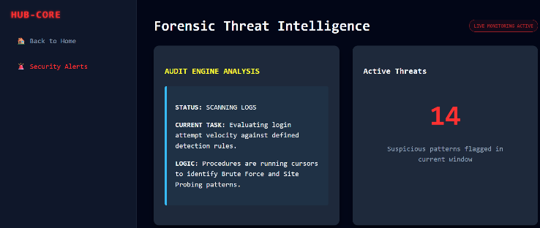
Figure 6.8: Forensic Threat Intelligence Panel

6.9 Portal Login — User Sign In Interface
The user-facing Portal Login page allows users to select their destination site (SocialConnect, Global Trust Bank, SwiftCart Shopping, or EduPortal) from a dropdown and sign in with their registered email and password.
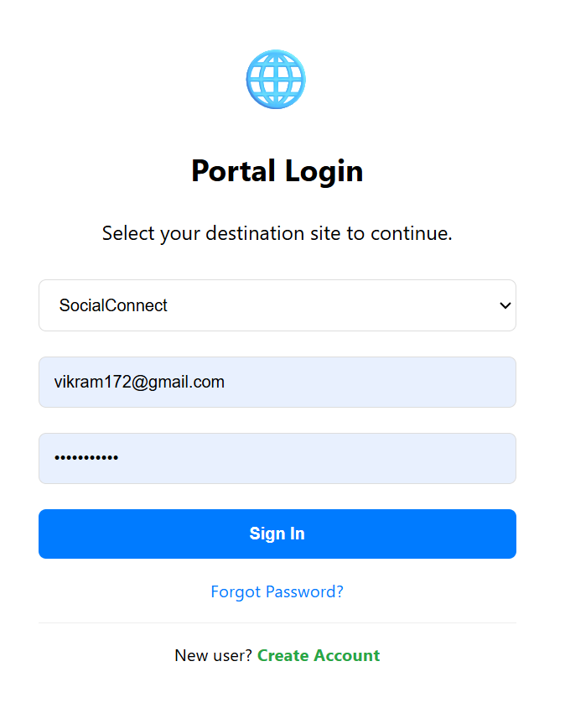
Figure 6.9: Portal Login — User Sign In Interface

6.10 Create Account — New User Registration Form
The account creation page enables new users to register on the system by providing their email address, a password, and selecting the portal they wish to register with. The system stores the hashed password and associates the account with the chosen site.
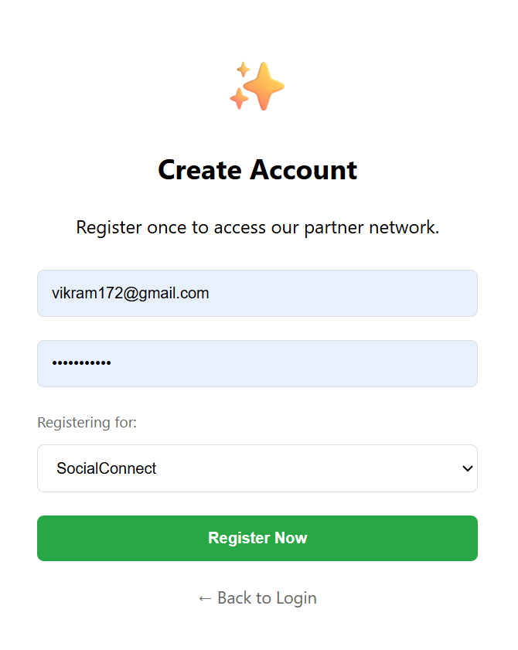
Figure 6.10: Create Account — New User Registration Form

Chapter 7: Conclusion
This project successfully demonstrates how database systems can be integrated with cybersecurity mechanisms to detect suspicious login activities and prevent unauthorized access. The Credential Stuffing and Account Takeover Detection System provides a multi-layered defense strategy by combining structured relational database design, behavioral analysis, and automated security response.

By combining structured data storage, SQL operations including DDL, DML, triggers, stored procedures, and user-defined functions, the system achieves a high degree of automation in threat detection. The normalization of the database to 3NF ensures minimal redundancy and optimal data integrity, while the trigger-based IP blacklisting mechanism provides real-time threat response without manual intervention.

The admin forensic dashboards provide comprehensive visibility into all login events and suspicious activities, enabling administrators to take proactive security measures. The IP reputation scoring system, implemented through the GetRiskLevel() function and UpdateIPReputation() procedure, provides a quantitative framework for evaluating the trustworthiness of connecting clients.

Future improvements can include the integration of machine learning models for adaptive anomaly detection, real-time geolocation API integration for enhanced geographic risk analysis, and the implementation of multi-factor authentication (MFA) to further strengthen the authentication layer. The system's modular architecture makes it well-suited for such extensions.

Chapter 8: References
[1] Sumita Arora, Informatics Practices, Class 11. Dhanpat Rai & Co., New Delhi.
[2] Sumita Arora, Informatics Practices, Class 12. Dhanpat Rai & Co., New Delhi.

