**Practical Number : 2 Course Name : DBMS**

**Name :Suhani Chafale PRN : 23070521154**

**Batch : 2023-2027 Semester : 3rd**

**Task 2 :**

Er Diagram:

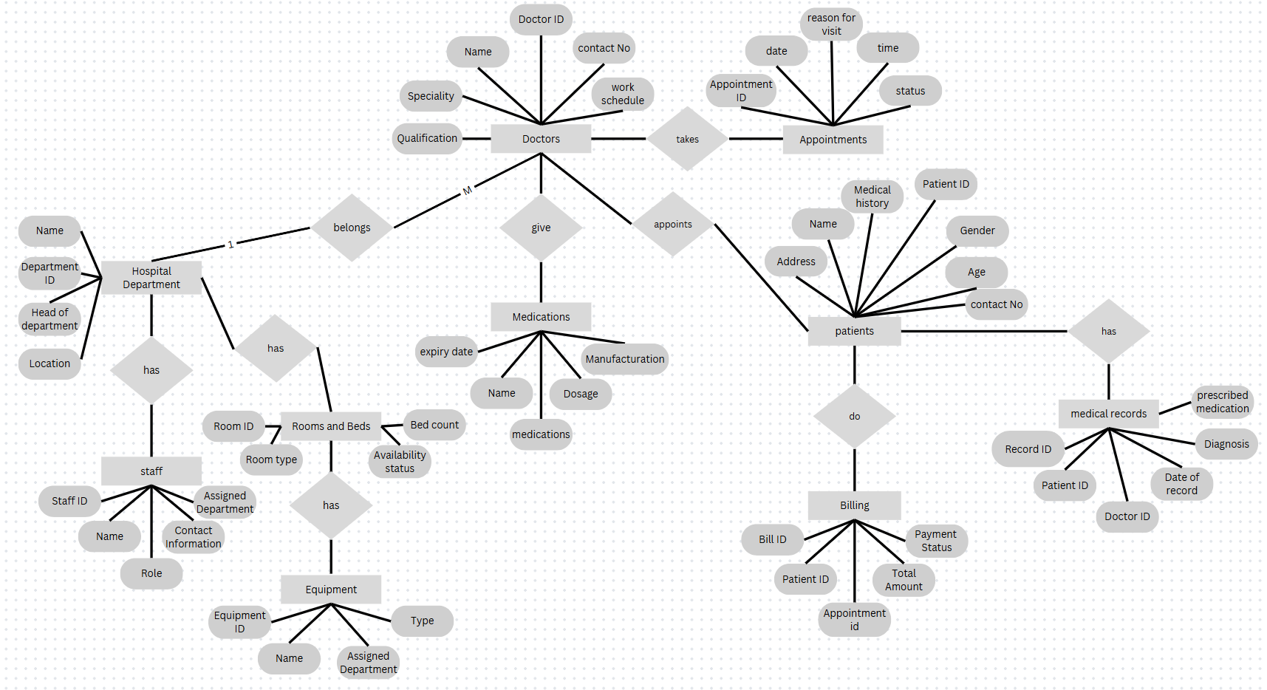

**Task 3:**

EER diagram:

