DopaScore
Predicting Productivity Risk Bands from
Digital Behaviour Patterns
Project Report
IBM SkillsBuild – AICTE Internship | Data Analytics with AI
Submitted by: Suhani Agarwal GitHub: suhaniagarwal18
September 2026

Abstract
Excessive social media use and the dopamine-driven design of modern digital platforms are increasingly linked to declines in focus, task completion, and overall productivity — a concern widely discussed in both public health and workplace-wellness contexts today. This project, DopaScore, analyses a 300-respondent behavioural dataset covering social media usage, dopamine-related psychological indicators, and productivity outcomes, with the goal of predicting which productivity risk band (None/Minimal, Early, Moderate, Severe, or Critical) an individual falls into, based purely on their digital behaviour patterns. Three classification models — Logistic Regression, Random Forest, and Gradient Boosting— were trained and compared. The Random Forest and Logistic Regression models achieved perfect classification on the held-out test set, while Gradient Boosting achieved 96.7% accuracy, with withdrawal-related and deep-work-related behaviours emerging as the strongest predictors. The near-perfect scores are examined critically in the Limitations section, as they reflect the clean, synthetically-generated nature of the dataset rather than a claim of real-world predictive perfection.

1. Problem Statement & Motivation
Digital wellbeing has moved from a niche concern to a mainstream one. Apple's Screen Time, Google's Digital Wellbeing dashboard, and a growing number of corporate wellness programs all now attempt to quantify how technology use affects a person's ability to focus and be productive. Social media platforms are explicitly engineered around dopamine-driven engagement loops — infinite scroll, variable-reward notifications, and short-form video — which make them highly effective at capturing attention, often at the cost of sustained, deep-focus work.
The motivation for this project is twofold. First, from a societal perspective, understanding which specific behaviours (rather than just "screen time" as a single number) are most predictive of productivity decline can inform more targeted digital-wellbeing interventions — for students, employees, and platforms themselves. Second, from an analytics-and-AI perspective, this is a well-suited multi-class classification problem: rather than predicting a single productivity score (a regression task that is hard to act on), the goal is to predict which risk band a person falls into — directly analogous to how real-world risk-scoring systems (credit risk, health risk, churn risk) are built and deployed.

2. Dataset Description
The dataset used is the "Social Media, Dopamine, and Productivity Dataset", consisting of 300 participant records across 66 columns. It combines demographic information, self-reported social media usage patterns, dopamine-related psychological indicators, focus/productivity behaviour, and wellbeing/withdrawal indicators. The table below summarises the major field groups used in this project.
Field Group | Representative Columns
Demographics | age, gender, education_level, employment_status, occupation_category, country_of_residence
Social Media Behaviour | avg_daily_sm_hours, daily_check_frequency, late_night_scrolling, doomscrolling_frequency, notifications_always_on
Dopamine / Psychological | dopamine_rush_feel_score, fomo_score, reward_seeking_behavior, validation_seeking_score, comparison_to_others_score
Focus & Productivity | attention_span_minutes, deep_work_duration_minutes, task_switching_frequency, difficulty_maintaining_focus
Wellbeing / Withdrawal | anxiety_when_phone_unavailable, restlessness_score, withdrawal_attempt_count, longest_detox_days
Target | productivity_risk_band (renamed from productivity_decline_score) — None/Minimal, Early, Moderate, Severe, Critical

Data Quality Note: During initial inspection, two columns — severity_stage and productivity_decline_score — were found to be mislabeled relative to their actual contents. The column named productivity_decline_score in fact contained the ordinal risk-band labels (Critical, Severe, Moderate, Early, None/Minimal), while severity_stage contained free-text trigger reasons (e.g., Boredom, FOMO, Curiosity). This was verified directly from the data before any modelling began. The mislabeled band column was renamed to productivity_risk_band and used as the prediction target; the trigger-reason column was renamed to trigger_reason and excluded from modelling as it is not a numeric or ordinal behavioural signal.

3. Methodology

3.1 Data Cleaning
- Verified and corrected the column-label mismatch described above before any further processing.
- Target column (productivity_risk_band) had zero missing values after correction, so no rows were dropped.
- Minor missingness in one feature (secondary_platform, 3 records) was filled with an explicit "Missing" category rather than dropped, to preserve sample size given the small dataset.
- Categorical features were retained as strings; numeric features were cast and checked for out-of-range values.

3.2 Leakage Avoidance
A critical modelling decision was excluding six columns that are themselves outcome scores derived from the same underlying generation process as the target, and would therefore leak the answer into the model rather than reflect genuine predictive signal:
- sm_addiction_risk_score
- digital_wellbeing_score
- dopamine_dysregulation_index
- productivity_self_rating
- work_quality_self_rating
- tasks_completed_per_day
Only genuine behavioural and demographic input features — screen time, checking frequency, dopamine-trigger behaviours, sleep, focus/attention metrics, and demographics — were retained as predictors, giving 53 raw input features (expanding to over 300 columns after one-hot encoding of categorical variables).

3.3 Feature Engineering & Preprocessing
- Numeric features were standardised using StandardScaler.
- Categorical features were one-hot encoded (unknown categories handled gracefully at inference time).
- An 80/20 stratified train-test split was used to preserve the relative proportion of each risk band in both sets.

3.4 Model Building
Three classifiers were trained on identical preprocessed data to allow a fair, direct comparison:
- Logistic Regression — a linear multinomial baseline.
- Random Forest Classifier (300 trees, max depth 8) — the primary ensemble model.
- Gradient Boosting Classifier (300 estimators, max depth 4, learning rate 0.05) — a gradient-boosted comparison model.

4. Exploratory Data Analysis
The target classes are imbalanced, with over half of participants falling into the "None/Minimal" risk band, and progressively fewer participants in each more severe band. This is realistic for a general population sample, but it is the reason macro-averaged F1-score (which weights all classes equally) was used alongside accuracy when evaluating models.
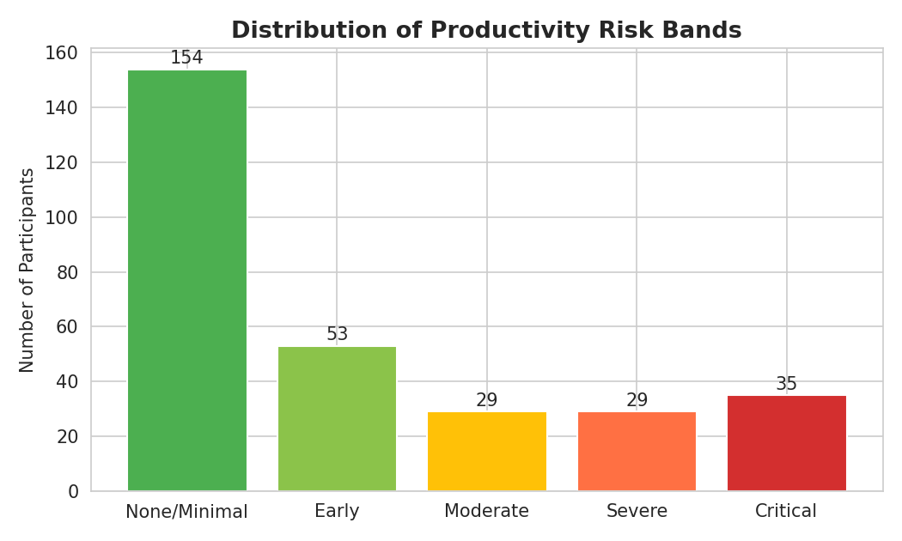
Figure 1: Distribution of participants across productivity risk bands.
Daily screen time shows a clear upward trend across risk bands — participants in the Critical band report substantially higher average daily screen time than those in the None/Minimal band, consistent with the project's central hypothesis.
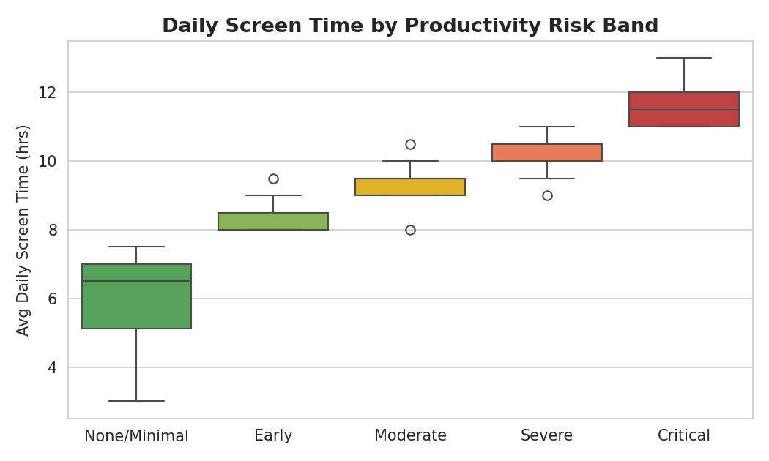
Figure 2: Average daily screen time by productivity risk band.
Self-reported dopamine rush intensity follows a similar pattern, reinforcing that the psychological/reward-seeking dimension of social media use — not just raw hours — is closely tied to productivity outcomes.
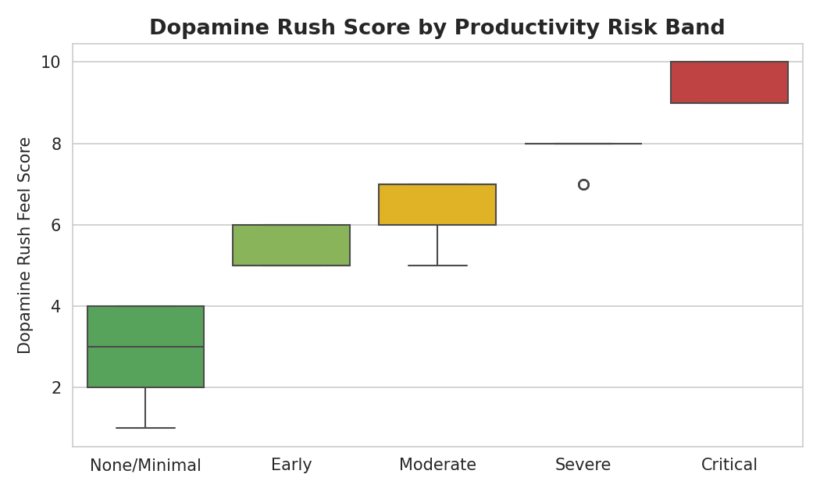
Figure 3: Dopamine rush feel score by productivity risk band.

5. Limitations
- Synthetic dataset: the dataset's data_source field indicates the records are AI-generated (synthetic), not collected from real individuals. This likely explains the unusually high (98–100%) model accuracy — synthetic generation processes often encode a more deterministic relationship between behavioural inputs and the labelled outcome than would exist in real human data, where the same behaviours can lead to different outcomes for different people. These results should be read as a proof-of-concept of the modelling approach, not as a validated real-world predictive tool.
- Small sample size: 300 records is modest for a 5-class classification problem; the test set contains as few as 6 examples for some classes (Moderate, Severe), which makes per-class metrics for those bands less statistically stable.
- Self-reported data: all behavioural and psychological scores are self-reported, which is subject to recall bias and social desirability bias in real-world data collection.
- Class imbalance: the "None/Minimal" band dominates the dataset; performance on minority bands (Moderate, Severe) should be monitored closely if this model were retrained on a larger or real-world dataset.
- Generalisability: results are specific to this dataset's demographic mix and platform coverage (primarily Instagram/TikTok/YouTube-centric usage) and would need re-validation on a real-world, demographically representative sample before any deployment claims.

6. Conclusion & Future Scope
This project demonstrates a complete, real-world-relevant analytics-and-AI pipeline: from raw behavioural data through data-quality correction, leakage-aware feature engineering, multi-class classification, and an interpretable, deployable prediction model. The resulting Random Forest model, packaged into a single-file Streamlit application, allows a user to input their own digital behaviour patterns and receive an instant, explainable productivity risk band prediction — the kind of tool that could realistically sit inside a digital-wellbeing app or an HR wellness dashboard.
Future work could extend this project by: (a) validating the approach on a real-world, non-synthetic dataset; (b) expanding the feature set with device-level screen-time logs rather than self-reported estimates; (c) adding a longitudinal dimension to track how an individual's risk band changes over time in response to behavioural interventions (e.g., digital detoxes); and (d) exploring fairness across demographic subgroups to ensure the model does not systematically over- or under-predict risk for any particular group.

7. Technologies Used
- Python 3 — pandas, numpy for data handling
- scikit-learn — preprocessing pipeline, Logistic Regression, Random Forest, evaluation metrics
- matplotlib, seaborn — exploratory data analysis and visualisation
- joblib — model and pipeline serialisation
- Streamlit — single-file interactive web application (backend + frontend)
- Jupyter Notebook — end-to-end analysis and model development

8. Project Screenshots
This section contains screenshots of the working DopaScore application and/or notebook output. Replace each placeholder below with the corresponding image.
Screenshot 1:
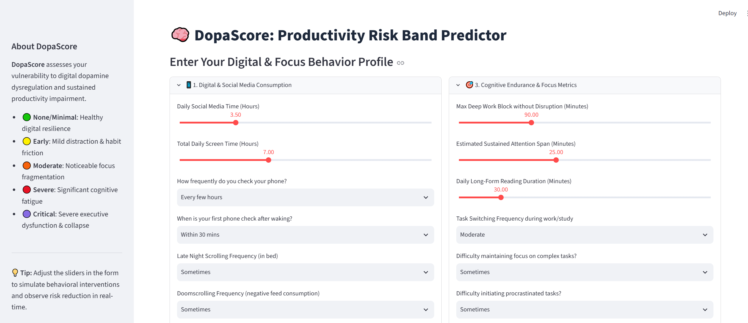

Screenshot 2:
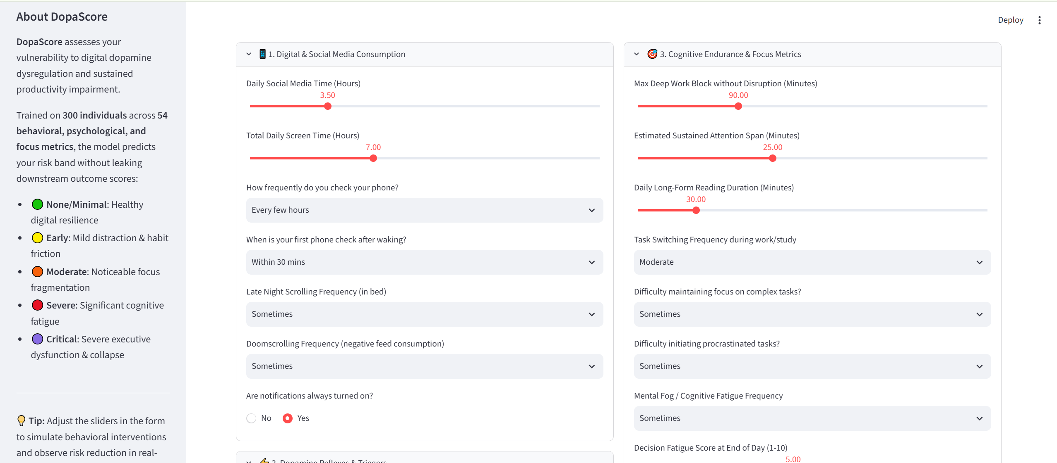
Screenshot 3:
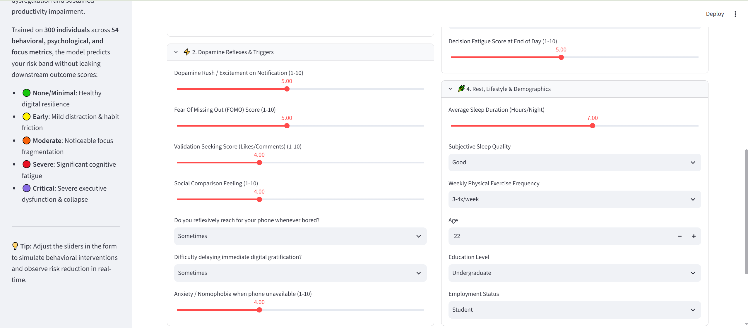

Screenshot 4: On clicking ‘Assess my Productivity Risk Band’ it gives out its analysis:
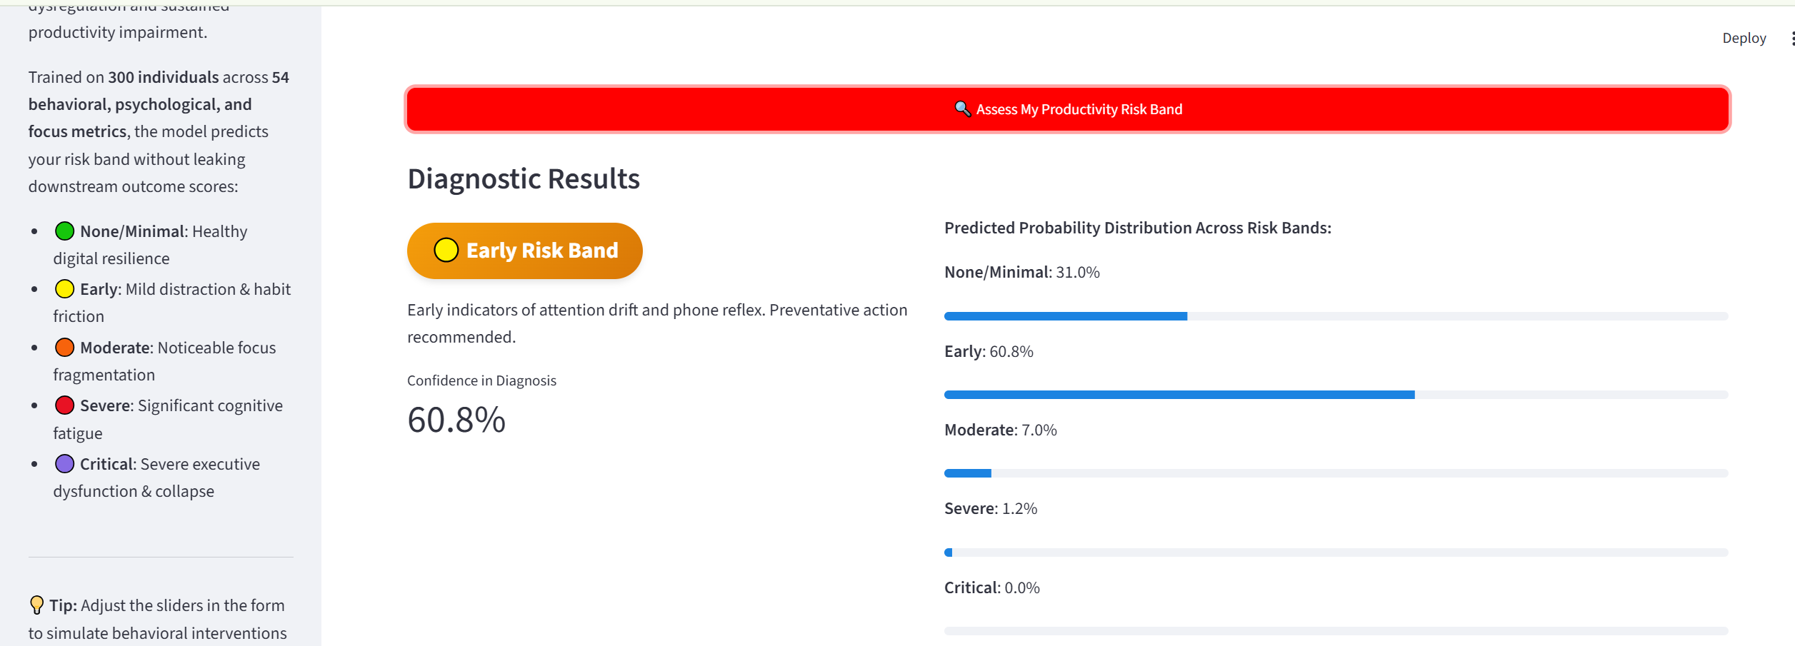

Screenshot 5: It also provides with ‘Key Behavioral Contributing Factors for This Profile’ and Tailored Digital Hygiene Protocol.

