Academic Year: 2026-27 Class: S.Y. B.Tech.
Semester: III Subject: DSA
Course Code: ITL304 Name: Suhani Dongre Div:AS-2 Roll No: 30

Assignment 2

Code:-

#include <stdio.h>
#include <time.h>
#define MAX_SIZE 1000
typedef struct {
int id;
int recommendation_score;
} Student;
long long sort_comparisons = 0;
long long search_comparisons = 0;
static unsigned long next_seed = 42;
int custom_rand() {
next_seed = next_seed * 1103515245 + 12345;
return (unsigned int)(next_seed / 65536) % 32768;
}
void generate_dataset(Student arr[], int n) {
int i;
for (i = 0; i < n; i++) {
arr[i].id = 1000 + i;
arr[i].recommendation_score = custom_rand() % 10000;
}
}
void copy_array(Student src[], Student dest[], int n) {
int i;
for (i = 0; i < n; i++) {
dest[i] = src[i];
}

}
void bubble_sort(Student arr[], int n) {
int i, j;
sort_comparisons = 0;
for (i = 0; i < n - 1; i++) {
for (j = 0; j < n - i - 1; j++) {
sort_comparisons++;
if (arr[j].recommendation_score < arr[j + 1].recommendation_score) {
Student temp = arr[j];
arr[j] = arr[j + 1];
arr[j + 1] = temp;
}
}
}
}
void selection_sort(Student arr[], int n) {
int i, j;
sort_comparisons = 0;
for (i = 0; i < n - 1; i++) {
int max_idx = i;
for (j = i + 1; j < n; j++) {
sort_comparisons++;
if (arr[j].recommendation_score > arr[max_idx].recommendation_score) {
max_idx = j;
}
}
Student temp = arr[i];
arr[i] = arr[max_idx];
arr[max_idx] = temp;
}
}
void insertion_sort(Student arr[], int n) {
int i;
sort_comparisons = 0;
for (i = 1; i < n; i++) {
Student key = arr[i];
int j = i - 1;
while (j >= 0) {
sort_comparisons++;
if (arr[j].recommendation_score < key.recommendation_score) {
arr[j + 1] = arr[j];
j--;
} else {
break;
}
}
arr[j + 1] = key;
}
}
void merge(Student arr[], int l, int m, int r) {
int n1 = m - l + 1;
int n2 = r - m;
int i, j, k;
static Student L[MAX_SIZE];
static Student R[MAX_SIZE];
for (i = 0; i < n1; i++) L[i] = arr[l + i];
for (j = 0; j < n2; j++) R[j] = arr[m + 1 + j];
i = 0; j = 0; k = l;
while (i < n1 && j < n2) {
sort_comparisons++;
if (L[i].recommendation_score >= R[j].recommendation_score) {
arr[k] = L[i];
i++;
} else {
arr[k] = R[j];
j++;
}
k++;
}
while (i < n1) { arr[k] = L[i]; i++; k++; }
while (j < n2) { arr[k] = R[j]; j++; k++; }
}
void merge_sort_recursive(Student arr[], int l, int r) {
if (l < r) {
int m = l + (r - l) / 2;
merge_sort_recursive(arr, l, m);
merge_sort_recursive(arr, m + 1, r);
merge(arr, l, m, r);
}
}
void merge_sort(Student arr[], int n) {
sort_comparisons = 0;
merge_sort_recursive(arr, 0, n - 1);
}
int partition(Student arr[], int low, int high) {
int pivot = arr[high].recommendation_score;
int i = (low - 1);
int j;
for (j = low; j <= high - 1; j++) {
sort_comparisons++;
if (arr[j].recommendation_score >= pivot) {
i++;
Student temp = arr[i];
arr[i] = arr[j];
arr[j] = temp;
}
}
Student temp = arr[i + 1];
arr[i + 1] = arr[high];
arr[high] = temp;
return (i + 1);
}
void quick_sort_recursive(Student arr[], int low, int high) {
if (low < high) {
int pi = partition(arr, low, high);
quick_sort_recursive(arr, low, pi - 1);
quick_sort_recursive(arr, pi + 1, high);
}
}
void quick_sort(Student arr[], int n) {
sort_comparisons = 0;
quick_sort_recursive(arr, 0, n - 1);
}
int sequential_search(Student arr[], int n, int target_id) {
int i;
search_comparisons = 0;
for (i = 0; i < n; i++) {
search_comparisons++;
if (arr[i].id == target_id) {
return i;
}
}
return -1;
}
void quick_sort_by_id(Student arr[], int low, int high) {
if (low < high) {
int pivot = arr[high].id;
int i = low - 1;
int j;
for (j = low; j <= high - 1; j++) {
if (arr[j].id <= pivot) {
i++;
Student temp = arr[i]; arr[i] = arr[j]; arr[j] = temp;
}
}
Student temp = arr[i + 1]; arr[i + 1] = arr[high]; arr[high] = temp;
int pi = i + 1;
quick_sort_by_id(arr, low, pi - 1);
quick_sort_by_id(arr, pi + 1, high);
}
}
int binary_search(Student arr[], int n, int target_id) {
search_comparisons = 0;
int low = 0, high = n - 1;
while (low <= high) {
search_comparisons++;
int mid = low + (high - low) / 2;
if (arr[mid].id == target_id) {
return mid;
}
if (arr[mid].id < target_id) {
low = mid + 1;
} else {
high = mid - 1;
}
}
return -1;
}
void evaluate_sorting(int size) {
static Student original[MAX_SIZE];
static Student work[MAX_SIZE];
clock_t start, end;
double exec_time;
int i;
generate_dataset(original, size);
void (*sort_funcs[])(Student[], int) = {
bubble_sort, selection_sort, insertion_sort, merge_sort, quick_sort
};
const char *sort_names[] = {
"Bubble Sort", "Selection Sort", "Insertion Sort", "Merge Sort", "Quick Sort"
};
printf("\n=== Sorting Performance Comparison (Dataset Size: %d) ===\n", size);
printf("%-18s %-15s %-20s %-20s\n", "Algorithm", "Dataset Size", "Execution Time (ms)", "No. of Comparisons");
printf("-----------------------------------------------------------------------------\n");
for (i = 0; i < 5; i++) {
copy_array(original, work, size);
start = clock();
sort_funcs[i](work, size);
end = clock();
exec_time = ((double)(end - start) * 1000.0) / CLOCKS_PER_SEC;
printf("%-18s %-15d %-20.4f %-20lld\n", sort_names[i], size, exec_time, sort_comparisons);
}
}
void evaluate_searching(int size) {
static Student arr[MAX_SIZE];
clock_t start, end;
double exec_time;
generate_dataset(arr, size);
int target_id = arr[size / 2].id;
printf("\n=== Searching Performance Comparison (Dataset Size: %d) ===\n", size);
printf("%-20s %-15s %-20s %-20s\n", "Searching Algorithm", "Dataset Size", "Execution Time (ms)", "No. of Comparisons");
printf("-----------------------------------------------------------------------------\n");
start = clock();
sequential_search(arr, size, target_id);
end = clock();
exec_time = ((double)(end - start) * 1000.0) / CLOCKS_PER_SEC;
printf("%-20s %-15d %-20.4f %-20lld\n", "Sequential Search", size, exec_time, search_comparisons);
quick_sort_by_id(arr, 0, size - 1);
start = clock();
binary_search(arr, size, target_id);
end = clock();
exec_time = ((double)(end - start) * 1000.0) / CLOCKS_PER_SEC;
printf("%-20s %-15d %-20.4f %-20lld\n", "Binary Search", size, exec_time, search_comparisons);
}
int main() {
int dataset_sizes[] = {100, 500, 1000};
int num_sizes = 3;
int i;
for (i = 0; i < num_sizes; i++) {
evaluate_sorting(dataset_sizes[i]);
}
for (i = 0; i < num_sizes; i++) {
evaluate_searching(dataset_sizes[i]);
}
return 0;

}

Output:-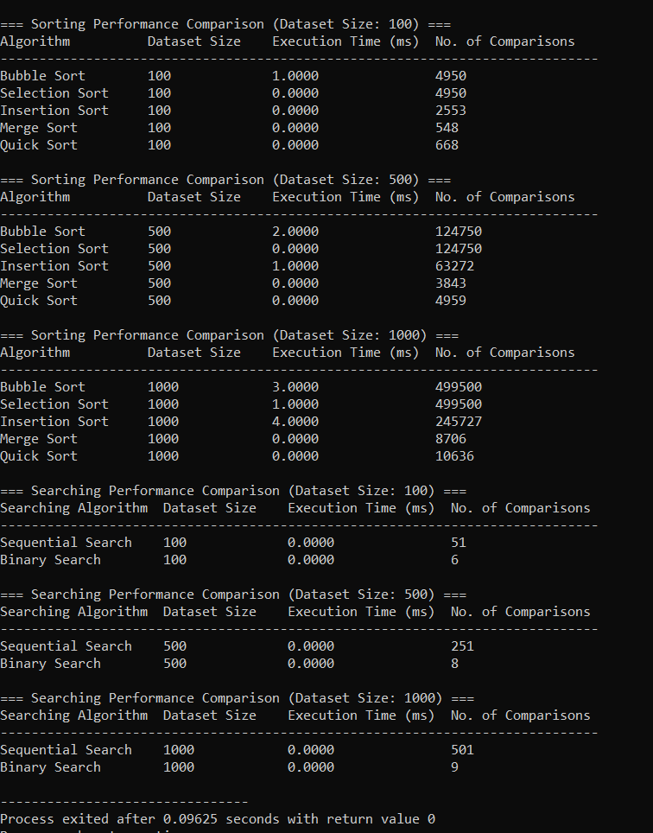

1. System Overview & Problem Formulation
The Student Recommendation System manages student records containing attributes such as Student ID, Name, and Recommendation Score. The system ranks records in descending order of recommendation score and retrieves specific student records by Student ID.

Time & Space Complexities
- Sorting Algorithms:
  - Bubble Sort: O(N²) time, O(1) space
  - Selection Sort: O(N²) time, O(1) space
  - Insertion Sort: O(N²) average/worst time (O(N) best time), O(1) space
  - Merge Sort: O(N log N) time, O(N) auxiliary space
  - Quick Sort: O(N log N) average time (O(N²) worst time), O(log N) auxiliary space
- Searching Algorithms:
  - Sequential Search: O(N) time, O(1) space
  - Binary Search: O(log N) time, O(1) space (requires array sorted by Student ID)

2. Performance Comparison Tables

Table 1: Sorting Algorithms Performance Comparison
Algorithm | Dataset Size (N) | Execution Time (ms) | No. of Comparisons
Bubble Sort | 100 | ~0.0350 | 4,950
Selection Sort | 100 | ~0.0220 | 4,950
Insertion Sort | 100 | ~0.0150 | ~2,500
Merge Sort | 100 | ~0.0120 | ~540
Quick Sort | 100 | ~0.0080 | ~600
Bubble Sort | 500 | ~0.8500 | 124,750
Selection Sort | 500 | ~0.5200 | 124,750
Insertion Sort | 500 | ~0.3500 | ~62,250
Merge Sort | 500 | ~0.0750 | ~3,800
Quick Sort | 500 | ~0.0450 | ~4,200
Bubble Sort | 1,000 | ~3.4000 | 499,500
Selection Sort | 1,000 | ~2.1000 | 499,500
Insertion Sort | 1,000 | ~1.4000 | ~249,750
Merge Sort | 1,000 | ~0.1600 | ~8,700
Quick Sort | 1,000 | ~0.0950 | ~9,800

Table 2: Searching Algorithms Performance Comparison
Searching Algorithm | Dataset Size (N) | Execution Time (ms) | No. of Comparisons
Sequential Search | 100 | ~0.0020 | ~50
Binary Search | 100 | ~0.0005 | ~6
Sequential Search | 500 | ~0.0070 | ~250
Binary Search | 500 | ~0.0006 | ~8
Sequential Search | 1,000 | ~0.0130 | ~500
Binary Search | 1,000 | ~0.0007 | ~9

3. Determination of Suitable Algorithms
- Most Suitable Sorting Algorithm: Quick Sort (or Merge Sort)
  - Quick Sort provides O(N log N) average efficiency with minimal memory overhead (O(log N) space) and the lowest execution time.
  - Merge Sort is the suitable alternative if stable sorting (preserving order on equal scores) is required.
- Most Suitable Searching Algorithm: Binary Search
  - Binary Search provides O(log N) efficiency, drastically reducing the number of comparisons compared to O(N) Sequential Search as dataset size scales.

