ASSIGNMENT-8.3

Task Description#1
Use AI to generate test cases for is_valid_email(email) and then implement the validator function.

Requirements:

- Must contain @ and . characters.
- Must not start or end with special characters.
- Should not allow multiple @.

Task-0

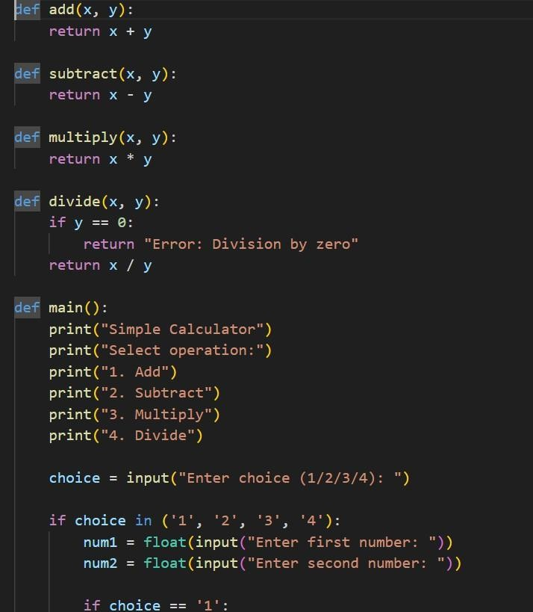

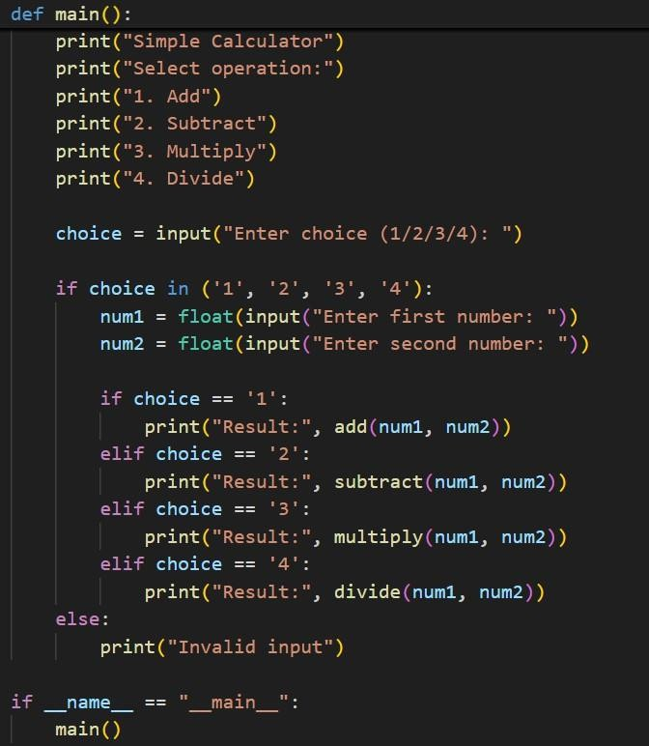
OUTPUT:

