TASK-1 GIVEN CODE-

AI ASSISTED CODING ASSIGNMENT-10.2

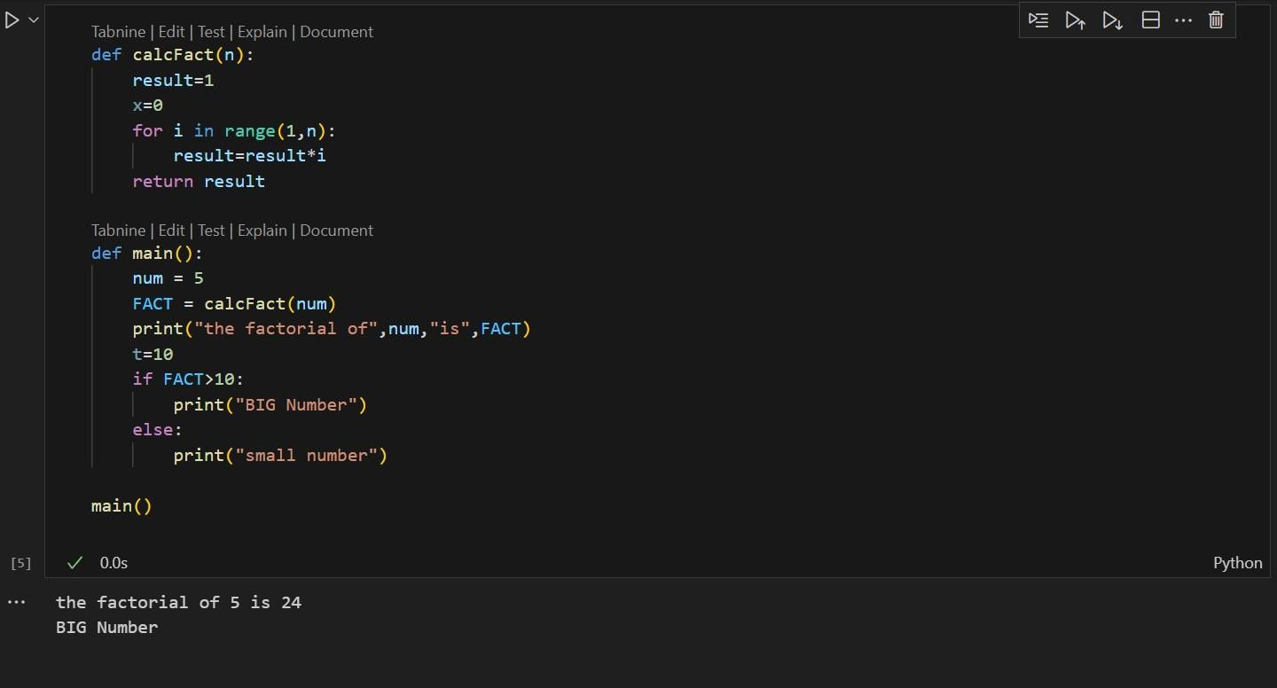
PROMPT-
review the above code and suggest correctionS.

AI GENERATED CODE-
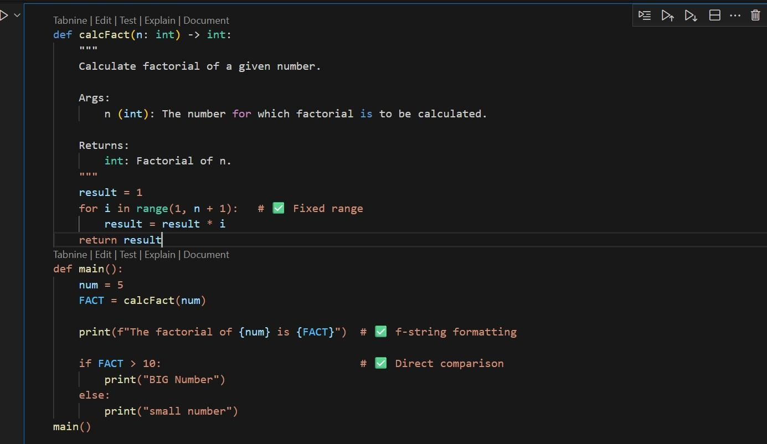
OUTPUT-

TASK-2

GIVEN CODE-
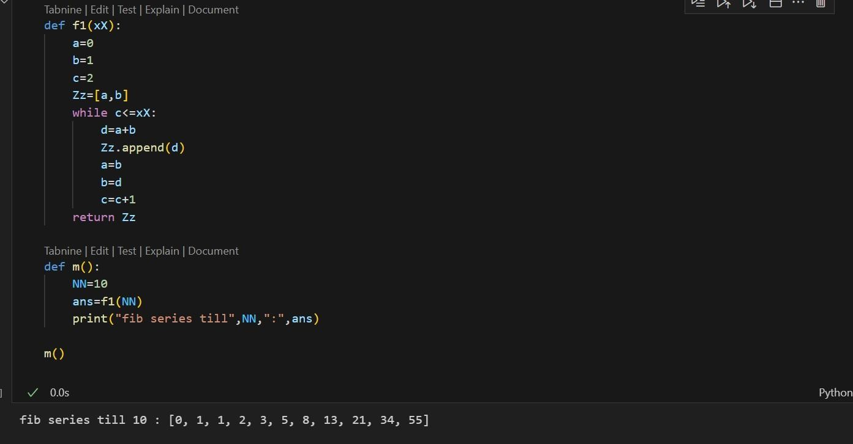
PROMPT-
Improve variable names, add comments, and apply PEP8 formatting.
AI GENERATED CODE-
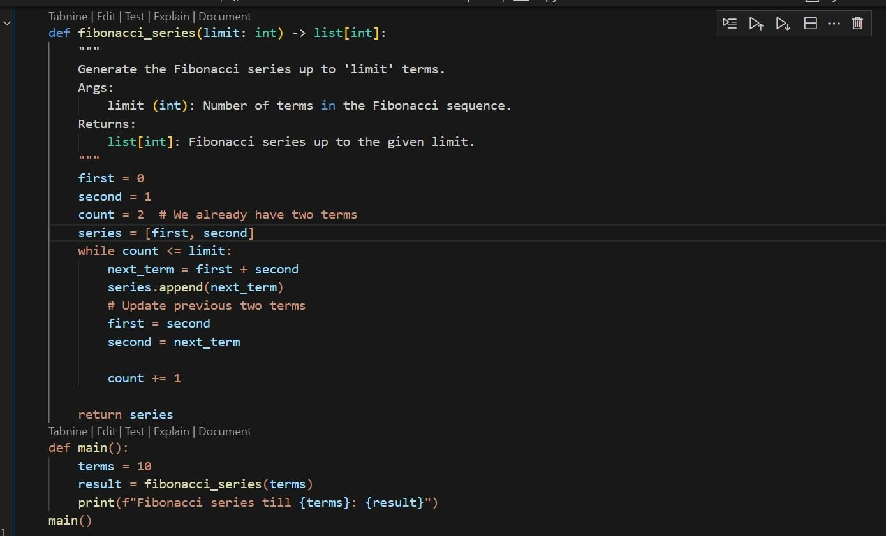
OUTPUT-

TASK 3-
- Write a Python script with 3–4 functions (e.g., calculator: add, subtract, multiply, divide).
- Incorporate manual docstring in code with NumPy Style
- Use AI assistance to generate a module-level docstring + individual function docstrings.
- Compare the AI-generated docstring with your manually written one.
CODE WRITTEN WITH MANUAL DOCSTRING-
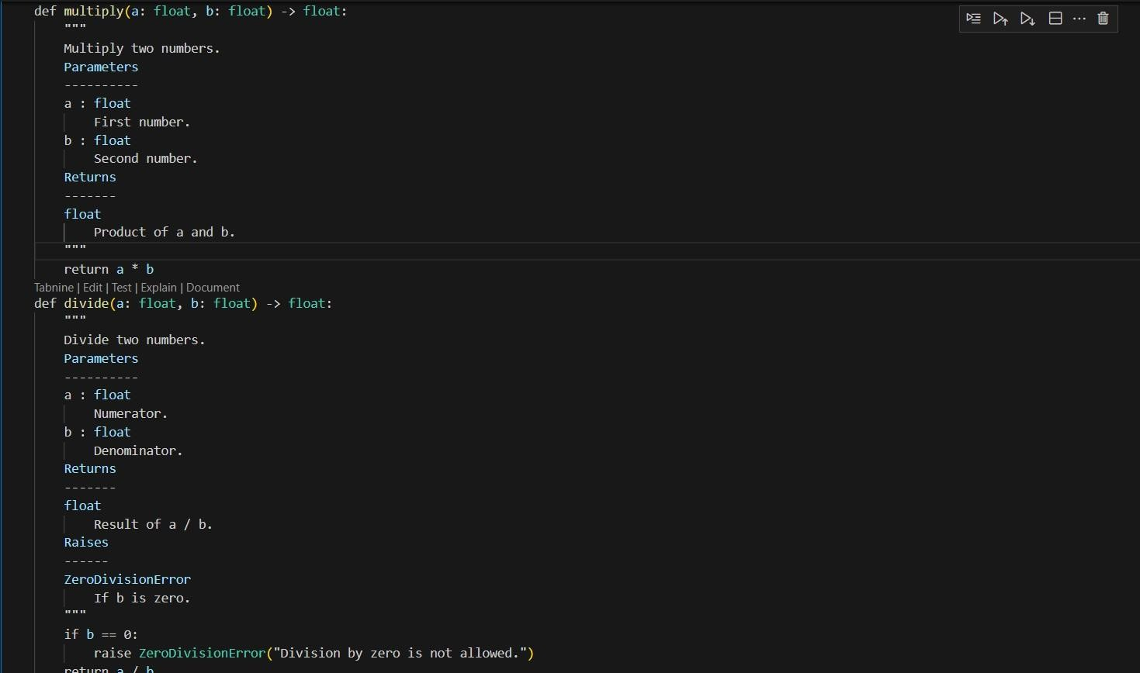
PROMPT-
Generate a module-level docstring + individual functiondocstrings for the above code.
Module-Level Docstring (AI):
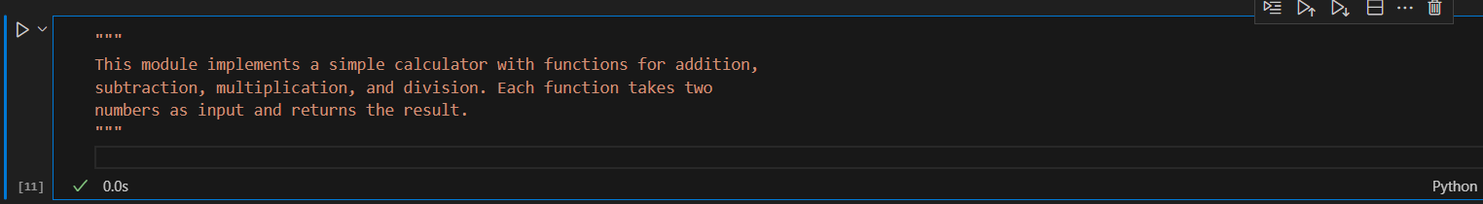
Function Docstring (AI Example for add):

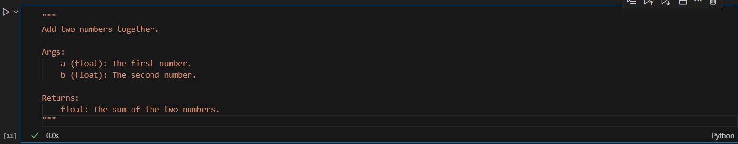
COMPARISON-
- Manual NumPy-style docstrings are detailed and structured with clear sections (Parameters, Returns, Raises).
- AI-generated docstrings are simpler, shorter, and easier for beginners to read.
- Manual ones follow professional/academic standards, while AI ones may skip error handling or details.
- AI saves time, but manual writing ensures accuracy and completeness.

