AI ASSISTED CODING
ASSIGNMENT-10.4
TEST – 1
Task: Identify and fix syntax, indentation, and variable errors in the
given script.
# buggy_code_task1.py
def add_numbers(a, b)
result = a + b
return reslt
print(add_numbers(10 20))
Expected Output:
• Corrected code with proper syntax (: after function, fixed variable
name, corrected function call).
• AI should explain what was fixed
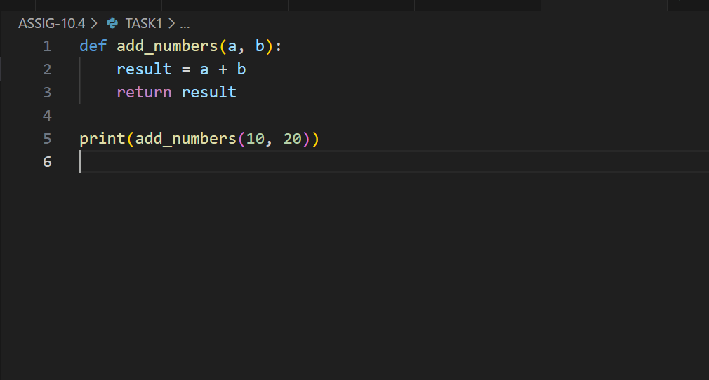
OUTPUT:
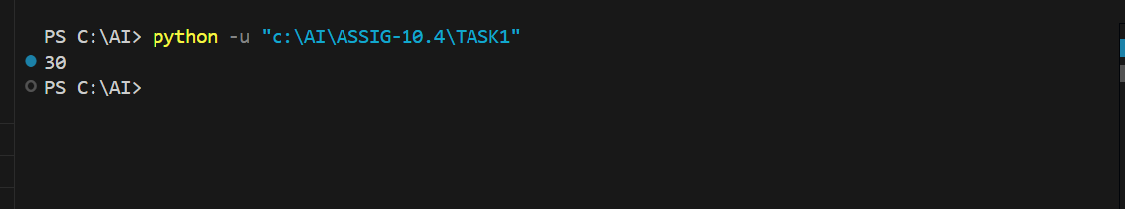

Explanation of fixes:
- Added missing colon (:) after the function definition line.
- Indented the function body correctly (2 spaces or 4 spaces).
- Corrected the variable name from reslt to result.
- Added missing comma between arguments in the function call add_numbers(10, 20).
TEST – 2
Task: Optimize inefficient logic while keeping the result correct.
# buggy_code_task2.py
def find_duplicates(nums):
duplicates = []
for i in range(len(nums)):
for j in range(len(nums)):
if i != j and nums[i] == nums[j] and nums[i] not in duplicates:
duplicates.append(nums[i])
return duplicates
numbers = [1,2,3,2,4,5,1,6,1,2]
print(find_duplicates(numbers))
Expected Output:
• More efficient duplicate detection (e.g., using sets).
• AI should explain the optimization.
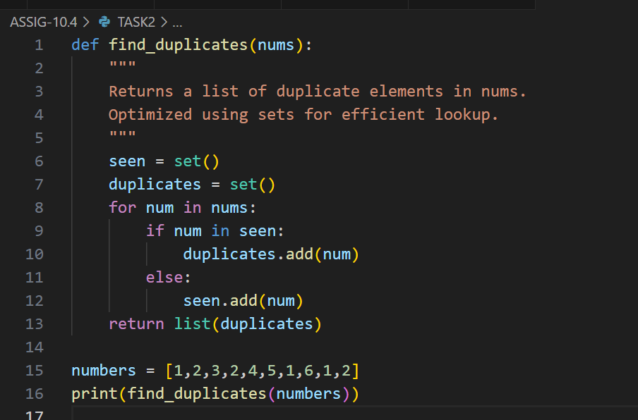
OUTPUT:
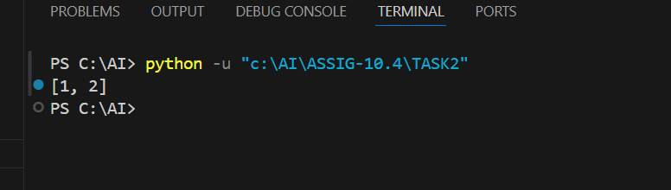
Explanation :
- Original approach: Uses nested loops (O(n^2)) comparing every element with every other element, which is inefficient for large lists.
- New approach: Uses two sets:
  - seen to keep track of elements already encountered.
  - duplicates to store elements that appear more than once.
- This reduces the complexity to O(n) because each element is processed only once.
- Sets provide O(1) average-time complexity for membership tests, making the duplicate detection much faster.
- Finally, the duplicates set is converted back to a list for output.

TEST – 3
Task: Refactor messy code into clean, PEP 8–compliant, well-
structured code.
# buggy_code_task3.py
def c(n):
x=1
for i in range(1,n+1):
x=x*i
return x
print(c(5))
Expected Output:
Function renamed to calculate_factorial.
Proper indentation, variable naming, docstrings, and formatting.
AI should provide a more readable version.
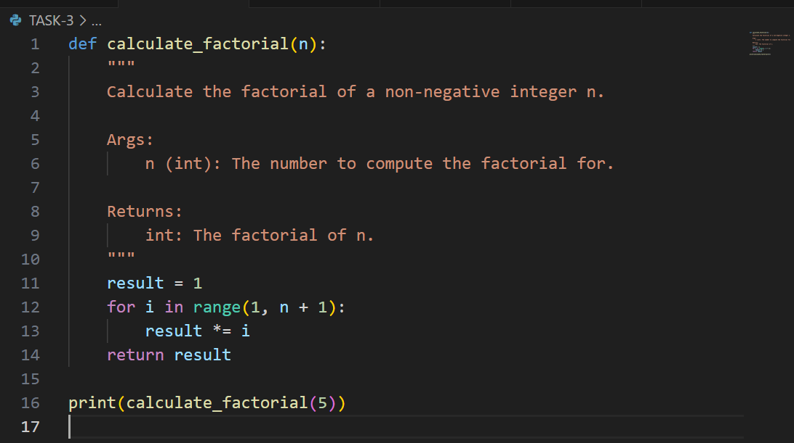

OUTPUT:
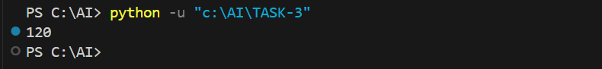

Task – 4
Task: Add security practices and exception handling to the code.
# buggy_code_task4.py
import sqlite3
def get_user_data(user_id):
conn = sqlite3.connect("users.db")
cursor = conn.cursor()
query = f"SELECT * FROM users WHERE id = {user_id};" #
Potential SQL injection risk
cursor.execute(query)
result = cursor.fetchall()
conn.close()
return result
user_input = input("Enter user ID: ")
print(get_user_data(user_input))
Expected Output:
Safe query using parameterized SQL (? placeholders).
Try-except block for database errors.
Input validation before query execution.
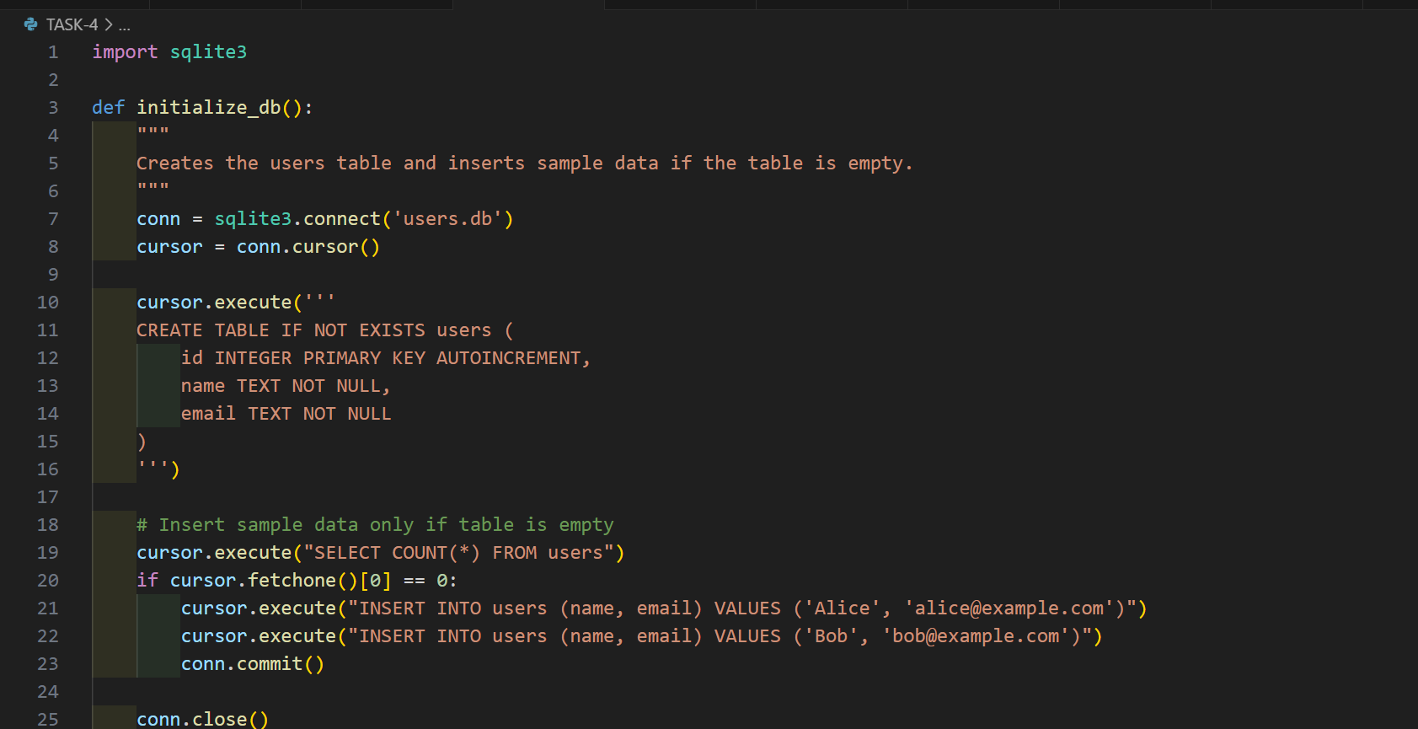
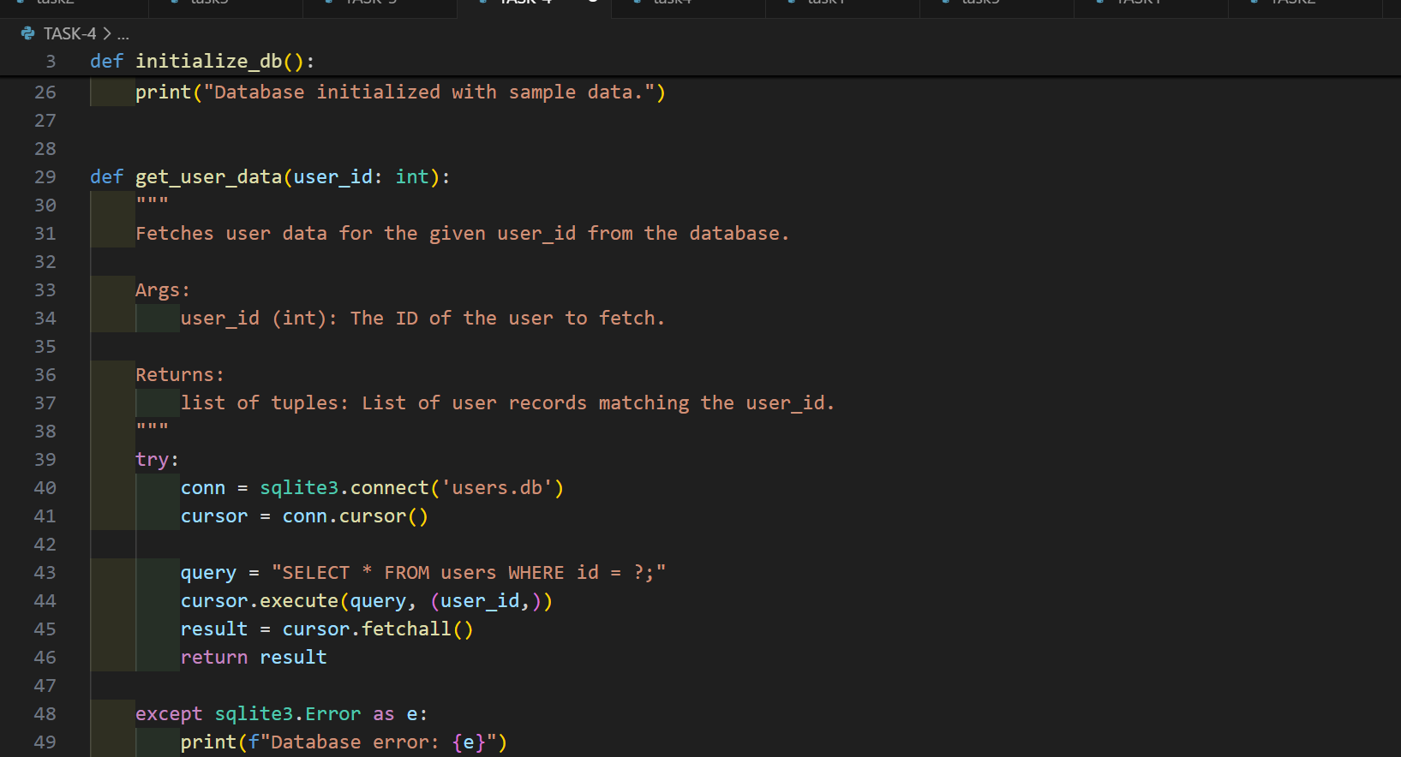
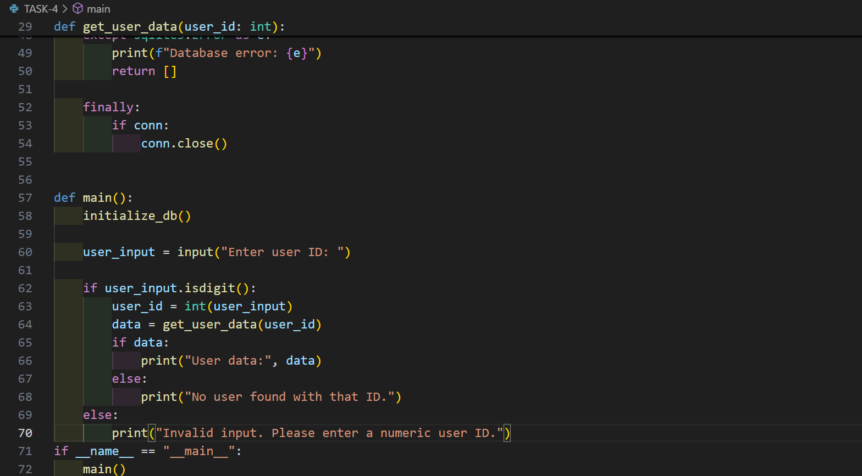
OUTPUT:
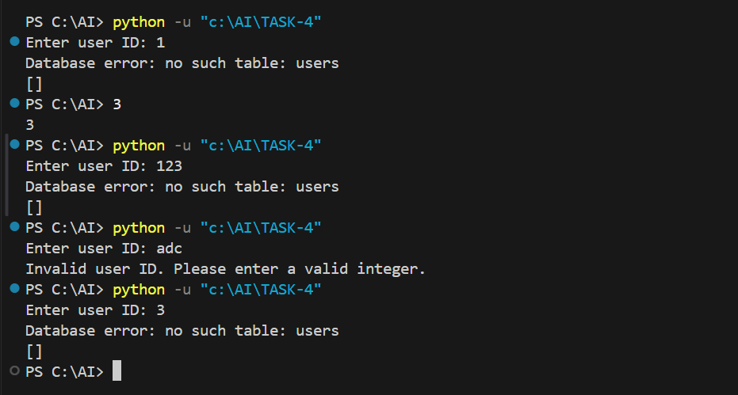
TEST – 5
Task: Generate a review report for this messy code.
# buggy_code_task5.py
def calc(x,y,z):
if z=="add":
return x+y
elif z=="sub": return x-y
elif z=="mul":
return x*y
elif z=="div":
return x/y
else: print("wrong")
print(calc(10,5,"add"))
print(calc(10,0,"div"))
Expected Output:
AI-generated review report should mention:
o Missing docstrings
o Inconsistent formatting (indentation, inline return)
o Missing error handling for division by zero
o Non-descriptive function/variable names
o Suggestions for readability and PEP 8 compliance
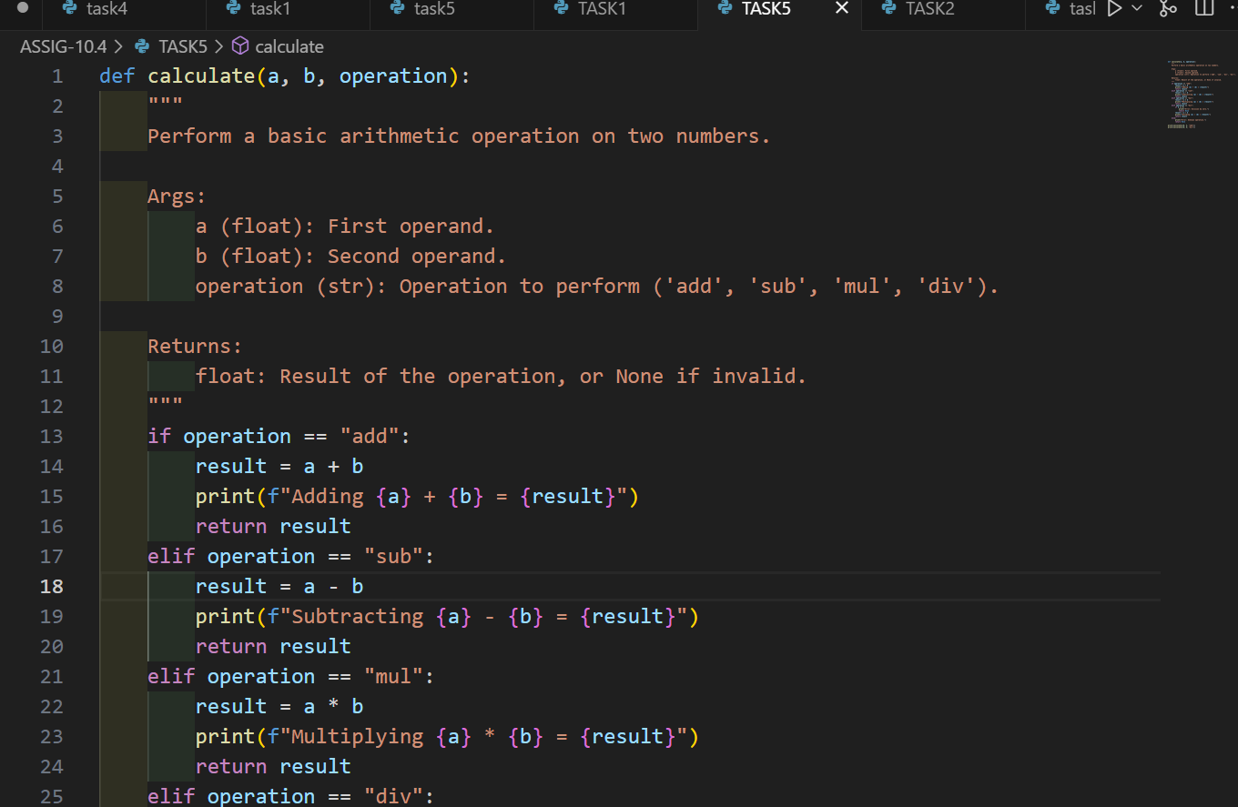
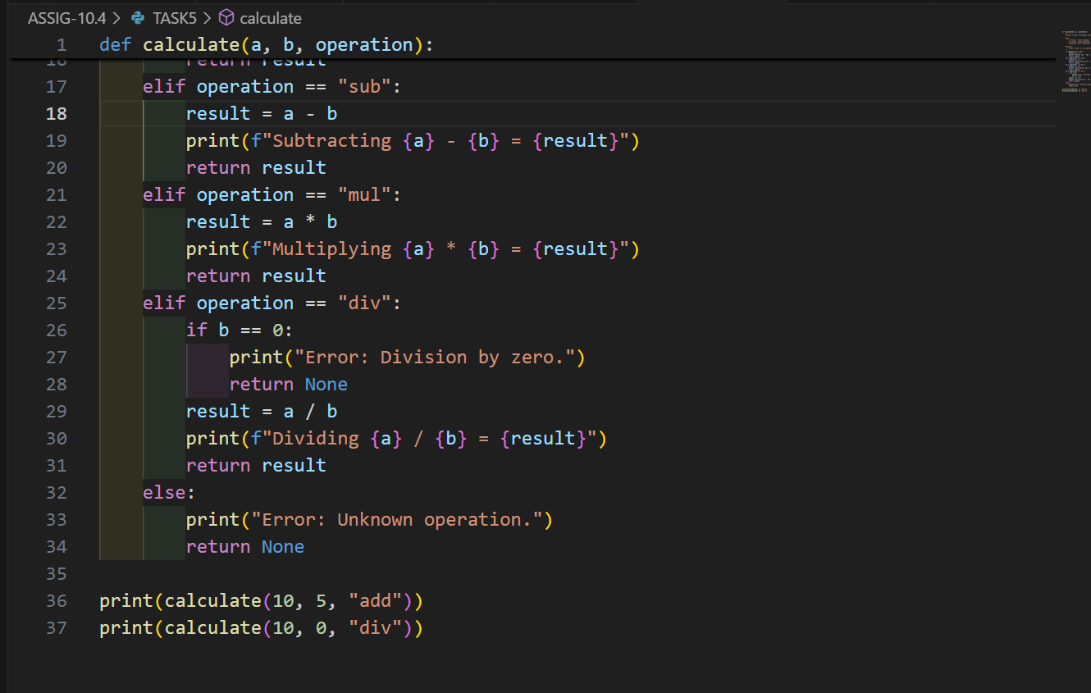
OUTPUT:
