AI ASSISTED CODING

ASSIGNMENT:3.1

TASK1:
Prompt:
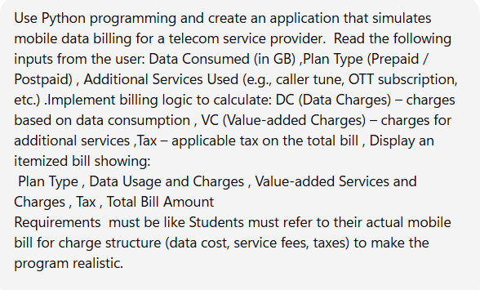
Code:

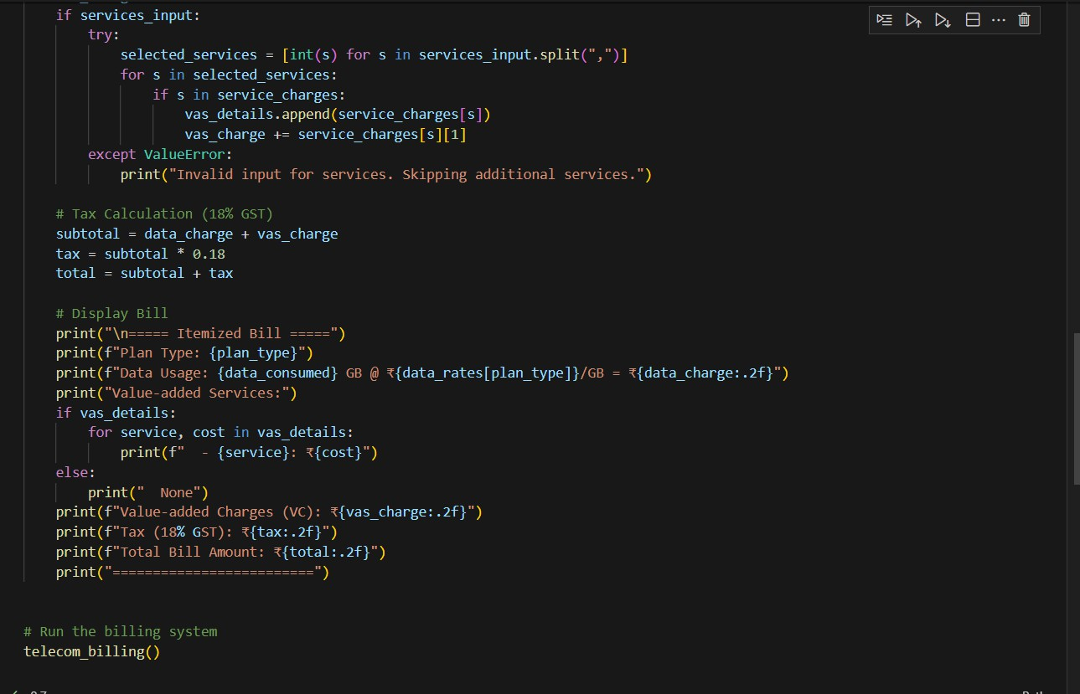
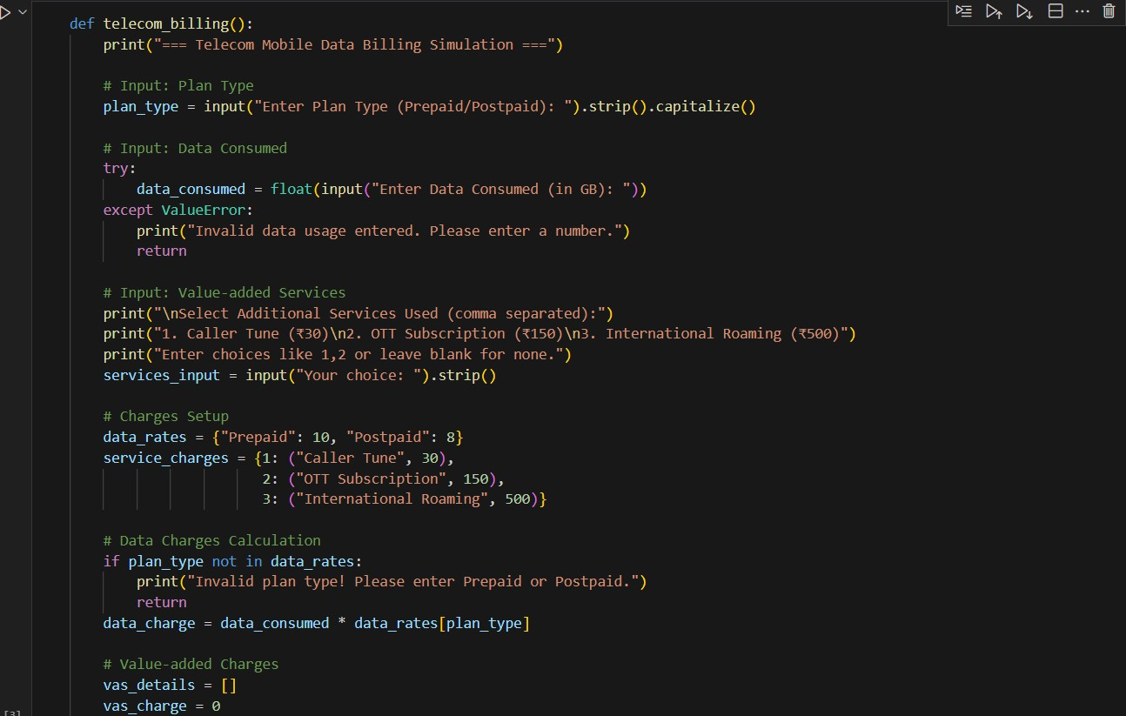
Output:

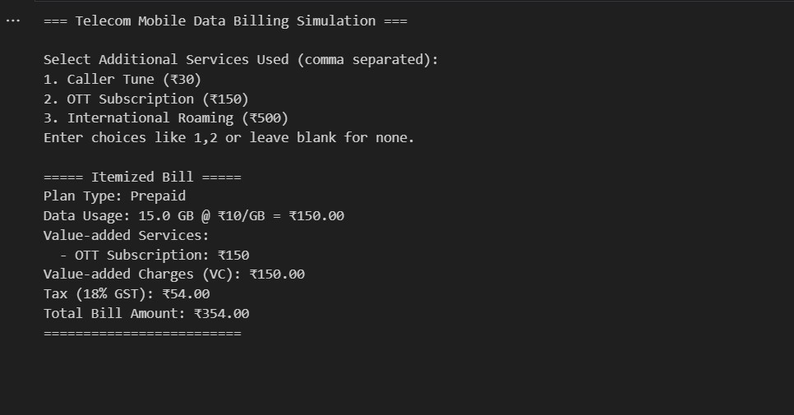

Task2:

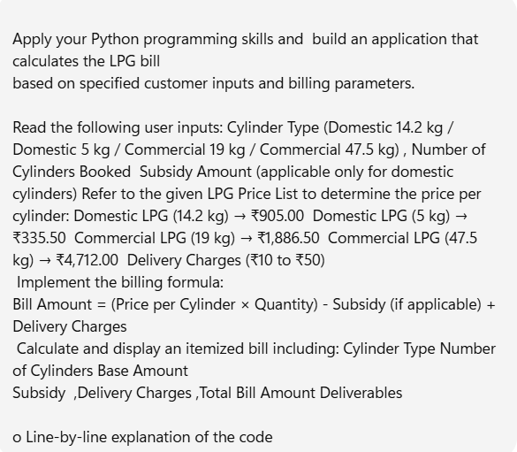
Code :

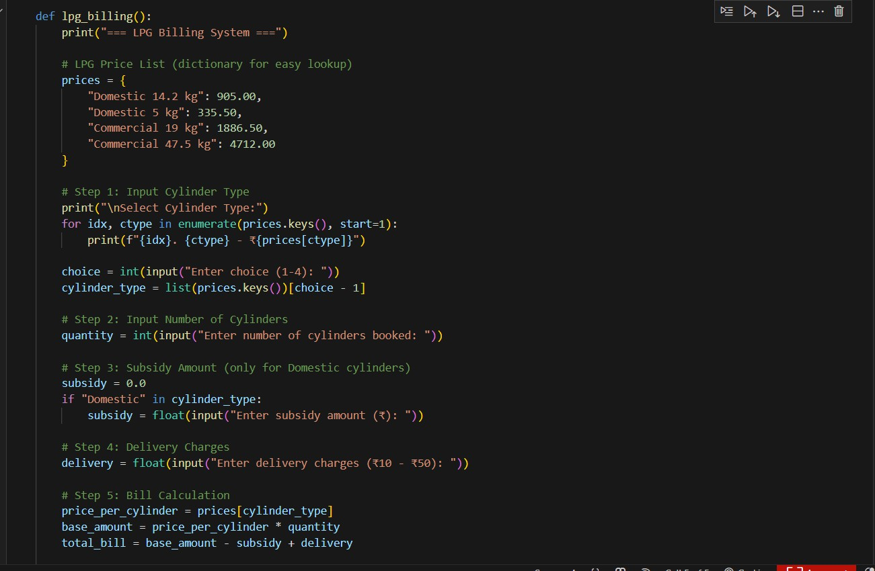
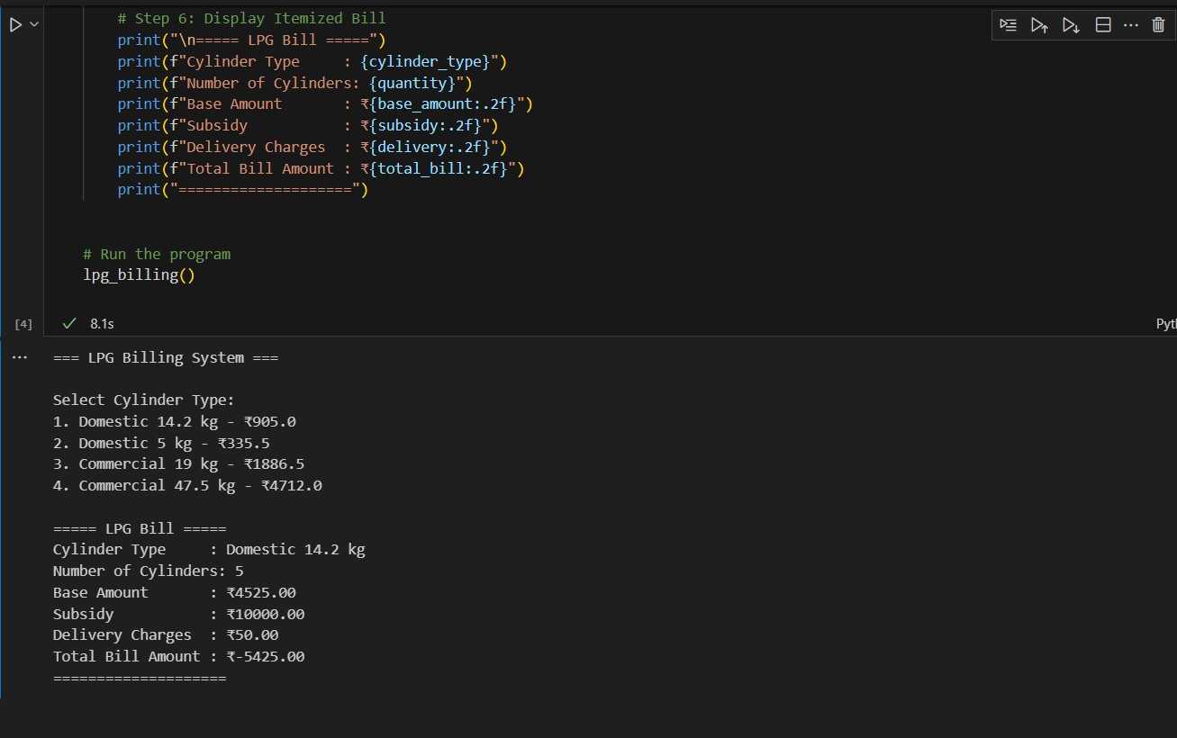
Explanation:

⬛ Line-by-Line Explanation
- Define function
- def lpg_billing():

We define a function lpg_billing() that contains the whole logic.

Print header
- print("=== LPG Billing System ===") Displays a title for the billing system.

Price list dictionary
- prices = {
- "Domestic 14.2 kg": 905.00,
- "Domestic 5 kg": 335.50,
- "Commercial 19 kg": 1886.50,
- "Commercial 47.5 kg": 4712.00
11. }
Stores price per cylinder for each type in a dictionary for quick lookup.

Show cylinder type menu
- for idx, ctype in enumerate(prices.keys(), start=1):
- print(f"{idx}. {ctype} - ₹{prices[ctype]}") Prints options like:
- Domestic 14.2 kg - ₹905.0
- Domestic 5 kg - ₹335.5
...

Take user choice
- choice = int(input("Enter choice (1-4): "))
- cylinder_type = list(prices.keys())[choice - 1]
Converts user input to index, then fetches cylinder type from dictionary.

Take number of cylinders
- quantity = int(input("Enter number of cylinders booked: ")) User enters how many cylinders they want.

Subsidy only for domestic cylinders
- subsidy = 0.0
- if "Domestic" in cylinder_type:
- subsidy = float(input("Enter subsidy amount (₹): ")) Checks if cylinder type contains "Domestic". If yes, ask subsidy.

Delivery charges
- delivery = float(input("Enter delivery charges (₹10 - ₹50): "))

Bill calculation
- price_per_cylinder = prices[cylinder_type]
- base_amount = price_per_cylinder * quantity
- total_bill = base_amount - subsidy + delivery Formula:
Bill Amount=(Price per Cylinder×Quantity)−Subsidy+Delivery Charges\text{Bill Amount} = (\text{Price per Cylinder} \times \text{Quantity}) - \text{Subsidy} + \text{Delivery
Charges}Bill Amount=(Price per Cylinder×Quantity)−Subsidy+Delivery Charges

Display bill
- print("\n===== LPG Bill =====")
- print(f"Cylinder Type : {cylinder_type}")
- print(f"Number of Cylinders: {quantity}")
- print(f"Base Amount : ₹{base_amount:.2f}")
- print(f"Subsidy : ₹{subsidy:.2f}")
- print(f"Delivery Charges : ₹{delivery:.2f}")
- print(f"Total Bill Amount : ₹{total_bill:.2f}")
- print("====================")
Shows a clean, itemized bill.

⬛ Sample Run
=== LPG Billing System ===

Select Cylinder Type:
- Domestic 14.2 kg - ₹905.0
- Domestic 5 kg - ₹335.5
- Commercial 19 kg - ₹1886.5
- Commercial 47.5 kg - ₹4712.0
Enter choice (1-4): 1
Enter number of cylinders booked: 2 Enter subsidy amount (₹): 100

Enter delivery charges (₹10 - ₹50): 25

===== LPG Bill =====
Cylinder Type : Domestic 14.2 kg Number of Cylinders: 2
Base Amount : ₹1810.00 Subsidy : ₹100.00
Delivery Charges : ₹25.00 Total Bill Amount : ₹1735.00
====================

