AI ASSISTED CODING
ASSIGNMENT-10.1
TASK 1
GIVEN CODE-

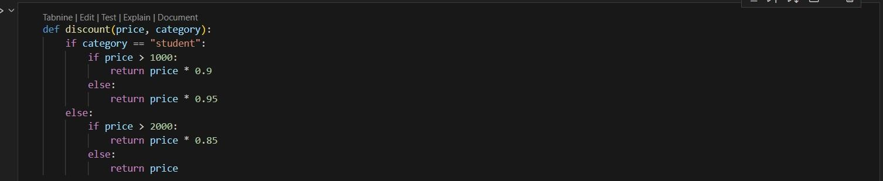
PROMPT-
Fortheabovecodesimplifyand refactor forreadability.
AI GENERATED CODE-

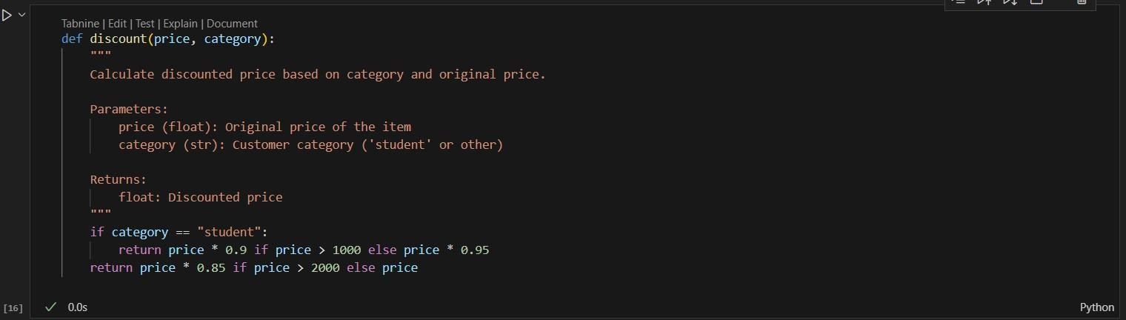

TASK 2

GIVEN CODE-
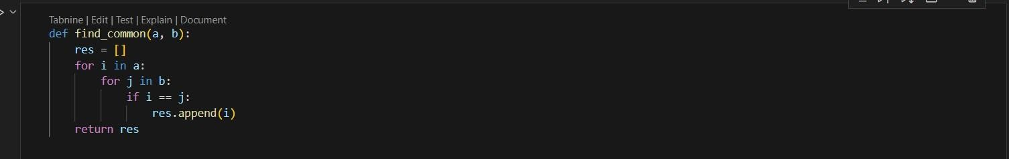
PROMPT-
Refactorand optimize theabovecode.
AI GENERATED CODE-
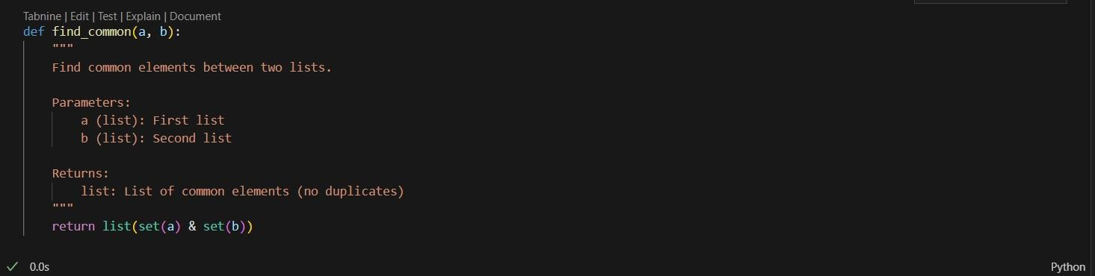

TASK 3
GIVEN CODE-
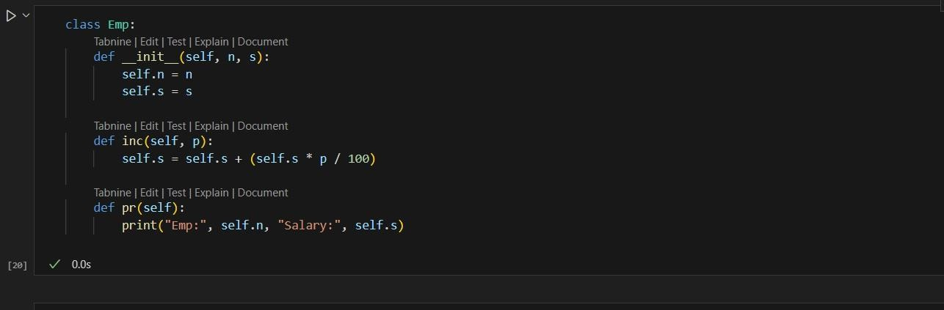
PROMPT-
For the above code improve Naming conventions, Encapsulation, Readability C maintainability.

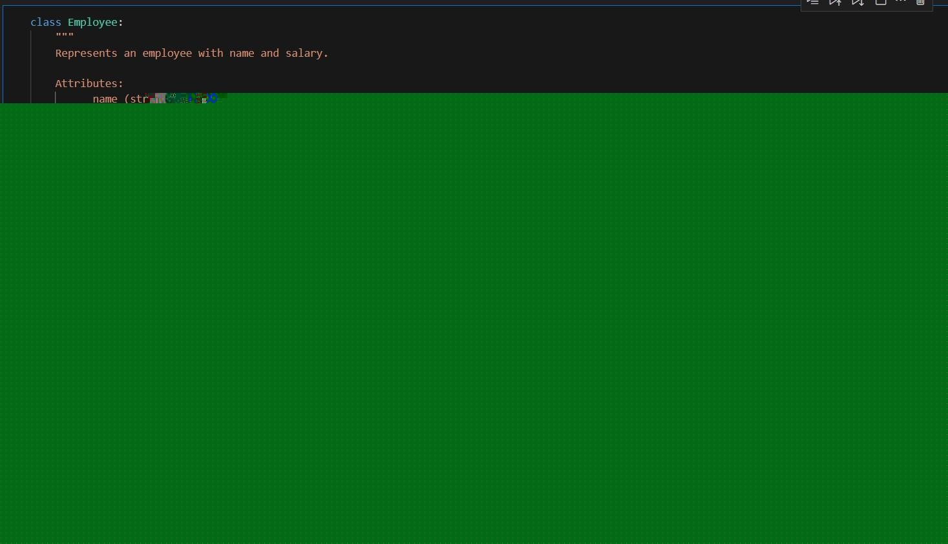
TASK 4
GIVEN CODE-
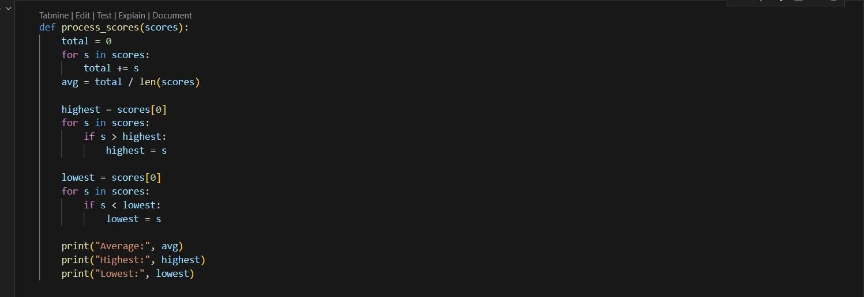
PROMPT-
Break the code into smaller helper functions.

AI GENERATED CODE-
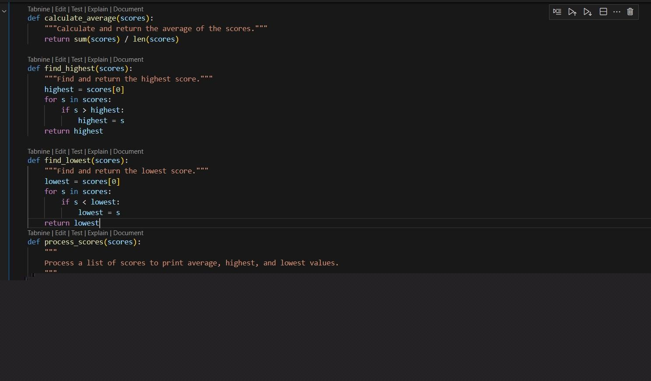
OUTPUT-
TASK 5
GIVEN CODE-
PROMPT-
Fortheabovecodeimprove errorhandling, naming, and readability.
AI GENERATED CODE-

TASK 6
GIVEN CODE-

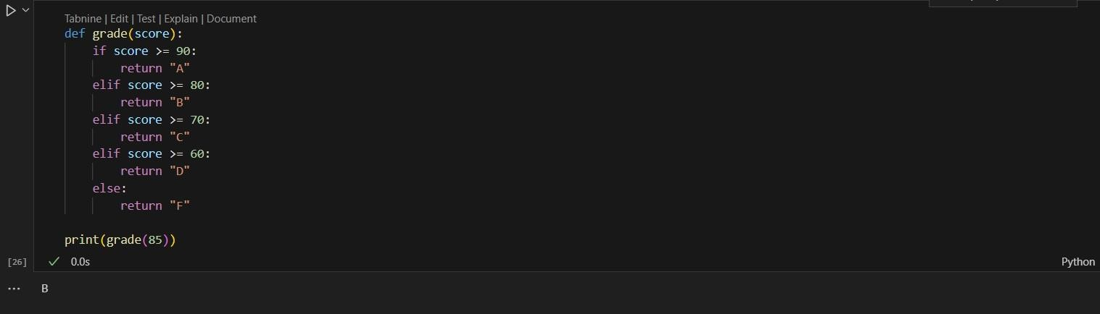
PROMPT-
Simplifyoverly complexlogic.

AI GENERATED CODE-

