**SOURCE CODE**

import pickle

import os

def databases(): #function defining

f=open('library.dat','wb')

header=["Book code","Book name","Author name","Book price"]

pickle.dump(header,f)

fields=[[1,'Klara And The Sun','Kazuo Ishiguro ',455],

[2,'Rich Dad Poor Dad','Robert Kiyosaki',568],

[3,'The Butterfield ',' Rosaria Buterld',667],

[4,'Geography Of India','Majid Hussain ',445],

[5,'Man Who Counted ','Malba Tahan ',325],

[6,'One Indian Girl ','Chetan Bhagat ',567],

[7,'Guns Of August ',' Barbara Tuchman',456],

[8,'Trans Atlantic ',' Colum McCannon',234],

[9,'Tortoise And Hare','Eric Ham Carle ',123]]

for i in fields:

pickle.dump(i,f)

f.close()

#function calling

databases()

def borrow_lend():

f=open('dates.dat','wb')

header=["Book code","Book name","Borrow Date","Return Date",'No of days book lent for',"Book Returned"]

pickle.dump(header,f)

fields=[[1,'Klara And The Sun','1 janaury 2022','15 janaury 2022',15,'Yes'],

[2,'Rich Dad Poor Dad','12 febraury 2022','27 febraury 2022',15,'Yes'],

[4,'Geography Of India','1 september 2022','-',20,'No'],

[8,'Trans Atlantic','12 janaury 2023','-',15,'No']]

for i in fields:

pickle.dump(i,f)

f.close()

#function calling

borrow_lend()

def user_offer(): #function defining

print('Read the following menu and enter your choice')

print('\n')

print('Press 1 to add records')

print('Press 2 to display all book records')

print('Press 3 to search a record by book code no.')

print('Press 4 to search a record by book name')

print('Press 5 to update a record without considering lending')

print('Press 6 to delete a record by book code no.')

print('Press 7 to search by code no. the details of lending the book')

print('Press 8 to calculate and display interest due on the book lended')

print('Press 9 to update details on return of the book lended')

print('Press 10 to exit')

#function calling

user_offer()

print('\n')

c=int(input('Enter your choice here:'))

if c==1:

def add_record(): #function defining

try:

f=open('library.dat','ab')

z=0

while True:

cn=int(input("Enter book code no:"))

name=input("Enter the book name:")

author=input("Enter name of the author:")

pr=float(input('Enter price of the book:'))

borrow=0

name=name.title()

author=author.title()

rec=[cn,name,author, pr,borrow]

pickle.dump(rec,f)

z+=1

print("Record added in file")

ch=input('Do you want to add more records? if yes press y or Y')

if ch=='y'or ch=='Y':

continue

else:

break

except EOFError:

f.close()

if z==0:

print('Problem occured.Please restart')

#function calling

add_record()

elif c==2:

def displayrecords(): #function defining

try:

f=open("library.dat","rb")

print('='*66)

i=0

while True:

rec=pickle.load(f)

if not rec:

break

print(rec[0],' '*7,rec[1],' '*5,rec[2],' '*7,rec[3],end='\n')

if i==0:

print('='*66)

i+=1

f.close()

except EOFError:

print('='*66)

f.close()

except IOError:

print("Unable to open the file")

#function calling

displayrecords()

elif c==3: #function defining

def search_bycode():

try:

z=0

s=int(input("Enter code no to search:"))

f=open("library.dat","rb")

while True:

rec=pickle.load(f)

if rec[0]==s:

z+=1

print('Book found')

print('='*77)

print("Book code",' '*9,"Book name",' '*13,"Author name",' '*9,"Book price")

print('='*77)

print(rec[0],' '*15,rec[1],' '*6,rec[2],' '*7,rec[3])

print('='*77)

f.close()

except EOFError:

f.close()

if z==0:

print("Book not found")

except IOError:

print("Unable to open the file.Please restart.")

#function calling

search_bycode()

elif c==4:

def search_byname(): #function defining

try:

z=0

s=input("Enter book name to search:")

s=s.title()

f=open("library.dat","rb")

while True:

rec=pickle.load(f)

if rec[1]==s:

z+=1

print('Book found')

print('='*77)

print("Book code",' '*9,"Book name",' '*13,"Author name",' '*9,"Book price")

print('='*77)

print(rec[0],' '*15,rec[1],' '*6,rec[2],' '*7,rec[3])

print(''='*77)

f.close()

except EOFError:

f.close()

if z==0:

print("Record not found")

except IOError:

print("Unable to open the file")

#function calling

search_byname()

elif c==5:

def update_record(): #function defining

try:

z=0

s=int(input('Enter book code:'))

f=open('library.dat','rb')

tf=open('temp.dat','wb')

while True:

rec=pickle.load(f)

if not rec:

break

if rec[0]==s:

z+=1

print('Old record')

print('='*77)

print("Book code",' '*9,"Book name",' '*13,"Author name",' '*9,"Book price")

print('='*77)

print(rec[0],' '*15,rec[1],' '*6,rec[2],' '*7,rec[3])

print('='*77)

print('\n')

print('Enter new data')

book_code=int(input('Book Code:'))

book_name=input('Book Name:')

author_name=input('Author Name:')

book_price=int(input('Book Price:'))

book_name=book_name.title()

author_name=author_name.title()

rec=[book_code,book_name,author_name,book_price]

pickle.dump(rec,tf)

except EOFError:

f.close()

tf.close()

if z==0:

print('Book not found')

else:

print('Record has been updated')

os.remove('library.dat')

os.rename('temp.dat','library.dat')

except IOError:

print('Unable to find the file.Please restart')

#Function Calling

update_record()

elif c==6:

def delete_record(): #function defining

try:

z=0

s=int(input("Enter book code to delete:"))

f=open('library.dat','rb')

tf=open('temp.dat','wb')

while True:

rec=pickle.load(f)

if rec[0]==s:

z+=1

print('The record being deleted is:')

print('='*77)

print("Book code",' '*9,"Book name",' '*13,"Author name",' '*9,"Book price")

print('='*77)

print(rec[0],' '*15,rec[1],' '*6,rec[2],' '*7,rec[3])

print('='*77)

else:

pickle.dump(rec,tf)

except EOFError:

f.close()

tf.close()

if z==0:

print("Record not found")

else:

print('Record deleted succesfully')

os.remove('library.dat')

os.rename('temp.dat','library.dat')

except IOError:

print("Unable to open the file")

#function calling

delete_record()

elif c==7:

def search_bycodeno(): #function defining

try:

z=0

a=int(input("Enter code no of book to be searched:"))

f=open("dates.dat","rb")

while True:

rec=pickle.load(f)

if rec[0]==a:

z+=1

print('Book found')

if rec[5]=='no' or rec[5]=='No' or rec[5]=='NO':

print('The entered book has not been returned')

print("It's details are")

else:

print('The entered book has been returned')

print("It's details are")

print('='*77)

print("Book code",' '*9,"Book name",' '*13,"Issue date",' '*9,"Return date")

print('='*77)

print(rec[0],' '*15,rec[1],' '*6,rec[2],' '*7,rec[3])

print('='*77)

except EOFError:

f.close()

if z==0:

print("Record not found")

except IOError:

print("Unable to open the file")

#function calling

search_bycodeno()

elif c==8:

def interest(): #function defining

try:

z=0

a=int(input("Enter code no of book to be searched:"))

f=open("dates.dat","rb")

while True:

rec=pickle.load(f)

if rec[0]==a:

z+=1

print('Book found')

print('='*120)

print("Book code",' '*9,"Book name",' '*13,"Issue date",' '*9,"Return date",' '*3,'No of days book was lent for')

print('='*120)

print(rec[0],' '*15,rec[1],' '*6,rec[2],' '*7,rec[3],' '*9,rec[4])

print('='*120)

print('\n')

if rec[5]=='no' or rec[5]=='No' or rec[5]=='NO':

t=rec[4]

r=5

inst=r*t

print('The entered book has not beeen returned')

print('The book was to be returned in ',rec[4],'days')

print('Interest due till the required date of return is',inst)

print('There will be a penalty charge of 10rs each day till the book is returned for late return')

else:

print('The entered book has been returned on',rec[3])

except EOFError:

f.close()

if z==0:

print("The entered book has not been lent")

except IOError:

print("Unable to open the file")

#function calling

interest()

elif c==9:

def update_byrecord(): #function defining

try:

z=0

s=int(input('Enter book code no: '))

f=open('dates.dat','rb')

tf=open('temp.dat','wb')

while True:

rec=pickle.load(f)

if rec[0]==s:

z+=1

if rec[5]=='no' or rec[5]=='No' or rec[5]=='NO':

print('Book found')

print('='*120)

print("Book code",' '*9,"Book name",' '*13,"Issue date",' '*9,"Return date",' '*3,'No of days book was lent for')

print('='*120)

print(rec[0],' '*15,rec[1],' '*6,rec[2],' '*7,rec[3],' '*9,rec[4])

print('='*120)

print('\n')

rec[5]='Yes'

m=input('Enter month of return in words:')

d=input('Enter date of return:')

y=input('Enter year of return:')

rec[3]=d+' '+m+' '+y

print('The entered return date is',rec[3])

tp=[rec[0],rec[1],rec[2],rec[3],rec[4],rec[5]]

pickle.dump(rec,tf)

print('Return succesful')

ch=input('Do you want to enter more records of return ?If yes enter y')

if ch=='Y' or ch=='y':

continue

else:

break

else:

print('The entered book has been returned on',rec[3])

break

except EOFError:

f.close()

tf.close()

if z==0:

print('The entered book has not been lended')

else:

os.remove('library.dat')

os.rename('temp.dat','library.dat')

except IOError:

print('Unable to find the file')

#Function Calling

update_byrecord()

elif c==10:

print('You chose to exit')

else:

print('Wrong choice entered .Please restart')

**OUTPUTS**

**When user chooses to:**

1)Add a record

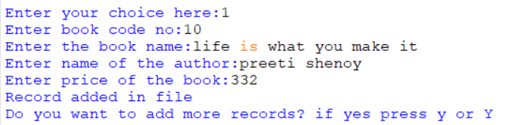

2)Display all records

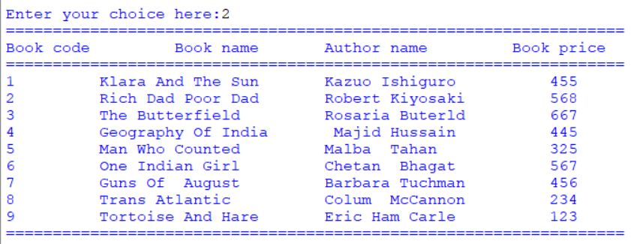

3)Search a record by book code

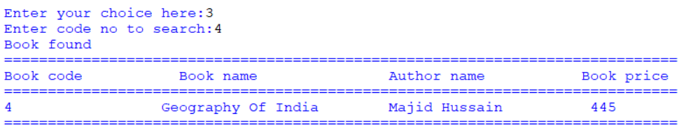

4)Search a record by book name

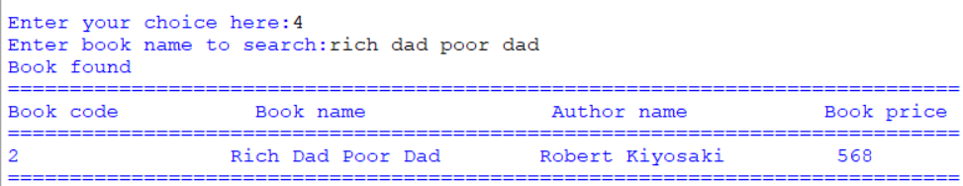

5)Update a record by book code

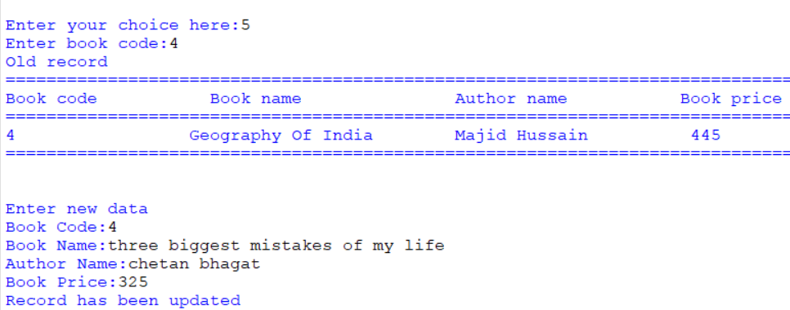

6)Search a record by book code

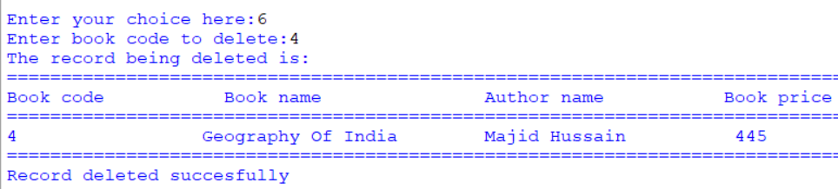

7)Search lending details of a record by book code

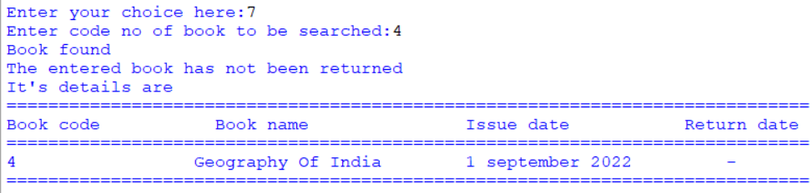

8)Display interest on a book lent by book code

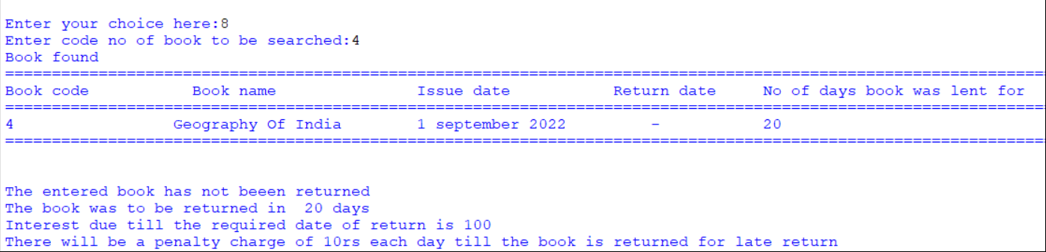

9)Entering date of return of a book by book code

