 Invention Disclosure Format (IDF)-B | Document No. | 02-IPR-R003
 | Issue No/Date | 2/01.02.2024
 | Amd. No/Date | 0/00.00.0000
1 Title of the invention

System and Method for Generation Safe Motion Guided Visual Key Value Memory Residency and Semantic Correction
Project name: MTR-KV
Version 1.0 Technical disclosure and evidence baseline 21 October 2026
2 Field and area of invention
Computer architecture and systems software; compressed-video processing; visual transformer inference; paged key-value memory; tensor representation management; and versioned runtime control. The invention concerns a processor-based arrangement that translates decoder motion evidence into visual-page residency intent and corrects that intent using later model attention through the same controller.
3 Prior patents and publications from literature
The following references identify existing approaches and the technical distinctions proposed for MTR-KV. The focused review was performed on 21 October 2026. It identifies relevant overlap and candidates for examination; it does not establish novelty or freedom to operate. Full source links and publication details appear before Section 10.
Prior patent publications
Published patent text | Disclosed territory reviewed | Technical distinction to examine
R7 US6072548A  Published 6 Jun 2000 | Dynamic decoder memory allocation for variable decoded-image size. | Decoder-originated memory allocation is old. Our target is transformer visual K/V rather than decoded-picture buffers.
R8 US20100098165A1 / US8300697B2  Published application 22 Apr 2010 | Recursive motion-vector analysis of regions related to decoder memory fetching. | Thresholded regional motion analysis is old. Tiling, hierarchy, or thresholds alone are not novelty anchors.
R9 US20250124105A1  17 Apr 2025  Claim 1 and description | Binary token vectors are bucketed; representative tokens supply representative cached K/V. | The prototype does not replace token groups with a representative token. It retains page identity and changes representation/residency.
R10 US20250225134A1  10 Jul 2025  Claim 1 and description | Inference requests reserve contiguous virtual cache space and generate pointers by layer/block. | Reservation and pointer management are established. Compare source metadata, version checks, readiness, and correction relationships.
R11 US20260080217A1  19 Mar 2026  Claims 1 to 4 and description | Gauge transformations canonicalize attention weights; embodiments split hot-window and cold-tail KV and compress cold data. | This prototype uses unchanged model weights, fp16/int8/raw-byte compression, and motion/semantic page intent. Generic hot/cold KV compression is not claimed as new.

Prior research publications
Reference and public date | Previously disclosed mechanism | Relationship to this disclosure
R1 PagedAttention / vLLM  12 Sep 2023 | Non-contiguous paged KV memory, block sharing, and copy-on-write. | Paging and logical-to-physical blocks are established. The candidate here adds a codec-originated page-intent and correction protocol.
R2 CodecSight v4  First 7 Apr 2026  Revised 15 Sep 2026 | Codec-guided patch pruning, GOP/frame-type refresh, and position-corrected KV reuse across VLM windows. | Closest identified research lead. Broad codec-guided KV reuse is already disclosed. Compare the precise residency transaction and model-feedback correction contract.
R3 CoPE-VideoLM v2  First 13 Feb 2026 | Motion vectors and residuals encoded into compact video-language representations. | Codec evidence as model input is established. Here that evidence controls residency descriptors; no codec encoder training is implemented.
R4 RESUME v1  30 Sep 2026 | An I-frame initializes a latent state; predictive-frame codec observations update it and produce VideoLM readouts. | Carried codec-derived state is related, but is not the tensor-store mechanism implemented here. Its filing-date relevance remains for counsel.
R5 H2O v3  First 24 Jun 2023 | Attention-heavy and recent tokens guide KV retention. | Attention-based importance is established; it must not be asserted as new by itself.
R6 SnapKV v2  First 22 Apr 2024 | An observation window selects clustered important KV positions per attention head. | Model-derived cache compression is established. Our software corrects a separate early codec tier proposal through the same versioned controller.

Search coverage and remaining work
The reviewed methods include codec-guided visual-token selection and KV reuse, paging, attention-guided retention, decoder memory and transformer cache management. CodecSight is the closest identified codec-guided reuse lead. The distinctions concern the exact residency transaction, generation checks and model-feedback correction relationship. A claim-by-claim family search, citation expansion and combination analysis remain necessary; an omission from a summary does not establish absence from a reference.

4 Summary and background of the invention
Video transformers repeatedly create and retain key/value tensors for visual tokens. Compressed video exposes spatial change before the model has produced semantic attention. Using that early signal can reduce fast-tier pressure, but low motion is not the same as low importance: a stationary object, text region, or scene cue may still matter to the task. A second problem is consistency. A delayed descriptor or correction must not install stale data after a newer frame has taken ownership of a page.
MTR-KV separates early evidence from later verification. A decoder adapter produces source-coordinate blocks, motion magnitude, confidence, and frame type. MTRE reconciles those blocks with the model preprocessing and token/page layout. A temporal engine and scene guard qualify the proposal. MKAD records the stream, generation, page span, operation, and target tier. KMC validates and commits a complete mapping before issuing readiness. Actual tensor representations are then consumed by attention.
After model execution, class-token attention is aggregated into page scores. SRCE identifies disagreement, particularly low codec activity with high model importance, and sends a generation-matched correction through the same descriptor/controller path. The software never bypasses generation checks for a semantic rescue. Missing metadata takes a conservative branch instead of being treated as a zero-motion observation.
Candidate distinguishing technical contribution
The proposed contribution is the coordinated control relationship: source-space codec evidence becomes page-specific tier intent before attention; a versioned reserve/prepare/commit/ready sequence gates use; and later model-derived importance corrects that intent through the same controller while stale generations are rejected. The reuse extension requires both codec/temporal eligibility and exact final-block page-input equality, and binds retained content to the new generation only after readiness.
This combination is the candidate for examination, not a conclusion that no earlier system implements it. R2 already establishes codec-guided VLM cache refresh, while R1 and R5-R11 cover adjacent memory and importance mechanisms. The claimable distinction, if any, must lie in concrete relationships and enabling details rather than the names MTRE, MKAD, KMC, or SRCE.

4.1 Technical relationship proposed for examination
The matrix separates an implemented local mechanism from the strongest known overlap. “Compare” identifies a concrete issue to investigate; it does not mean an earlier reference lacks the feature.
Element in MTR-KV | Relevant overlap | Candidate relationship to examine
Actual inverse preprocessing maps codec blocks to token pages. | R2 maps patch selection through model layout; R3 uses codec primitives. | Preserve source/crop/page identity through generation-tagged residency descriptors, including partial blocks and missing metadata.
Motion and temporal state propose T0/T1/T2 intent before attention. | Codec-guided decisions in R2; hot/cold KV in R11. | Tie a codec-derived spatial proposal to a page-tier operation rather than visual pruning or solely recency-based placement.
Reserve, prepare, commit, then ready; reject stale descriptors. | Paging/reservation in R1 and R10; general versioned transactions are established systems techniques. | Define the exact generation/range/operation checks, atomic publication model, failure preservation, and completion contract for this pipeline.
Model importance rescues a quiet page through the same KMC. | Importance-driven retention in R5/R6; R2 also offers residual-based rescue. | Use later model attention, not codec residual alone, to correct the earlier residency intent without bypassing the consistency path.
Static-page reuse also checks exact model input, owner, age, and versions. | R2 uses GOP/frame identity and position correction for approximate VLM reuse. | The narrow final-block implementation avoids reuse solely on motion assumptions and explicitly rebinds retained content after new-generation readiness.
Conservative invalidation and auditable trace. | Fallback, validation, and tracing are established engineering practices. | Specify their interaction with the proposed controller arrangement; do not claim these practices individually.

5 Objectives of invention
Use early compressed-video evidence to propose visual-page residency before the relevant model attention computation.
Reconcile actual source pixels, preprocessing crop/resize, patch tokens, and logical page spans without assuming codec blocks and patches align.
Preserve generation consistency during allocation, replacement, semantic correction, and cross-frame payload reuse.
Retain conservative behavior when evidence is missing, uncertain, or transitioning; avoid treating absence of metadata as proof of static content.
Recover important low-motion pages using later model-derived scores through the normal controller transaction.
Measure real tensor payloads and actual execution, distinguish them from simulator capacity estimates, and expose reproducible evidence.

6 Working principle of the invention in brief
Decode a frame and extract motion-vector side data. Normalize it, map source regions to the actual model token grid, and aggregate activity by logical page. Update temporal and transition state. Construct one or more generation-tagged MKADs, validate them, reserve replacement space, prepare the complete shadow mapping, and publish it before emitting a ready token.
The model can then attach or reuse K/V for the current ready generation. A reuse candidate must also pass exact feature, owner, parameter, and age checks. Prefix tokens and queries are computed normally. Attention reads every patch page through the tier store. After attention, SRCE compares page importance with early motion evidence and requests safe corrections through KMC. The next frame carries temporal state forward; old-generation updates remain stale.
The live implementation is sequential around the Python controller and model. The event simulator separately models asynchronous ordering and adversarial delays. Physical overlap between a media engine and GPU/RTL controller is a proposed embodiment, not a measured property of the Python run.
7 Description of the invention in detail
7.1 System arrangement and component contracts
The decoder adapter supplies blocks, vector scale, source dimensions, presentation timestamp, and frame type. MotionNormalizer creates canonical MotionBlock records. MTRE produces token and page activity; temporal and scene logic govern conservative residency. MkadBuilder groups compatible adjacent page ranges into MKADs. KMC owns the authoritative logical mapping and readiness state.
TorchKVStore holds actual model tensors associated with the committed page generation. ViTAttentionFeedback replaces only the last attention block in the model-backed path. SRCE produces corrections from later class-token attention. JSONL records and the dashboard expose measurements but do not participate in the allocation decision.
The live controller processes one stream per instance. The simulator also includes a multistream workload. The phone adapter has one exclusive capture session per server; it decodes continuously and retains the latest frame when model work is slower than capture.
Component | Executable role
MTRE | Motion-to-Token Reconciliation Engine maps source regions to patch tokens and pages.
MKAD | Motion-Keyed Allocation Descriptor carries stream, generation, page span and operation.
KMC | KV Memory Controller behavioral model owns mappings and readiness.
SRCE | Semantic Residency Correction Engine sends model-derived correction through KMC.
TorchKVStore | Stores actual fp16, int8 or compressed fp16 K/V associated with page generations.

Figure 1 Implemented software architecture
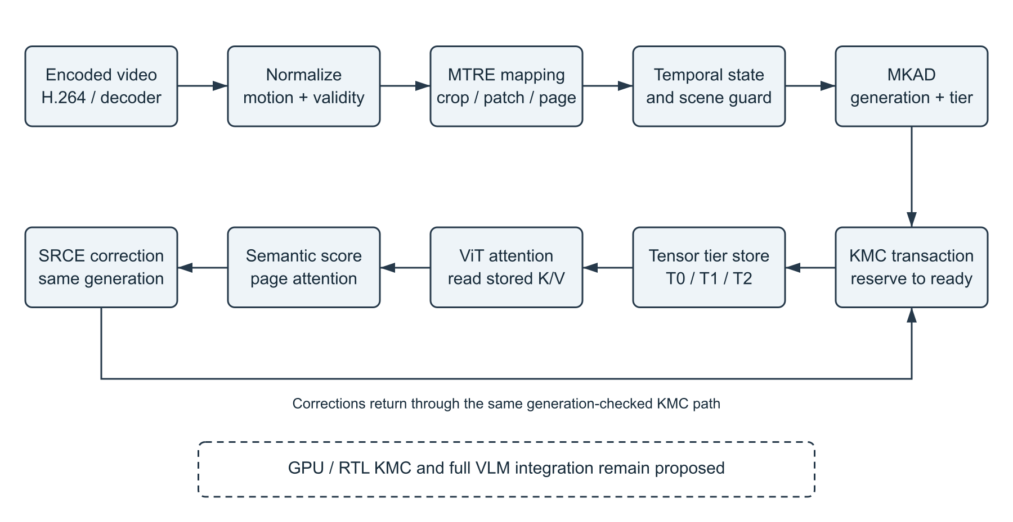
Encoded video produces source-space evidence; MTRE reconciles geometry, temporal state qualifies tier intent, and KMC commits readiness before the model consumes stored K/V. Later attention returns as a same-generation correction through KMC. The dotted GPU/RTL and full VLM extension is proposed.
7.2 Execution order and consistency boundary
The live Python embodiment executes decoder, controller and model work sequentially. Its separate event simulator tests asynchronous ordering and adversarial delays. Logical readiness and a Python fence counter represent the consistency contract; they do not demonstrate a physical GPU fence, asynchronous hardware FIFO or media/GPU overlap.
A current ready mapping is required before attachment, reuse or read. Semantic correction arrives after that frame has executed; it can change residency safely but cannot avoid the inference pass that produced the score. This timing is part of the implemented control loop.

7.3 Source geometry and page reconciliation
Figure 2 Actual model crop and visual page geometry
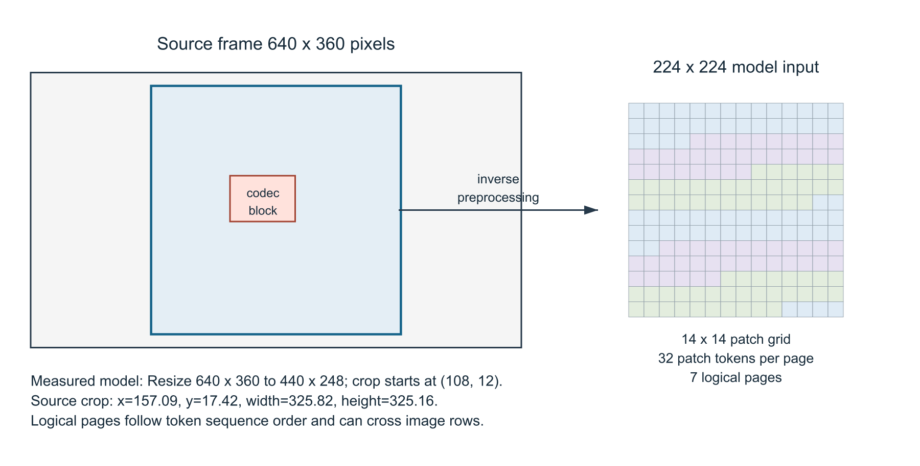
The measured ViT transform resizes the 640 by 360 source to 440 by 248, then center-crops 224 by 224 at offset 108 by 12. The inverse source crop is recorded in every trace. Colors illustrate logical pages, which can cross image rows.
Source: full-demo-serial.jsonl source_crop; runtime ViTAttentionFeedback transform Resize 248 and CenterCrop 224.
Let a model patch occupy rectangle T in source coordinates after inverting preprocessing. For codec block B, overlap weight is area(B intersect T) divided by area(T). Token evidence is accumulated with these weights. Mixed active/static overlap is treated conservatively: a high-change component can dominate the plain mean. Confidence remains an independent guard.
The optimized path indexes blocks into spatial tiles, enumerates only candidates that can intersect each patch, and restores original block order before accumulation. Global page aggregation is then performed once; it is not incorrectly repeated as one page per token. Randomized mixed-block tests, duplicate observations, boundary tiles, and persistence values match the complete oracle exactly.
The crop in Figure 2 is the benchmark model configuration. A separate regression test deliberately uses Resize 256 to check a different transform; its coordinates are not substituted for the measured run.

7.4 Generation checked allocation and readiness
Figure 3 Transaction and failure preservation
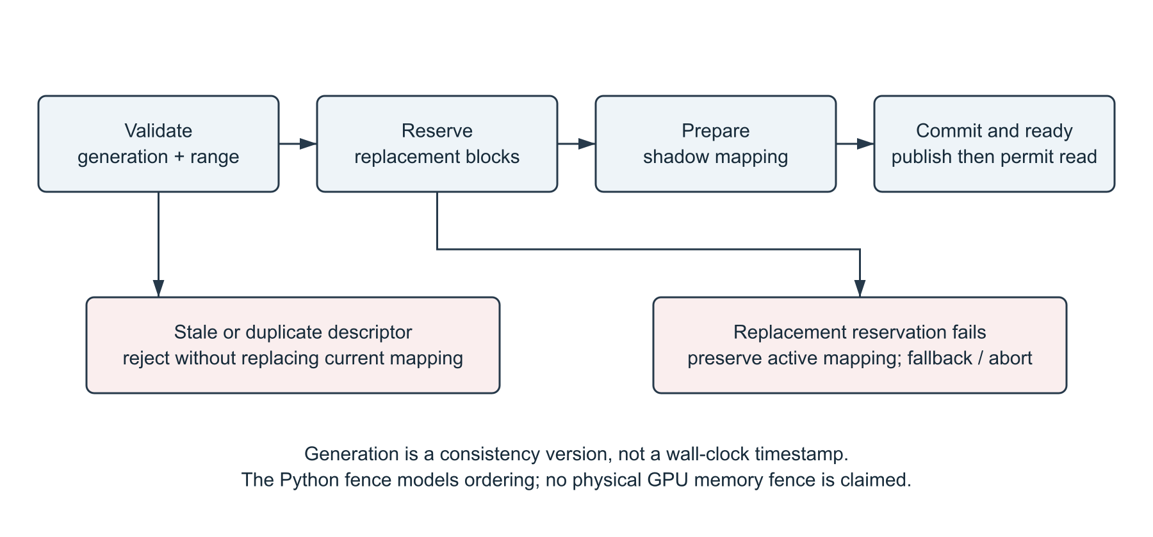
Validate, reserve replacement space, prepare a shadow mapping, and publish before signaling ready. A stale operation is rejected. Failed replacement reservation preserves the active mapping. Atomic publication is modeled in Python.
Descriptor field | Role
stream_id and generation | Identify the source stream and ownership version.
page_start and page_count | Specify a contiguous logical page range; range is validated.
operation and target_tier | Allocate, promote, demote, retire, or prefetch intent.
activity, confidence, cause | Record evidence and the reason for the operation.
descriptor_id and frame_index | Support idempotence and traceability. IDs advance for both normal and correction descriptors.

A successful allocation first reserves all required replacement blocks. The old mapping remains active while the shadow mapping is prepared. Publication updates the complete page range and committed generation. A ready token records stream, generation, span, and modeled fence ID. Tensor access checks both readiness and exact generation.
A failed replacement reservation preserves the old mapping; fallback or abort is reported without pretending the new generation is ready. Duplicate descriptor handling and stale rejection are separately tested. The software allocator uses a shared pool with replacement headroom, not physically distinct tier banks.

7.5 Actual tensor representations and model feedback
Tier | Actual implementation | Boundary
T0 HOT | Contiguous fp16 tensors on the selected torch device. | The verified runs use CPU; a selected torch device is not a custom GPU controller.
T1 WARM | Symmetric per-tensor int8 on CPU with a scale, decoded on read. | Lossy relative to original fp16; classifier/logit comparison measures observed deviation.
T2 COLD | Shape header plus zlib-compressed contiguous fp16 bytes on CPU. | Lossless relative to the fp16 payload. Archive/pickle overhead was removed in this build.
T3 | Optional RECONSTRUCT controller/simulator state. | Actual tensor reconstruction is not implemented; tensor writes to T3 are rejected.

The tensor store records payload bytes written/read and synchronized operation time. Payload accounting excludes Python object overhead, model weights, decoder buffers, and reuse-validation features. The controller separately estimates capacity using its configured tier ratios; that estimate is not an actual measured tensor allocation.
Class-token attention from the final ViT block is averaged over heads, normalized, and aggregated by page. A low-motion page with high score is a candidate for SRCE promotion. This is a model signal, not a human-labeled measure of relevance. The score arrives after that frame has completed inference, so it does not avoid the pass that produced it.
Corrections carry the current generation through MkadBuilder and KMC. The store synchronizes only representations whose tier actually changed. Unchanged pages are not decoded again merely to refresh a snapshot. Actual reads required inside attention remain counted.
Illustrative failure sequence
If generation 12 is current and a semantic correction for generation 11 arrives, the live controller returns STALE_DROP. A current-generation quiet page can be promoted; its retained tensor remains associated with the current generation and original content age. A subsequent attempt to read generation 11 fails even when the underlying content had been reused.
7.6 Exact input validation for temporal reuse
Low codec motion is an eligibility signal, not a sufficient proof of unchanged model features. Earlier ViT blocks use global attention, so a moving region can change contextual features elsewhere. The final-block adapter compares each eligible page input exactly with the retained feature buffer and additionally checks owner, generation continuity, model signature, geometry, device, dtype and payload age.

Figure 4 Bounded reuse decision sequence
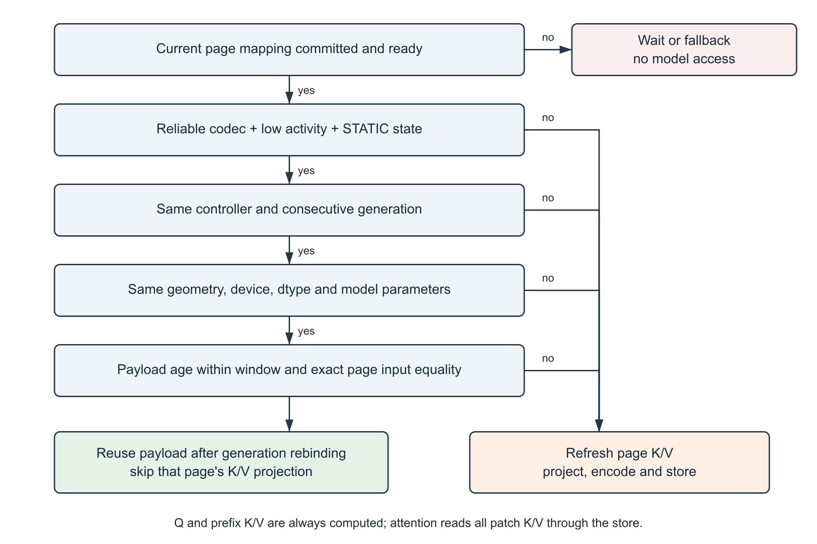
Readiness failure blocks model access. A failed later reuse condition refreshes the page. Passing candidates rebind retained K/V to the new ready generation; queries and prefix K/V are computed normally, and all patch K/V is still read through the store.
The exact-input check applies at the final attention block, after earlier global attention. This matters because low pixel motion does not guarantee unchanged contextual features. The adapter computes Q for every token and K/V only for prefix tokens and misses; attention still reads each patch page through the store.
The default maximum origin age is eight processed generations. Tier migration preserves origin_generation, so repeated promotion cannot indefinitely renew stale content. Only the latest validation features and payloads are retained. Inference failure, controller change, generation gaps, and parameter changes invalidate history.

7.7 Input transport and optimized implementation
File input uses PyAV/FFmpeg export_mvs and emits one JSONL record per processed frame. A missing-vector intra frame, unsupported codec, or unreliable metadata enters fallback. Residual energy is unavailable through this adapter and is not fabricated. FFmpeg-compatible encoded network inputs are accepted, subject to decoder support.
The Android USB mode uses scrcpy direct-camera H.264 capture and ADB on Android 12 or newer. A private FIFO carries Matroska bytes without saving a camera recording, audio is disabled, and the decoder keeps one latest decoded frame. Software tests exercise a real encoded producer, timeout/cleanup, and exclusive sessions. scrcpy/ADB installation and a physical-phone trial remain pending; neither is presented as completed evidence.
Optimizations implemented in this build
Change | Reason and verification
Enable tiled reconciliation in LiveController | Avoid all-block scans per patch. Restore original accumulation order and compare complete token/page outputs against the oracle.
Correct page aggregation | Combine all token records before page aggregation; prevent duplicate per-token page summaries.
Align actual preprocessing geometry | Invert the selected model resize/center crop and apply it to token regions. Bounds are covered by tests.
Use compact T2 bytes | Compress fp16 bytes and shape metadata without torch.save ZIP/pickle containers. Scalar, empty, and multidimensional round trips are exact after fp16 conversion.
Synchronize only changed tiers | Remove unnecessary post-attention full-page rereads. Migration I/O remains measured.

The correctness oracle remains selectable with mtre.use_optimized_path=false in configuration. The frozen architecture document is preserved. The default implementation path changes, but the candidate transaction and correction sequence remains the same.
Not implemented: a physical GPU/RTL KMC, an all-layer VLM integration, cross-window language-model context management, production asynchronous media/GPU overlap, generic browser/webcam upload, or a representative downstream task benchmark.
7.8 Other embodiments and industrial application
The arrangement can be applied to continuous visual inference in edge video analytics, robotics and camera-based assistive systems where visual K/V residency competes with limited fast memory. A hardware embodiment could receive codec metadata from a media engine, translate page intent into device-memory operations and use a hardware completion fence before attention. That embodiment requires its own implementation and validation.
A full vision-language embodiment would additionally define token ownership across frames and language context, layer-specific K/V layouts and decoder metadata availability. These proposed uses do not extend the evidence from the current final-block image-classifier prototype to all VLM layers or device-level throughput.

8 Experimental validation results
8.1 Implemented prototype and test setup
Evidence was generated from the current local working tree on 21 October 2026. It is a self-run engineering validation, not an independent replication. The generated H.264 source is 640 x 360, 12 fps, and 216 frames, with still, moving-object, still, and scene-cut phases. Generated input is deliberately labeled; it is not described as a representative external dataset.
Setting | Value
Model | vit_tiny_patch16_224.augreg_in21k_ft_in1k, pretrained ViT-Tiny image classifier
Scope | Final attention block; 196 patch tokens, 32 tokens/page, 7 pages; prefix tokens remain in the model
Device | CPU; this runtime reports CUDA unavailable and MPS unavailable
Paired experiment | 3 alternating oracle/indexed pairs; 60 frames/run; first 6 excluded; identical crop, storage, model, source, and reuse settings
Comparison inside each run | Standard model inference on the same frame plus stored-K/V inference; top-1 and mean absolute logit error recorded
Timing boundary | Decoder plus processing; excludes model loading, JSON serialization, dashboard rendering, and presentation pacing
Functional run | A separate serial 216-frame run covering all four generated phases

Environment: Python 3.14.3, macOS 26.6.2 arm64, PyAV 19.0.1, PyTorch 2.14.1 and timm 1.0.30. The runtime reports CUDA and MPS unavailable. The generated input hash is 5f51727be4c68e07b409f4f56645b84d97a004369ec13fab61d07c359bb36357.
8.2 Procedure and comparison
We ran a 216-frame encoded sequence through the actual decoder, generation-safe controller, tensor store and final ViT attention block. Standard model logits were computed on the same frames for comparison. We also alternated three 60-frame oracle/indexed pairs, excluding the first six frames of each run. The crop, model, storage and reuse settings remained equal; the reconciliation path was the changed condition.
The timing boundary includes decoder and processing work, including the baseline comparison; it excludes weight loading, JSON serialization, dashboard rendering and display pacing. The primary statistic is the median of three per-run means, not a pooled-frame median.

8.3 Measured optimization results
Figure 5 Paired CPU processing time
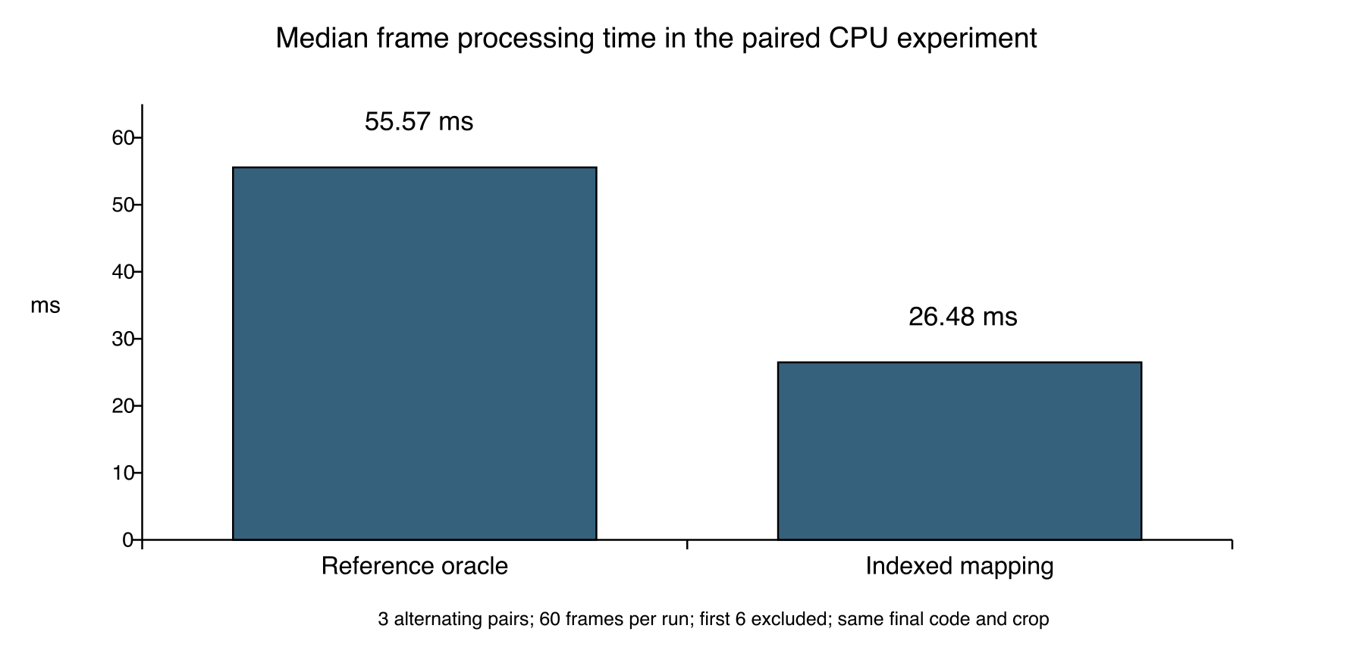
The indexed path has 52.34 percent lower measured frame time than the reference reconciliation path in the same final build. All paired controller-decision hashes match. This comparison isolates mapping choice and does not establish speedup over standard ViT or a production VLM.
Source: paired-serial/manifest.json and six paired JSONL traces.
Pair | Path | Frames | Mean ms | P95 ms | Page reuses | Top 1 agreement
1 | oracle | 54 | 55.570 | 58.799 | 294 | 100.0%
1 | indexed | 54 | 26.467 | 30.292 | 294 | 100.0%
2 | indexed | 54 | 26.484 | 30.436 | 294 | 100.0%
2 | oracle | 54 | 55.944 | 68.404 | 294 | 100.0%
3 | oracle | 54 | 55.347 | 59.913 | 294 | 100.0%
3 | indexed | 54 | 27.909 | 37.995 | 294 | 100.0%

The median of the three per-run mean frame times is 55.57 ms for the oracle and 26.48 ms for indexed mapping. The observed ratio is 2.10x, equivalent to 52.34% lower frame time in this experiment. All paired controller-decision hashes match, including page tiers, descriptors, readiness, correction actions, and source crop.

8.4 Full sequence validation and interpretation
Full serial generated video run
Measurement | Observed value
Frames ready / compared | 216 / 216
Page reuses / recomputed pages | 862 / 650
Patch K/V tokens reused | 24112
Top 1 agreement / mean absolute logit error | 100.0% / 0.00022324
Mean / P95 decoder plus processing time | 28.760 / 38.854 ms
Metadata fallback | 1.852% of frames
Peak tensor payload / peak validation input buffers | 150,528 / 150,528 bytes

These results demonstrate working reuse and an indexed-mapping improvement on this sample. They do not show a memory reduction for the whole model: validation buffers are additional, and the payload peak excludes model weights. They also do not establish a speedup over standard inference. In the full run, the baseline model and stored-K/V model times are separately recorded; earlier ViT blocks still execute.
The experiment has no task labels, confidence interval, thermal controls, power measurement, or external corpus. Top-1 agreement is only classifier consistency on these frames. Representative static/motion/scene-change videos and downstream quality tasks remain necessary before broader numerical assertions.
Meaning of agreement and memory figures
Top-1 agreement means that the stored-K/V classifier and standard classifier selected the same class on these generated frames. It is not task accuracy against ground truth. Tensor payload excludes weights, decoder buffers and Python overhead; the reuse validation buffer is additional memory. There is no measured whole-model memory-reduction claim.

8.5 Behavioral evidence from individual frames
The following observations come from the same serial trace. They link the claimed mechanism to a trigger, an executed action and a recorded outcome, rather than relying on the interface alone.
Frame and trigger | Recorded action | Observed outcome
1  No motion-vector metadata | Conservative T0 allocation; no history reused. | READY; 7 recomputed pages; 7 consumed pages; baseline top-1 agrees.
3  Quiet codec evidence | Codec descriptor places pages in T2; semantic feedback promotes pages 0, 5 and 6. | Three APPLIED corrections; final mapping 3 T0 and 4 T2 pages.
8  Static eligible features | All 7 pages retain origin generation 7 and rebind after current readiness. | 196 patch tokens reused; only 1 prefix token projected for K/V.
43  Origin age exceeded | window_expired for all 7 pages. | 0 reused; 7 refreshed. Nearby static frames resume reuse.
55  Moving phase begins | Exact final-block inputs reject 5 candidates; codec/temporal checks reject 2. | All 7 refreshed despite 5 pages passing the earlier eligibility filter.
163  Scene-cut phase begins | Missing metadata causes conservative fallback. | All 7 refreshed; no retained payload reused on the cut frame.

Every listed frame is READY and its baseline top-1 comparison agrees. A selected-record export retains the full descriptors, ready tokens, semantic actions and reuse provenance for inspection. Frame numbers identify processed generations in this fixed file run.

Figure 6 Running prototype with committed page residency
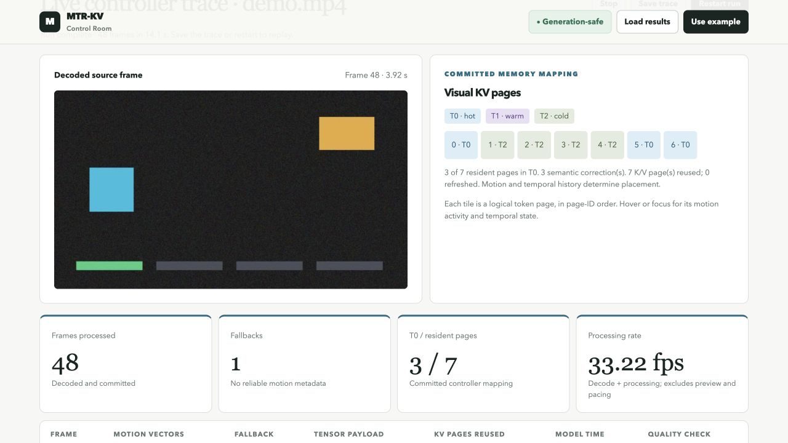
At frame 48 the actual dashboard shows the decoded input, seven logical pages, three T0 pages after semantic correction and seven reused K/V pages. The page tiles are logical token-page order, not object boxes. The displayed 33.22 fps is the inverse of this frame's decoder/processing time and excludes preview and pacing.
Source: Running local MTR-KV dashboard, 21 October 2026; unmodified prototype-video-and-pages.png. Screenshot session is separate from the serial benchmark.
How this view demonstrates the mechanism
The source pane establishes actual decoding. The committed page display exposes the controller result. Reuse counts come from tensor operations in the model-facing path, while the trace table compares the resulting classifier output with standard inference. The screenshot is corroborating visual evidence; the raw trace remains the primary numerical record.

Figure 7 Reuse and age bound visible in the frame table
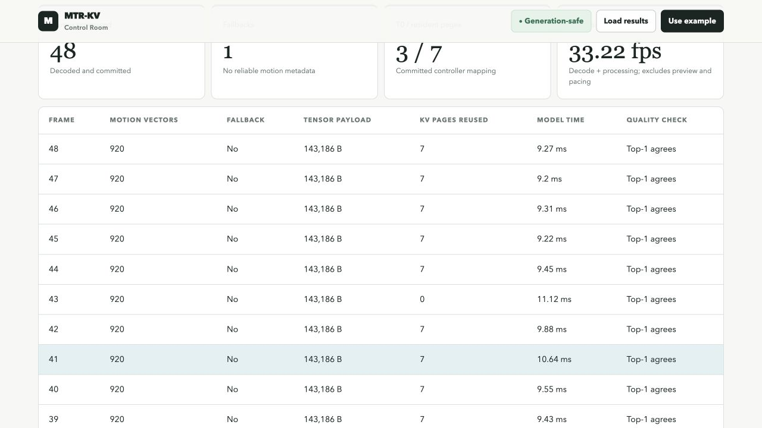
Frame 43 refreshes all pages at the configured age limit; neighboring static frames reuse seven pages. The displayed observations contain 143186 payload bytes, distinct from the run-wide peak. The quality column reports standard-model top-1 agreement.
Source: Running local MTR-KV dashboard, 21 October 2026; unmodified prototype-reuse-trace.png.
8.6 Semantic correction witness
Page | Codec activity | Attention proxy | Correction | Final tier
0 | 0.0 | 0.999979 | T2 to T0 | T0
5 | 0.0 | 0.889083 | T2 to T0 | T0
6 | 0.0 | 1.000000 | T2 to T0 | T0

Frame 3 contains a single codec ALLOCATE descriptor covering pages 0 to 6 in T2, followed by three APPLIED semantic corrections for the same generation. The final page records preserve T0 for pages 0, 5 and 6 and T2 for pages 1 to 4. Scores are normalized class-token attention proxies, not human-labeled importance.

8.7 Operating states captured from the running prototype
Figure 8 Missing metadata invokes conservative residency
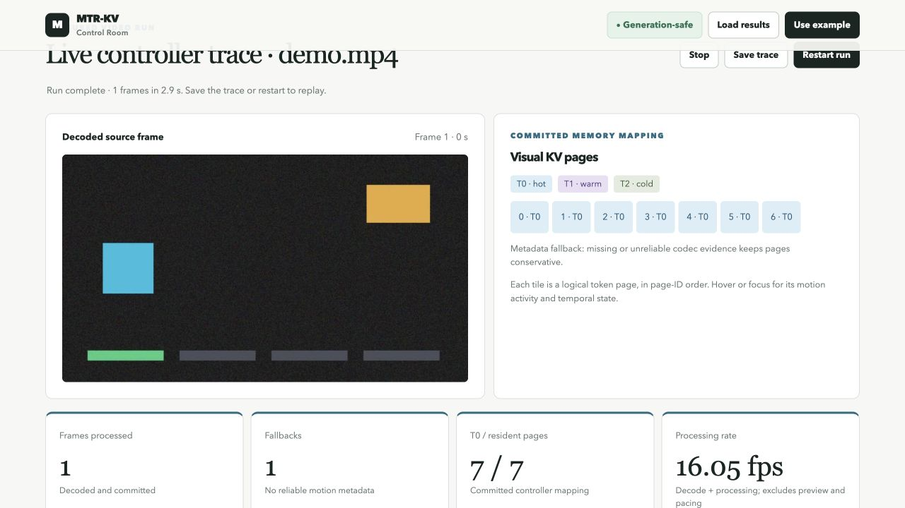
The actual decoder supplies zero motion vectors at frame 1. The controller returns READY with seven T0 pages, while K/V reuse remains zero and all seven pages are computed. Missing metadata is handled as uncertainty; it is not interpreted as a static scene.
Source: capture-through-1.jsonl, final generation 1; prototype-fallback-frame-1.png; capture-manifest.json.
Matching frame record | Observed value
status / metadata_fallback | READY / true
motion_vectors / pages_reused / pages_recomputed | 0 / 0 / 7
mapping / baseline comparison | 7 T0 pages, all ready / top-1 agrees

These screenshots are unmodified browser captures from three independent runs ending at the indicated generation. The capture helper observes the normal dashboard path and stores the exact records sent to the browser without preview JPEGs. Their controller decisions, semantic actions, page states and reuse provenance match the corresponding primary serial records. Displayed timing is an observation from the capture session, not a replacement benchmark.

Figure 9 Moving input rejects apparently reusable pages
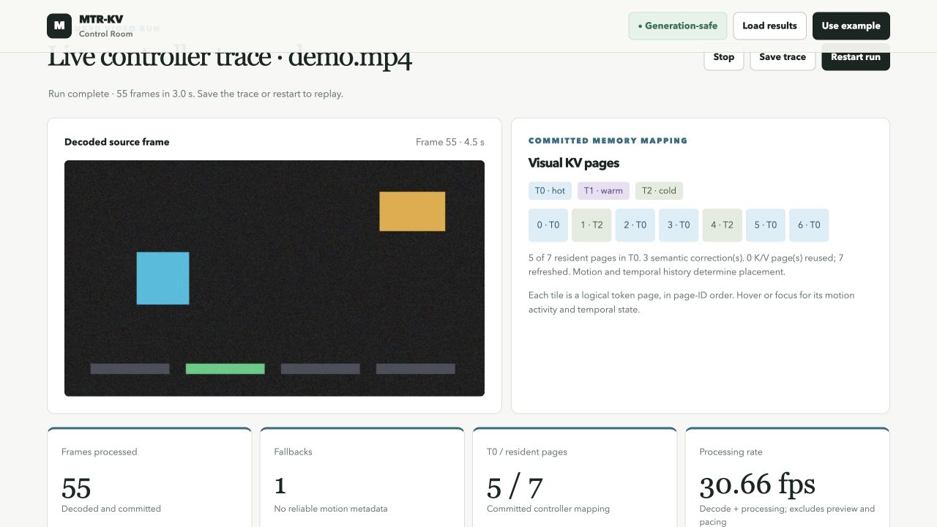
Frame 55 starts the moving-object phase. The interface shows zero reused pages, seven refreshed pages and five T0 pages after semantic correction. The matching record identifies why the candidates were rejected; low codec activity alone cannot authorize reuse.
Source: capture-through-55.jsonl, final generation 55; prototype-moving-frame-55.png; capture-manifest.json.
Matching frame record | Observed value
source_seconds / motion_vectors | 4.5 / 902
model_input_changed | 5 pages rejected after exact feature comparison
codec_or_temporal_invalidation | 2 pages rejected by earlier eligibility checks
pages_reused / pages_recomputed / top-1 | 0 / 7 / agrees

The five model-input rejections demonstrate the second validation stage in the implemented reuse contract. Unchanged local codec evidence can coexist with changed contextual features because earlier transformer attention is global. This example is evidence that the guard executed, not a count of detection accuracy on an external task.

Figure 10 Scene change discards retained payload eligibility
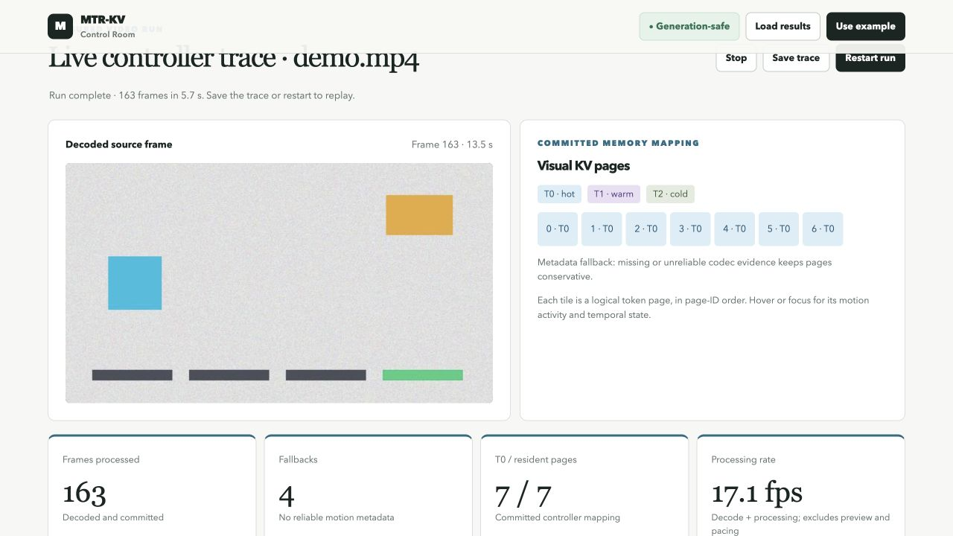
The source background changes at frame 163, at 13.5 seconds. The decoder exposes no usable motion vectors for that frame. Conservative fallback places all seven pages in T0, with zero pages reused and seven recomputed. The displayed cumulative fallback count is four; that count includes earlier frames.
Source: capture-through-163.jsonl, final generation 163; prototype-scene-cut-frame-163.png; capture-manifest.json.
Matching frame record | Observed value
status / metadata_fallback / motion_vectors | READY / true / 0
reuse rejection reason | codec_or_temporal_invalidation for all 7 pages
pages_reused / pages_recomputed | 0 / 7
actual tensor payload / baseline top-1 | 150528 bytes / agrees

The phase boundary is defined by the controlled source generator. This observation shows safe processing of that cut through fallback; it does not establish a general scene-cut detector or a measured scene-change recall rate.

8.8 Feature to code test and evidence map
Each row identifies an implemented mechanism, an executable entry point, a regression case and an observation in the supplied evidence. Code modules are under mtr_kv and regression files under tests in the archived code directory. Function names are exact source identifiers. The 128-pass JUnit report is the common test record.
Feature | Code entry point | Regression evidence | Run or figure evidence
Source crop and page geometry | vision_feedback.py  source_crop  mtre.py  reconcile_optimized | test_geometry.py  test_model_center_crop_maps_token_bounds_to_actual_source_window  test_mtre_optimized_matches_oracle | Figure 2  source_crop in all frame records; paired decision hashes match
Generation checked readiness | controller.py  Kmc.apply  _generation_check  _allocate | test_memory_generation.py  test_stale_descriptor_rejected  test_ready_implies_committed  test_exhaustion_preserves_old_mapping_and_ready_state | ready_tokens and apply_statuses in each captured frame; reservation failure is covered by tests
Same generation semantic correction | live.py  LiveController.semantic  semantic.py  Srce.evaluate | test_live.py  test_live_semantic_feedback_promotes_current_quiet_page | Generation 3  pages 0, 5, 6: T2 to T0  Section 8.6
Actual tiered tensor access | tensor_store.py  TorchKVStore.put / get  sync_tiers | test_tensor_store.py  test_tensor_store_roundtrip_real_payloads  test_tier_sync_does_not_count_spurious_reads | kv_consumed_pages=7; actual tensor_storage fields in live and serial traces
Exact input reuse and age bound | vision_feedback.py  _reuse_attention_kv  tensor_store.py  reuse | test_kv_reuse.py  test_changed_model_input_is_recomputed_despite_zero_codec_motion  test_window_refreshes_old_origins | Figure 9  5 changed-input rejections; generation 43 window_expired; generation 8 reuse
Metadata fallback | video.py  run_video  live.py  LiveController.frame | test_reference_cases.py  test_T08_missing_metadata_fallback | Figures 8 and 10; original VP8 natural-video run uses fallback on every frame
Synchronized dashboard and USB transport | dashboard.py  DashboardHandler  phone.py | test_dashboard_server.py  test_dashboard_streams_synchronized_decoded_preview  test_phone.py  test_phone_live_pipe_decodes_vectors_and_cleans_up | Figures 6 to 10 show actual local dashboard. Physical Android hardware remains untested.

Controller tests and simulator race cases establish software behavior within their tested scope. They do not certify hardware atomicity, general model quality, or patent novelty. The Python prototype retains one final ViT attention block as its model-facing embodiment.

8.9 Natural scene video validation
Figure 11 Decoded natural scene used for the additional check

An actual decoded frame from the H.264 derivative of Big City Life, showing pedestrians in an urban scene. This is input imagery, not a dashboard screenshot or a generated scene.
Source: Coverr, Big City Life, 2015, Wikimedia Commons, CC0 1.0, reference R14. Derived input and conversion provenance are supplied.
We evaluated the complete original 1920 by 1080 VP8 file and a 640 by 360 H.264 derivative sampled at 12 fps with audio omitted. The derivative uses libx264, CRF 20, medium preset, GOP 48 and no B frames. The original SHA-1 matches the checksum listed on Commons; SHA-256 values and sampled source timestamps are recorded in natural-video-provenance.json. Both runs use the same final-block ViT, stored-K/V, reuse and baseline-comparison options as the controlled run.
Observation | Original VP8 | H264 derivative
Frames ready / compared | 356 / 356 | 171 / 171
Metadata fallback | 100.00% | 11.11%
Pages reused / recomputed | 0 / 2492 | 0 / 1197
Classifier top1 agreement | 356 / 356 | 170 / 171
Mean absolute logit error | 0.00004438 | 0.00171237
Mean decoder plus processing ms | 31.61 | 28.57

The original decoded successfully with conservative fallback because no motion-vector side data was exposed. The H.264 derivative exposed motion evidence, but continuous scene change and exact feature validation produced zero reuse hits. Frame 124 at 10.25 seconds had one classifier disagreement, with mean absolute logit error 0.00412252. No causal ablation was performed to isolate which representation difference changed its ranking. This single convenience sample has no task labels or representativeness guarantee. It demonstrates compatibility and limitations, not an accuracy or reuse benefit across natural videos.
The timing columns describe different encodings, resolutions and frame counts. They are observations from single runs, not a controlled codec comparison or an optimization speedup measurement.

8.10 Verification and evidence traceability
The optimized build passed 128 automated tests. The saved text report and JUnit XML record 128 passes and no failures. Tests cover controller behavior, adversarial ordering, semantic correction, geometry, actual tensor representations, model consumption, temporal reuse, encoded video, local HTTP streaming, and the simulated USB camera transport.
Safety or correctness case | Evidence entry point
Stale ownership, duplicate descriptors, reservation failure preservation | tests/test_memory_generation.py and tests/test_race.py
Pixel crop bounds and exact indexed/oracle output equality | tests/test_geometry.py
Quiet codec evidence with changed final-block features | tests/test_kv_reuse.py
Intra frames, missing metadata, generation gaps, age expiry | tests/test_kv_reuse.py and tests/test_live.py
Actual fp16/int8/compressed tensor round trips and tier migration | tests/test_tensor_store.py
Full model/decoder reuse and observed classifier comparison | tests/test_video.py
USB transport cleanup and exclusive browser sessions | tests/test_phone.py and tests/test_dashboard_server.py

The randomized geometry regression includes mixed valid/invalid blocks, out-of-bounds rectangles, different tile counts, duplicate observations, page persistence, and full token/page equality. Raw compressed fp16 tests include scalar, empty, two-dimensional, and three-dimensional tensors. These checks support software behavior; they do not prove physical-device atomicity or formal RTL correctness.
Evidence package contents
MTR_KV_Frozen_Evidence_v1_0.zip contains the controlled and natural-scene source inputs, full serial and paired traces, evaluations, test text/XML, five authentic UI screenshots, matching capture records, source/configuration snapshots, references, conversion provenance and a SHA-256 manifest. The archive includes this version of the disclosure. A verification script checks hashes; they identify bytes, not a trusted timestamp or independent certification.
The code snapshot includes uncommitted Python modules because the working tree was not clean. The package therefore preserves exact source bytes rather than implying that Git HEAD alone identifies this build. Environment versions and the dirty-tree state are recorded. The original frozen architecture remains a separate design record.
Selected behavior records are supplied as MTR_KV_Implementation_Records.json with the source trace path and SHA-256. The final document has been checked against those records. The underlying trace, paired comparisons, input and test reports are preserved in the existing evidence archive.
Implementation status and operating limits
The implemented scope is encoded video, actual final-block K/V consumption, generation checks, semantic correction, bounded reuse, a local dashboard and a software-tested Android USB adapter. A physical Android trial and scrcpy/ADB setup remain pending. Generic browser upload, arbitrary-codec success, all-layer VLM processing and real-time performance across devices are not established.

8.11 Reproducing the demonstration
How to inspect the same behavior
.venv/bin/python -m mtr_kv dashboard results/demo.mp4 \
--semantic-model --kv-inference --kv-reuse \
--compare-baseline --max-frames 48 --port 8768
Open http://127.0.0.1:8768 and restart the run. Hover or focus a page tile to inspect its temporal state and activity. Load a simulator artifact separately only when comparing simulated strategies; it is not the source of the measured live cards.
Evidence locations and entry points
Local evidence | Purpose
paired-serial/manifest.json | Input hash, settings, six trace hashes, per-run metrics, decision hashes, and median ratio.
paired-serial/repeat-N-PATH.jsonl | All raw measured frames from each paired run.
full-demo-serial.jsonl and evaluation JSON | Complete generated four-phase run and machine summary.
test-results.txt and test-results.xml | 128 passing tests and machine-readable test outcomes.
prototype-video-and-pages.png and prototype-reuse-trace.png | Unmodified screenshots captured from the live local browser.
source snapshot and manifest.json | Exact Python, tests, configuration, frontend, requirements, and SHA-256 inventory.

Measurements live under results/optimization-20261021 in the working project and are copied into the evidence archive. The verify_evidence.py script checks every listed SHA-256 digest after extraction. No network upload is required to inspect the prototype or evidence.
Source entry points: mtr_kv/mtre.py for reconciliation; controller.py for transactions; live.py for frame and correction coordination; tensor_store.py for actual K/V storage and rebinding; vision_feedback.py for preprocessing and attention integration; video.py for decoding and records. Reproduction requires the dependencies and cached or downloaded model weights.

9 Aspects of the invention for which protection is sought
Protection is requested for the specific coordinated controller arrangement, subject to professional prior-art and enablement review. The following are technical topics for claim drafting, not final legal claims.
9.1 Coordinated codec intent readiness and correction
A processing system receives compressed-video change metadata before the relevant model attention; reconciles source regions with actual visual-token and page geometry; uses temporal and confidence state to issue a generation-tagged page-range and tier descriptor; validates, reserves, prepares, commits, and signals readiness before use; and applies later model-derived page-importance correction through the same generation-checked controller path.
9.2 Failure preservation and qualified temporal reuse
A method preserves the active mapping on failed replacement reservation, rejects stale or duplicate operations, and ties access to a current-generation readiness result. A temporal reuse method retains actual page K/V only when codec/temporal eligibility and exact model-input identity both hold, checks controller/model/geometry ownership and an origin-age bound, and rebinds retained content after the replacement generation is ready. Otherwise the page is recomputed.
9.3 Supporting geometry and generation relationships
Candidate dependent topics include inverse crop/resize mapping; conservative mixed-evidence aggregation; missing-metadata fallback; distinct confidence and activity signals; current-generation low-motion/high-attention promotion; page-span coalescing; explicit source and origin generations; and representation migration without age renewal. The implemented descriptors, predicates, failure cases, and measurements provide details for narrower drafting.
9.4 Technical boundary of the proposal
Motion vectors, thresholds, spatial indexing, paging, quantization, compression, attention-derived importance, generic transactions, and KV reuse are established techniques. The Android camera adapter, dashboard, compact serialization, and faster Python mapping are implementation conveniences, not the principal proposed invention. The searches reviewed here do not establish that the proposed combination is absent from earlier art or non-obvious.
Hardware media engines, asynchronous FIFOs, physical tier banks, GPU page-table publication, and all-layer VLM windows are proposed extensions. Their claim breadth requires a separately enabling design and inventor confirmation. A Python fence counter must not be described as a fabricated or tested hardware fence.
9.5 Relationship of the implemented evidence to the proposal
The software establishes a concrete embodiment of the control relationship: frame records show codec tier intent, a current-generation readiness result, actual stored tensor consumption and model-derived correction. Reuse provenance records source and origin generations separately. The examples and tests support narrower technical drafting; they do not determine whether a proposed claim is novel or non-obvious over the cited combinations.

References and reviewed source locations
R1 Kwon et al. Efficient Memory Management for Large Language Model Serving with PagedAttention. arXiv:2309.06180v1, 12 Sep 2023; SOSP 2023. Methods sections 4.1-4.4.
https://arxiv.org/html/2309.06180v1
R2 Zou et al. CodecSight Leveraging Video Codec Signals for Efficient Streaming VLM Inference. arXiv:2604.06036v4, 15 Sep 2026; first submitted 7 Apr 2026. Sections 3.3-3.5.
https://arxiv.org/html/2604.06036v4
R3 Sarkar et al. CoPE-VideoLM Leveraging Codec Primitives For Efficient Video Language Modeling. arXiv:2602.13191v2, 30 Mar 2026; first submitted 13 Feb 2026. Section 3.
https://arxiv.org/html/2602.13191v2
R4 Zhang et al. RESUME Recurrent State Updates from Motion and Residual Signals for Efficient Video Language Modeling. arXiv:2609.39563v1, 30 Sep 2026. Section 3.
https://arxiv.org/html/2609.39563v1
R5 Zhang et al. H2O Heavy-Hitter Oracle for Efficient Generative Inference of Large Language Models. arXiv:2306.14048v3; first submitted 24 Jun 2023.
https://arxiv.org/abs/2306.14048
R6 Li et al. SnapKV LLM Knows What You are Looking for Before Generation. arXiv:2404.14469v2; first submitted 22 Apr 2024.
https://arxiv.org/abs/2404.14469
Source access date: 21 October 2026. Descriptions are paraphrases. Source performance numbers are not transferred to MTR-KV and are not used as proof of this prototype's performance.
R14 Coverr. Big City Life. 2015. Wikimedia Commons source file and license record. Listed as CC0 1.0 Universal; original VP8 duration 14.24 seconds, 1920 by 1080. Accessed 21 October 2026. Natural-video checks are reported in Section 8.9.
Big City Life source and license record

References continued and disclosure record
R7 US6072548A. Video decoder dynamic memory allocation system and method allowing variable decoded image size. Published 6 Jun 2000.
https://patents.google.com/patent/US6072548A/en
R8 US20100098165A1 / US8300697B2. Dynamic motion vector analysis method. Published application 22 Apr 2010; grant publication 30 Oct 2012.
https://patents.google.com/patent/US8300697B2/en
R9 US20250124105A1. Efficient token pruning in transformer-based neural networks. Published 17 Apr 2025. Reviewed claim 1 and related description.
https://patents.google.com/patent/US20250124105A1/en
R10 US20250225134A1. Key-value cache management system for inference processes. Published 10 Jul 2025. Reviewed claim 1 and pointer/reservation description.
https://patents.google.com/patent/US20250225134A1/en
R11 US20260080217A1. Key-value cache compression based on gauge transformation. Published 19 Mar 2026. Reviewed claims 1-4 and hot/cold description.
https://patents.google.com/patent/US20260080217A1/en
R12 Indian Patents Act 1970, Section 10. Contents of specifications. Official IP India text, accessed 21 Oct 2026.
https://ipindia.gov.in/acts/patent-act-1970/section-10
R13 WIPO. Frequently Asked Questions on Patents, including novelty and public-disclosure timing. Accessed 21 Oct 2026.
https://www.wipo.int/en/web/patents/faq_patents
Search expressions: motion vector transformer KV cache page table; codec metadata descriptor memory controller attention; video decoder semantic cache correction generation; visual token page residency motion residual; KV cache generation motion controller; and attention-guided retention. No-result or broad-result queries are not treated as evidence that an element is absent from prior art.
Disclosure and contributors
The frozen architecture dated 22 September 2026 records Kunwar Shaurya Pratap Singh, Kanan Tayal and Suhani Gupta, B.Tech CSE AI and Data Engineering, VIT Vellore. Contributor names are a design record; legal inventorship, ownership and applicant details require confirmation. The user reported no known earlier public posting, presentation, submission or patent filing on 21 October 2026. Engineering dates and hashes are not patent priority dates.

Invention Disclosure Format (IDF)-B | Document No. | 02-IPR-R003
 | Issue No/Date | 2/01.02.2024
 | Amd. No/Date | 0/00.00.0000
10 Technology readiness level of the invention
TRL 3 is selected for the demonstrated software mechanism as an experimental proof of concept. The executable prototype processes real encoded video, commits generation-safe page mappings, consumes actual tiered K/V tensors and applies semantic correction. Section 8 supplies the method, measurements, screenshots, frame witnesses and reproducibility records.
This self-assessment applies to the disclosed architecture as a whole. Some software components have local laboratory validation, but physical GPU/RTL integration, full VLM processing and physical-phone operation have not been demonstrated. A user interface alone is not the basis for the selection.
Evidence date: 21 October 2026. Scope: controlled CPU software proof of concept. Faculty certification is not asserted.
Research |  |  | Development |  |  | Deployment
TRL 1 | TRL 2 | TRL 3 | TRL 4 | TRL 5 | TRL 6 | TRL 7 | TRL 8 | TRL 9
Basic | Technology | Experimental | Technology | Technology | Technology | System | System | Actual system
Principles | concept | proof of | validated in | validated in a | demonstrated | prototype | complete | proven in an
observed | formulated | concept | a lab | relevant | in a relevant | demonstration | and | operational
 |  |  |  | environment | environment | in an | qualified | environment
 |  |  |  | (industrially | (industrially | operational |  | (competitive
 |  |  |  | relevant in | relevant in | environment |  | manufacturing
 |  |  |  | case of key | case of key |  |  | in case of key
 |  |  |  | enabling | enabling |  |  | enabling
 |  |  |  | technologies) | technologies) |  |  | technologies,
 |  |  |  |  |  |  |  | or in space )
 |  | [X]
Selected column: TRL 3. Inventor contributions, institutional rights, prior-disclosure history and final claim scope should be confirmed with VIT IPR and TT Cell before submission. The present record is an invention disclosure for review; it does not constitute a patent-office filing.
END OF THE DOCUMENT

