Stress Level Detection from Lifestyle Data
Machine Learning Classification Mini Project
Name: ______________________________
Roll No. / Class: ______________________________
Course / Subject: ______________________________
Instructor: ______________________________
Date: ______________________________

1. Problem Definition
Stress affects academic performance, sleep and overall wellbeing, yet many people do not notice how their daily habits contribute to it. This project builds a machine learning classifier that predicts a person's stress level from everyday lifestyle information.

1.1 Objective
To build and evaluate a supervised classification model that predicts stress level from lifestyle habits, and to identify which habits contribute most to the prediction.

1.2 Target classes
- Low - the person shows few signs of stress.
- Medium - moderate stress.
- High - high stress.

1.3 Input features
Feature | Type | Description
age | Numeric | Age in years
gender | Categorical | Male / Female / Other
sleep_hours | Numeric | Average hours of sleep per night
screen_time_hours | Numeric | Daily screen time in hours
caffeine_cups | Numeric | Cups of tea/coffee/energy drinks per day
exercise_min_per_week | Numeric | Minutes of exercise per week
study_work_hours | Numeric | Daily study or work hours
social_hours_per_week | Numeric | Hours spent socialising per week
diet_quality | Categorical | Poor / Average / Good

2. Dataset Selection and Preprocessing

2.1 Dataset
The dataset contains 1,500 records and 10 columns (9 features plus the target). It is a synthetic dataset that simulates survey responses about lifestyle habits. Stress level is derived from the habits (less sleep, more screen time, more caffeine, longer work hours, less exercise, less social time and poorer diet increase stress) plus random noise to imitate real human variation. About 4% of values in four columns were deliberately left missing to mimic an incomplete survey.
Note: if you replace this dataset with your own survey data, update this section with the data source, number of respondents and how stress was recorded.
The target classes are reasonably balanced: Medium 600, Low 525 and High 375 records, so no resampling was needed.
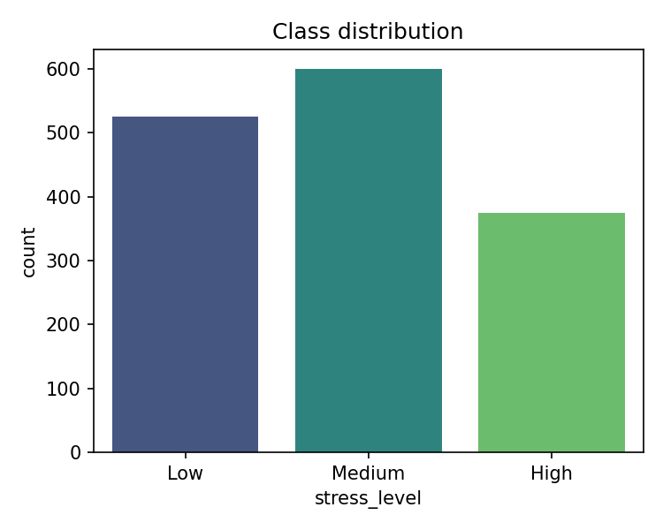
Figure 1: Class distribution of the target variable

2.2 Preprocessing steps
- Missing values: numeric columns were filled with the median and categorical columns with the most frequent value.
- Encoding: gender and diet_quality were converted to numeric form using one-hot encoding.
- Scaling: numeric features were standardised (mean 0, standard deviation 1), which matters for Logistic Regression, KNN and SVM.
- Train/test split: 80% training (1,200 records) and 20% testing (300 records), stratified so each class keeps its proportion, with a fixed random seed of 42.
- No data leakage: all preprocessing steps are placed inside a scikit-learn Pipeline, so imputation and scaling statistics are learned from the training data only.
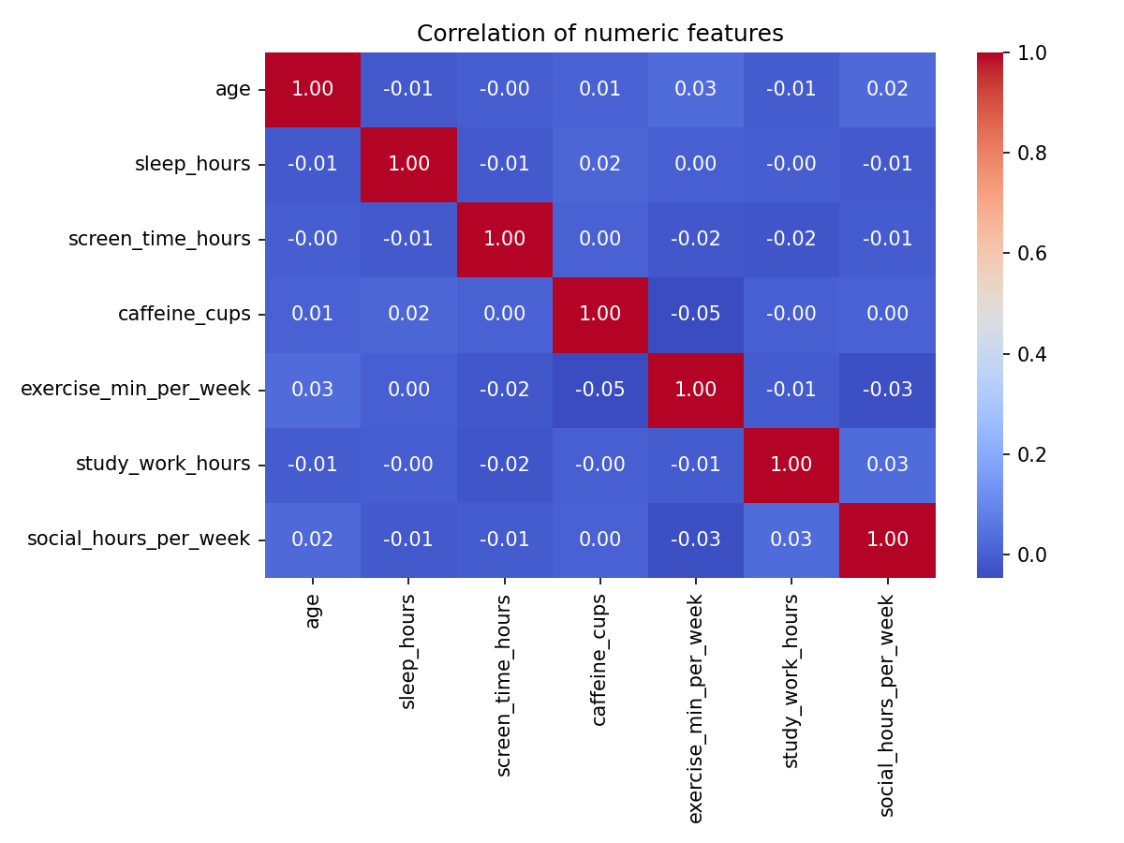
Figure 2: Correlation between numeric features

3. Model Selection and Implementation
Four classification algorithms from the suggested list were implemented and compared, so that the choice of final model is based on evidence.
Algorithm | Why it was chosen
Logistic Regression | Simple, fast, interpretable baseline for multi-class problems.
Random Forest | Ensemble of decision trees; handles non-linear relationships and gives feature importance.
K-Nearest Neighbors (k=7) | Distance-based method that classifies by similarity to nearby people.
Support Vector Machine (RBF) | Finds a flexible boundary between classes; strong on medium-sized data.

Each model was trained inside the same pipeline on the same training data, so the comparison is fair. The implementation uses Python with pandas, scikit-learn, matplotlib and seaborn.

4. Model Evaluation
Models were evaluated on the unseen test set using accuracy, macro-averaged precision, recall and F1-score, plus 5-fold cross-validation F1 on the training data. Macro averaging gives each class equal weight, so the smaller High class is not hidden by the larger classes.
Model | Accuracy | Precision | Recall | F1 | CV F1 (5-fold)
Logistic Regression | 0.760 | 0.777 | 0.751 | 0.760 | 0.742
Random Forest | 0.707 | 0.734 | 0.699 | 0.711 | 0.688
KNN | 0.630 | 0.640 | 0.626 | 0.632 | 0.612
SVM | 0.733 | 0.755 | 0.727 | 0.738 | 0.720

Best model: Logistic Regression (F1 = 0.760), also the best in cross-validation, which suggests the result is not a lucky split.

4.1 Per-class performance (Logistic Regression)
Class | Precision | Recall | F1-score
Low | 0.81 | 0.83 | 0.82
Medium | 0.68 | 0.76 | 0.72
High | 0.83 | 0.67 | 0.74

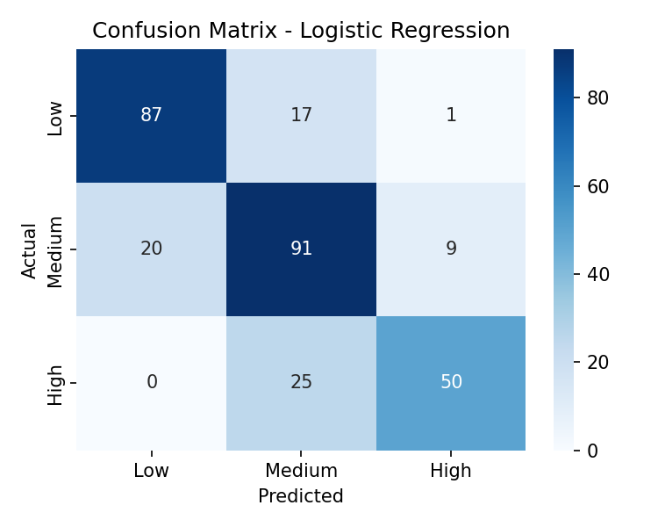
Figure 3: Confusion matrix of the best model on the test set

5. Results and Interpretation

5.1 Findings
- Logistic Regression performed best (76% accuracy), followed by SVM (73%), Random Forest (71%) and KNN (63%). Because stress in this data increases or decreases fairly steadily with each habit, a linear model suits it well. KNN did worst, probably because distances become less meaningful when several noisy features and one-hot columns are mixed.
- Medium is the hardest class. Medium sits between Low and High, so most mistakes are between neighbouring levels rather than between Low and High.
- High stress is the most under-detected class: its precision is high (0.83) but recall is 0.67, so about one in three high-stress people is predicted as a lower level. For a wellbeing application, missing a high-stress person is the more costly error.

5.2 What drives stress?
Random Forest feature importance ranks sleep hours first (0.24), followed by exercise per week (0.17), study/work hours (0.14), screen time (0.13) and social time (0.10). Age, gender, caffeine and diet had smaller influence. This agrees with the common view that sleep and physical activity are major factors in managing stress.
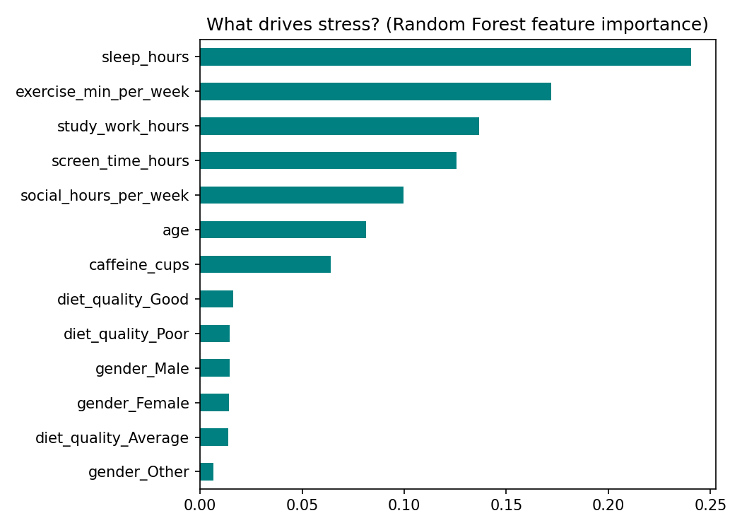
Figure 4: Feature importance from the Random Forest model

5.3 Limitations
- The dataset is synthetic. The relationships between habits and stress were built into the data, so the feature rankings show what the generator assumed and should not be treated as scientific findings. Real survey data would be needed to draw real conclusions.
- In real data, stress would be self-reported and subjective, which adds noise and bias.
- The model sees only lifestyle habits. Real stress also depends on health, relationships, finances and many other factors that are not captured.
- Accuracy of about 76% is moderate, and the model should not be used for any real diagnosis or decision about a person.

5.4 Possible improvements
- Collect real survey data from students and retrain the model.
- Tune hyperparameters with grid search and try gradient boosting.
- Use class weights or a lower decision threshold to improve recall on the High class.

6. Code Quality and Project Demonstration
The code is organised into numbered sections (data, EDA, preprocessing, models, evaluation, interpretation, saving) with comments, uses a fixed random seed for reproducibility, and is provided both as a Python script and as a Jupyter notebook. The trained model is saved with joblib.

6.1 Demonstration
- Streamlit app (app.py): the user sets sliders for sleep, screen time, caffeine, exercise, work and social time, picks gender and diet, and clicks Predict to see the predicted level with class probabilities.
- Offline web demo (stress_detector_prototype.html): a standalone page that runs the same Logistic Regression model in the browser, updating the prediction live as sliders move. It shows which habits push the prediction.
Example: a person sleeping 4.5 hours with 10 hours of screen time, 5 cups of caffeine, no exercise, 11 work hours, little social time and poor diet is predicted as High stress. A person with 8 hours of sleep, 250 minutes of exercise, 5 work hours and good diet is predicted as Low.

6.2 How to run
- Install requirements: pip install -r requirements.txt
- Train and evaluate: python stress_detection.py
- Launch the app: streamlit run app.py (or double-click run_app.bat on Windows)

7. Conclusion
This project built a classifier that predicts Low, Medium or High stress from nine lifestyle features. After imputing missing values, encoding and scaling the data, four algorithms were compared; Logistic Regression performed best with 76% accuracy and a macro F1-score of 0.76. Sleep and exercise were the most influential factors. The main limitations are the synthetic data and the weaker recall on the High class, which real data collection and model tuning could address in future work.

Appendix: Mapping to the Assessment Rubric
Criterion | Marks | Where covered
Problem Definition | 1 | Section 1: objective, target classes, features
Dataset Selection and Preprocessing | 2 | Section 2: dataset, missing values, encoding, scaling, split
Model Selection and Implementation | 2 | Section 3: four algorithms implemented and compared
Model Evaluation | 2 | Section 4: accuracy, precision, recall, F1, cross-validation, confusion matrix
Results and Interpretation | 1 | Section 5: findings, feature importance, limitations
Code Quality and Demonstration | 2 | Section 6: commented code, notebook, Streamlit app, offline demo
Total | 10

