

MEET THE FELLOWS

2023 – 2024

Rachel Beauregard

Internship: MJHS Hospice and Palliative Care
New York, NY

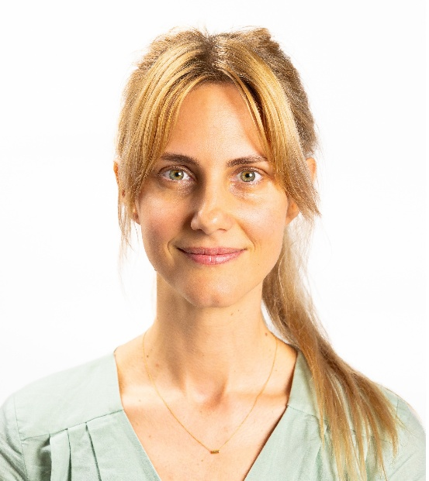
Working in end-of-life care has been something that I have wanted to do for a very long time. It brought me to study social work when I first moved to the United States from France. After graduating with my Bachelor of Social Work, I contacted the Fordham University Graduate School of Social Service Office of Admissions and learned, to my astonishment, about the Palliative Care Fellowship. This was when I ultimately chose to pursue my master's degree at Fordham University.

After being accepted into the Fellowship, I received the delightful news of being offered a field placement at MJHS Hospice and Palliative Care. After the first semester of working exclusively with an adult population, I transitioned to the pediatric team in the second semester. Having the opportunity to work in the pediatric hospice field was a request of mine, and I am extremely grateful to MJHS for having trusted and supported me as an intern in working with this vulnerable population. During my internship, I have learned to create a strong therapeutic alliance with my patients and their families by offering a safe space, allowing them to express their fears, feelings, and emotions freely, and slowly moving towards more acceptance of their present situation while emphasizing their quality of life. I also developed skills in providing emotional support through grief and pre-bereavement counseling. I have learned to navigate the services and resources available to my patients. I liked seeing patients in their environments (whether their home, a nursing home, assisted living, or other type of residence) and providing patient-centered care. I also enjoyed working closely with the Hospice Interdisciplinary Team and forming close relationships to provide the best end-of-life care.

Looking back on this past year, I now recognize the reciprocal and transformative nature of this work and appreciate the huge privilege of being part of the Palliative Care Fellowship. I felt supported every step of the way, not only at an academic and professional level, but also emotionally. Being surrounded by the other Fellows with like-minded values, receiving mentorship, professional guidance, and educational opportunities was beneficial and comforting for my goals and trajectory.

I am ready and excited to begin a meaningful career in hospice and palliative care. I will be forever grateful to my husband, co-Fellows, mentors, supervisors, patients, and their families for their time, trust, and kindness.

Fortunata Campbell

Internship: Westchester Medical Center, Palliative Care Service
Valhalla, NY

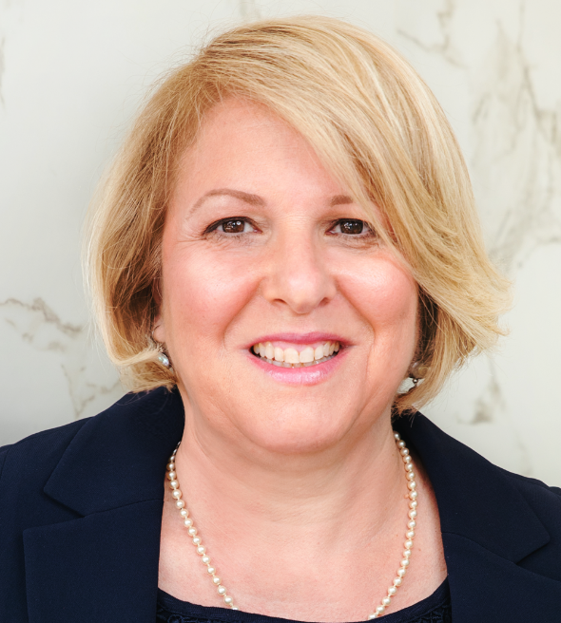
My interest in Palliative Care spans many years. Social work is a second career for me. I had been on a quest, since working as an accountant in midtown Manhattan, for an opportunity to use my innate social work skills of empathy and compassion to make a difference in the lives of others. After years of caregiving for my four sons, my parents, and in-laws, I decided the best use of my talents was social work. Fordham University was the only graduate school that I considered because of the Palliative Care Fellowship. I feel blessed to be selected for this very competitive program.

My internship was at Westchester Medical Center (WMC) in Valhalla, NY. I am the first Palliative Care intern on their inpatient Palliative Care Service. While at WMC, I learned how to introduce patients and families to palliative care and dispel misunderstandings. I learned how to conduct psychosocial assessments and provide psychosocial support to those with life-limiting illnesses and their families. I attended family meetings and made valuable contributions to the Palliative Care Team. I am especially grateful for the support of Adam Schoenfarber, my field instructor, and to the doctors, nurses, social workers, and chaplains on the team. They encouraged me and were vested in my learning. I was able to shadow a pediatric oncology social worker, which was important to me because of my interest in working in pediatric palliative care.

The Palliative Care Fellowship was invaluable in helping me to obtain the skills necessary to enter this field. I appreciate the guidance from our Fellowship Director, Dr. Berkman and her assistance in preparing my resume and refining personal statements for jobs and post-graduate fellowships. The workshops in the Fall and Spring presented by palliative social work experts were great experiences. I also enjoy our monthly lunches with Dr. Berkman and the other Fellows. The gift of five colleagues to support and learn with and from during the Fellowship year was one of the highlights of the Fellowship. The Palliative Care Fellowship has provided me with the skills I need to be successful in my career as a palliative social worker. I am grateful to Dr. Berkman, Brian and Kathy MacLean (our scholarship donors) and to Fordham University Graduate School of Social Service for this extraordinary opportunity.

Renata Eski

Internship: Bennett Cancer Center
Stamford, CT

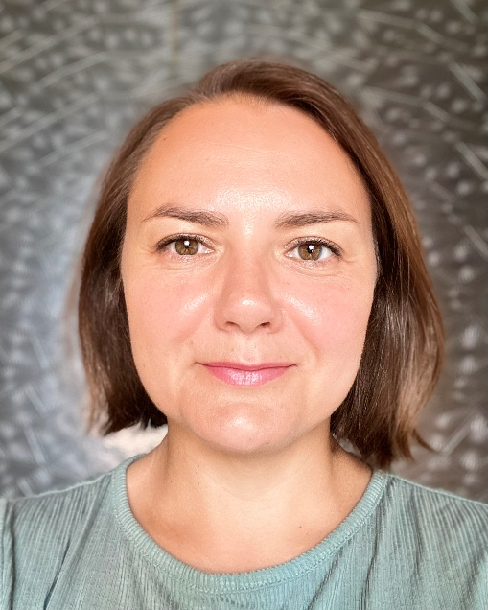
I was drawn to palliative social work due to my firsthand experiences when my father was diagnosed with terminal cancer. I witnessed the impact his diagnosis had on my family and the effect that lack of support had on us. I saw a great need for support that extends way beyond medical treatment. I saw how being diagnosed with a life-altering illness can profoundly impact a person’s life, and I knew I would love to go into the social work field where I could support patients and their families as they navigate their journey. Witnessing firsthand the complexities of navigating a cancer diagnosis fueled my passion to make a difference in the lives of others facing similar challenges.

Once I discovered that Fordham University Graduate School of Social Service has a Palliative Care Fellowship, I knew I wanted to be part of it. I was very grateful to learn I had been selected for this Fellowship. As a Fellow, I learned so much about palliative care and especially oncology social work. I took two courses directly connected to palliative care, providing me with specialized training in this field. As Palliative Care Fellows, we received tremendous support from the Fellowship Director, Dr. Cathy Berkman, our Field Advisor, Dr. Sarah Wichman, and professors who are leaders in the field of palliative care and have great passion for this work.

I was placed at the Bennett Cancer Center in Stamford Hospital for my internship this year. We supported patients undergoing chemotherapy and radiation treatments. I met with patients as they started treatment and provided them with ongoing support throughout. During my internship, I provided one-on-one counseling sessions, family support, helped the patients navigate any practical concerns, and connected them to resources. I engaged with patients from diverse cultural and socioeconomic backgrounds. I gained a deep appreciation for the multifaceted challenges patients face during cancer treatment. I am profoundly grateful for the invaluable experiences, mentorship, and opportunities for growth that I received at the Bennett Cancer Center.

My Fellowship experience equipped me with the knowledge, skills, and confidence to continue making a meaningful difference in the field of palliative care and oncology social work, guided by the principles of compassion, dignity, and respect. I am profoundly grateful to have been a part of this Fellowship.

Molly McCullen

Internship: Bellevue Hospital, Palliative Care Service
New York, NY

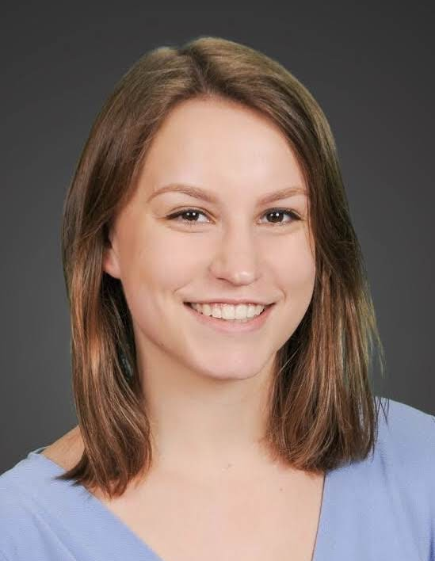
I am deeply honored and grateful to have had the opportunity to participate in the Palliative Care Fellowship this past year. In my first year at Fordham University Graduate School of Social Service, I weighed carefully if and how I wanted to proceed with the jump to palliative social work. While I always had a deep interest in working with seriously ill individuals and their families, I did not know how the experience of working in an acute care setting and being present in difficult and important conversations around goals of care and bereavement would be for me. I am so grateful I decided to apply for the Palliative Care Fellowship. The experience was extremely valuable and rewarding and I felt supported by Dr. Berkman, my cohort of fellows, and our academic adviser through the entire process.

I completed my internship at Bellevue Hospital on the inpatient oncology service and out-patient palliative care during the Fall semester and on the inpatient palliative care consult service in the Spring semester. I cannot think of a better internship opportunity. I provided emotional support to patients and families contending with the challenges of serious illness, hospitalization, and end-of-life. I helped facilitate goals of care discussions with our interdisciplinary team of nurse practitioners, doctors, social workers, and chaplains. I helped patients consider and complete advance directives and helped families navigate resources and the healthcare system.

I found the process of working with patients and families to be enriching, especially within the New York City public healthcare system. Interning at Bellevue provided an opportunity to work closely with families from diverse backgrounds, addressing their unique needs, implementing culturally competent interventions, and, at times, acting as an advocate. This experience not only deepened my understanding of serious illness and palliative care, but also strengthened my understanding and commitment to social justice and healthcare equity.

Thanks to my experience at Bellevue and the unwavering support of the Palliative Care Fellowship, I feel excited and prepared to pursue my career in palliative care social work.

Christine Tabone

Internship: Weill-Cornell Medical Center, Inpatient Palliative Care Service
New York, NY

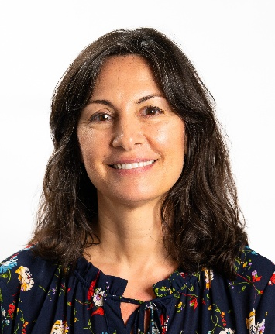
When I decided to advance my career and obtain my Master’s in Social Work degree, I knew I wanted to enter an area of practice that would build on the knowledge and skills I had developed over several years of working with people in crisis. I thought about what that might look like in practice and recalled the outstanding care that my father (and our family) received from an excellent team of hospice clinicians several years ago. As our family navigated many end-of-life decisions and emotions, the hospice nurses, chaplain, and social worker treated us with kindness and compassion during a heartbreaking time. They offered their support and shared information as we prepared for my father’s death, and in doing so, created moments of ease, comfort, and clarity that I had not thought possible. As a result of this deeply meaningful experience, for which I am still so grateful, I developed an interest in palliative care.

As a Fordham Palliative Care Fellow, I was immersed in a rich and supportive environment that equipped me with the skills and resources to deepen my understanding of palliative care principles and provided me with a solid foundation and network for my career in palliative care.

At the core of this experience was a highly coveted field placement at Weill Cornell Medical Center on the Inpatient Palliative Care Team, providing invaluable firsthand experience alongside a dedicated interdisciplinary team of doctors, physician assistants, nurse practitioners, chaplains, and social workers. This placement exposed me to palliative care and instilled in me the importance of providing holistic care aimed at enhancing the quality of life and symptom management for patients and their families facing serious or life-limiting health concerns. It was an honor to work with patients who shared their hopes and fears about their health concerns and charted their path forward based on what mattered most to them.

I received invaluable support throughout my Fellowship, including mentorship from Dr. Berkman, engagement with a close-knit cohort of fellow students, specialized field instruction seminars, and access to workshops and conferences. These resources and tailored coursework deepened my knowledge, skills, and commitment to palliative social work. My field supervisor at Weill Cornell was amazing and offered valuable insights and guidance, further enriching my learning experience.

As I take the next step in my professional role as a palliative social worker, I look forward to providing compassionate care to patients and families as they grapple with the complex challenges of serious health issues. Building on the knowledge and skills I gained as a Palliative Care Fellow, I am dedicated to uplifting each individual's healthcare rights and wishes based on their goals, values, and priorities. My education and experience as a Fellow have deepened my appreciation for the significance of walking alongside people during such a difficult time. While it can be challenging, it is also an honor and privilege to be of service at such a crucial moment.
Kirsten Wyatt

Internship: Mount Sinai Hospital, Palliative Care and Oncology Services
New York, NY

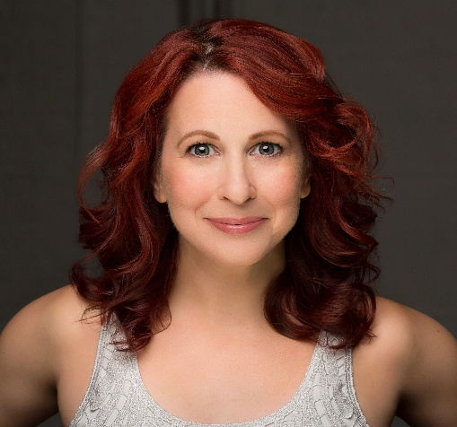
I transitioned into the field of social work following a 25-year career as an actor in New York City. Throughout my life, I've always sought ways to serve my community, but the COVID-19 pandemic gave me an opportunity to reevaluate how I want to contribute and expand the way I impact the world around me. In late 2020, I trained as a volunteer end-of-life doula, inspired by my grandparents’ vastly different experiences with the dying process earlier in my life. I witnessed firsthand how the shortcomings of our current care systems imposed an almost unbearable burden of additional suffering and grief on my family, as well as many others. As a doula, I had the privilege of walking alongside my clients as they navigated their illnesses. I witnessed their pain and suffering, but also their joy and resilience. Supporting individuals during their most vulnerable moments brought me immense fulfillment and eventually steered me toward a career in palliative social work.

My internship at Mount Sinai Hospital in both oncology and palliative care was an invaluable experience, immersing me in the day-to-day realities of the work. As a member of the outpatient oncology team, I had the privilege of working with patients throughout their treatment journeys. I learned to provide both clinical and practical support as patients and their families navigated the profound physical, emotional, financial, and social impacts of serious illness. As part of the inpatient Palliative Care Consult Service team, I participated in family meetings, assisted with advance care planning, and provided counseling to patients and their loved ones during some of the most vulnerable times of their lives. As a member of an interdisciplinary team, I learned the power of collaboration as we strove to center our patients’ goals and values. I also learned to advocate on behalf of my patients to ensure they were seen as individuals with rich, full lives, not merely as diagnoses. I plan to carry these experiences and lessons into whatever opportunities are next for me.

The Fellowship has thoroughly equipped me to enter the job market as a palliative social worker. Beyond the focused coursework, one-on-one mentorship, and participation in conferences, the experience of an incredible internship further solidified my readiness. Additionally, I developed a wonderful support network with my colleagues. Our dedicated palliative care field seminar allowed us to share experiences, collaboratively solve problems, and form genuine connections that will extend beyond our time at Fordham.

I am deeply honored to be a Fordham Palliative Care Fellow and look forward to carrying the exceptional education and experiences I have gained into my social work career.

