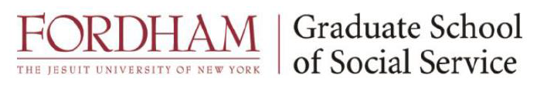

MEET THE FELLOWS

2024 – 2025

Kerstin Aumann
Brielle Brook
Kimberlee Curry
MT Regan
Eleanor Smith

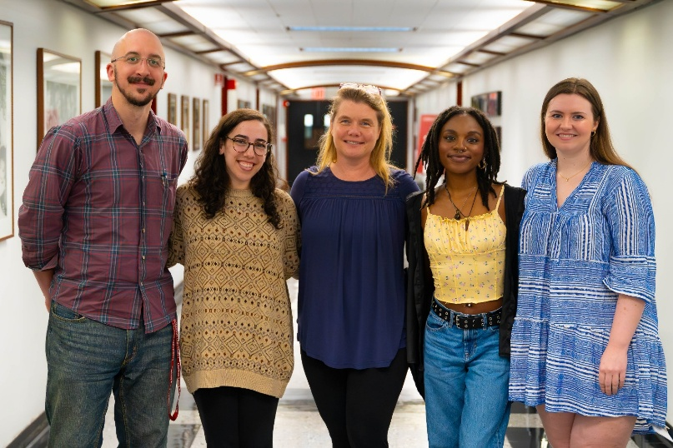

Kerstin Aumann
Internship: Westchester Medical Center, Palliative Care Service
Valhalla, NY
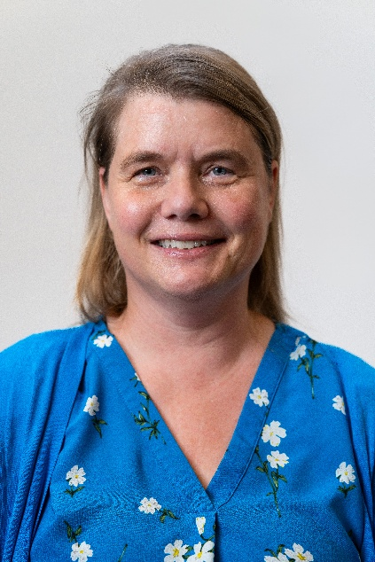
As a Palliative Care Fellow at Westchester Medical Center, I worked with an incredible interdisciplinary team to support seriously ill patients and their families throughout their hospital stay. Whether we were helping someone manage pain, navigate a new diagnosis, or face end-of-life decisions, our work was grounded in empathy, presence, and respect. I provided counseling, conducted biopsychosocial assessments, supported ethical decision-making, and helped families process grief and uncertainty. Every day was different—and every day I was reminded of how meaningful this work truly is.
Before coming to Westchester Medical Center, I interned at Cabrini of Westchester, a long-term care and short-term rehab facility. I’ll admit, those early days were hard. I often felt overwhelmed and unsure of how to help. I’m not a medical doctor, and I couldn’t change the realities of illness or aging. But over time, I learned that being present—truly present—for someone is a powerful form of support. I think of M., a 98-year-old resident with dementia, who began smiling and laughing again when we spoke in her native German. Or J., a quadriplegic woman who found renewed strength and community through advocacy that helped her attend daily mass. Those relationships showed me that even small interventions can have a huge impact.
Palliative care feels like the work I was meant to do because it also draws on the skills I developed earlier in my career. I earned a PhD in Social-Organizational Psychology from Columbia University and spent over a decade in research, teaching, and consulting on topics like workplace equity, caregiving, and well-being. That experience gave me a deep appreciation for people’s lives in context—and it continues to inform how I approach patients and families today.
Making the shift to social work was a big leap for me. It meant reshaping our family life and starting over professionally. I was nervous, but I felt strongly that this path aligned with my purpose. Along the way, I’ve learned to give myself grace, ask for help, and stay open to growth. I’ve learned that no one expects perfection—what patients and families need most is someone who will show up, stay present, and walk with them on a difficult journey.
I’ve also learned that this work requires as much care for ourselves as it does for others. As my supervisor said at the end of an intense first day at Westchester Medical Center: "there are only deep ends in this pool." Through my experience at Fordham, my field placements and the support of the Palliative Care Fellowship, I've learned that no matter how much you love the water or how strong a swimmer you are, you need an interdisciplinary team of "lifeguards" to help you keep swimming.
I’m proud of how far I’ve come, and excited for what lies ahead. Palliative social work is the career I was searching for all along—a path where I can offer meaning, dignity, and presence when it matters most. Thanks to the Palliative Care Fellowship, I feel well prepared for what comes next.

Brielle Brook

Internship: Cohen Children’s Medical Center,
Division of Hematology/Oncology - Stem Cell Transplantation and Cellular Therapy Unit
New Hyde Park, NY

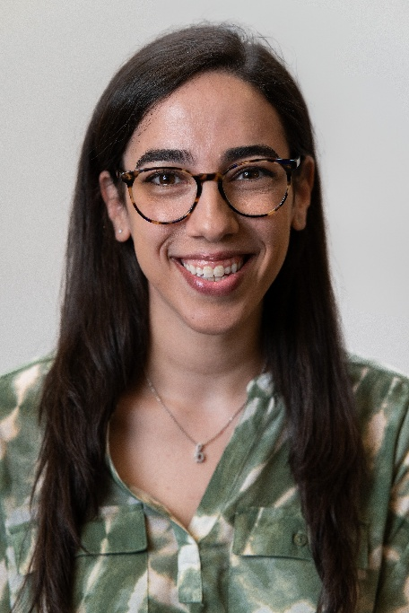
My interest in social work began during my career at the Sunrise Association, a non-profit organization that runs summer day camps and in-hospital programs for children with cancer, and their siblings, free of charge. It was there that my passion for serving the pediatric oncology community took root as I supported children and families facing the immense challenges associated with childhood cancer. I chose to pursue my MSW at Fordham University because of the opportunity to join the Palliative Care Fellowship and access this specialized education and support as an Master’s of Social Work student.

My specialist year field placement was at Cohen Children’s Medical Center in the Division of Hematology/Oncology - Stem Cell Transplantation and Cellular Therapy Unit. As a clinical social work intern, I provided psychosocial support to patients and families undergoing the intense and complex process of stem cell transplantation/cellular therapy in inpatient and outpatient settings. My internship was filled with countless opportunities for growth. I honed my clinical skills while supporting families through some of the most challenging times in their lives, I connected families to vital community resources, and I learned how to work collaboratively with a large interdisciplinary team in a fast-paced hospital environment.
The Palliative Care Fellowship not only afforded me this field placement opportunity, it provided me with an incredible support network. Working with critically ill patients is not easy, but having support from my field instructors, the other Fellows, Dr. Berkman, our field advisor, and my professors kept me going through challenging times. I was also able to apply concepts from the courses I took as a Fellow, including Palliative Social Work and Grief, Loss, and Bereavement, to my field work in real time. These courses were invaluable and taught by outstanding professionals who do this work every day.
Because of the Palliative Care Fellowship, I feel incredibly prepared to enter the field and continue doing this important work. I am humbled and grateful to have had the opportunity to be a Palliative Care Fellow.

Kimberlee Curry

Internship: Peconic Bay Medical Center, Palliative Medicine Department
Riverhead, NY

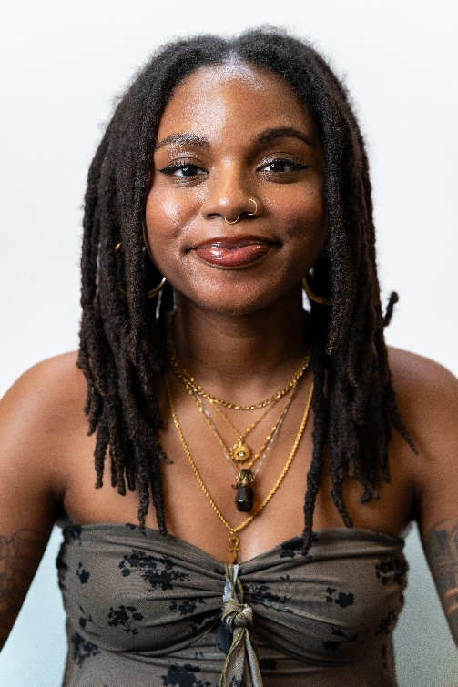
My interest in palliative care began after receiving my Bachelor’s degree in psychology, when I was working at an elementary school with a population that was predominantly people of color. There, I encountered a student with sickle cell anemia, prompting conversations with his mother about his condition. She shared the frequent discriminatory treatment they faced at hospitals, where doctors and staff often spoke condescendingly or downplayed her son’s chronic pain. The Palliative Care Team at a new hospital, particularly the social worker, emerged as a crucial ally for her son. Witnessing the impact of the social worker’s advocacy sparked my interest in palliative care as a career. My interest in palliative care, and specifically pediatric palliative care, has only grown from that point. This field intrigues me due to its emphasis on promoting quality of life, aligning well with my personal commitment to the liberation of all people from oppressive systems and the fight for true health equity.
My field placement was at Peconic Bay Medical Center in Riverhead, NY in the Palliative Medicine Department. I worked very closely with seriously ill patients and their families on determining goals of care, providing hospice referrals, educating about advance directives, and assisting individuals in finding meaning and purpose in this difficult phase of their lives. I worked with an amazing team of physicians, nurse practitioners, social workers, and chaplains. It was truly one of the most fulfilling and inspiring experiences of my life. The Fellowship provided me with a worthwhile field experience, as well as providing many layers of support with monthly lunches with the other Fellows, opportunities to speak with alumni Fellows, and the mentorship of Dr. Berkman. Post-graduation, I am now working as a palliative social worker at Stony Brook University Hospital in Stony Brook, NY, and feel as though participating in the Fellowship has given me all the knowledge, confidence, and experience to excel in this role.

MT Regan
Internship: Memorial Sloan Kettering Cancer Center
New York, NY

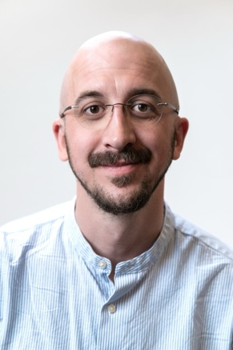
I came to social work through a calling to meet suffering with presence. For much of my life, I’ve been drawn to questions about making meaning in the face of loss, and how humans can best care for one another in moments of profound vulnerability. These interests, shaped by direct personal and family experience, led me to pursue training as a qualified Mindfulness-Based Stress Reduction (MBSR) teacher and end-of-life doula before formalizing my path to palliative social work through Fordham’s MSW program. Here, at the intersection of care for the whole person, justice-seeking, and personal and societal transformation, I found a home.
During my specialist year, I interned at Memorial Sloan Kettering Cancer Center, where I supported the outpatient thoracic oncology service by providing psychosocial support and resource navigation to patients and caregivers facing the complexities of serious illness. The majority of my work focused on individuals with lung cancer, offering me a window into the realities of a highly fatal and deeply stigmatized disease. Many of the patients and families I worked with were facing new diagnoses, treatment-related burdens, disease progression, or transitions in care. I worked intensively with several individuals across multiple encounters, helping them process fear, grief, and existential uncertainty. Monthly opportunities to co-facilitate the Lung Cancer Support Group offered insight into the power of communal care - how patients come together to uplift and hold space for one another and themselves. Through this work, I was humbled by the breadth of human suffering I witnessed and the resilience that often emerged in its midst. This placement deepened my understanding of palliative social work and strengthened my commitment to a practice grounded in presence and relationality.
The Palliative Care Fellowship was key in making my time at Fordham a meaningful and enriching professional experience. Our cohort supported one another both in and out of the classroom, learning together through dedicated coursework and monthly seminars. That spirit of camaraderie has continued as we have pursued licensure and navigated job searches. The mentorship and guidance of Dr. Berkman, Adam Schoenfarber, Sarah Wichman and an array of guest speakers, lecturers, and alumni Fellows helped bring academic concepts to life, showcased the range of approaches to practice, and eased the transition from the role of student to emerging professional. I am deeply grateful for this experience and look forward to supporting future Fellows in the years to come.
I am excited to continue this journey as a post-graduate fellow in palliative social work at Nuvance Health/Vassar Brothers Medical Center in Poughkeepsie, NY.
Eleanor Smith

Internship: Mount Sinai Medical Center, Palliative Care Service
New York, NY

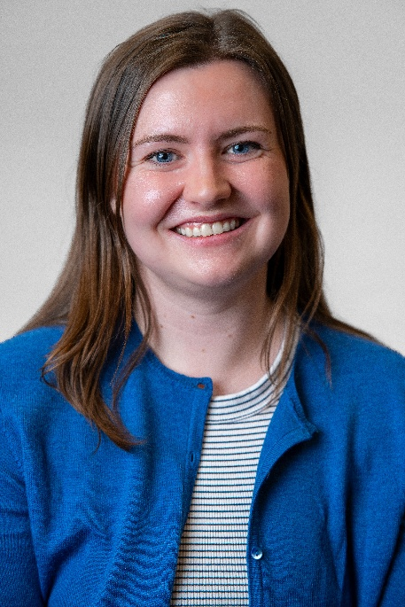
I first encountered palliative care at 18 years old, when my grandfather was enrolled in hospice at the end of his life. The hospice staff - nurses, volunteers, and of course, social workers - provided incredible support to my family during this time, and made this difficult period more manageable. While my grandfather was not on hospice for a very long period of time, the compassionate care of the hospice staff made a deep impact on me. Such an impact that, when I graduated Barnard College and elected to take a gap year prior to applying for my MSW, I became a hospice volunteer. When I first started, I visited four patients a week; this number quickly grew to ten. It was truly a privilege to take part in a person's final months, weeks, days, or hours. Every week, as I visited with my patients - advocating for their needs, reflecting on their lives, having conversations about death - I affirmed my desire to pursue social work, and palliative social work particularly. My time as a hospice volunteer solidified my decision to attend Fordham University Graduate School of Social Service, with the Palliative Care Fellowship specifically in mind.
For my Specialist year field placement, I was fortunate to be able to work with the Palliative Care team at Mount Sinai Hospital, both with their consult service and inpatient Palliative Care Unit. With the consult team, I visited seriously ill patients across the hospital, at different points in their illness, assisting families and primary medical teams in facilitating conversations around goals of care. In the inpatient Palliative Care Unit, I assisted patients and family navigating end-of-life - the complex emotions this situation raises as well as the complicated systems and processes for accessing care. My time at Mount Sinai underscored the fulfilling, demanding, and rewarding nature of this work. There, I was able to observe the wonderful palliative social workers, hone my clinical skills, and receive mentorship (for which I am so grateful). The Palliative Care Fellowship has been a critical element of my time at Fordham. The Fellowship connected me to peers and colleagues who are similarly passionate about working with seriously ill individuals and their families, resources, and educational opportunities. The courses related to the Fellowship - Palliative Social Work with Adam Schoenfarber and Grief, Loss, and Bereavement with Victoria Lassen - were especially memorable and informative elements of my Fordham education. I am so excited to be entering the field of palliative social work, as I graduate from Fordham and embark on my career - and am sure that my time and skill development in the Palliative Care Fellowship will make a difference in my social work practice with patients and their loved ones.

