Name: SUHAN | Roll Number / CU ID: CU25260160 | Course: BCA Desktop Publishing
Practical 1: Photoshop Interface and Basic Tools
Objective: To understand the Adobe Photoshop workspace, explore toolbars, and practice basic shape and text tools.
Tools Used: Move Tool, Shape Tool, Type Tool, Brush Tool, Eraser Tool, Marquee Tool.
My Step-by-Step Procedure:
1. I opened Adobe Photoshop and created a new document by going to File > New.
2. I set the canvas dimensions to 1200 pixels width and 800 pixels height at 72 DPI resolution in RGB color mode.
3. I explored the workspace panels, including the Menu Bar, Options Bar, left Toolbar, and the Layers Panel on the right.
4. Using the Shape Tool, I drew three distinct geometric shapes (rectangle, ellipse, and polygon) on separate individual layers.
5. I filled each shape with a different solid color using the color picker in the options bar.
6. I selected the Horizontal Type Tool and typed my name, roll number, and course details onto the canvas.
7. I used the Move Tool to adjust and align all the shapes and text neatly.
8. Finally, I saved my project as a layered PSD file and exported a clean copy as a JPG image.
Required Submission Files:
• Practical_01_SUHAN_CU25260160.psd
• Practical_01_SUHAN_CU25260160.jpg
Visual Output Preview:
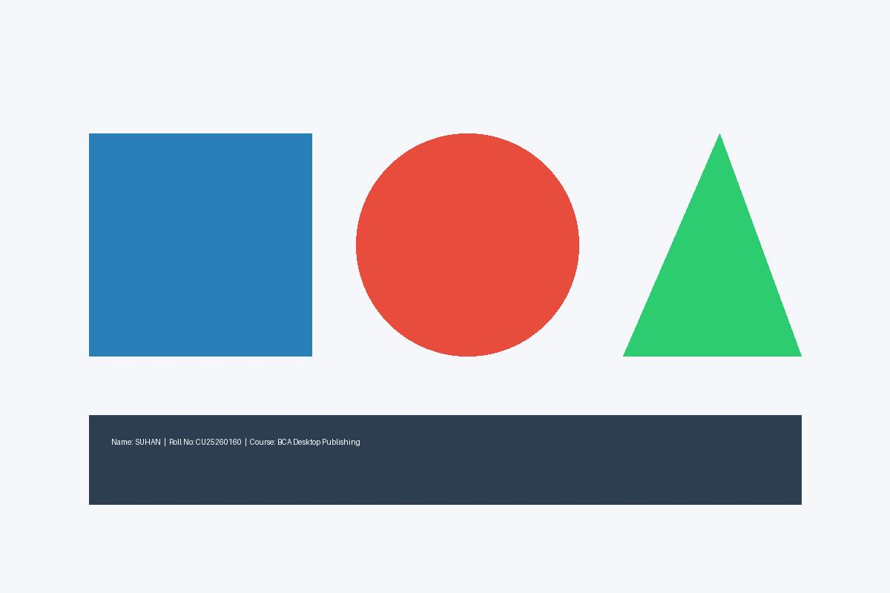
Figure 1: Practical 01 Canvas Layout with Shapes & Student Details

