Name: SUHAN | Roll Number / CU ID: CU25260160 | Course: BCA Desktop Publishing
Practical 2: Photo Editing and Basic Retouching
Objective: To perform basic photo editing, cropping, color correction, and spot removal using Photoshop retouching tools.
Tools Used: Crop Tool, Spot Healing Brush Tool, Healing Brush Tool, Clone Stamp Tool, Brightness/Contrast, Color Balance.
My Step-by-Step Procedure:
1. I opened a standard photograph inside Photoshop to practice retouching.
2. I selected the Crop Tool to trim unwanted borders and straighten the horizon line of the image.
3. I opened Image > Adjustments > Brightness/Contrast to improve the lighting and overall exposure.
4. I used Color Balance and Hue/Saturation adjustments to correct the color tones and make the photo look natural.
5. I zoomed in closely on the image and used the Spot Healing Brush Tool and Healing Brush Tool to clean up blemishes and unwanted spots.
6. I also used the Clone Stamp Tool with Alt-sampling where I needed precise texture copying.
7. I saved my working project as a PSD file.
8. I exported the final edited version as a JPG and also prepared a side-by-side comparison image showing the before and after states.
Required Submission Files:
• Practical_02_SUHAN_CU25260160.psd
• Practical_02_SUHAN_CU25260160.jpg
• Before_After_Practical_02.jpg
Visual Output Preview:
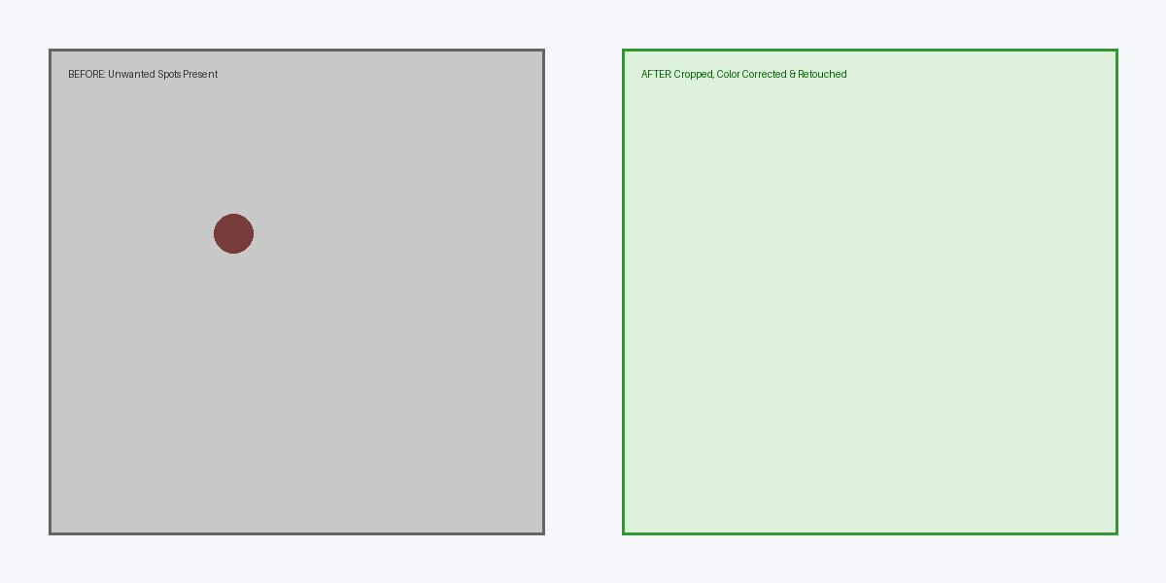
Figure 2: Practical 02 Before vs After Retouching & Color Correction Comparison

