Name: SUHAN | Roll Number / CU ID: CU25260160 | Course: BCA Desktop Publishing
Practical 4: Advanced Selection, Color Correction and Adjustment Layers
Objective: To practice advanced selection techniques and non-destructive color correction using adjustment layers and masks.
Tools Used: Quick Selection Tool, Magic Wand, Select and Mask, Adjustment Layers (Hue/Saturation, Levels).
My Step-by-Step Procedure:
1. I opened a photograph with a clear main subject in Photoshop.
2. I used the Quick Selection Tool to carefully outline the main subject.
3. I clicked on 'Select and Mask' in the top options bar to refine the selection edges so they looked clean and sharp.
4. I created a new Hue/Saturation Adjustment Layer from the Layers Panel.
5. Because I had an active selection, Photoshop automatically applied it as a Layer Mask, restricting the color changes only to the selected area.
6. I tweaked the sliders to change the color appearance of the subject without altering the original pixels permanently.
7. I saved the project as a PSD file and exported the final image as a JPG.
Required Submission Files:
• Practical_04_SUHAN_CU25260160.psd
• Practical_04_SUHAN_CU25260160.jpg
Visual Output Preview:
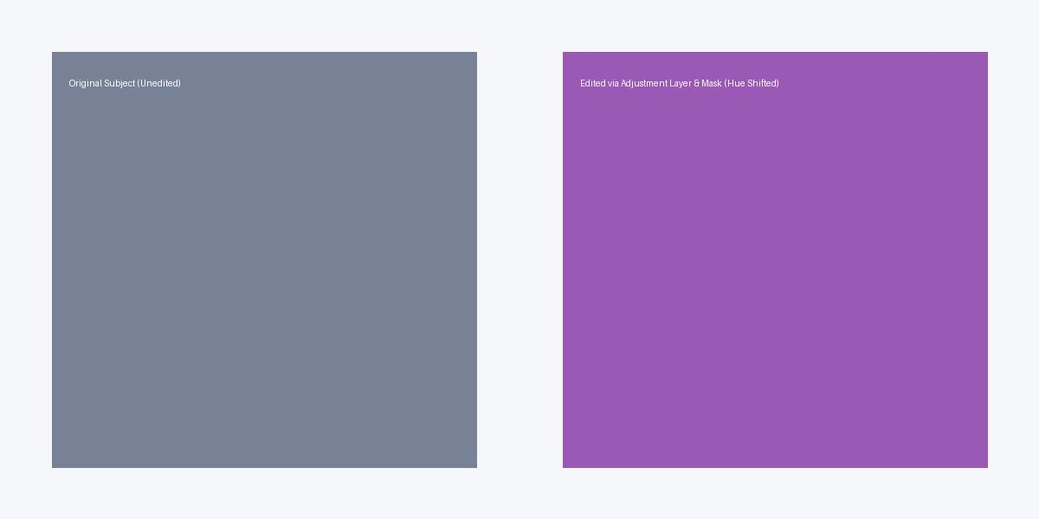
Figure 4: Practical 04 Non-Destructive Selection & Color Correction

