Name: SUHAN | Roll Number / CU ID: CU25260160 | Course: BCA Desktop Publishing
Practical 6: Complete Photoshop Project - Promotional Poster
Objective: To integrate all Photoshop skills learned across both modules into a complete promotional poster project.
Tools Used: All Photoshop tools: Selections, Masks, Adjustment Layers, Filters, Blending Modes, Custom Brushes, Typography.
My Step-by-Step Procedure:
1. I planned and created a high-resolution canvas for a promotional college tech fest poster.
2. I built a multi-layered background using custom brush strokes, filter textures, and blended images.
3. I used advanced selection tools to extract the main event image cleanly and placed it on top.
4. I added non-destructive Adjustment Layers (Curves and Hue/Saturation) paired with Layer Masks to fix the lighting and color grading.
5. I set layer blending modes to Soft Light to merge the graphic elements smoothly.
6. I added all necessary event details: Title, Date, Time, Venue, and Department Name using clean, styled typography and layer styles like Drop Shadow.
7. I organized all my layers into meaningful groups and named them properly.
8. Finally, I saved the complete project as a PSD and exported the final poster as a high-quality JPG.
Required Submission Files:
• Practical_06_SUHAN_CU25260160.psd
• Practical_06_SUHAN_CU25260160.jpg
Visual Output Preview:
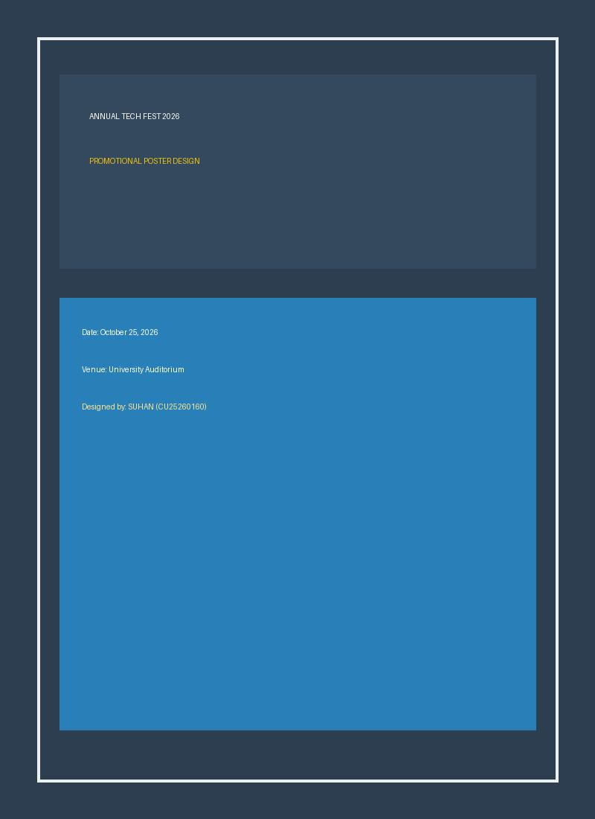
Figure 6: Practical 06 Promotional Poster Final Output

