Ticket Booking and Reservation System
By 25MIS0355 Suhas E
25MIS0349 Nagasanjeevi Balaji N 25MIS0378 Lokesh Kumar G

Problem Analysis – Ticket Booking and Reservation System:
The Ticket Booking and Reservation System is designed to provide a centralized online platform for searching, reserving, booking, and managing tickets for transportation services such as buses, trains, and flights. Traditional ticket booking methods may involve manual processes, long waiting times, difficulty checking seat availability, and challenges in managing cancellations and refunds. The proposed system aims to overcome these issues through an automated and user-friendly application.

The system has four major modules: Login and User Management, Ticket Search and Reservation, Payment and Booking Management, and Admin and Schedule Management. Customers can register, log in, search for available schedules, check seat availability, select seats, reserve tickets, make payments, and receive electronic tickets. They can also view their booking history, cancel eligible bookings, and request refunds. Administrators can manage schedules, routes, ticket prices, user information, seat inventory, and booking records.

The system must ensure that each booking is associated with a customer and contains one or more tickets. Each ticket must be linked to a valid schedule and an allocated seat. Payment processing is handled through an external payment gateway, and the system must maintain accurate booking, payment, ticket, and refund statuses.
The major challenges include maintaining real-time seat availability, preventing duplicate reservations and overbooking, handling payment failures, managing reservation expiry, and ensuring data consistency during cancellations and schedule updates. Security is also essential to protect user information and restrict administrative operations to authorized users.

The proposed system addresses these problems by automating the booking workflow, providing accurate schedule and seat information, integrating secure payment processing, and maintaining centralized booking records. The overall objective is to reduce manual effort, improve booking efficiency, prevent reservation conflicts, and provide a reliable ticket booking experience for customers and administrators.

Module 1 – Login & User Management

Scope:

This module handles user authentication, registration, profile management, and role-based access to the system.

Objectives:

• Allow users to register and log in securely. • Authenticate users based on their roles.
• Manage user profiles and passwords.
• Ensure secure access to system functionalities.

Challenges:

• Secure password storage and authentication. • Prevent unauthorized access.
• Handle forgotten password requests.
• Manage multiple user roles (Customer and Admin).

Module 2 – Ticket Search & Reservation

Scope:

This module enables customers to search available tickets, view schedules, check seat

availability, select seats, and reserve tickets before payment.

Objectives:

• Provide quick ticket search.

• Display accurate schedules and seat availability.

• Prevent double booking of seats.

• Create temporary reservations before payment.

Challenges:

• Maintaining real-time seat availability.

• Handling simultaneous reservations.

• Preventing duplicate bookings.

• Managing reservation expiry if payment is not completed.

Module 3 – Payment & Booking Management

Scope:

This module manages payment processing, booking confirmation, ticket generation,

cancellation, and refunds.

Objectives:

• Secure payment processing.

• Generate electronic tickets.

• Maintain booking history.

• Process cancellations and refunds efficiently.

Challenges:

• Handling payment failures.

• Integrating with external payment gateways.

• Updating booking status correctly.

• Managing refund requests.

Module 4 – Admin & Schedule Management

Scope:

This module allows administrators to manage schedules, routes, pricing, users, seat

inventory, bookings, and reports.

Objectives:

• Maintain accurate schedules.

• Manage ticket pricing.

• Monitor bookings.

• Generate reports for system analysis.

Challenges:

• Updating schedules without affecting existing bookings.

• Managing large volumes of booking data.

• Maintaining data consistency.

• Providing secure administrative access

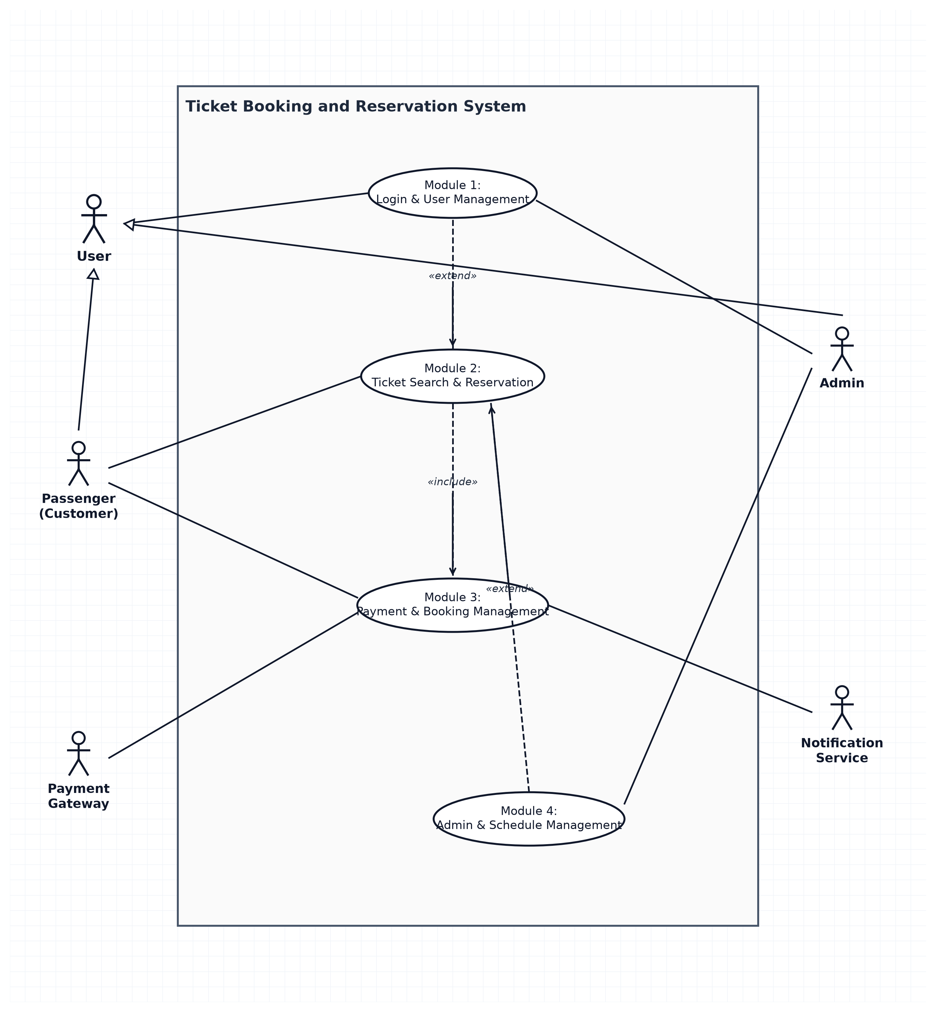
Overall Use Case Diagram

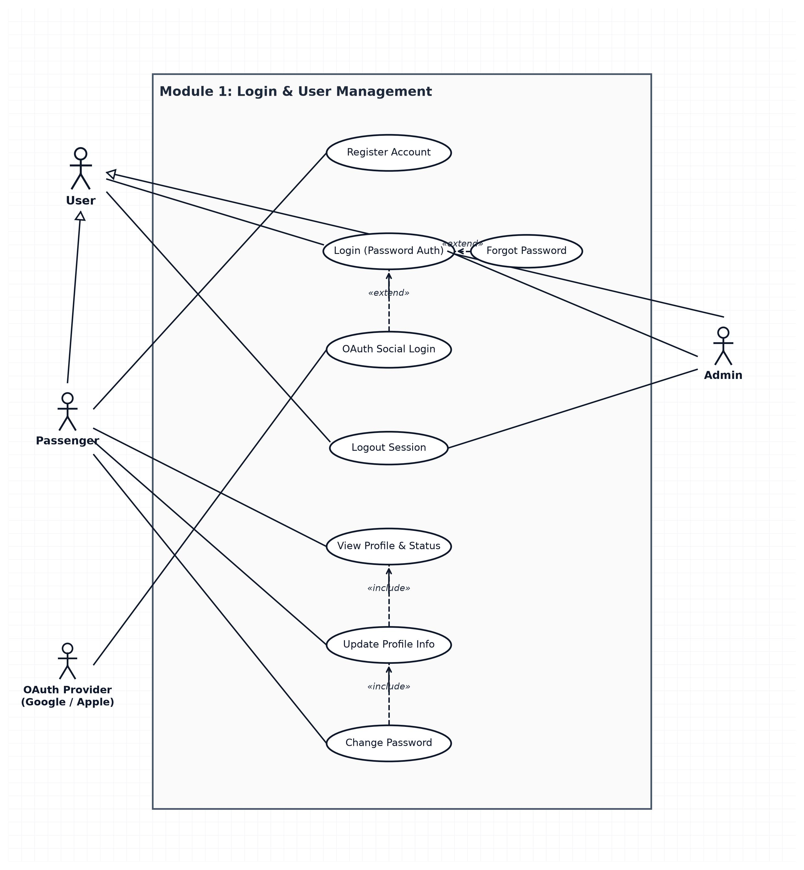
Module 1 – Login & User Management:

Module 2 – Ticket Search & Reservation

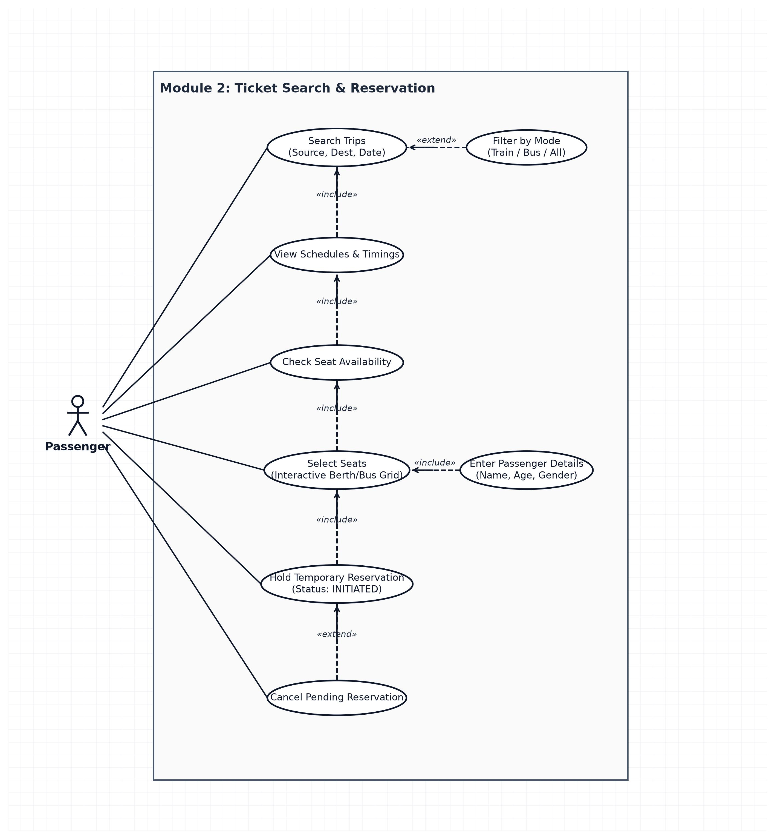

Module 3 – Payment & Booking Management

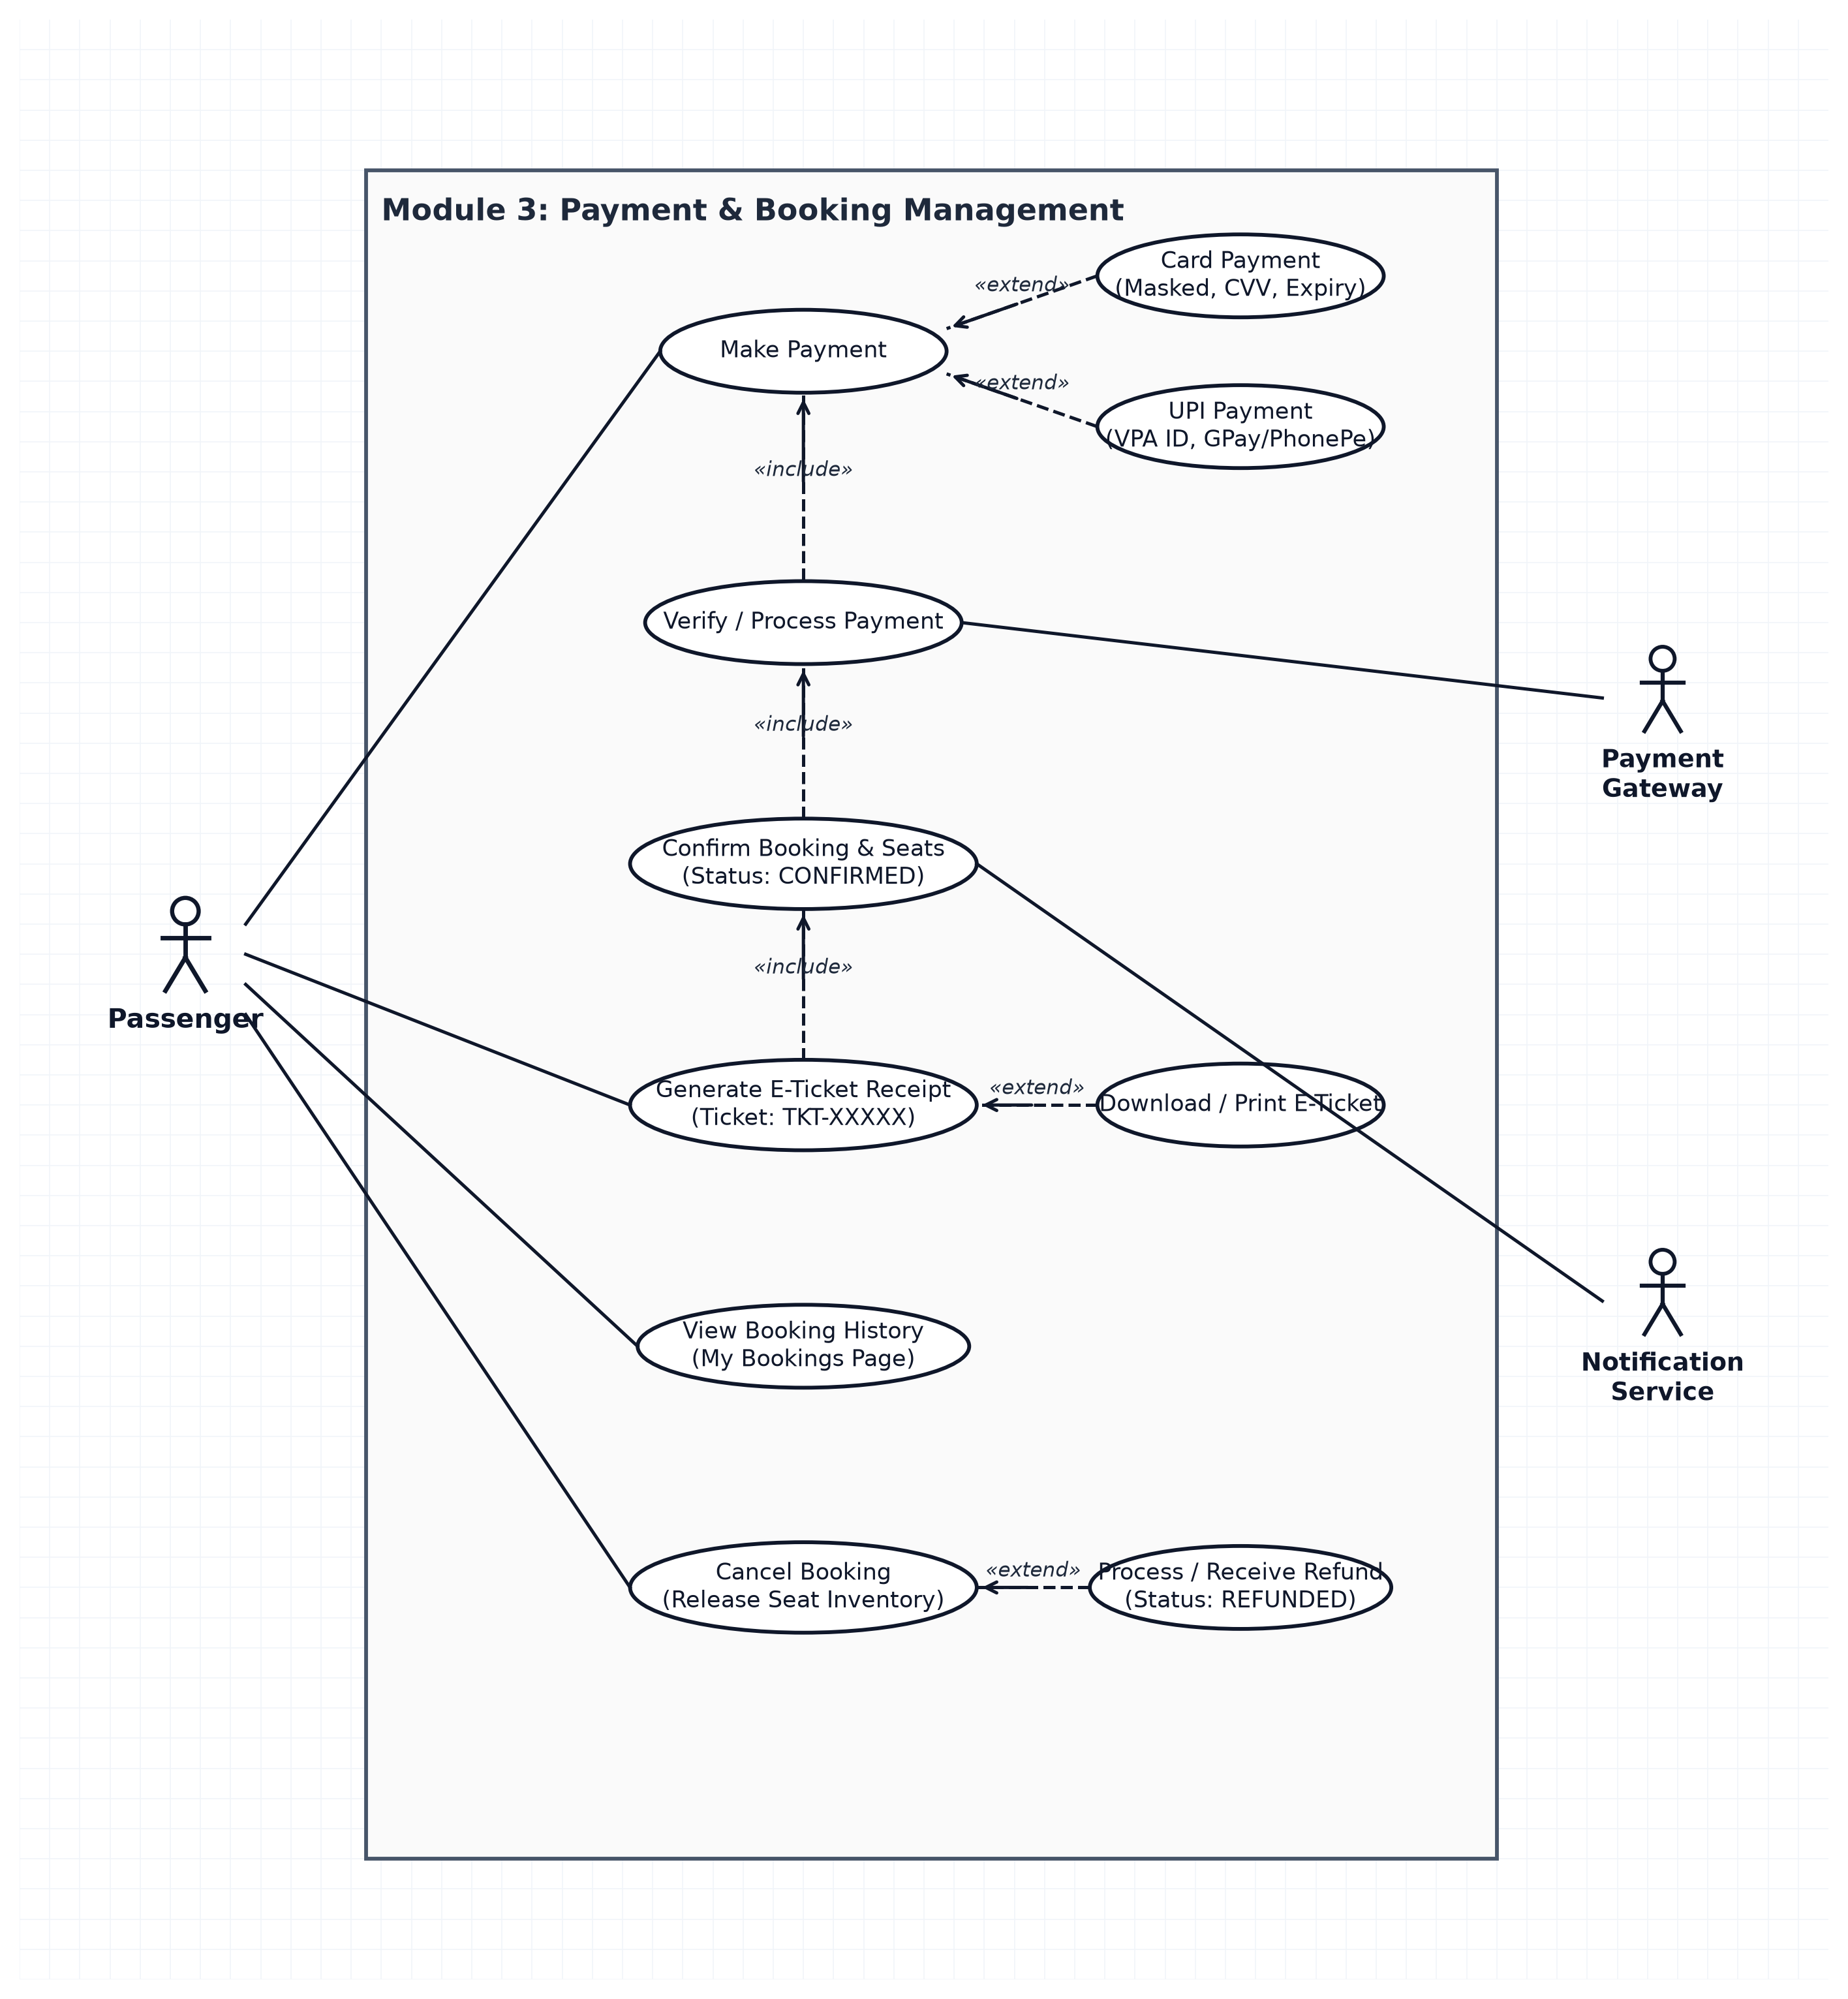

Module 4 – Admin & Schedule Management

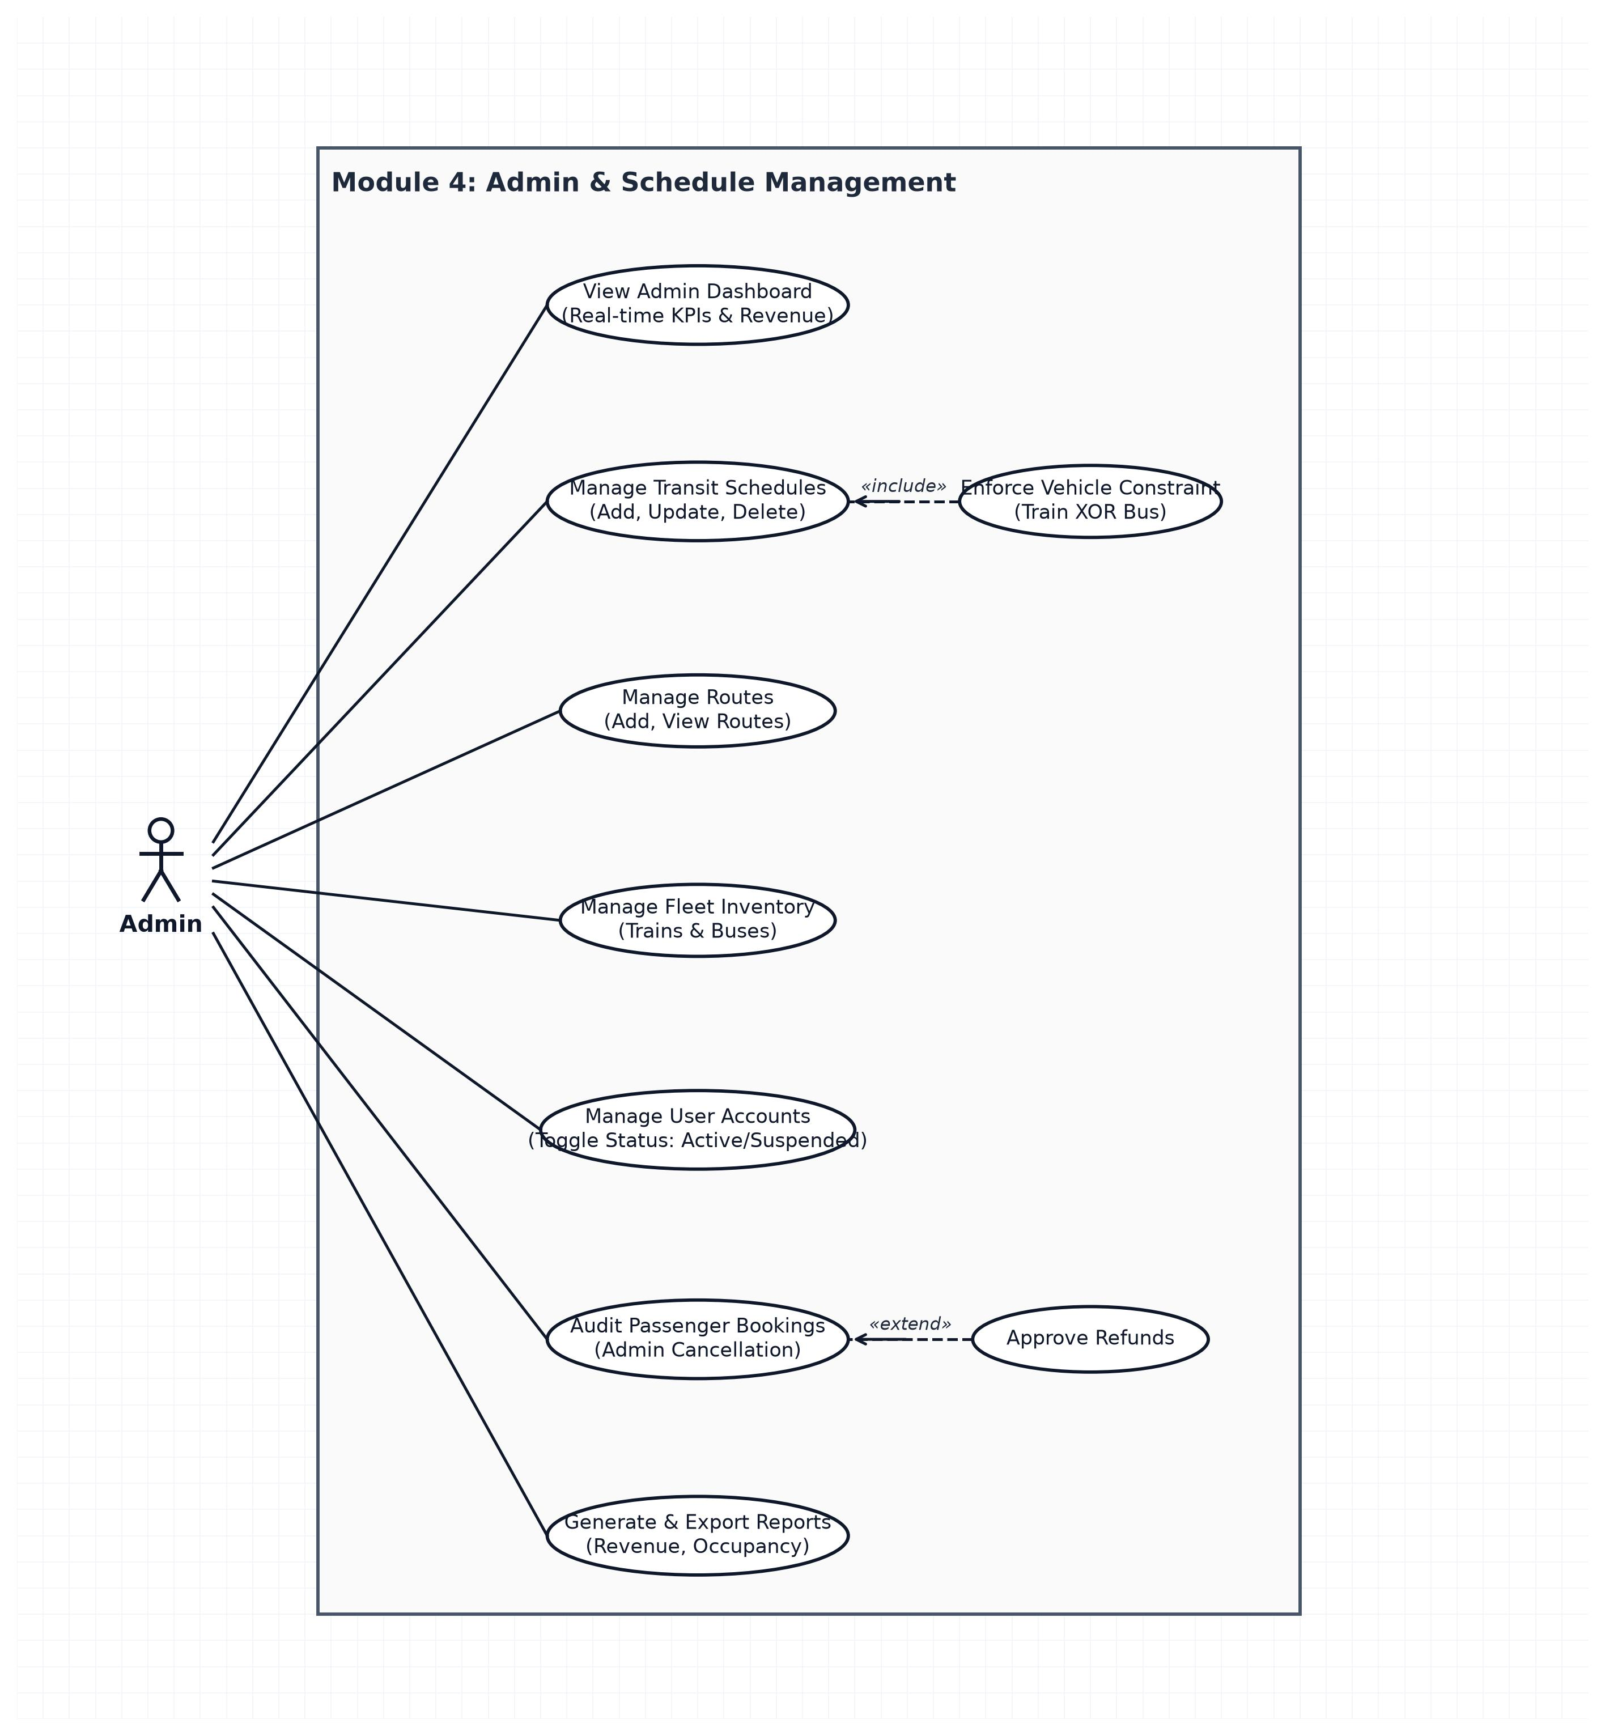

Overall Class Diagram:

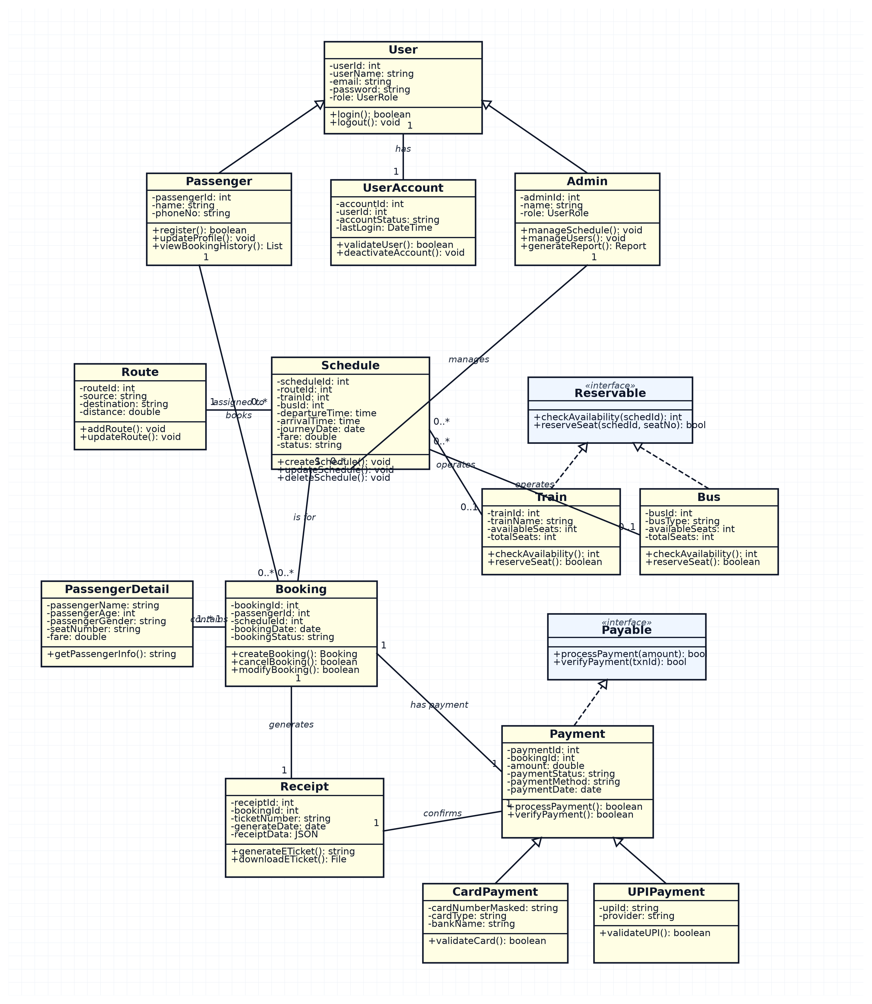

Module 1 – Login & User Management
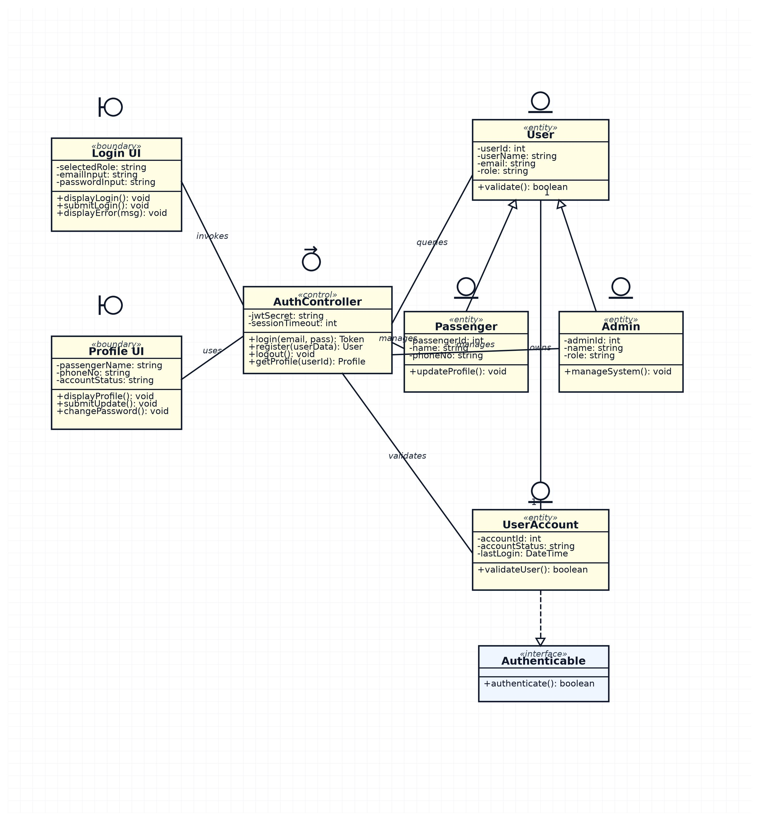

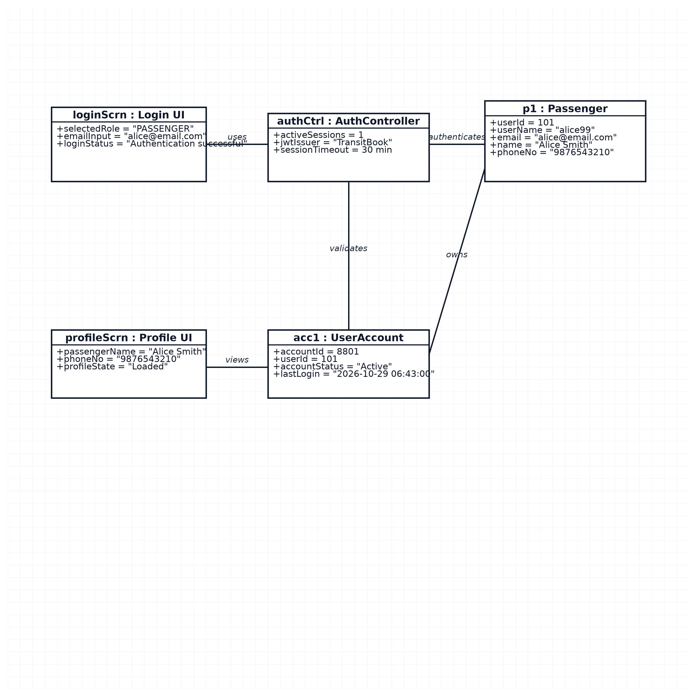
Object Diagram
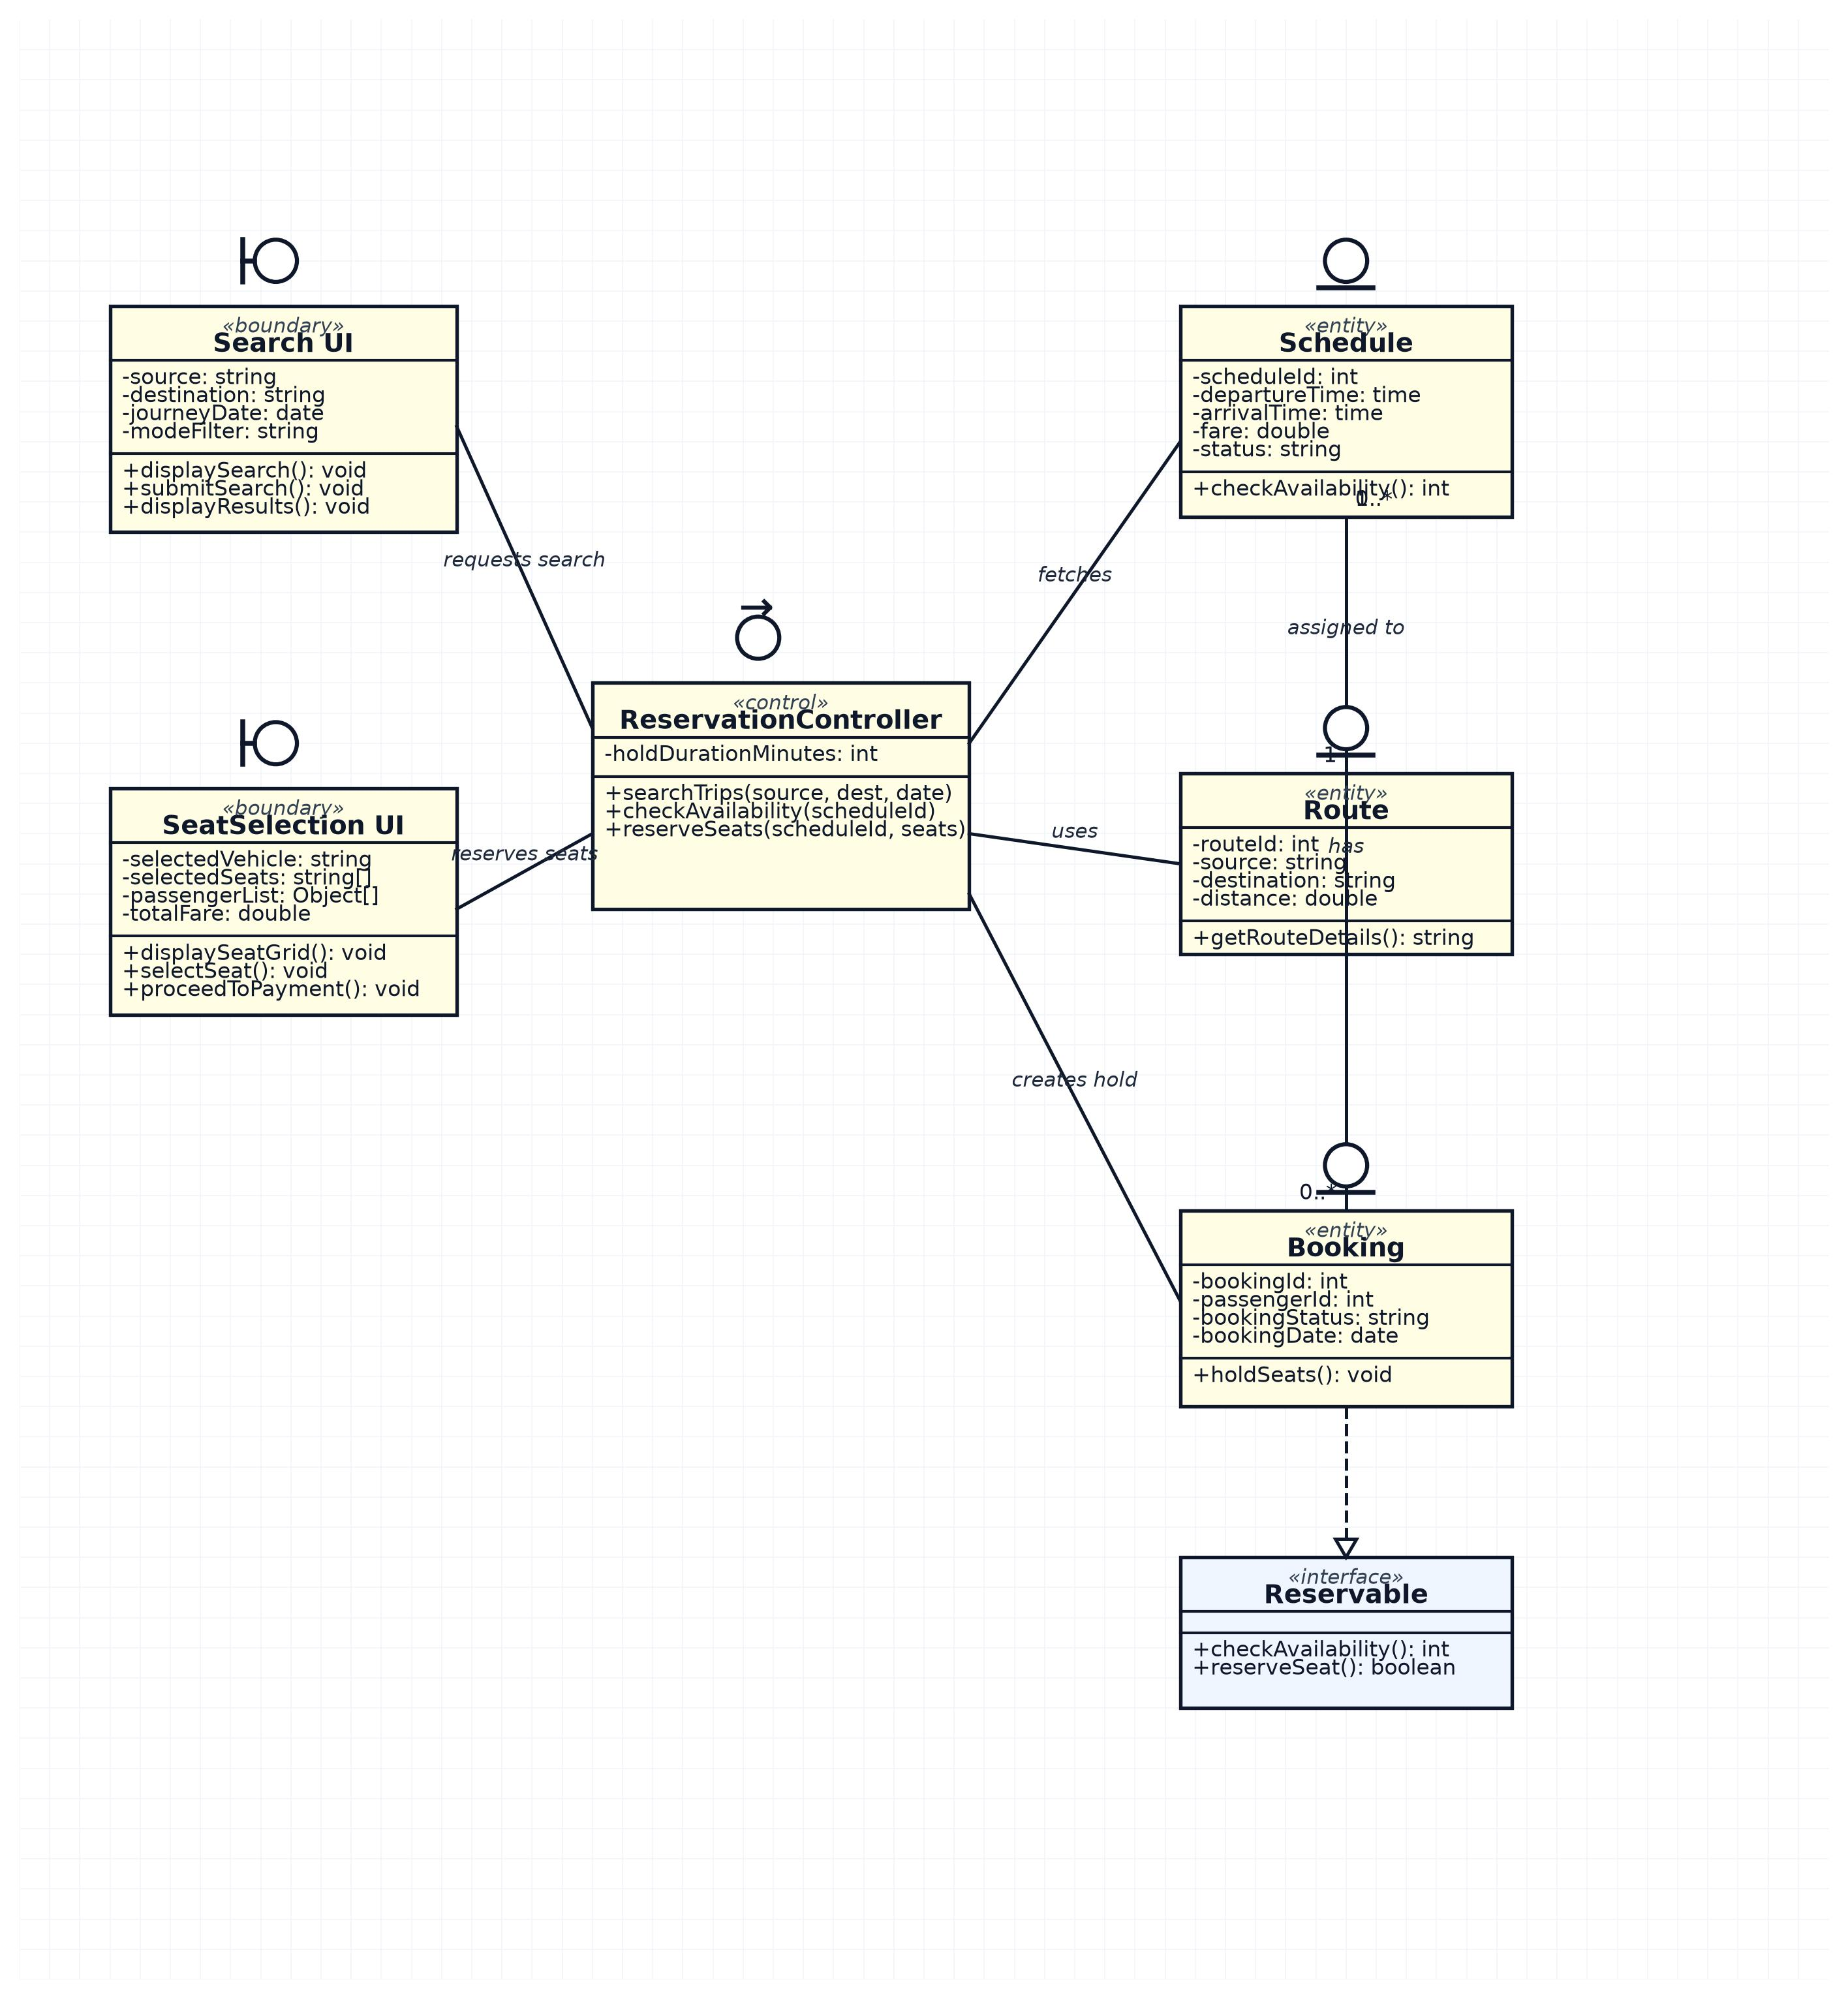

Module 2 – Ticket Search & Reservation

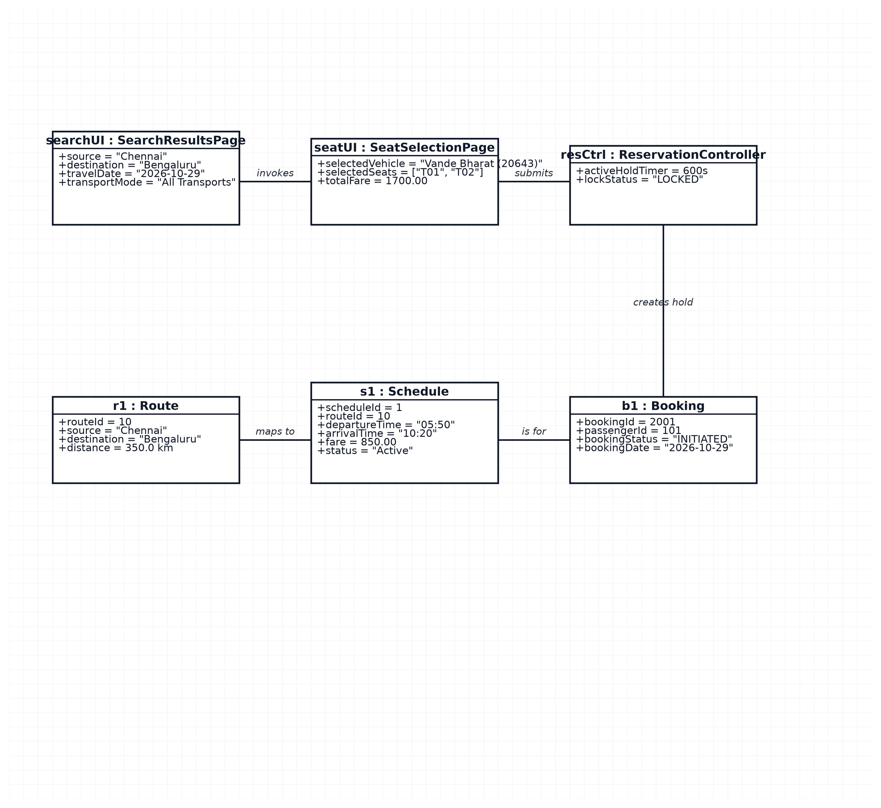
Object Diagram

Module 3 – Payment & Booking Management

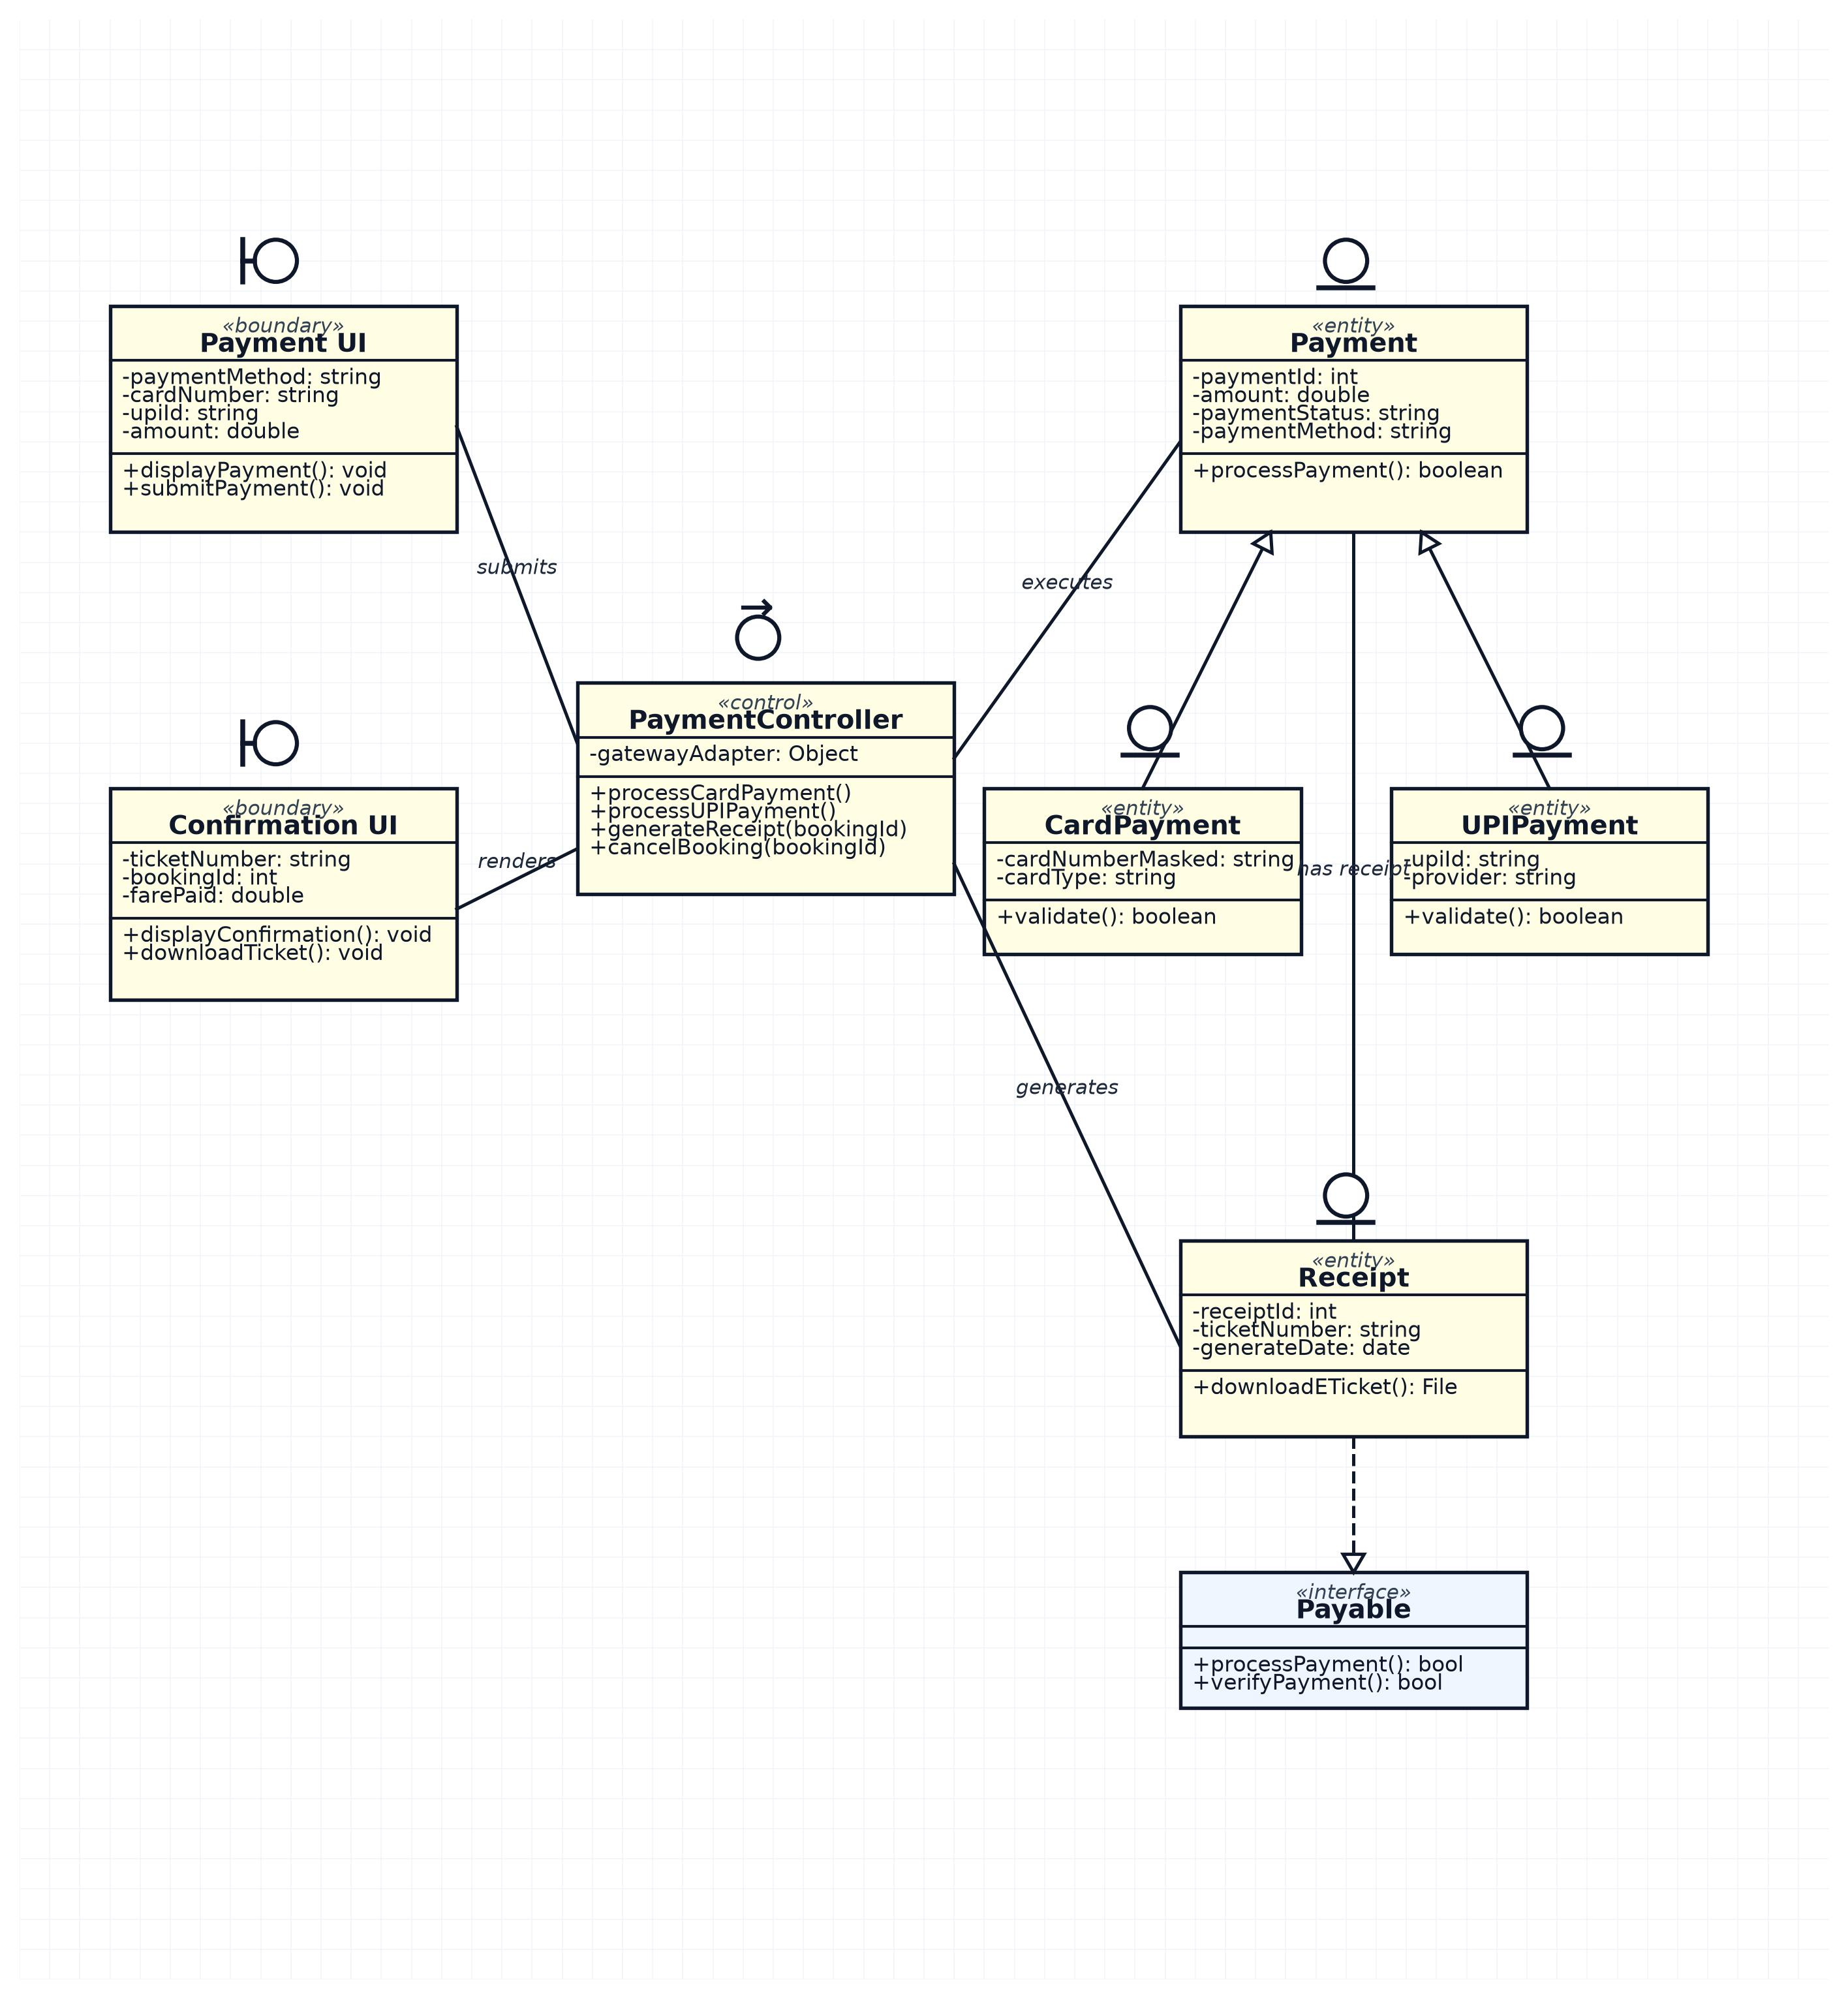

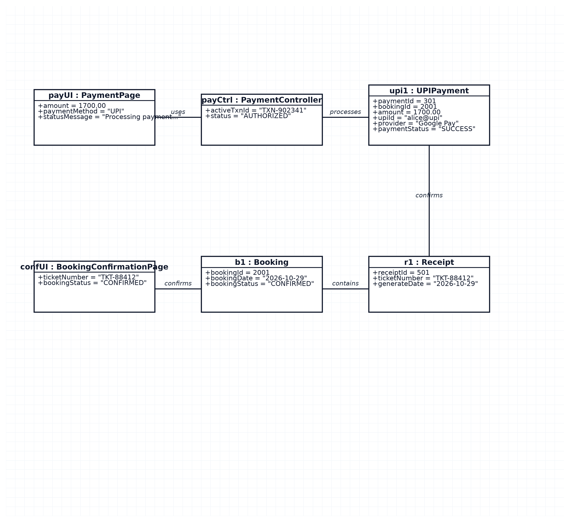
Object diagram

Module 4 – Admin & Schedule Management

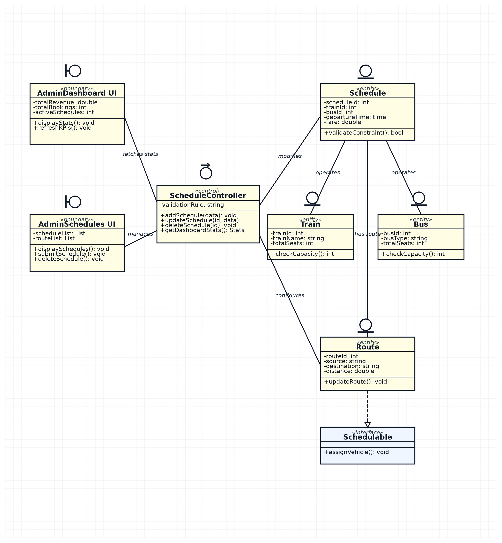

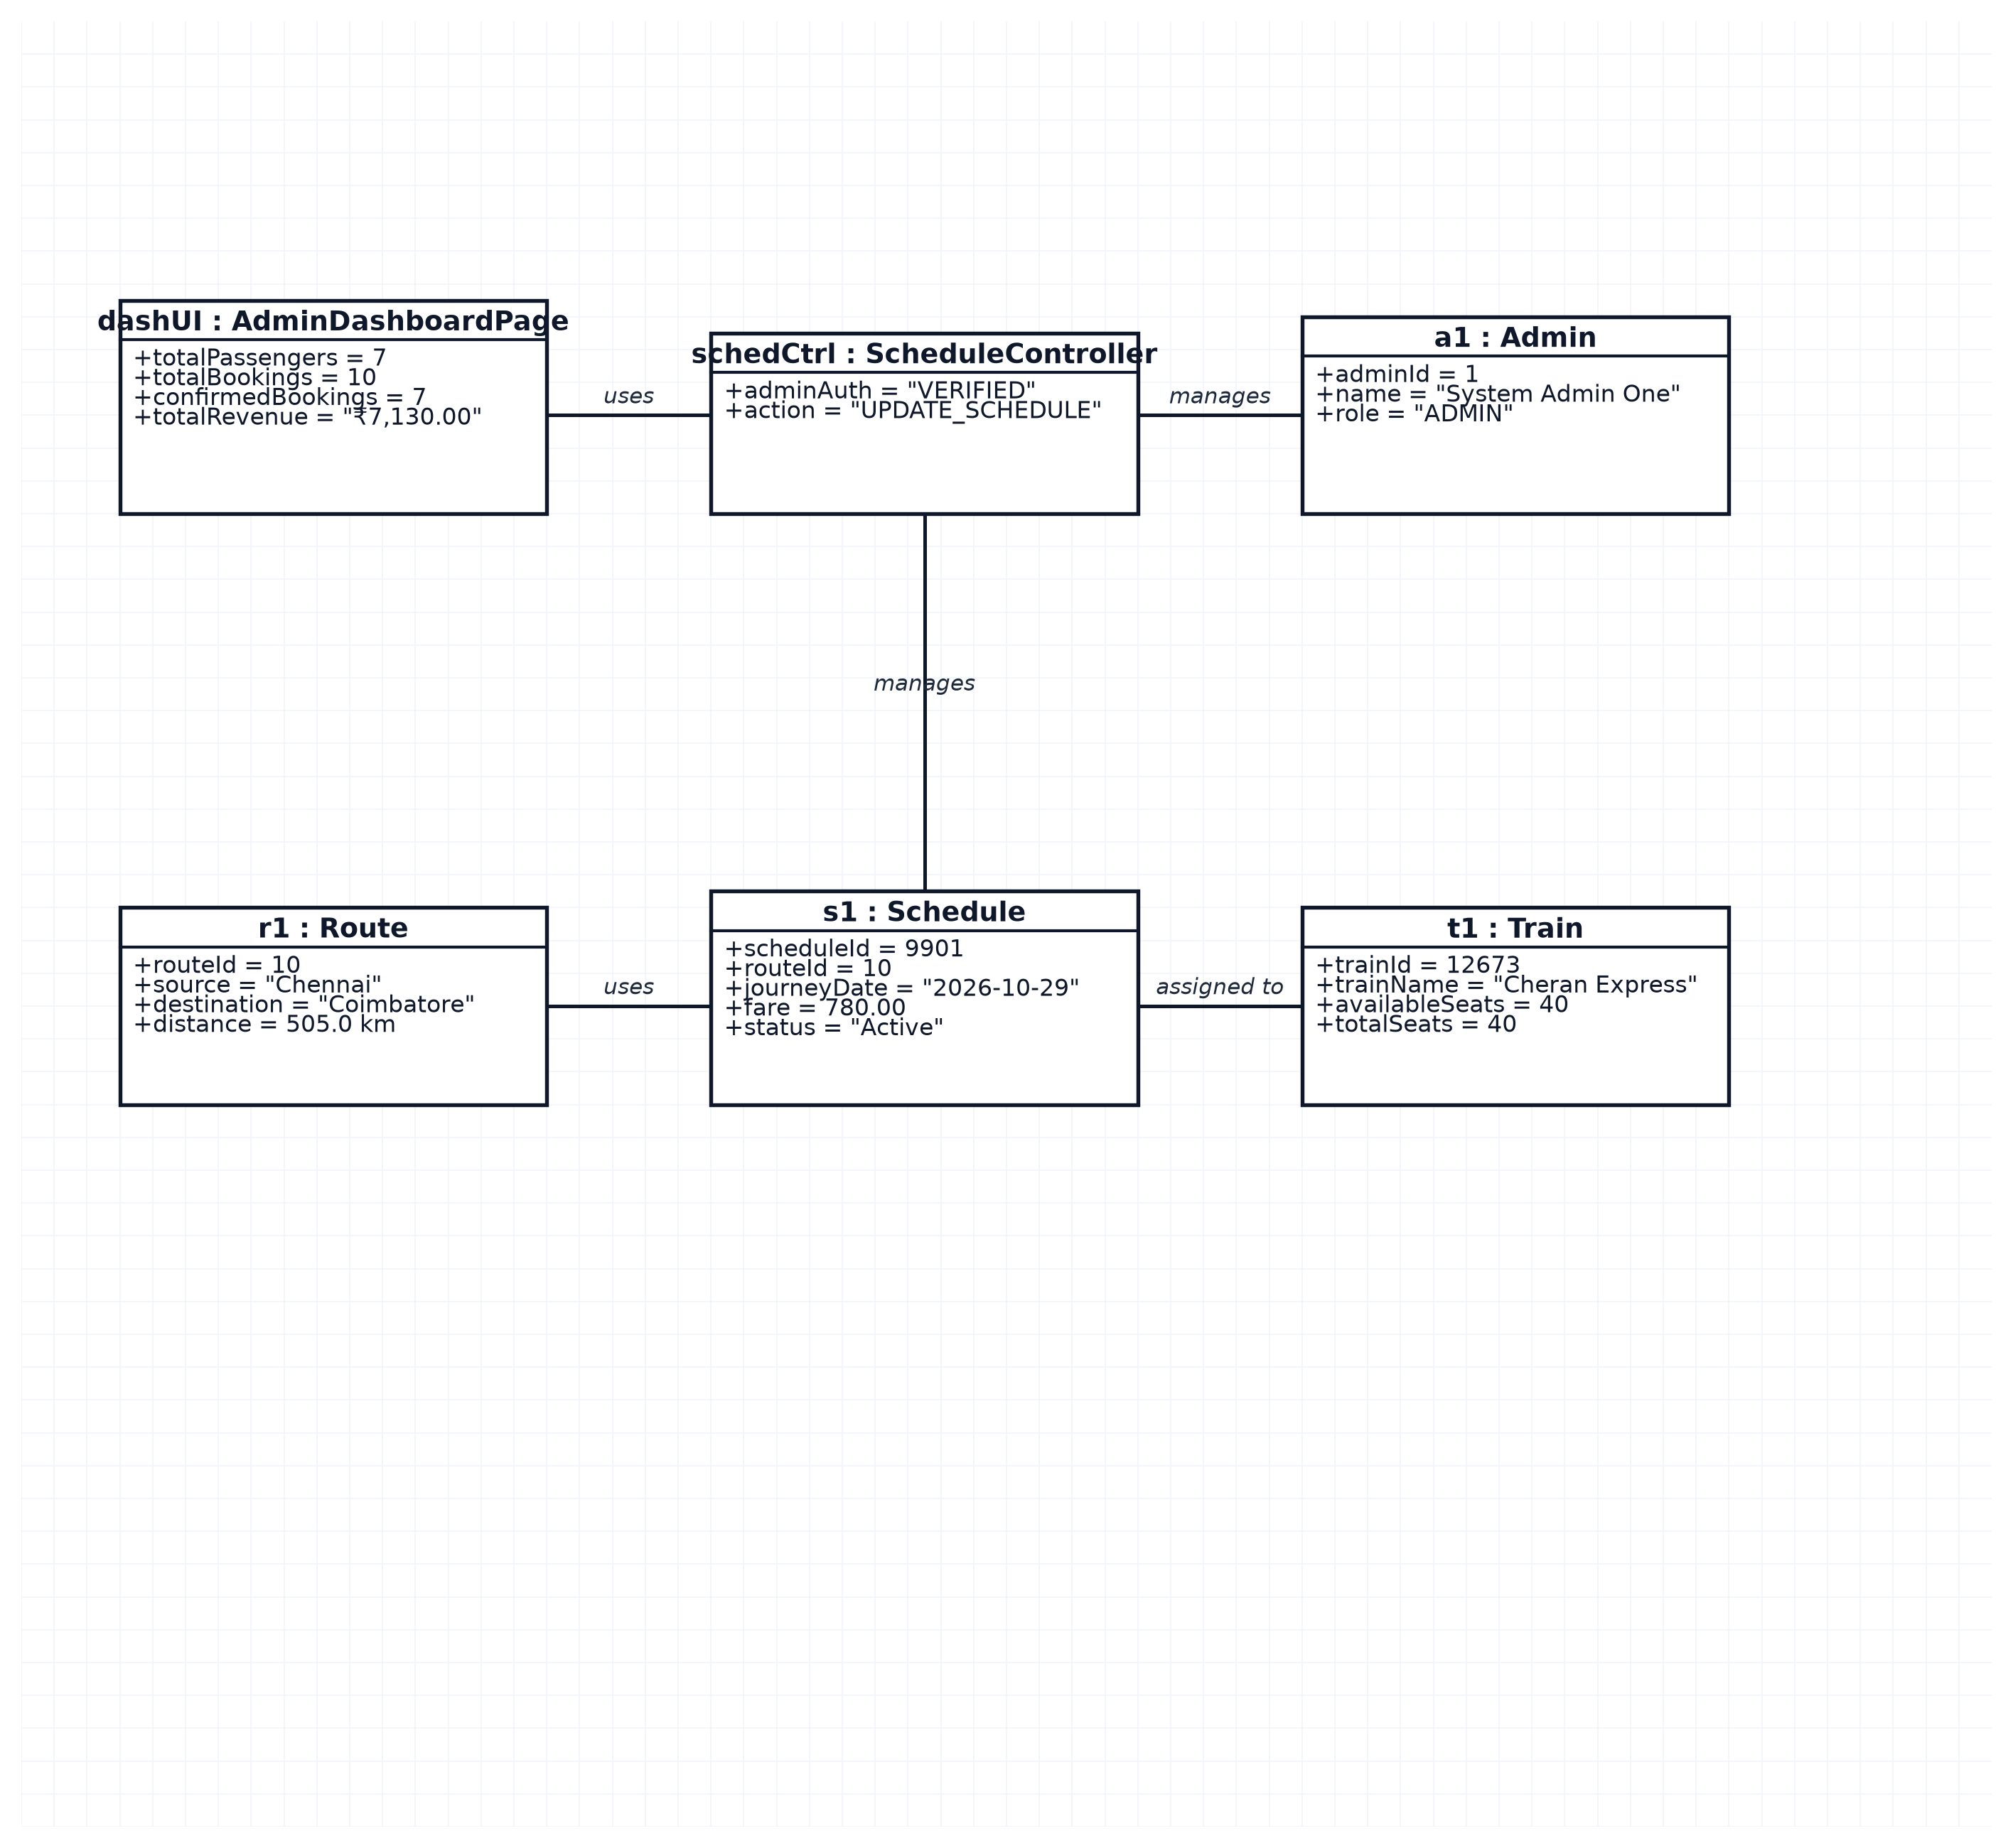
Object Diagram

Module 1 – Login & User Management

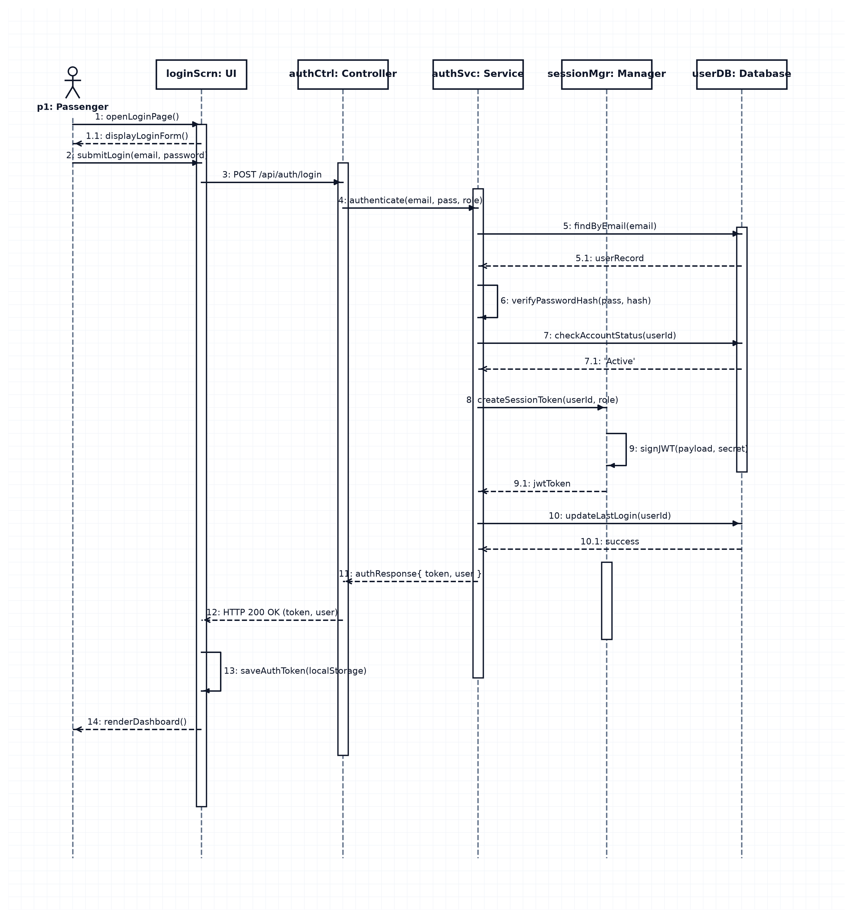

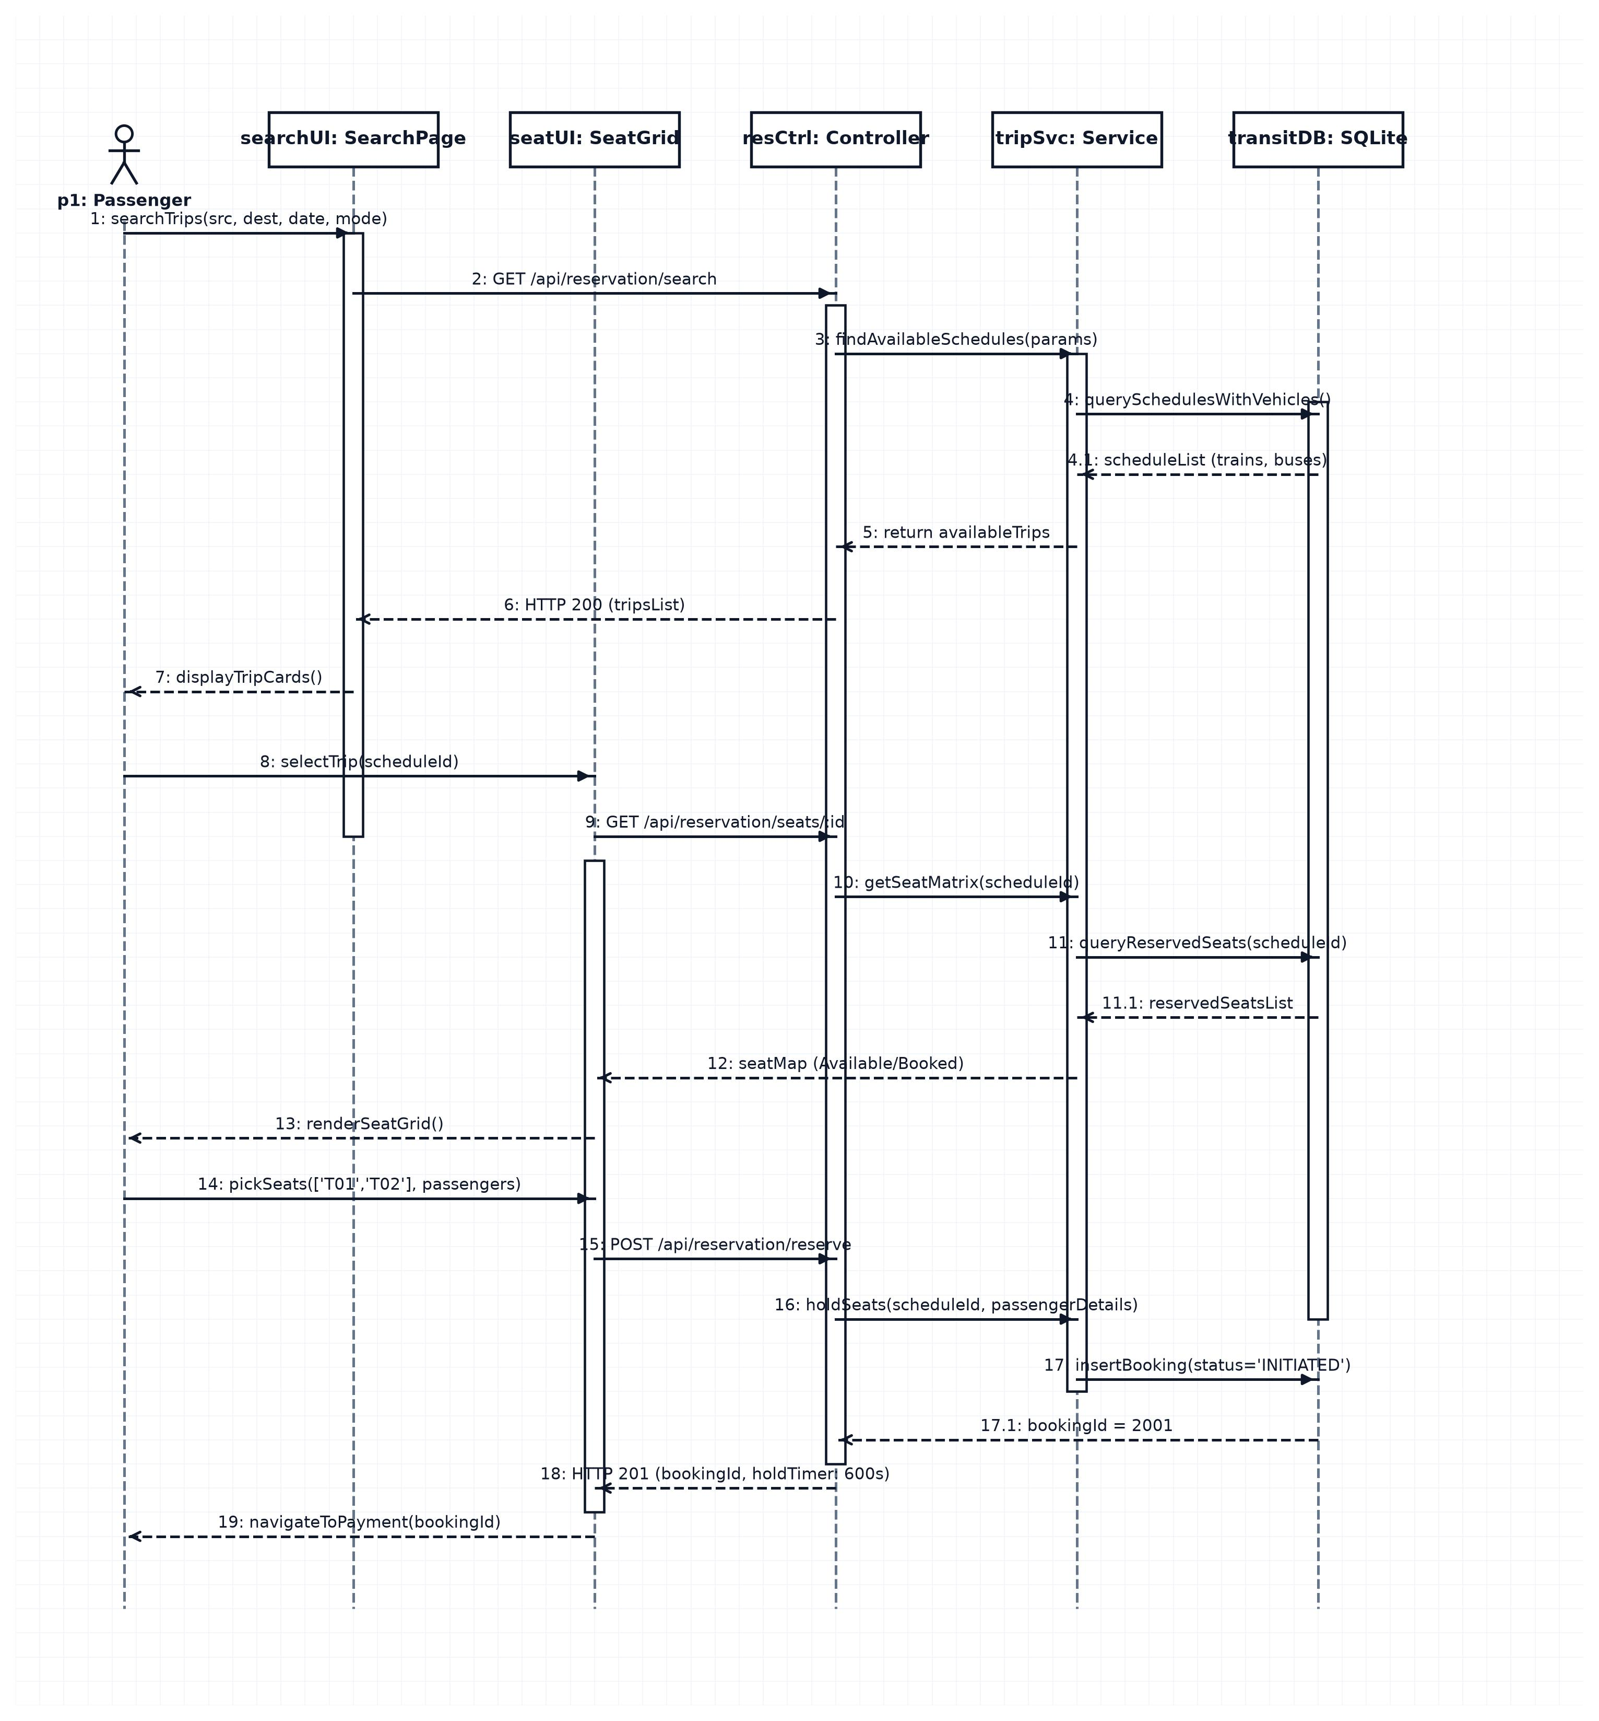
Module 2 – Ticket Search & Reservation

Module 3 – Payment & Booking Management
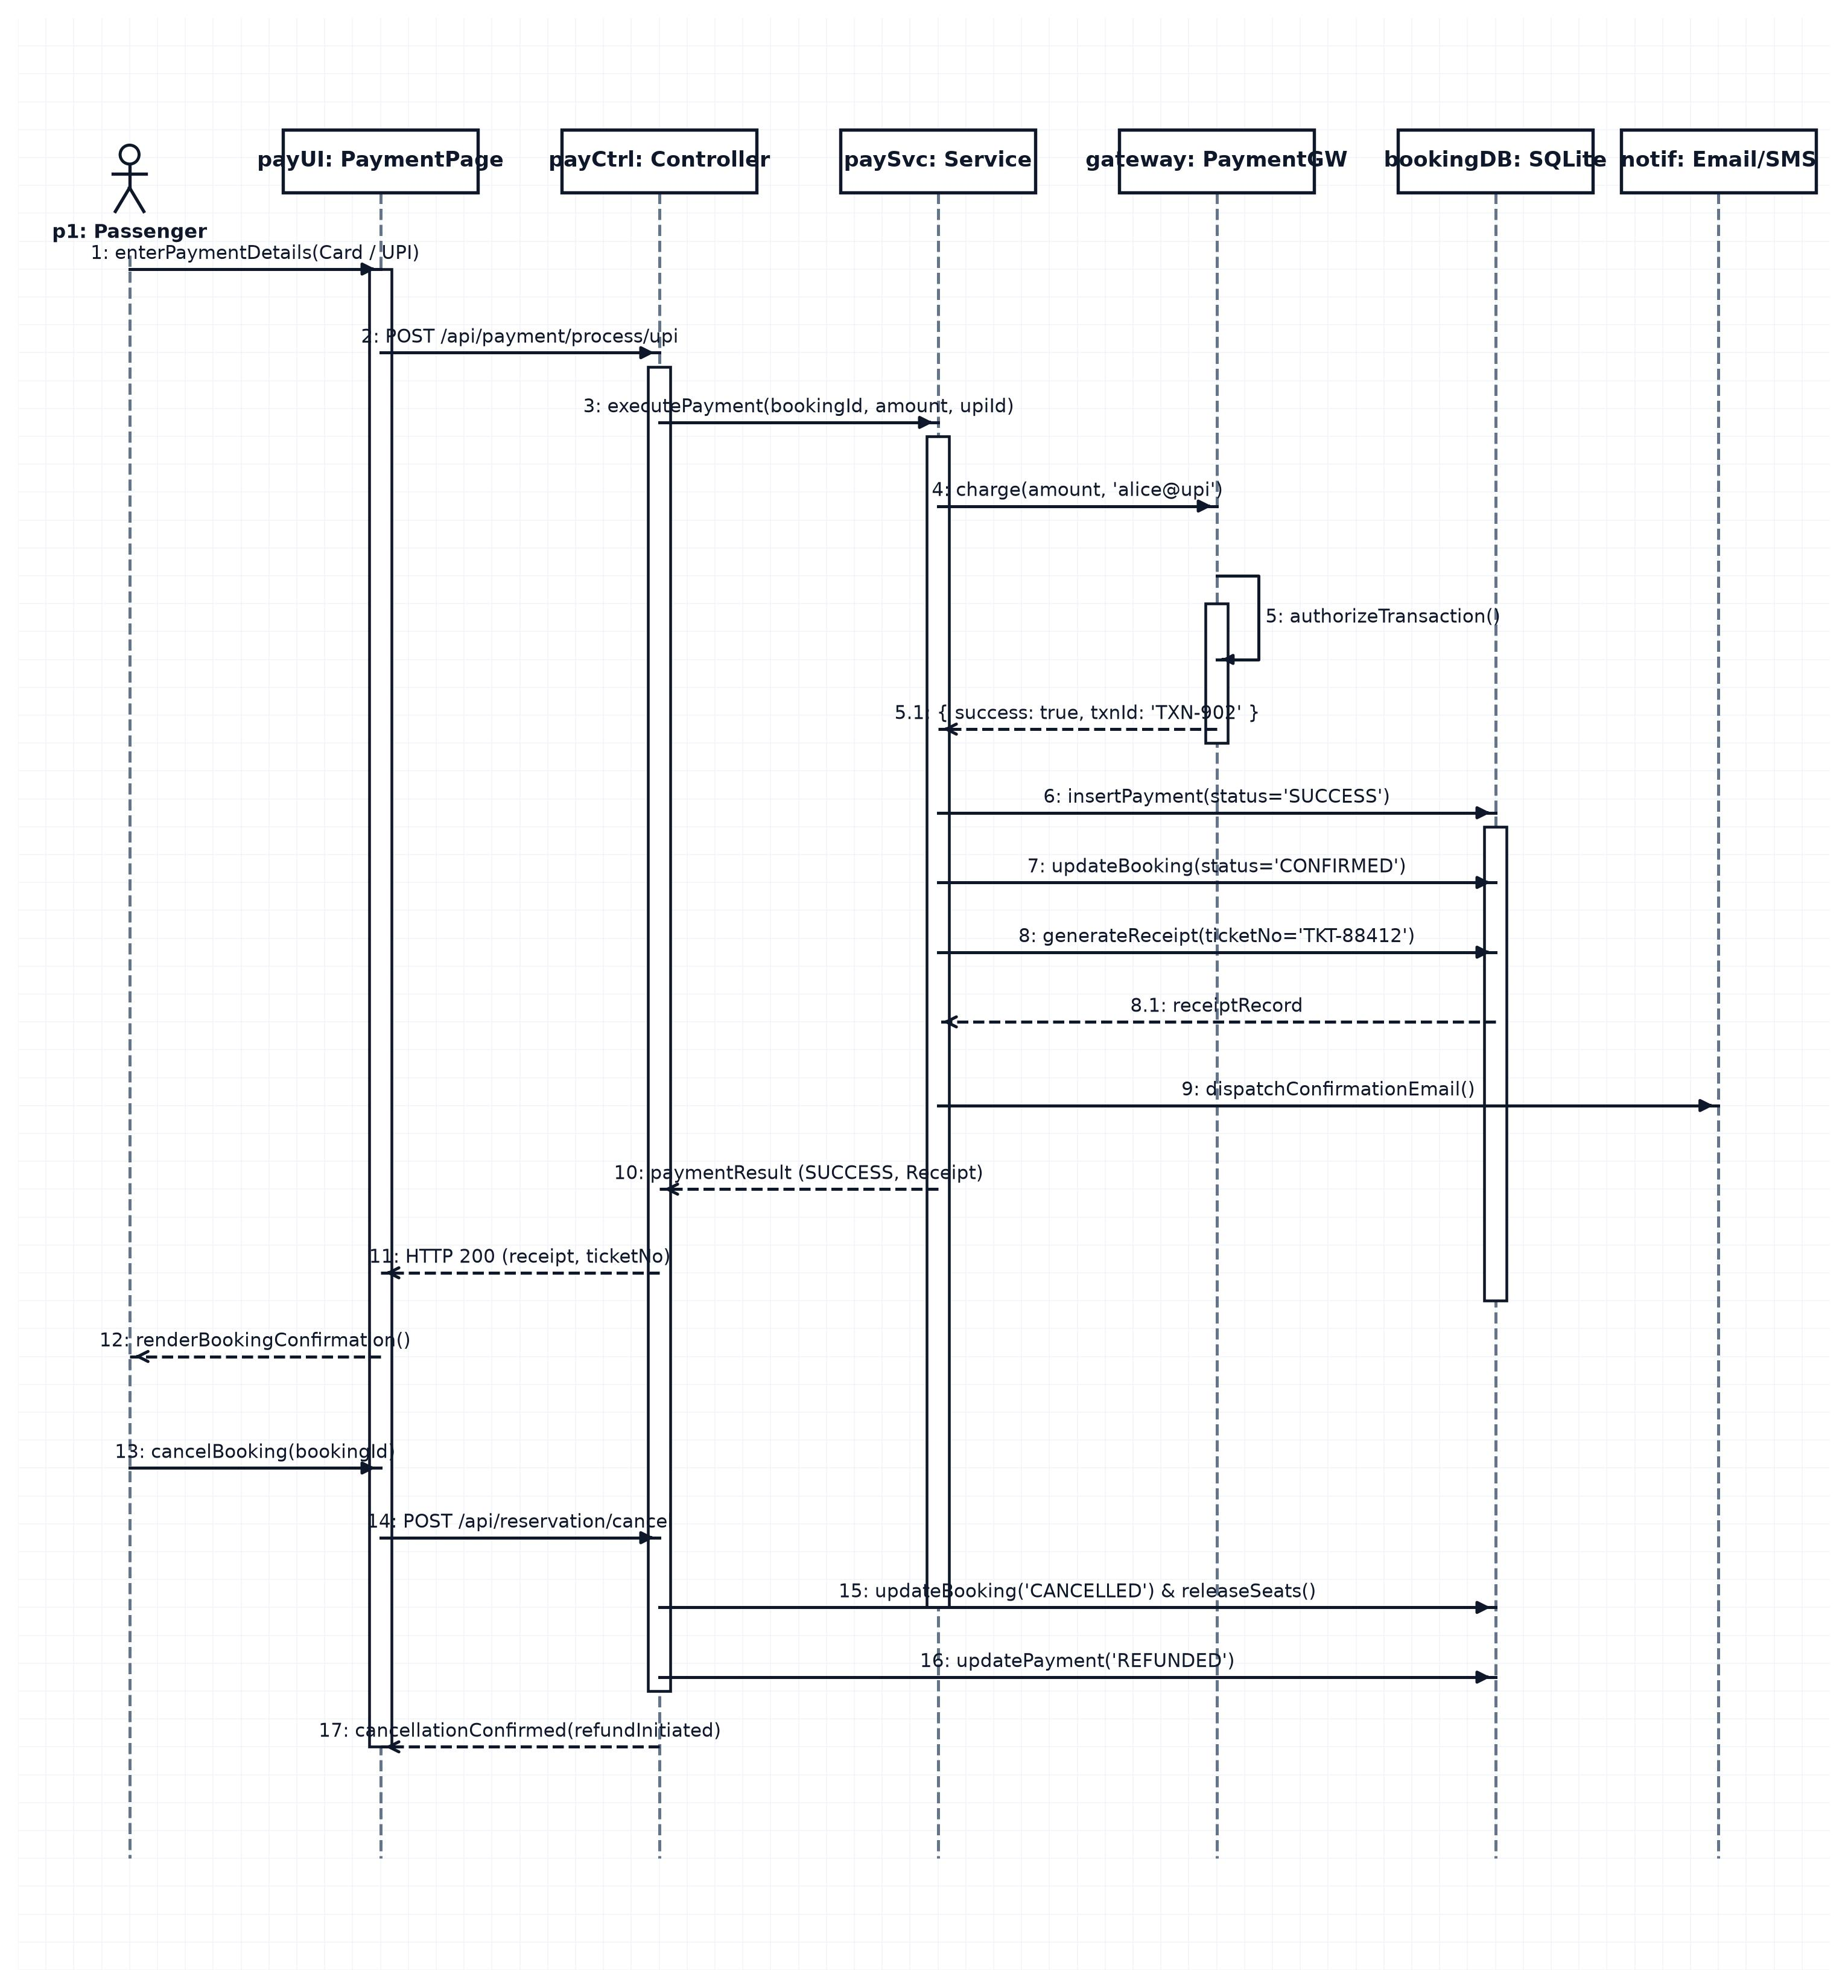

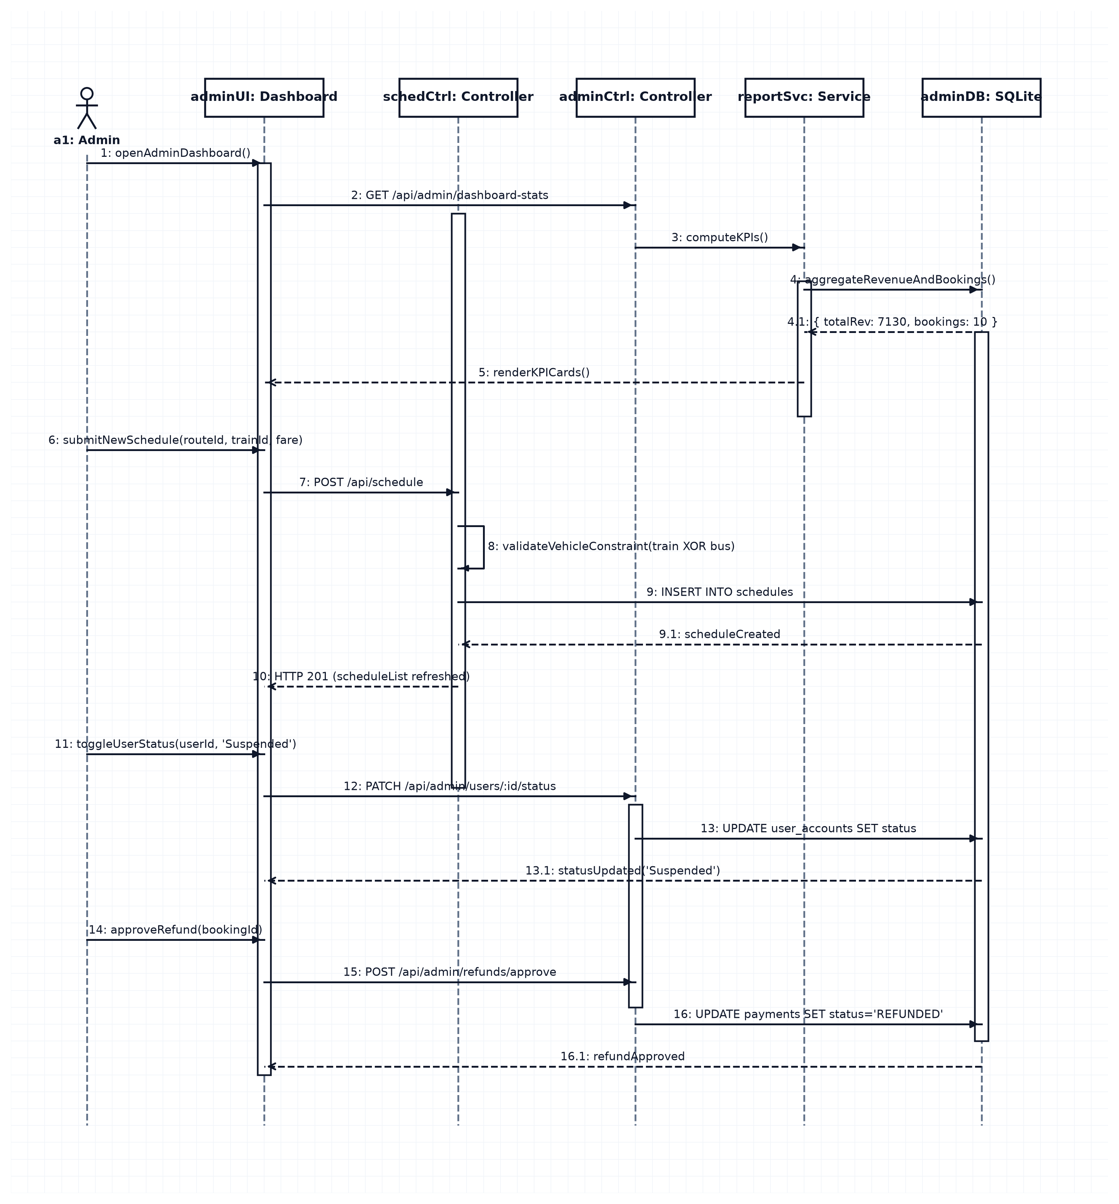
Module 4 – Admin & Schedule Management

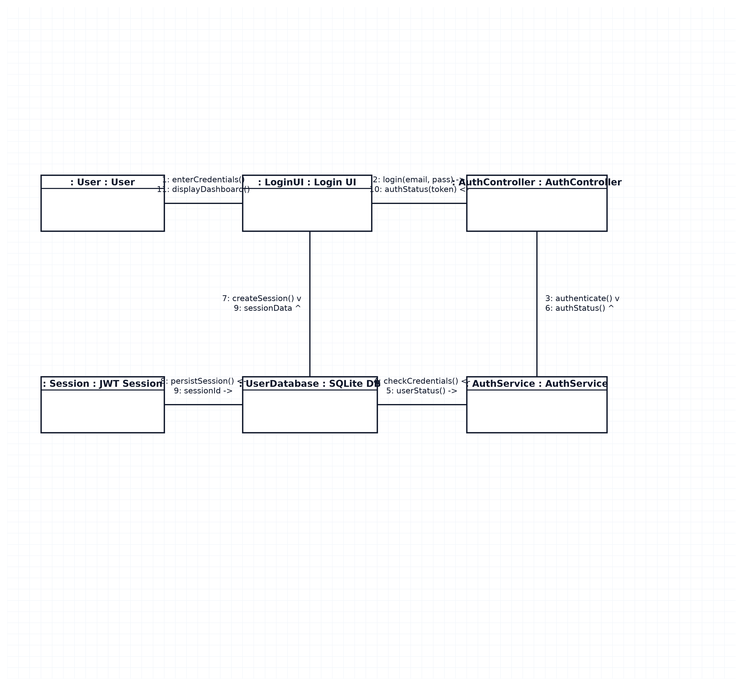
Collaboration Diagram for Login & User Management module:

Activity Diagram

Module 1 – Login & User Management

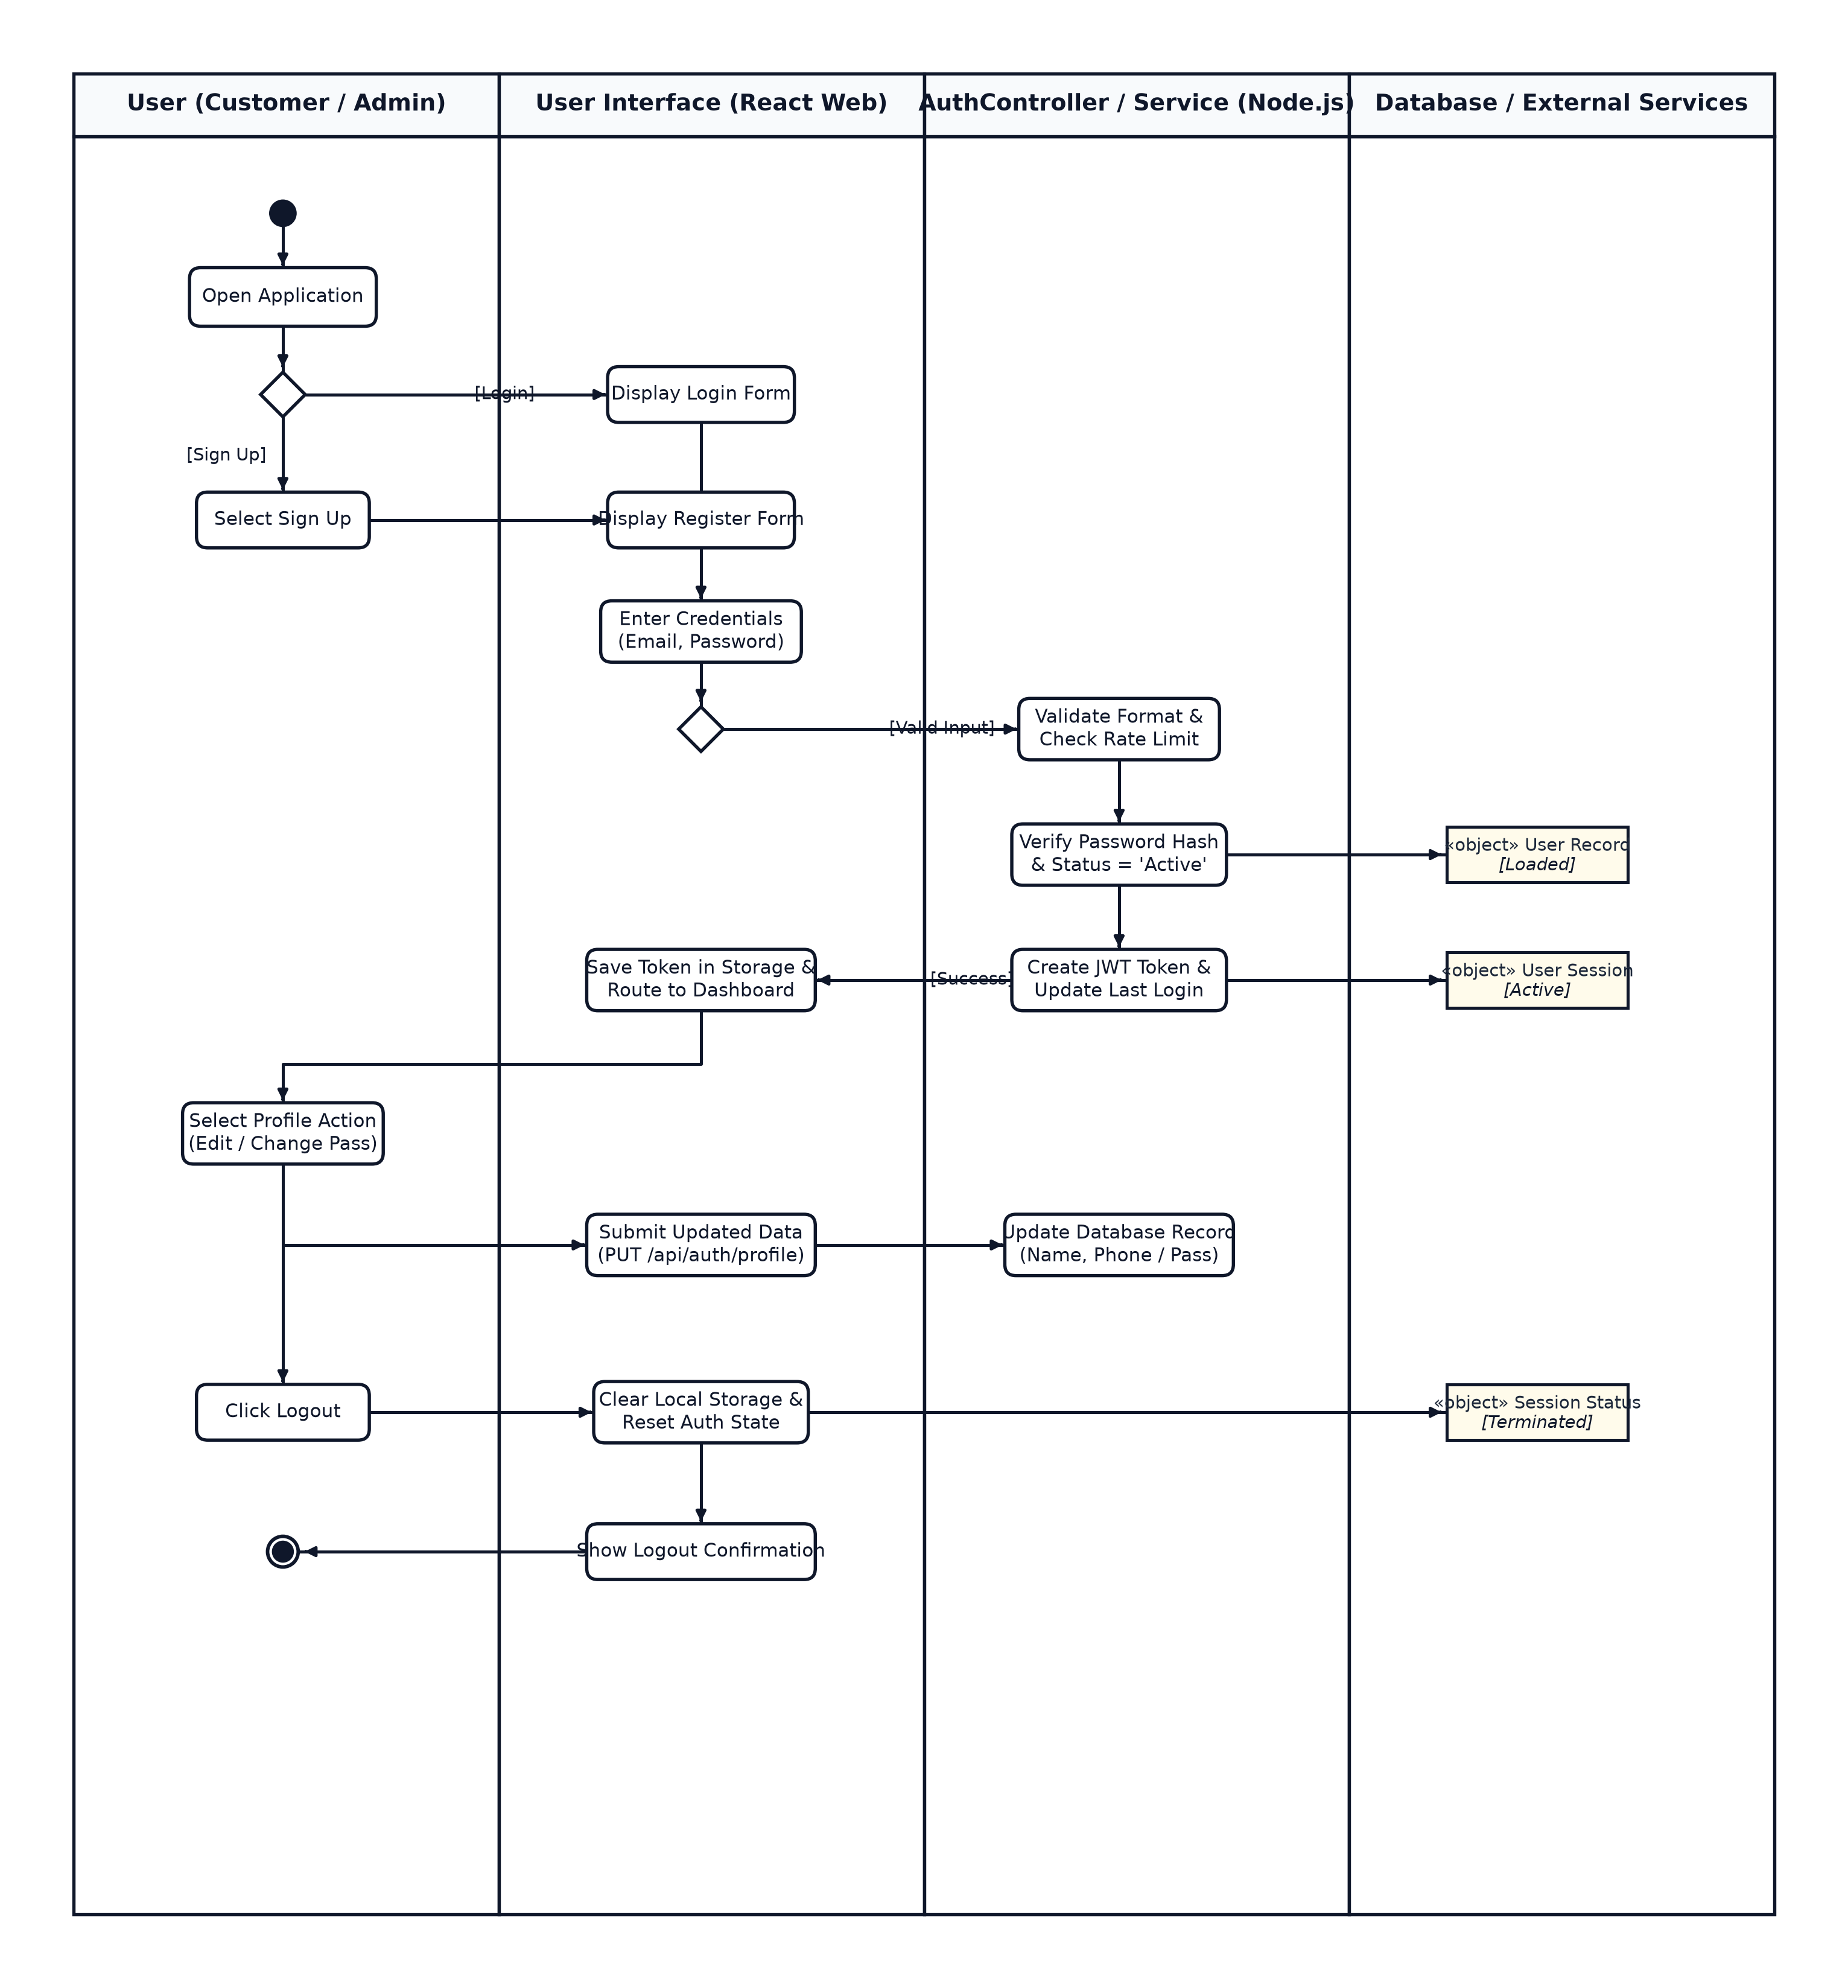

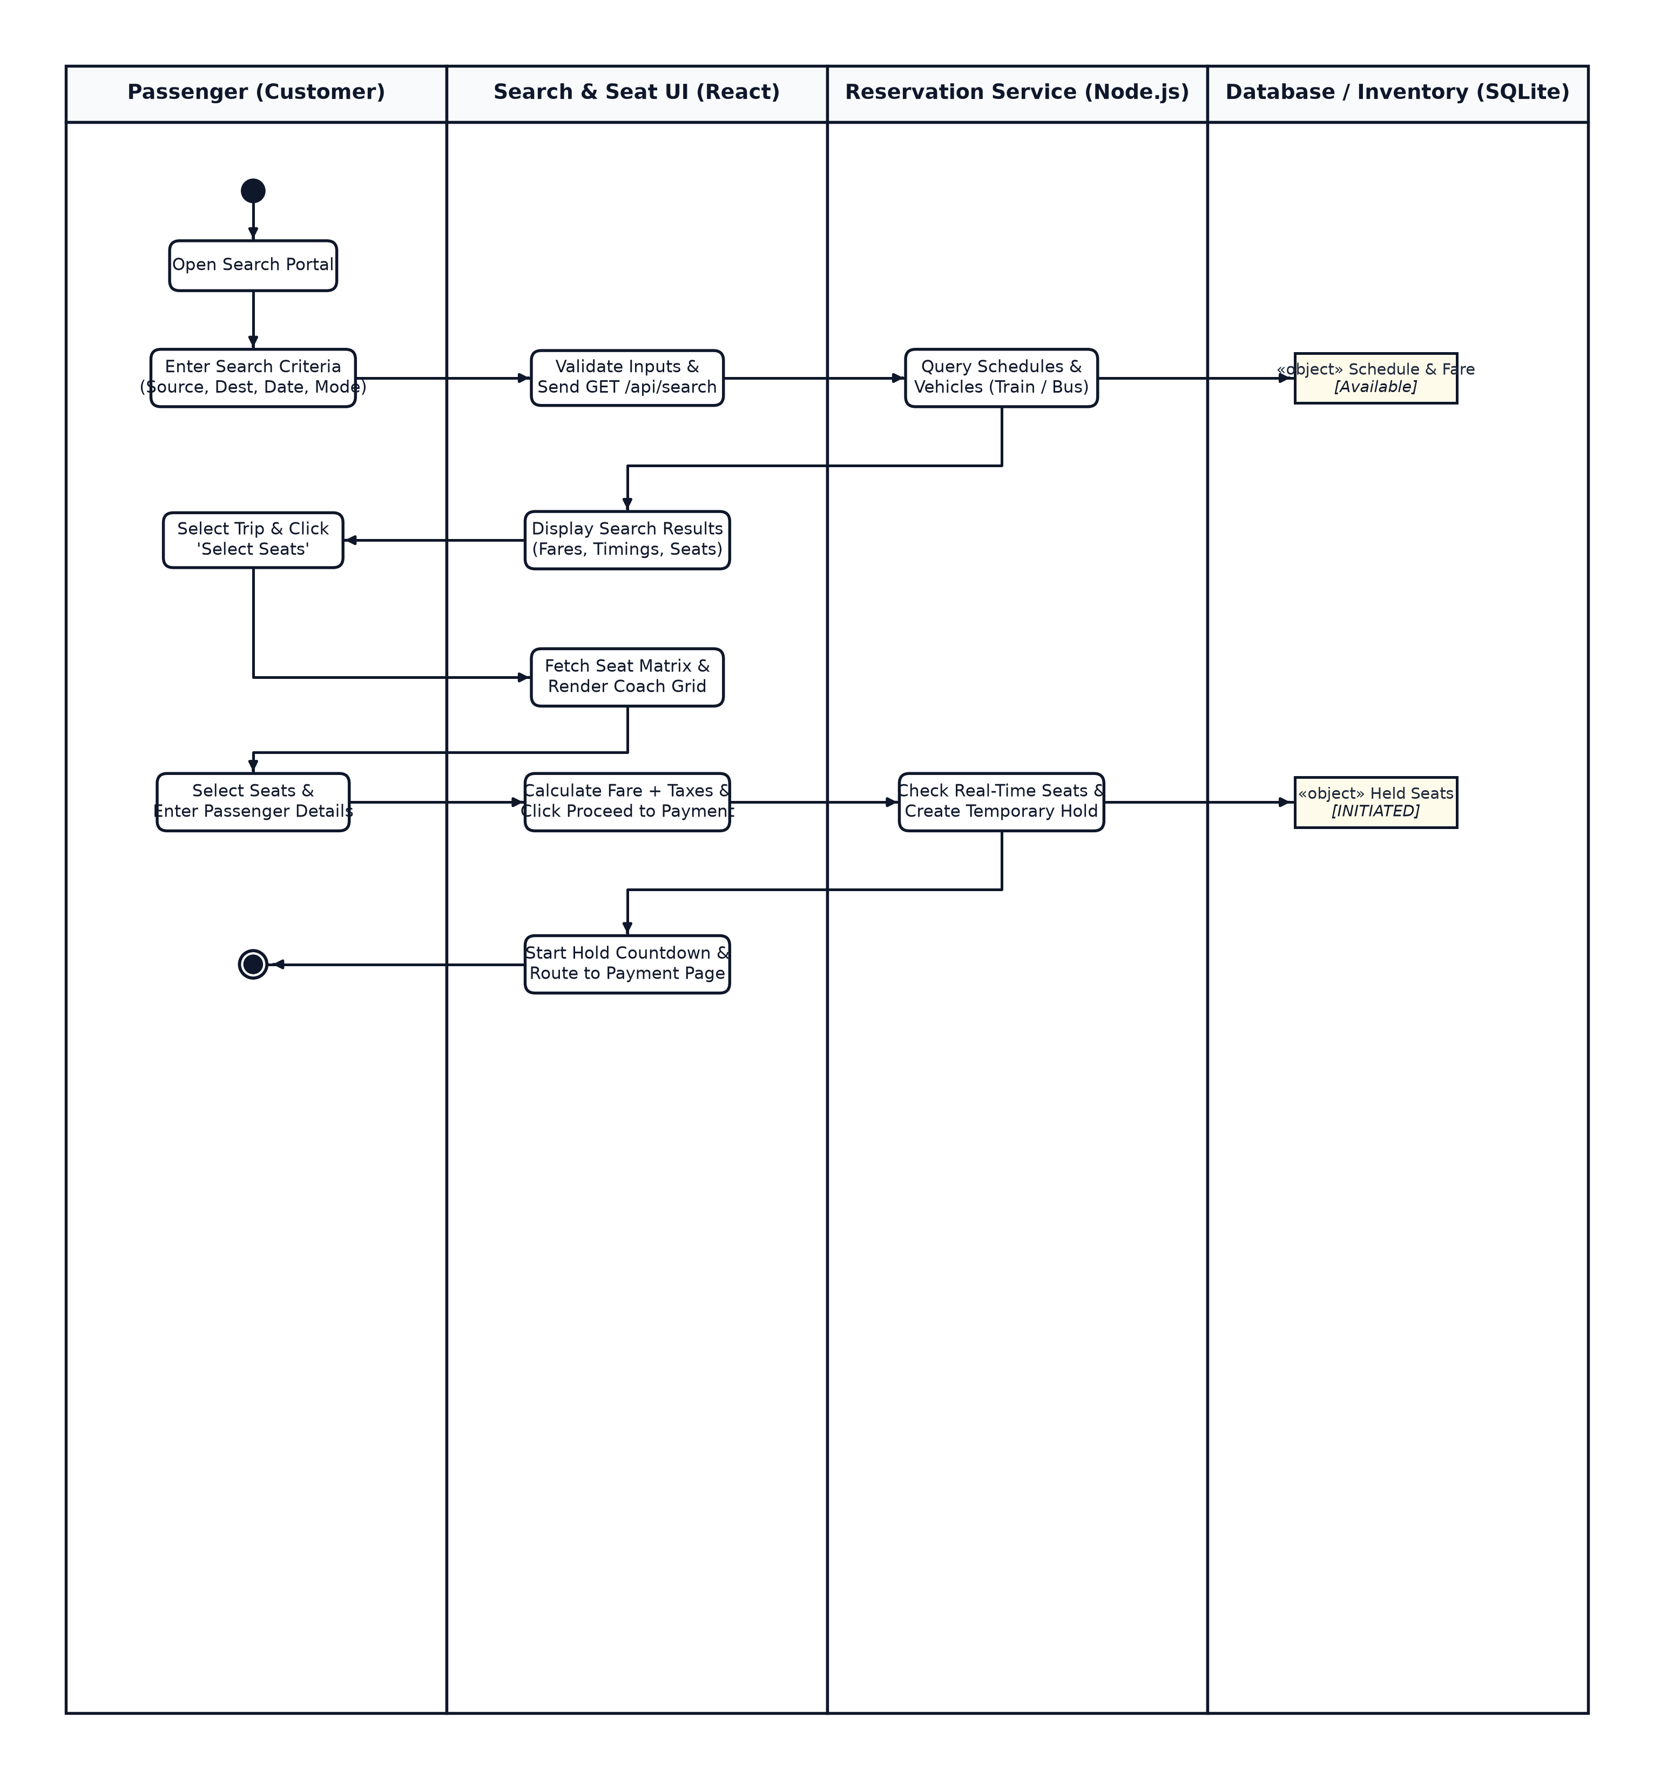
Module 2- Ticket Search & Reservation


Module 3- Payment & Booking Management

Module 4- Admin & Schedule Management

Overall Statechart diagram

.

Component diagram

Module 1 – Login & User Management:

Module 2 – Ticket Search & Reservation

Module 3 – Payment & Booking Management

Module 4 – Admin & Schedule Management
Overall Deployment Diagram

Java code generated using the Overall class diagram:
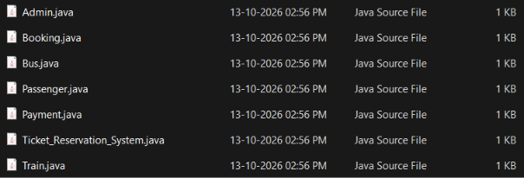

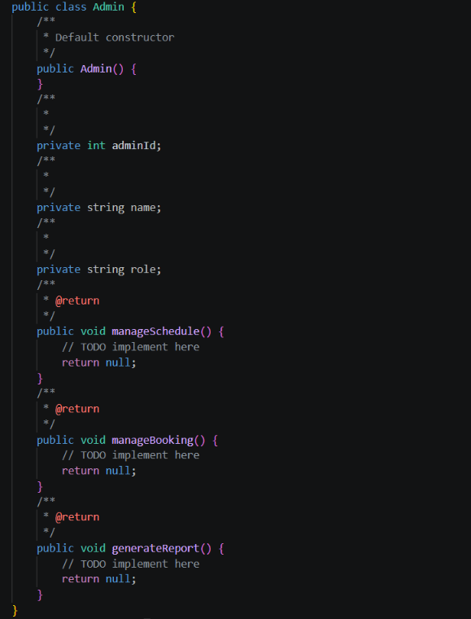

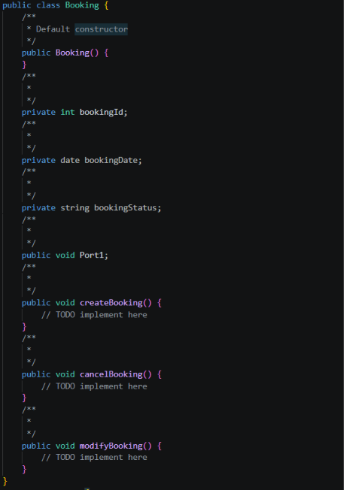

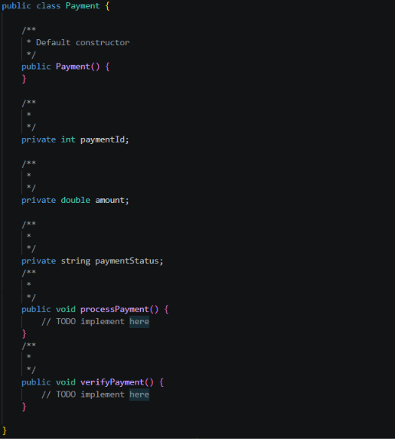

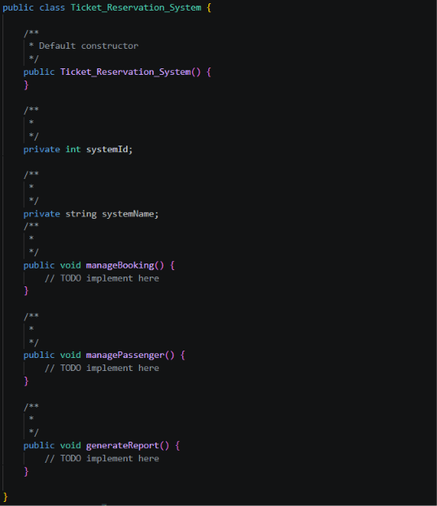

Sample UI Design:
