SUHAS R
1NT19IS163
C2 BATCH

1.Problem Statement & Dataset
Create a collection named "Employee" under the "EmployeeDB" database with each document in the format shown below Table
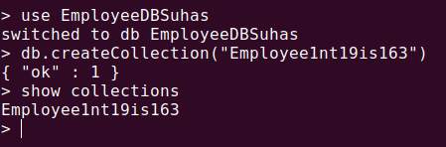

2. Queries
1. Populate the database with atleast 15 documents
db.Employee1nt19is163.insertMany([
{
Firstname: "-",
Middlename: "SUHAS",
Lastname: "R",
Age: 25,
Salary: 75000,
Designation: "Employee",
Role: ["Software developer","Tester"],
},
{
Firstname: "Vinay",
Middlename: "T",
Lastname: "G",
Age: 26,
Salary: 75000,
Designation: "HR",
Role: ["Manager","UI Designer"],
},
{
Firstname: "T",
Middlename: "Nikit",
Lastname: "R",
Age: 27,
Salary: 45000,
Designation: "Employee",
Role: ["Tester","Software Developer"],
},
{
Firstname: "M",
Middlename: "Kumar",
Lastname: "Babu",
Age: 27,
Salary: 70000,
Designation: "Researcher",
Role: ["Team Lead","Tester", "UI Designer"],
},
{
Firstname: "Rajesh",
Middlename: "P",
Lastname: "N",
Age: 36,
Salary: 50000,
Designation: "Scientist",
Role: ["UI Designer","Tester"],
},
{
Firstname: "vishal",
Lastname: "M",
Age: 36,
Salary: 50000,
Designation: "Scientist",
Role: ["UI Designer","Team Lead"]
},
]);

db.Employee1nt19is163.insertMany([
{
Firstname: "venky",
Middlename: "c",
Lastname: "h",
Age: 30,
Salary: 45000,
Designation: "Employee",
Role: ["Team Lead","Manager"]
},
{
Firstname: "vishruth",
Middlename: "Sai",
Lastname: "r",
Age: 30,
Salary: 40000,
Designation: "Employee",
Role: ["Junior Architect","Manager"],
},
{
Firstname: "T",
Middlename: "a",
Lastname: "adhi",
Age: 30,
Salary: 20000,
Designation: "Employee",
Role: ["Software developer","Tester"],
},
{
Firstname: "Vishal",
Middlename: "Kumar",
Lastname: "H K",
Age: 40,
Salary: 75000,
Designation: "Scientist",
Role: ["Research and Developer","Tester"],
},
{
Firstname: "V",
Middlename: "Mohan",
Lastname: "Babu",
Age: 38,
Salary: 750000,
Designation: "President",
Role: ["Software developer","Research and Developer"]
},
]);

db.Employee1nt19is163.insertMany([
{
Firstname: "Rajesh",
Middlename: "C",
Lastname: "R",
Age: 25,
Salary: 25000,
Designation: "Employee",
Role: ["Junior Lead","Junior Architect"],
},
{
Firstname: "Sohal",
Middlename: "M",
Lastname: "N",
Age: 33,
Salary: 60000,
Designation: "Employee",
Role: ["Junior Engineer","Software developer"],
},
{
Firstname: "Pranay",
Middlename: "M",
Lastname: "V L S S S",
Age: 28,
Salary: 75000,
Designation: "Employee",
Role: ["Software developer","UI Designer"],
},
{
Firstname: "abhi",
Middlename: "S",
Lastname: "A",
Age: 29,
Salary: 50000,
Designation: "Scientist",
Role: ["Research and Developer","UI Designer"],
},
{
Firstname: "punith",
Middlename: "kumar",
Lastname: "B",
Age: 30,
Salary: 20000,
Designation: "System Engineer",
Role: ["Intern","Software developer"],
},
]);

2. List all the records having salary in the range of 20000 – 35000(Exclusive)

db.Employee1nt19is163.find({$and:[{Salary:{$gt:20000}},{Salary:{$lt:35000}}]}).pretty()

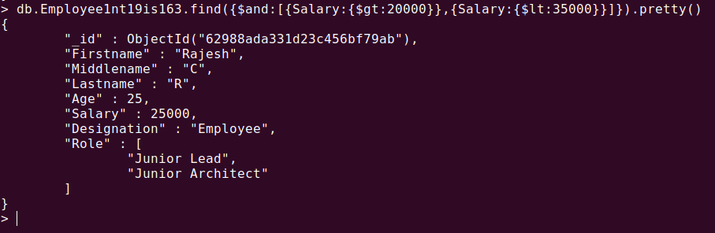
3. List all the Employee whose Middle name is "Kumar"
db.Employee1nt19is163.find({Middlename:"Kumar"}).pretty()
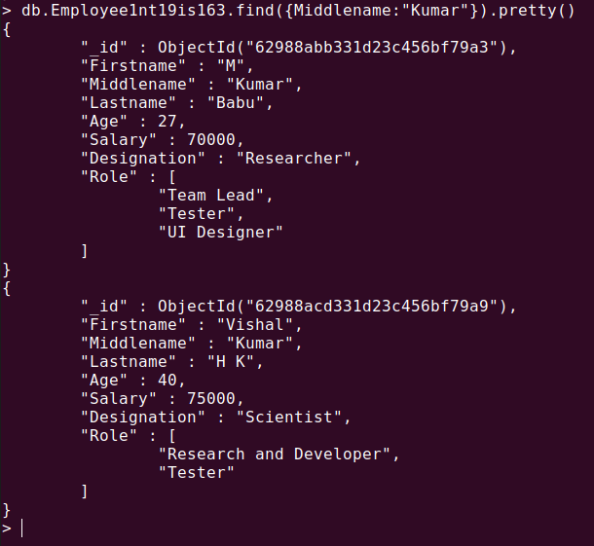

4.Count the number of Employees who has a role "Manager" in the Role field.
db.Employee1nt19is163.count({Role:"Manager"}).pretty

5. Find out all the documents who have age < 35 and salary in the range of 30000-50000
db.Employee1nt19is163.find({$and:[{Salary:{$gt:30000}},{Salary:{$lt:50000}},{Age:{$lt:35}}]}).pretty()

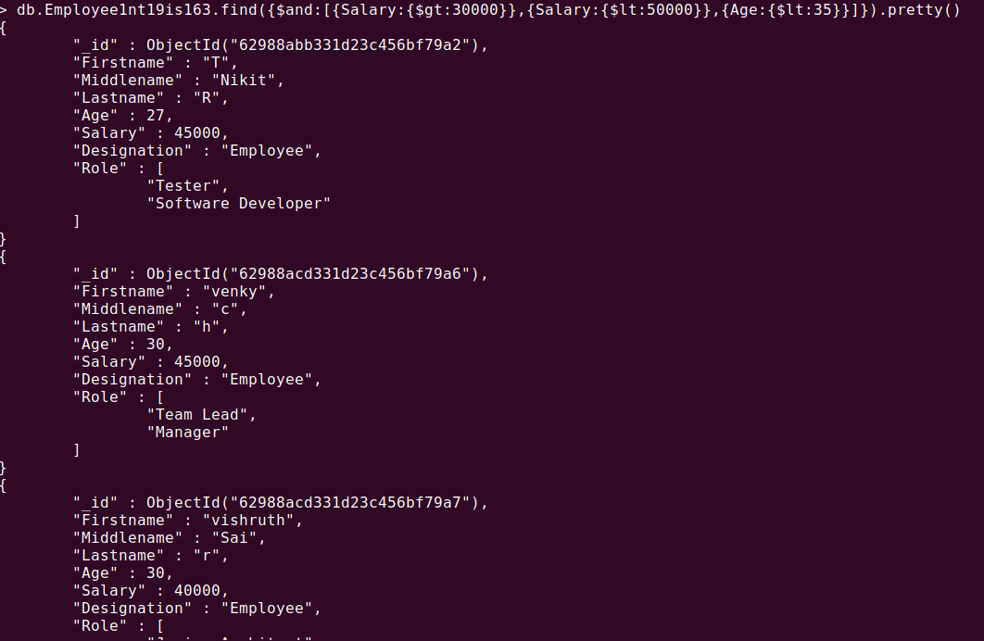

6.Delete an Employee whose "Firstname" is "Rajesh" and having the designation as "Scientist"
db.Employee1nt19is163.deleteOne({$and:[{Firstname:"Rajesh"},{Designation:"Scientist"}]})
db.Employee1nt19is163.find()

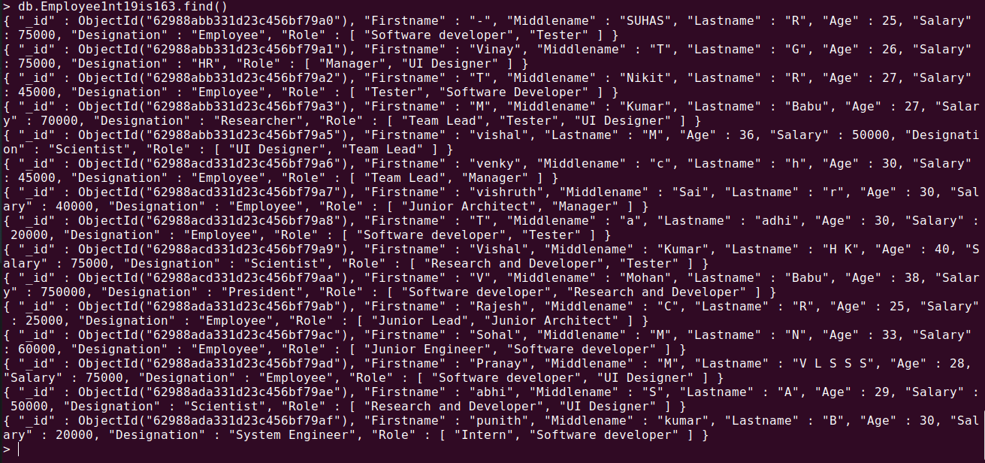

7. Update all the Employees whose role is "Team Lead" with a salary of 55650 INR
db.Employee1nt19is163.updateMany({Role:"Team Lead"},{$set:{Salary:55650}})

db.Employee1nt19is163.find()

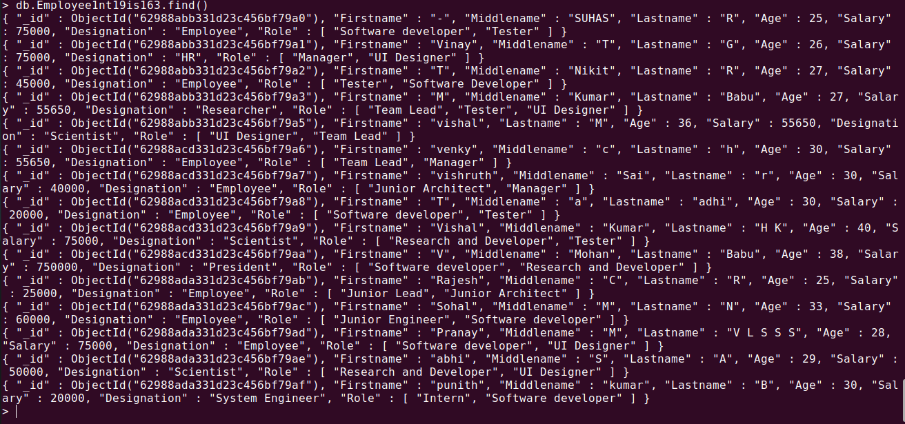

8. Group all the Employees by their age(common age should be there) and calculate the average salary obtained in the each group
db.Employee1nt19is163.aggregate([{$group:{_id:"$Age",Average:{$avg:"$Salary"}}}])

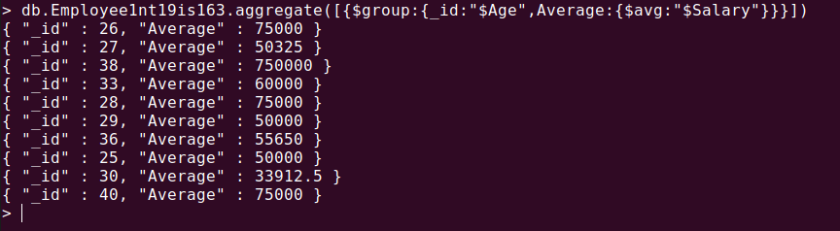

9. Apply the map-reduce to perform the above operation and obtain the results
var mapfunction=function(){emit(this.Age,this.Salary)}
var reducefunction=function(key,values){return Array.avg(values)}
db.Employee1nt19is163.mapReduce(mapfunction,reducefunction,{'out':'result'})
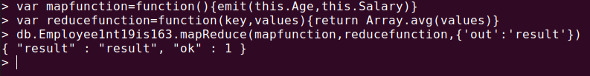
db.result.find()
