SUHAS R
1NT19IS163
C2

Tasks To complete,

To start with hadoop
hadoop version
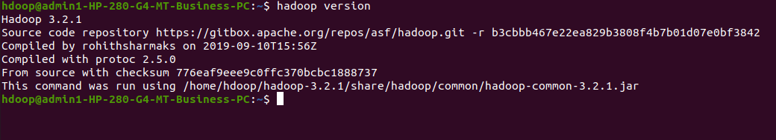

start-dfs.sh
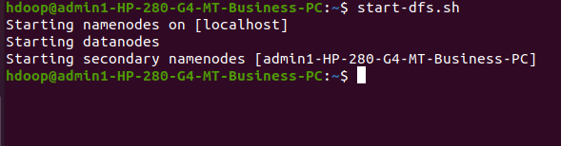
1. Create a directory named by your name
hadoop fs -mkdir /suhas
hadoop fs -ls /
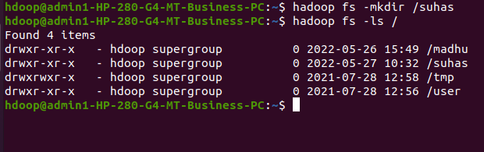

2. Add two empty files
hadoop fs -touchz /suhas/o.txt
hadoop fs -touchz /suhas/a.txt
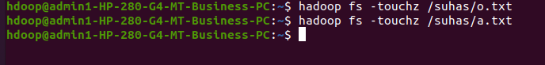
3. List all the files in the directory that you have created
hadoop fs -ls /suhas
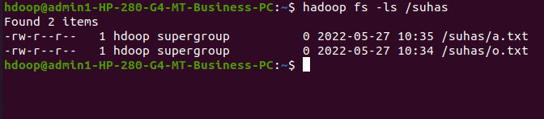
4. Create one more directory by your usn and put that inside the directory of your name
hadoop fs -mkdir /suhas/1NT19IS163
hadoop fs -ls /suhas
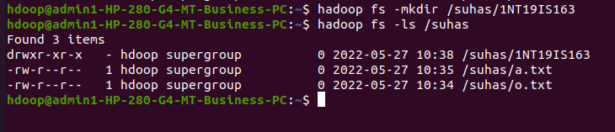
5. Create a file in your local system by the name_usn.txt and add the contents as "Syntax to list Is command is hadoop fs -Is "
cat > suhas_1NT19IS163.txt
"Syntax to list ls command is hadoop fs -ls"
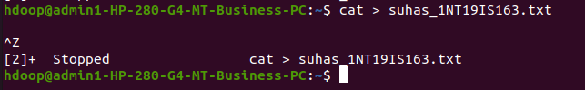

6. Put the file usn_name.txt in your hdfs directory called usn
hadoop fs -touchz /suhas/1NT19IS163/1NT19IS163_suhas.txt
hadoop fs -ls /suhas/1NT19IS163
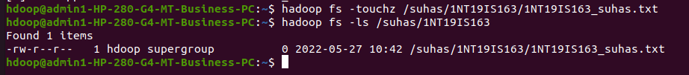
7. Put empty file of hdfs into the local file system
hadoop fs -copyToLocal /suhas/1NT19IS163/1NT19IS163_suhas.txt
ls
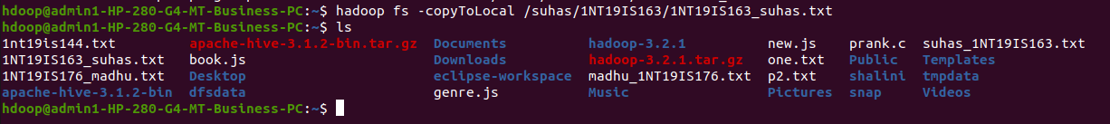
8. Use mv command to move files from local file system and hdfs file system
hadoop fs -mv /suhas/a.txt /suhas/1NT19IS163
hadoop fs -ls /suhas/1NT19IS163
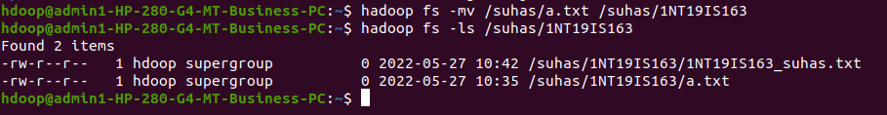
9. Experiment of cp command
hadoop fs -cp /suhas/o.txt /suhas/1NT19IS163
hadoop fs -ls /suhas/1NT19IS163
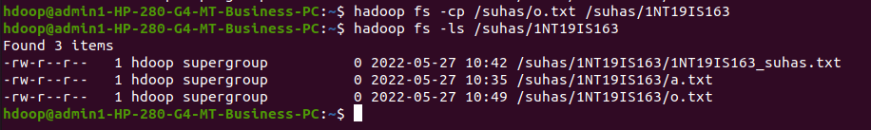

10. Display the total size of all the files in name directory
hadoop fs -moveFromLocal suhas_1NT19IS163.txt /suhas
hadoop fs -du /suhas
hadoop fs -du -s /suhas
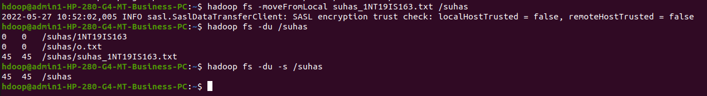
11. Display each file size in usn directory Use stat command on name and usn directories
hadoop fs -du /suhas/1NT19IS163
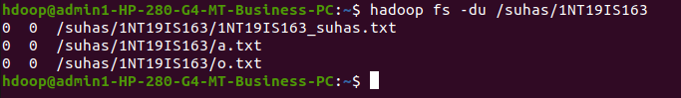
12. Illustrate the use of append command
cat > o.txt
hii
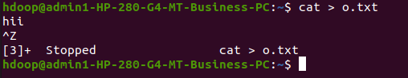

hadoop fs -appendToFile o.txt /suhas/1NT19IS163/a.txt
hadoop fs -cat /suhas/1NT19IS163/a.txt

