Medilink One Health One Card
In this project we are combining Health Management & AI power to ease patient disease prediction and to manage patients Records. Propose application allows patients to sign up with the application and then can get authenticated using login option. After login patients can view list of doctors and can book or schedule appointment with desired doctors. Patients can meet with the doctor on scheduled appointment and their generated prescription will be saved in database. Generated prescription can be access by patients anytime online.
Doctors also can sign up and authenticate themselves via login, after login doctors can view list of appointments and generate prescription for visited patients.
Doctors are enabled with AI modules equipped with CNN and SVM algorithm and doctor can upload patient brain MRI to application and then CNN will give instant prediction to doctor and based on prediction doctor will suggest medicines to patients.
All the above records are electronically saved inside MYSQL database.
To run project copy content from DB.txt file and then paste in MYSQL console to create database. Now double click on ‘run.bat’ file to start python DJANGO web server and then will get below page.
When application started at that time system will train SVM and CNN with PCA features selected and then calculate accuracy on predicted test data. In below screen showing code for SVM and CNN performing prediction on test data
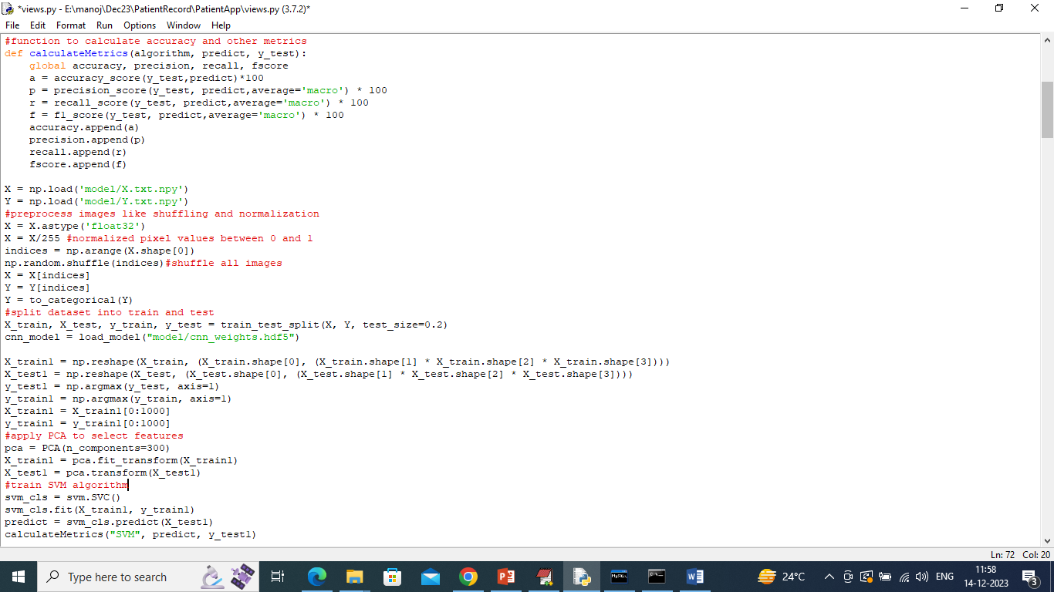
In above screen read red colour comments to know about SVM, CNN with PCA training
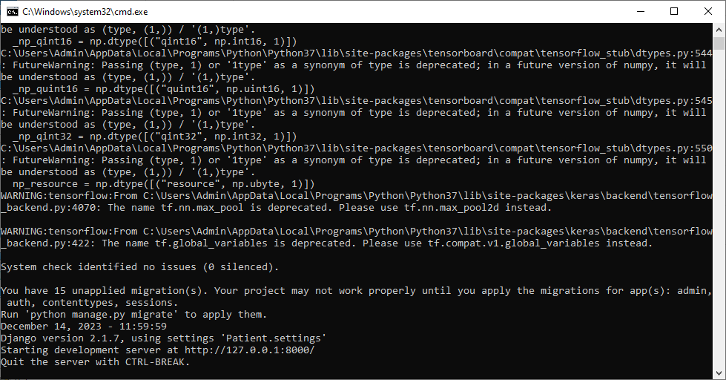
In above screen PYTHON web server started and now open browser and enter URL as http://127.0.0.1:8000/index.html and press enter key to get below page
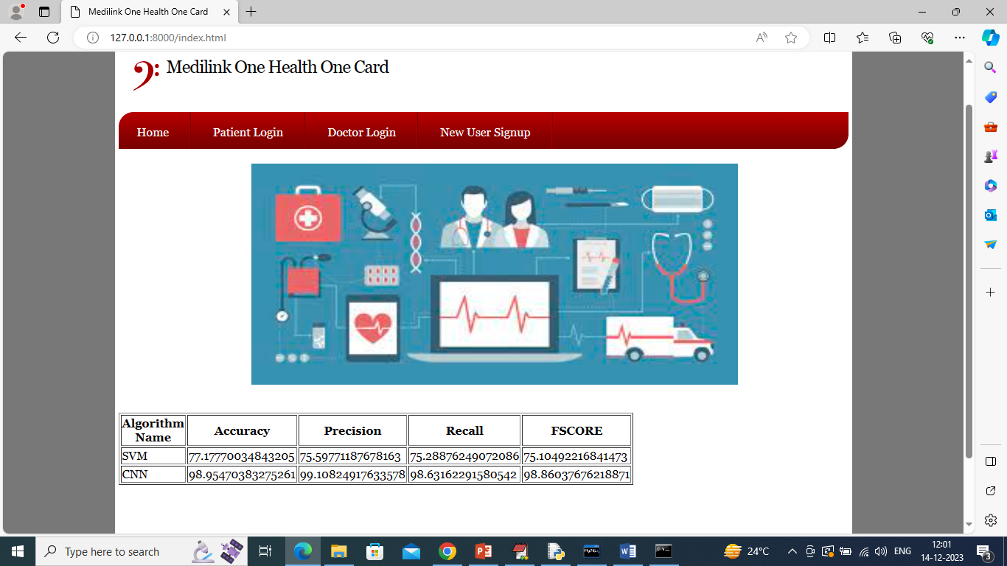
In above screen can see SVM and CNN training completed and can see both algorithm accuracy and other metrics and in both algorithm CNN accuracy or performance is high and now click on ‘New User Signup’ link to get below page
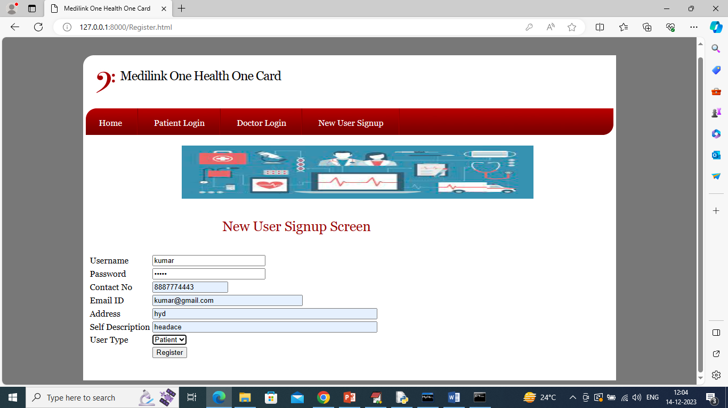
In above screen patient is entering sign up details and then press button to get below page
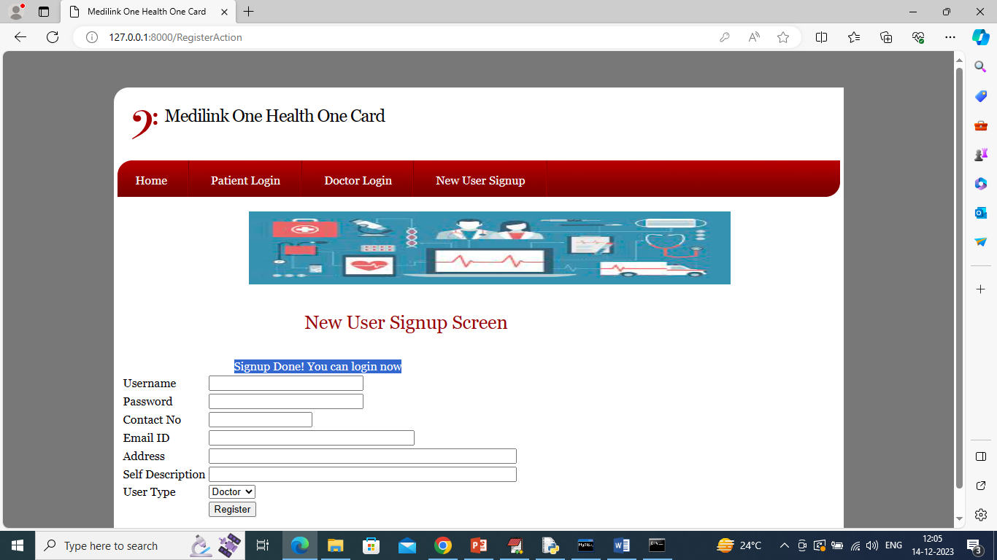
In above screen patient sign up completed and similarly sign up doctor also
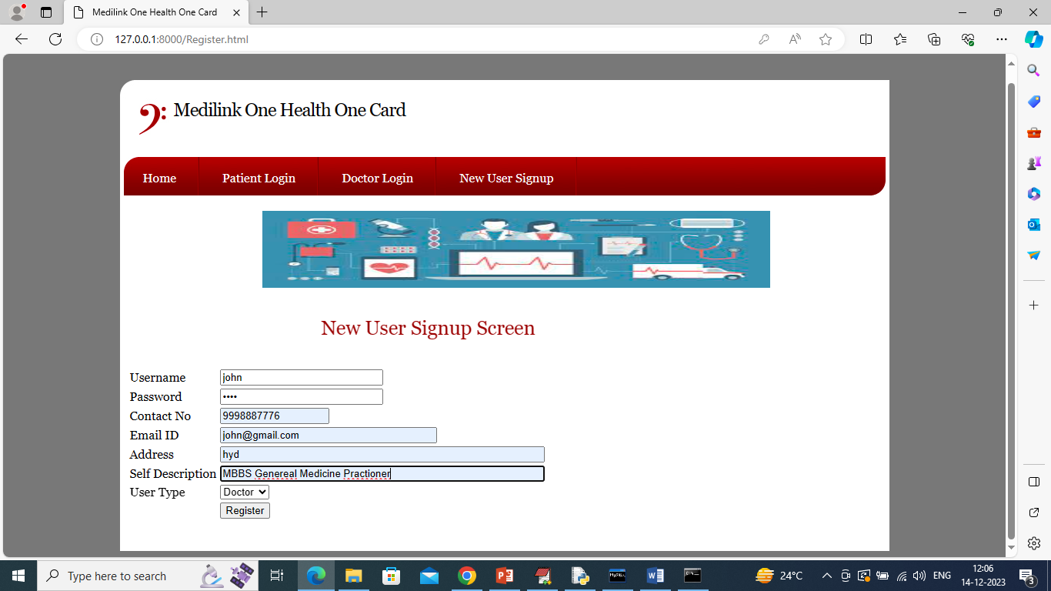
In above screen doctor is entering signup details and then press button to complete sign up and get below page
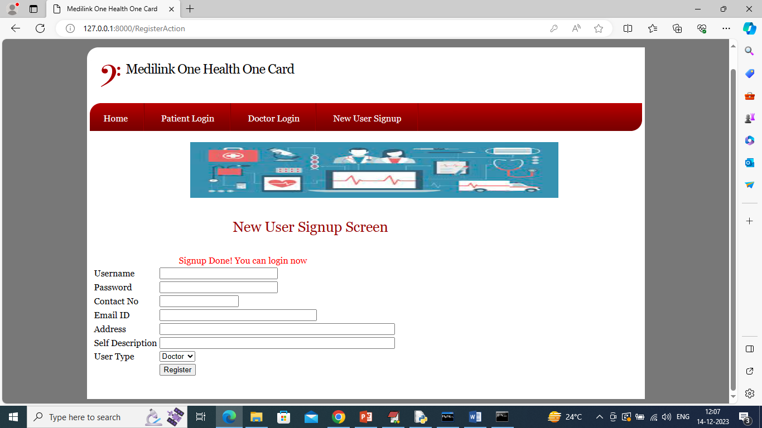
In above screen doctor sign up completed and now click on ‘Patient Login’ link to get below page
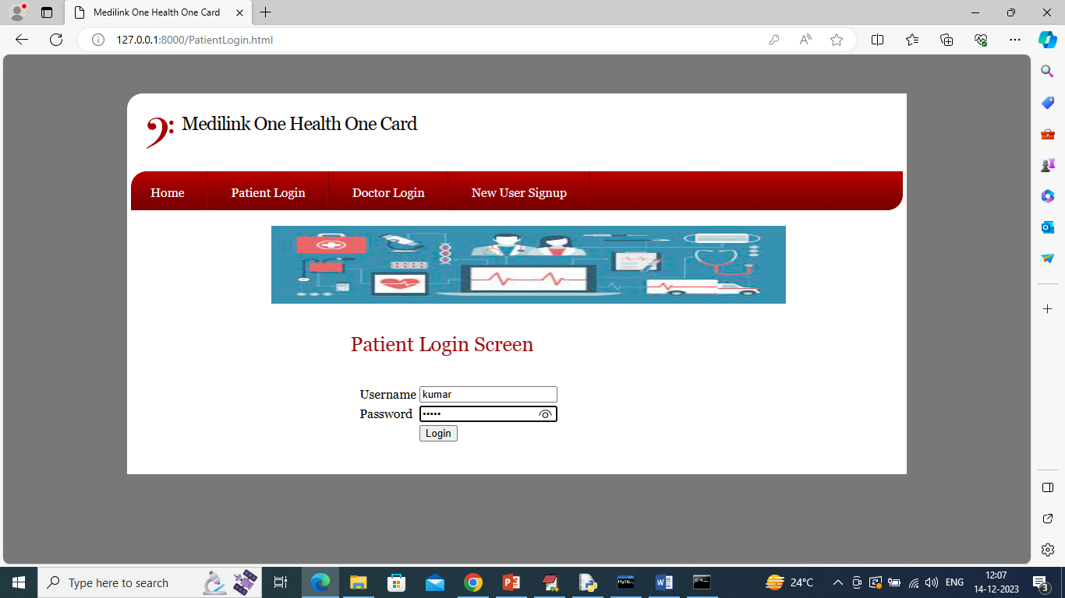
In above screen patient is login and after login will get below page
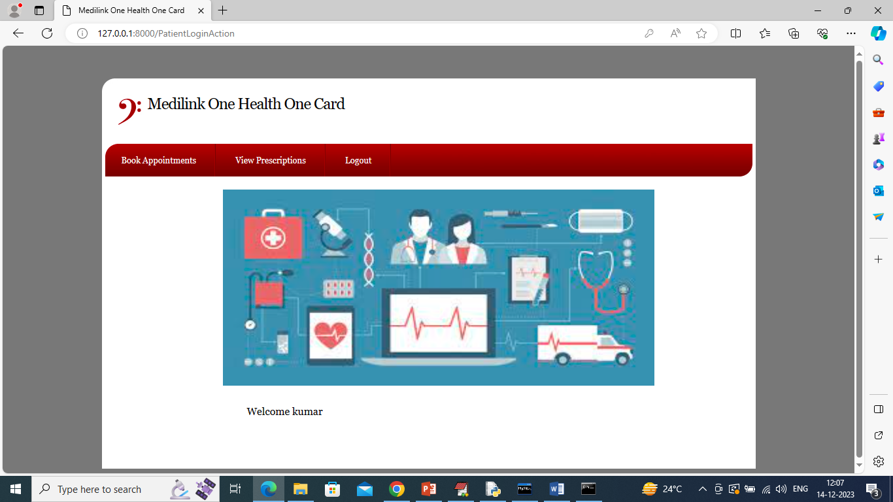
In above screen patient can click on ‘Book Appointment’ link to view below list of doctors
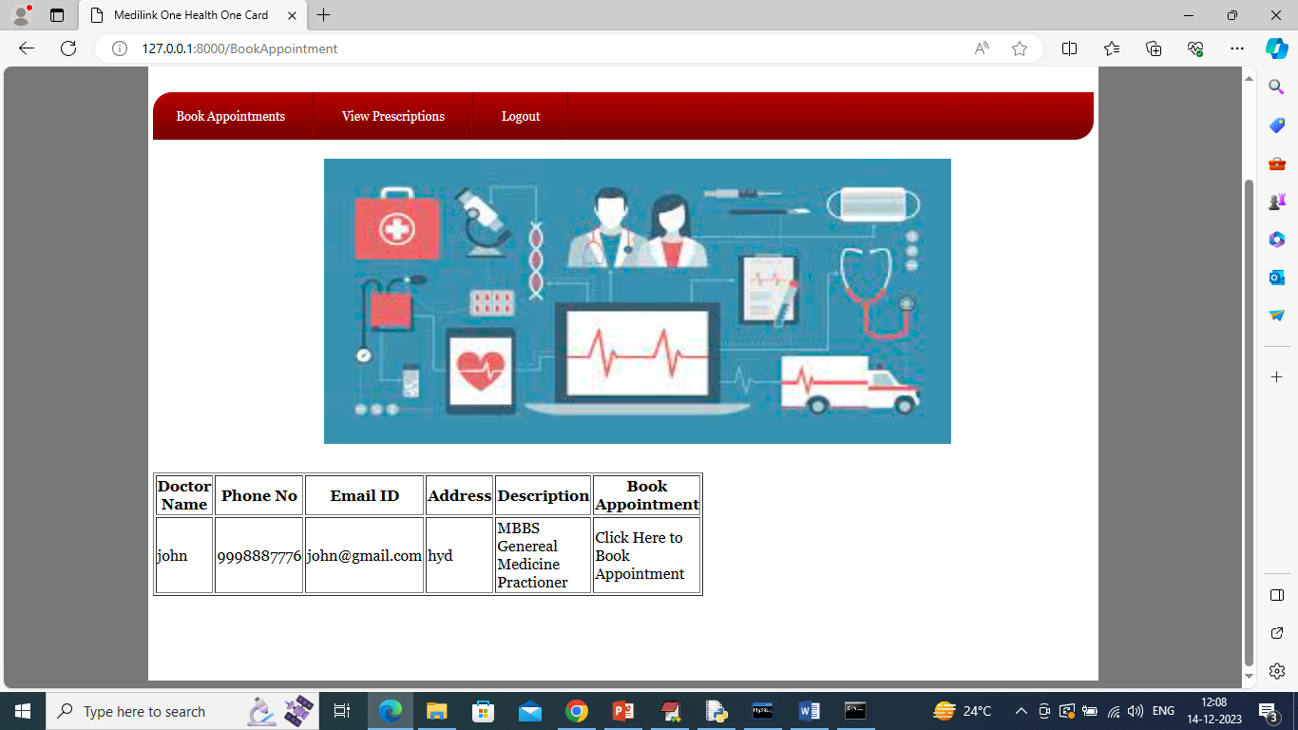
In above screen patient can view list of all sign up doctors and then can click on ‘Click Here to Book Appointment’ link to schedule appointment with selected doctor and get below page
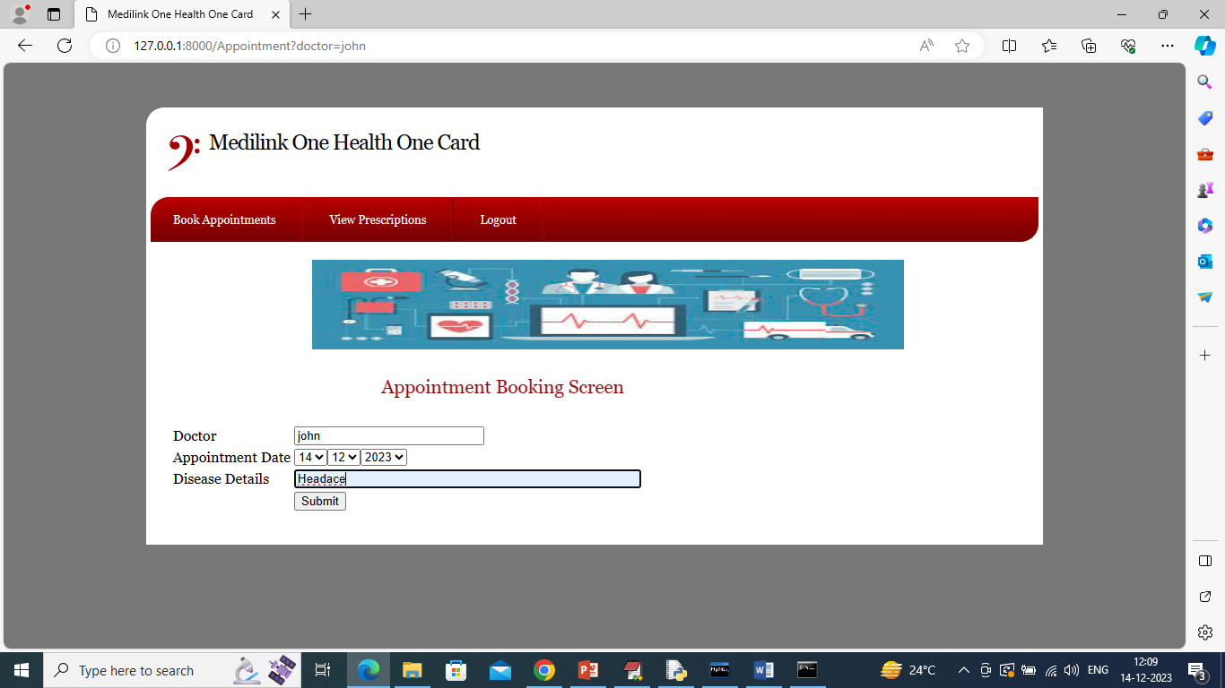
In above screen doctor name is default selected and can choose date from drop down box and then enter disease details and press button to get below page
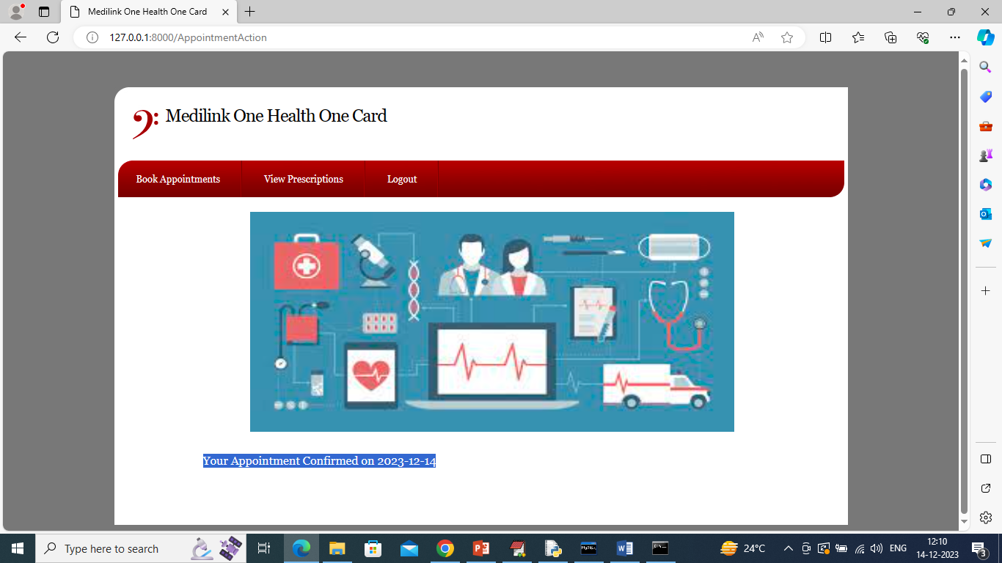
In above screen in blue text can see appointment is confirmed and now click on ‘View Prescription’ link to get below page
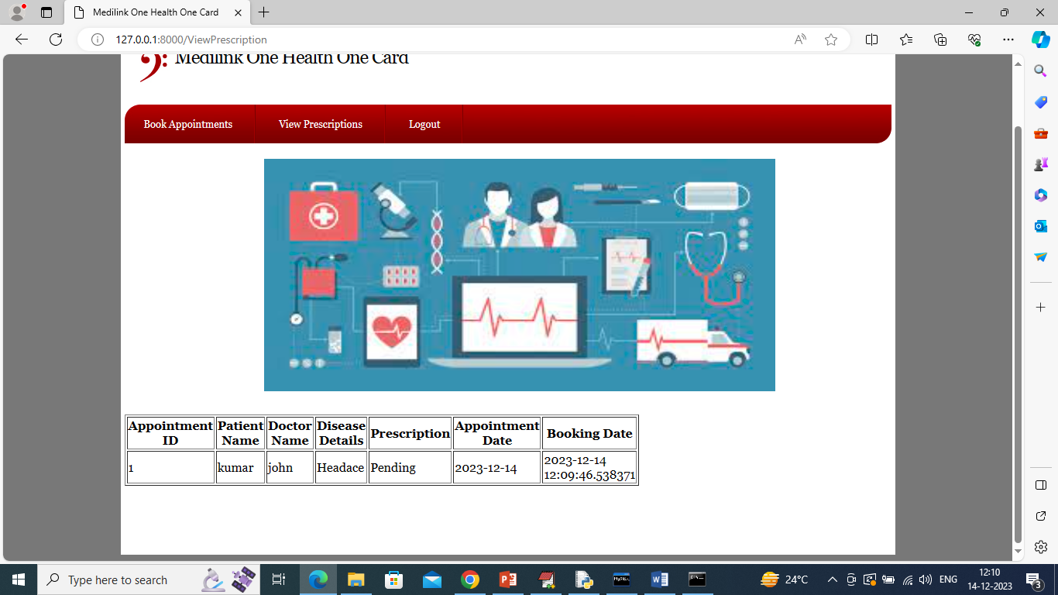
In above screen can see patient appointment is confirmed and prescription is pending and once doctor generated prescription then patient can access all those prescriptions and now logout and login as doctor
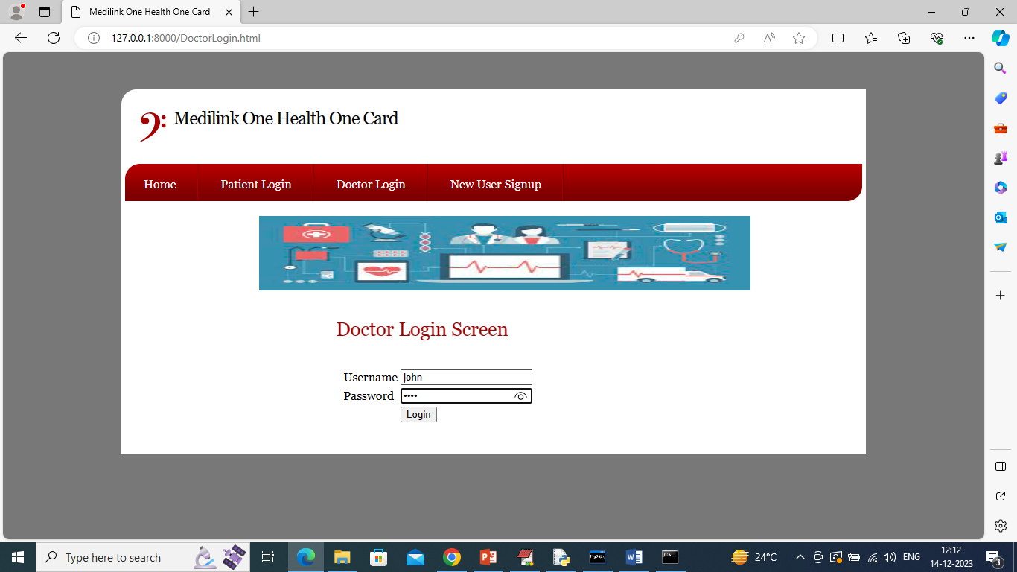
In above screen doctor is login and after login will get below page
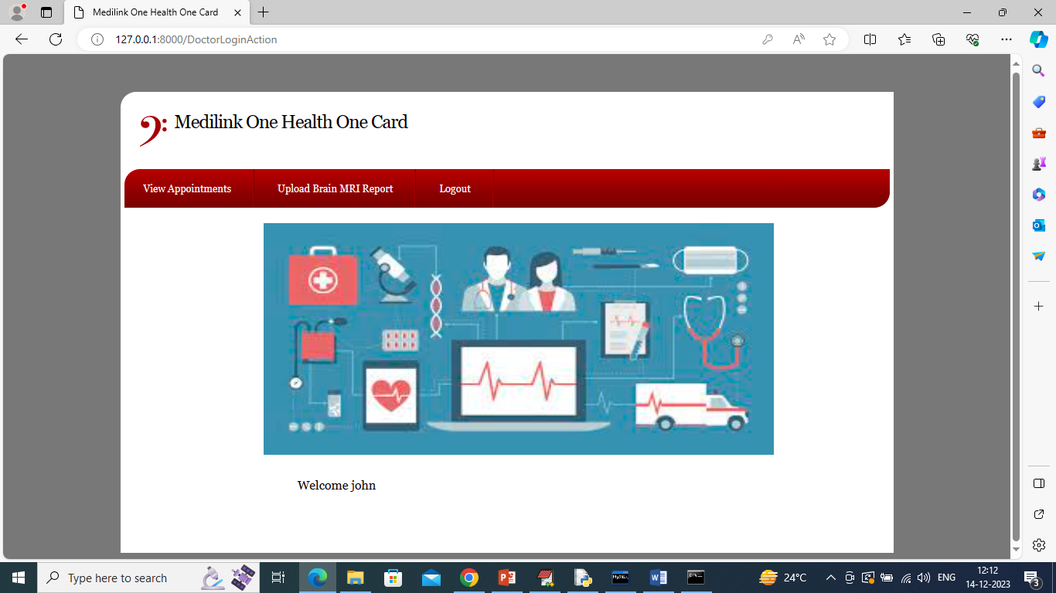
In above screen doctor can click on ‘View Prescription’ link to view all today appointments list and get below page
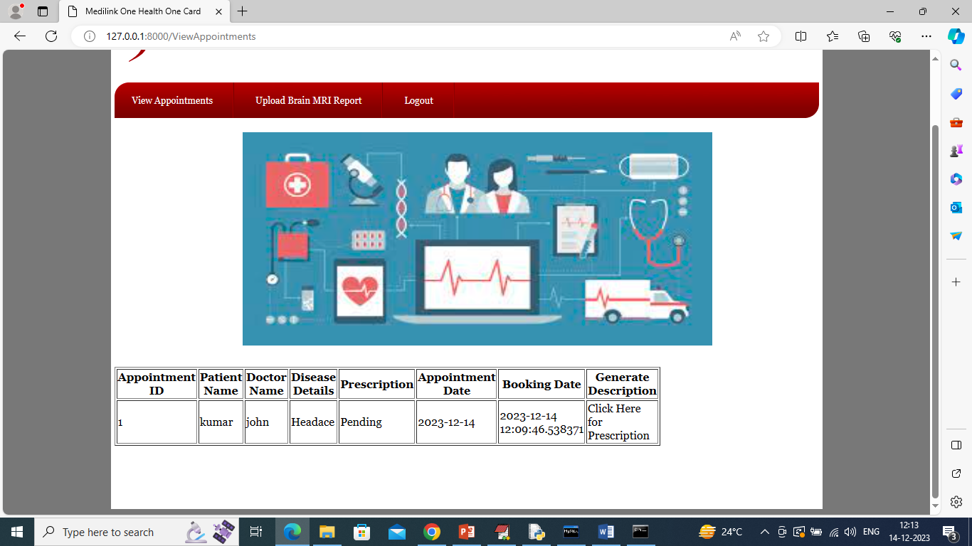
In above screen doctor will view all details and then click on ‘Click Here for Prescription’ link to get below page
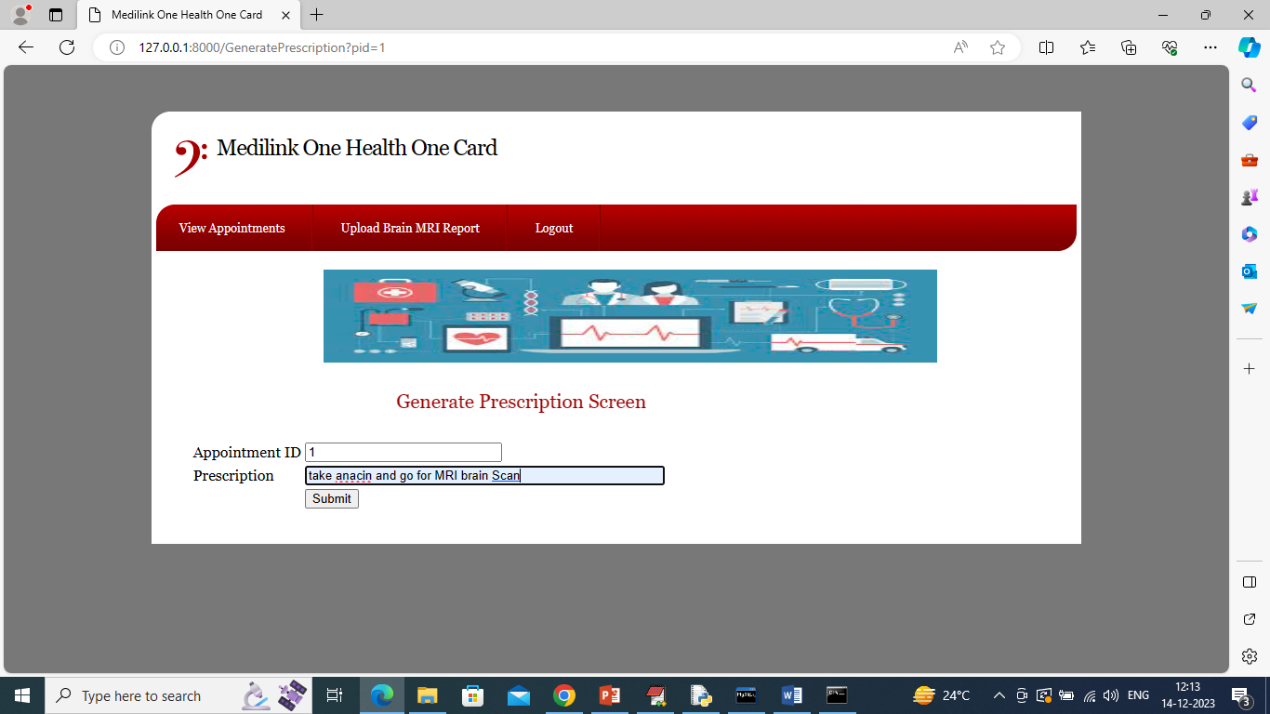
In above screen doctor will write some prescription and press button to get below page
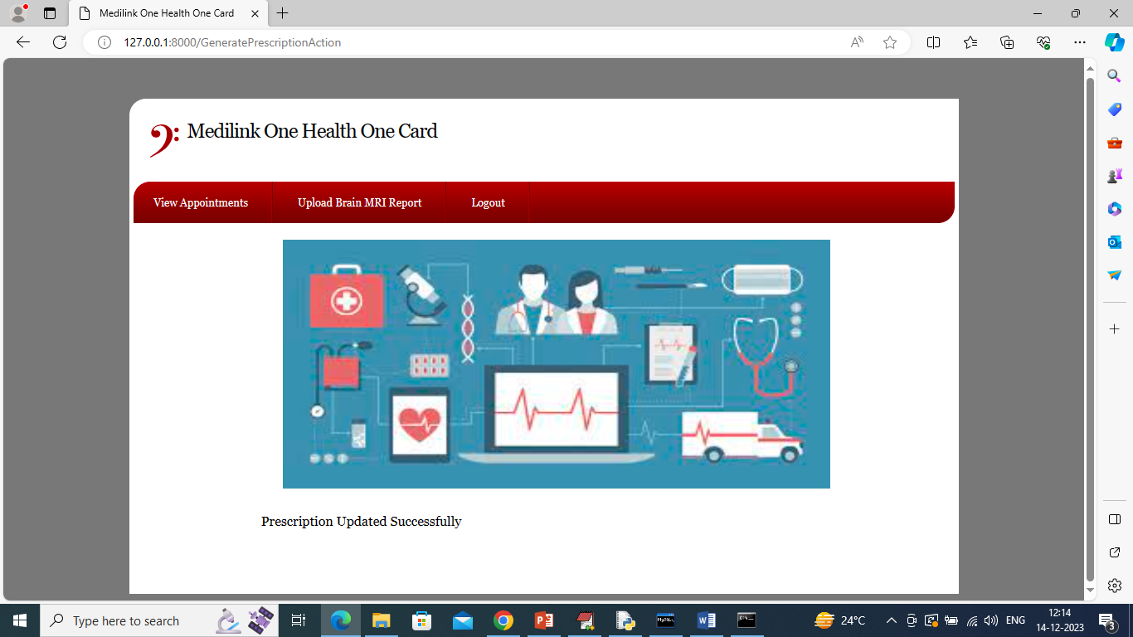
In above screen ‘Prescription Updated” and if any patient comes up with MRI report then doctor will click on ‘Upload MRI Report’ link to get below page
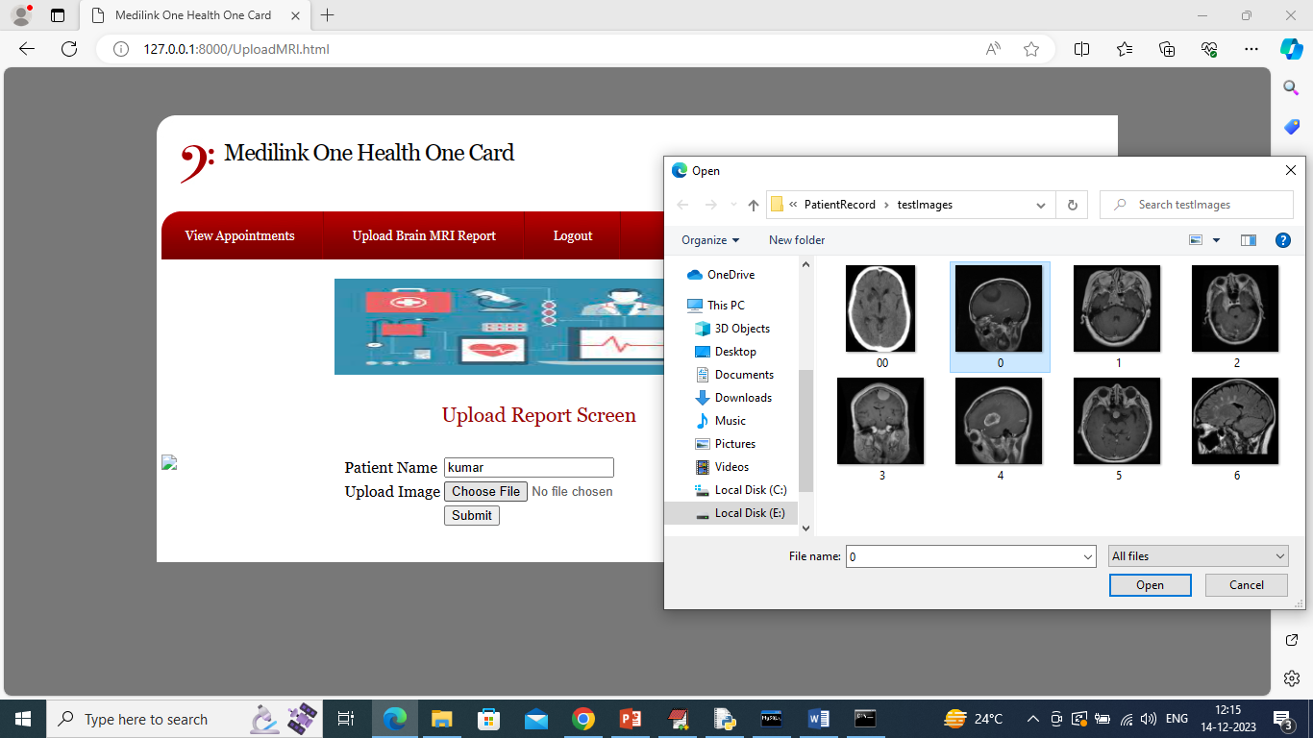
In above screen doctor will enter patient name and then upload MRI images (all above test images you can see inside ‘TestImages’ folder) and then click ‘Open’ and ‘Submit’ button to get below page
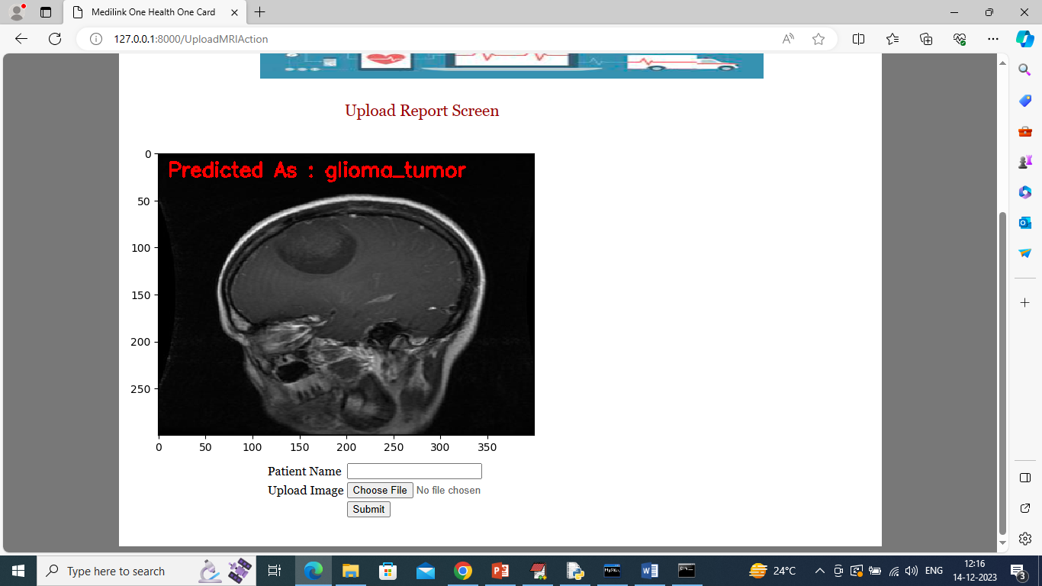
In above screen in uploaded image CNN predicted tumor as ‘Glioma Tumor’ and similarly you can upload and test remaining images. Predicted disease will be display on image in red colour text
So in above screen we have seen Patient Records Management with AI disease prediction.

