Example1





Ans-

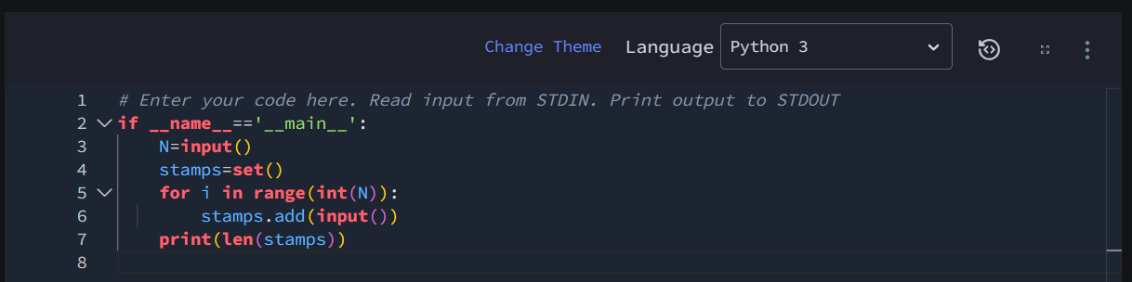

Example2

Example3

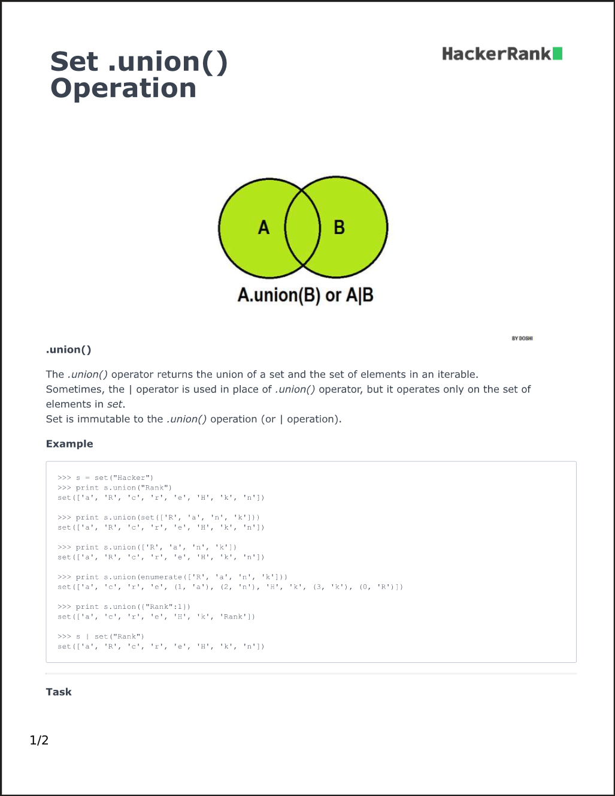

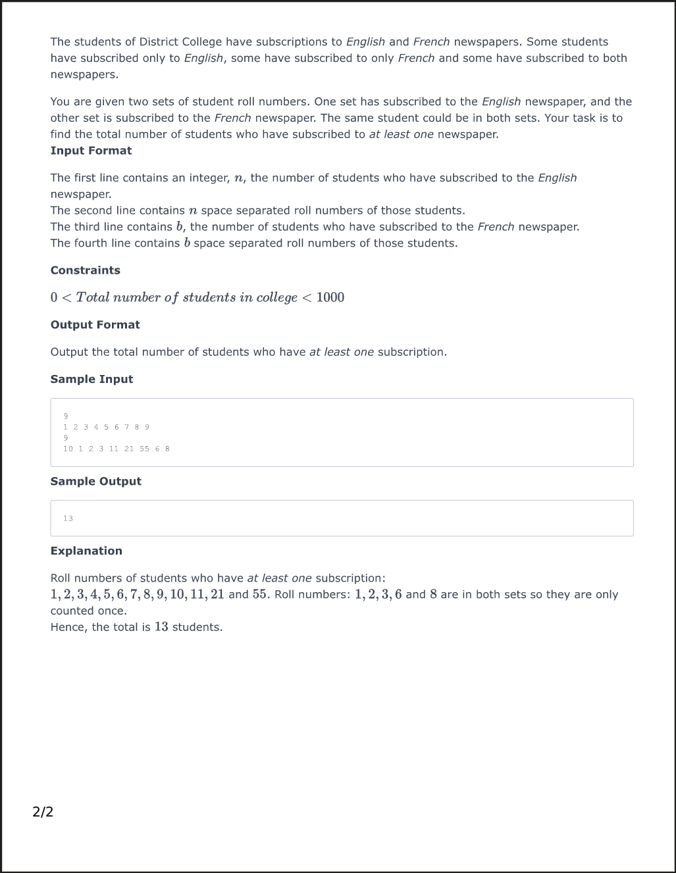

Ans-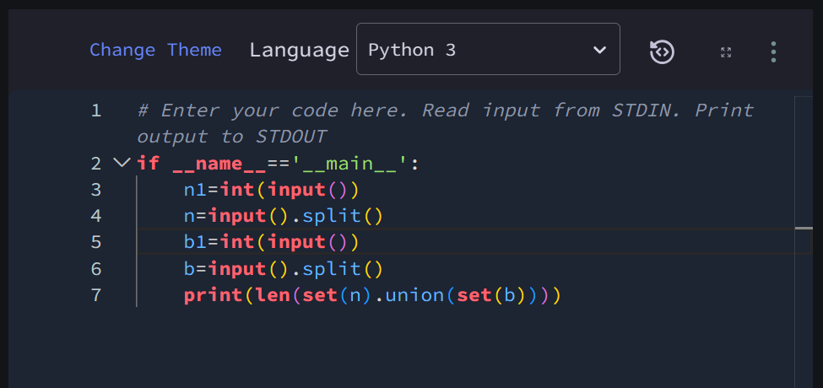

Exaple4

Example5

