A Stacking Ensemble-based Approach for Lung Cancer Detection
K Suresh[0000-0001-6495-9999], H Sai Karthik V, D Vivek Reddy, A Suhas, Pritam Khan[0000-0001-8223-3809]
Department of Computational Intelligence,
SRM Institute of Science and Technology, Kattankulathur-603203,
Tamil Nadu, India
{ sureshk8, hv3828, vd8837, aq7195, pritamk}@srmist.edu.in
Abstract. In this work, a framework for lung cancer classification from medical images is introduced leveraging ensemble learning approaches. We use CNNs (Convolutional Neural Networks), XG-Boost, Random Forest, and SVMs (Support Vector Machines) to increase the accuracy and confidence in diagnosing lung cancer. The deep learning-based stand-alone models are shown to perform independently. In the study, individual models are trained on a dataset of CT (Computed Tomographic) scan images, appraised, and then stacked in a novel stacking ensemble approach. The collective predictive power of the ensemble strengthens the model's accuracy, precision, and recall through a smart combination of separate models' predictions. The receiver operating characteristic-area under curve (ROC-AUC) and confusion matrix illustrate the characteristics of our proposed model to distinguish among benign, malignant, or normal situations. The proposed model finds diagnostic applications for the medical industry through the introduction of stacking ensembles for lung cancer detection.
Keywords: Lung Cancer Detection, CT Scan Images, Stacking Ensemble, Deep Learning, Machine Learning, Classification.
- Introduction
This research work focuses on a sophisticated artificial intelligence-based approach to classify lung. We conduct a comprehensive examination of various machine learning models such as Support Vector Machines (SVM), Decision Trees, Random Forest, Naïve Bayes, K-Nearest Neighbour (KNN), XG-Boost, AdaBoost as well as deep learning models such as Convolutional Neural Networks (CNN) and Restricted Boltzmann Machine (RBM). We systematically evaluate each model's unique strength and traits to determine their effectiveness in diagnosing lung cancer from complex medical imagery. The proposed model is a unified and strong ensemble that is based on stacking techniques, utilizing the collective intelligence from multiple machine learning and deep learning algorithms [12]. The ensemble method combines the various strengths of these models to create a novel solution for classifying lung cancer, which has the potential to outperform the individual models in terms of accuracy and dependability.
The intention here is to improve the survival rates of lung cancer patients who form a major fraction of cancer-related mortality world-wide, and, at the same time, the specificity of the disease, which is often diagnosed in the later stages. Leveraging machine learning, one can extract profound data-driven insights from the complex datasets phased out in medical imaging and patient records. In this way, such an approach seems to be very effective in revealing undetected markers and patterns that remain beyond the reach of conventional analysis tools, leading to the early diagnosis and most accurate prediction of the disease. Following such progress would have profound clinical implications since this could enable healthcare professionals to be armed with decision-aid tools through accurate prediction models and thus identify high-risk individuals, implement timely interventions, and improve the treatment plans for their patients. Thorough prediction models are laying the foundations for what-if scenarios of population-level screening, which can potentially provide further relief for the global epi-demic of lung cancer.
In addition to this progress, our study also examines how artificial intelligence can be combined into current clinical methods. This means doctors can make use of more sophisticated analytics while diagnosing lung cancer through embedding it with AI-driven instruments. The combination speeds up decisions and makes them more accurate at the same time as it allows for treatment protocols that are personalized according to individual patient profiles. Such a type of personalized medicine powered by AI could change cancer care forever because it ensures that treatments not only work but also do less harm and are better timed. What we propose here is an attempt on patients’ lives through applying state-of-the-art technology against one of the hardest diseases in modern healthcare history.
  - Related Work
In recent decades, rapid advancements in pattern recognition and image processing techniques have led to an increased focus on lung cancer detection and classification. The article [1] describes current literature techniques for distinguishing various obstructive lung disorders using textural analysis of thin-section CT images. Previous studies used programs such as MATLAB to classify and process images. Steps were taken to apply artificial neural networks (ANN) and deep learning models to enhance precision. Trouble arises with the current systems because they are offline, have slow processing speeds, and have difficulties in accurately diagnosing small nodules, especially in a large population of patients [2]. Xie et al. [3] combine the application of metabolomics and AI technologies to find early-diagnosis biomarkers of lung cancer. The report demonstrates the application of LC-MSMS metabolomic methods incorporated with the Naïve Bayes machine learning method for predictive purposes, which is proven effective. However, these limits include the rather small size of the sample and the need for external validation in the studies concerning larger populations. The research by Asuntha et al. on lung cancer detection and classification includes techniques such as extracting textural features like wavelet transforms, local binary patterns (LBP), scale-invariant feature transforms (SIFT), and Zernike moments [4]. Raut et al. [5] have used digital image processing and intelligent algorithms, including C4.5 decision trees for detecting lung cancer. Strategies such as Otsu's method with thresholding and feature extraction, followed by visual image analysis with the use of CNNs, are primarily focused on, in [5]. Challenges including the massive cloud for online software and the complexity of getting an accurate diagnosis utilizing CNN for a rapid lung cancer diagnosis, were overcome. The relevance of cancer diagnosis and the capacity of ML algorithms increased the determination rate, notwithstanding the limitations of small population datasets [5]. Singh et al. have employed image processing methods, though contrast-limited adaptive histogram equalization (CLAHE), extraction of texture features using the grey-level co-occurrence matrix (GLCM), and extraction of statistical parameters have been used alternatively. Techniques of supervised machine learning, such as image categorization, have been used. One of the challenges is that the tool may sometimes wrongly categorize cancer as benign or malignant. In addition, it can lead to overfitting a model with a relatively limited amount of data, although that can be tackled by using validation data [6]. Pawar et al. [7] have introduced a new computer-aided device (CAD) to check whether there is a tumor or not. By using this CAD, it will highlight the tumor in the circle. Radhika et al. [8] use datasets from the Machine Learning Repository on UCI and data.world to create precise classification methods for diagnosis purpose. The SVM model exhibits the highest accuracy of 96.2% as compared to other models in their study. Improving accuracy rates is a significant challenge that can be addressed through preprocessing operations [8].
  - Contributions
In this work, a novel method is developed for outsourcing the association of machine learning model predictions from various ML models using stacking ensemble techniques. Convolutional Neural Networks (CNNs), XGBoost, Random Forest, and Support Vector Machines (SVMs) are used to form an ensemble. This formation is able to surpass the existing limits on modeling homogeneous clusters with the new method. Given that every model among those provided gives some viewpoint on the process of recognizing complicated patterns in medical imaging, the choice of not sticking to one after another model selection was consciously made [9].
Apart from the uniqueness of longitudinal trials, which is manifested in the en-graftment of a vast scope of individual models, it also portrays the strength of having aggregative proficiency through a stacking approach. This meta-model in the stack-ing ensemble is responsible for making a decision about whether particular stacked ensemble networks form better input for convolutional neural networks (CNNs) in spatial features or go back to traditional machine learning models for response function approximations (the decision boundaries) [10]. The multi-headed fashion and variations of a few outputs of prediction models are worked out to improve the ensemble's ability to distinguish between benign, malignant, and normal cases of lung cancer.
Another aspect that mentions the flexibility of the whole process is the choice of a model. By coming up with an integrated strategy that links old and new methods of machine learning in its approach, the method offers a hybrid structure that combines standard machine learning systems with deep learning architectures. This mix of sin-gular stacking ensembles with single classifiers is an epitome of the field's versatility in terms of the collection of different methods and models to be tailored accordingly. Therefore, it is expected that such hybridization coupled with robustness might also be useful in the following studies.
The revolutionary part of this research is a stacking ensemble technique that gives a system long-term capacity and the ability to change by utilizing the best ways of various models for the classification of lung cancer as medical imaging is processed [11]. Here, a new opinion is formulated. Instead of choosing only the best model, different models are combined to create a powerful mechanism capable of refining clinical decision-making.
- Methodology
  - Data Collection and Processing
The present study is centered on the ‘Iraq-Oncology Teaching Hospital/National Center for Cancer Diseases’ (IQ-OTH/NCCD) dataset that mainly consists of chest X-ray pictures, which are used for lung cancer detection in the early stages. It consists of three separate categories: ‘Benign classes’, ‘Malignant classes’, and ‘Normal classes’ [5]. Every class has details on various lung problems, which leads the model to produce a higher recognition rate for healthy people with lung disorders than for sick people. The data is split into training and testing sets. Thus, the process makes sure that the model will be trained by one subset, and will be tested by another, thereby enabling evaluation of the model’s capability to generalize.
Performing image normalization beforehand is an important pre-processing step. Consistency of every image size to 100x100 pixel will result in uniformity, and pixel values will be meticulously adjusted so as to land within the [0, 1] range. Encoding categories into a one-hot format ensures proper compatibility of categorical labels with machine learning algorithms.
  - Base Models
- Convolutional Neural Network or CNN
The Convolutional Neural Network (CNN) is very popular for image categorization roles. The convolutional layers extract hierarchical information from input images. The pooling and fully connected layers follow the same steps. A convolutional initial layer is followed by max-pooling, flattening, and then a dense layer. The CNN is then fine-tuned via the core process of optimizing the value of various hyper-parameters. It is necessary to consider the learning rate, optimizer, regularization, and batch size, which play a very important role in specifying the model speed, reducing overfitting, and treating vanishing gradient types.

- Traditional Machine Learning models

- XG-Boost: As a gradient-boosting algorithm with strong capabilities, XGBoost has earned much appreciation for its efficiency in the field. It constructs a set of decision trees, built one by one, that aim at identifying and remedying the mistakes committed by the tree placed on top.
- Random Forest (RF): The Random Forest is an ensemble learning algorithm that creates several decision trees (a tree-like structure of hypotheses made during training) and classifies data points according to the most common class.
- Support Vector Machine (SVM): Support Vector Machine (SVM) is a classifier or predictive technique built upon the concept that distinct classes can be separated by the hyperplane that results in such a decision border between them.

  - Stacking Ensemble
The stacking ensemble fuses results from structural classification base models to generate a blended ensemble of multiple models’ capabilities. Figure 1 shows the block diagram of lung cancer detection with the proposed stacking ensemble architecture.

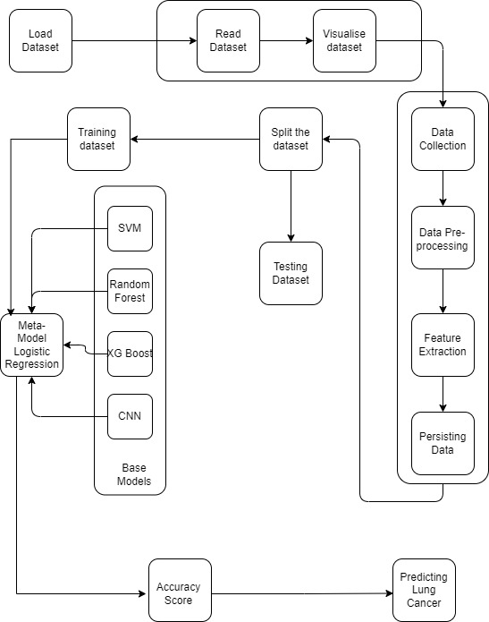

Fig. 1 Proposed stacking ensemble architecture for Detecting Lung Cancer

The central tool is a meta-package based on logistic regression. Weights are assigned to the predictions produced by the different base models using a logistic regression meta-training model. As observed from Figure 1, the base models used in the proposed architecture are CNN, SVM, XGB, and Random Forest. Here, the sample set stacking method exchanges information, introducing a more impactful approach.
The stacking technique is based on the fact that different models specialize in one or another region of the problem space; thus, combining them with the help of stacking allows for more precise prediction of outcomes. The system proceeds with an in-depth assessment by engaging performance measurements such as accuracy, precision, and recall to implement a multidimensional evaluation of performance.
The methodical process covers data pre-processing in detail and describes the creation of each base model individually. It also explains the stacking ensemble, which leads to synergy. All the accounting is done by a set of complex math formulas that can give any advanced insight about the technical theories that are peripheral to the code.
- Experimental Result and Discussion
The primary goal of this study was to carefully assess and classify lung cancer based on CT images. Initiating complex analysis using machine learning and deep learning models, each with unique characteristics, we explore the nuances of individual model accuracy and discuss the stacking ensemble method. In addition, the discussion extends to important aspects of the receiver operating characteristic (ROC) curve and confusion matrix analysis.
  - Individual Base Model Accuracies:
In this work, we prudently select and test some models to ensure accuracy in lung cancer classification. From Table I, we can observe the individual model’s test performance metrics on the IQ-OTH/NCCD dataset for lung cancer detection. It is observed that the Naïve Bayes and AdaBoost algorithms do not perform well on the data. Models namely K-nearest neighbor (KNN), Decision Tree, and Restricted Boltzmann Machine (RBM) perform well individually on the test data; however, they reduce the performance of an ensemble on being a base model. Additionally, we observe the individual performances of the support vector machine (SVM), random forest, XG-Boost, and CNN, as well as the enhanced performance of the ensemble obtained by leveraging them as the base models. These examples encompass a variety of different techniques, each providing a unique insight into the complexity of CT image analysis. Notable illustrators are:

- Support Vector Machine (SVM): This model shows an appreciable accuracy of 97.87%. It has a good capability in understanding complexity in a CT scan dataset.

- Random Forest: In group learning, a strong random forest achieves a sufficient accuracy of 94.98%, providing a starting point when combined with other samples.

- XG Boost: Taking advantage of the power of gradient boosting, XG Boost appears at an impressive accuracy of 97.35%, building on its knowledge of complex relationships with lung cancer data to emphasize the structure.

- Convolutional Neural Networks (CNN): Deep learning through the mean time of CNN confirms its dominance after 100 times with an accuracy of 97.83%. The model exhibits a weak aptitude for image feature extraction and classification.

Tabe I: Performance metrics of different models on the IQ-OTH/NCCD dataset for lung cancer detection
Model | Accuracy | Precision | F1 Score | Recall
SVM* | 97.5904 | 0.94 | 0.96 | 0.98
Logistic Regression ^ | 96.8675 | 0.98 | 0.99 | 1.00
Random Forest* | 93.9759 | 0.96 | 0.97 | 0.99
KNN | 97.1084 | 0.99 | 0.99 | 0.99
Naive Bayes | 62.0468 | 0.83 | 0.78 | 0.75
Decision Trees | 89.8795 | 0.95 | 0.95 | 0.95
XG Boost* | 97.3494 | 0.98 | 0.99 | 1.00
AdaBoost | 78.5542 | 0.90 | 0.90 | 0.84
CNN (100 epochs)* | 97.83132 | 1.00 | 0.99 | 0.98
RBM (100 epochs) | 93.7349 | 0.96 | 0.97 | 0.98
* = base model in stacked ensemble model
^= meta-model in stacked ensemble model

  - Stacking Ensemble Results:
The Stacking Ensemble model outlines a complex ensemble technique for detecting lung cancer using CT images. Such a combination of several state-of-the-art machine learning models—which include CNNs, XG-Boost, Random Forest, and SVMs—in a synergistic way, helps to make this diagnostic tool very robust and reliable. By merging the unique strength of each model, the ensemble compensates for their individual limitations. Indeed, the ensemble achieves an incredible test data accuracy of 99.52%. Here, the ensemble demonstrates a quality of 99.11% precision, which is very crucial in medical diagnostics, where false positives' costs are highly critical. The recall rate is also at 99.07%, which helps in the detection of true cases of lung cancer, hence paving the way for effective and proper medical interventions. This approach uses logistic regression as a meta-model and finally tunes the amalgamation of predictions from the base models finely. The ROC-AUC analysis further goes ahead to prove the ability to distinguish lung condition categories with high precision. This stacking ensemble also accelerates the strategy for early detection and is thus very beneficial for effective treatment of lung cancer, thereby increasing the chances for better patient survival. Future improvements in this framework include the integration of state-of-the-art machine learning algorithms and some state-of-the-art technologies, which will improve feature extraction, interpretability, and, finally, performance of the diagnosis. This new method holds huge potential for the combination of multiple models, especially in finding hard diseases like lung cancer in medical imaging. In this sense, this will surely lead to better patient outcomes by making diagnoses that are much more accurate, reliable, and actionable..

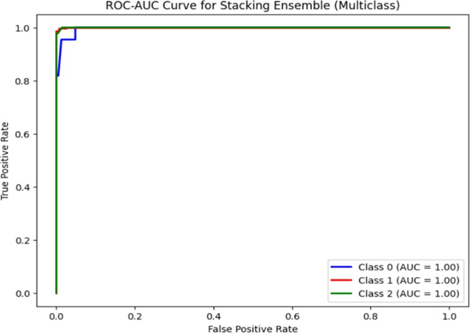

Fig. 2 ROC – AUC Curve for the proposed model

- ROC curve for multiple studies:

The ROC-AUC curve that follows below is a plot showing the performance of the stacking ensemble with respect to multiclass classification for the detection of lung cancer. Each of the lines drawn in this plot represents a different class of lung conditions: Class 0, Class 1, and Class 2, that likely represent benign, malignant, and normal cases, respectively. The fact that all the classes have an AUC score of 1.00 is highly remarkable and indicates that the ensemble model can perfectly classify, without any overlap between the different classes.

Perfect performance of this kind indicates that the model can discriminate between the different classes without any false positives or false negatives and yields unequivocal diagnostic decisions. Such a clear-cut discrimination is a rarity and highly desirable in the field of medical diagnostics since, to a great extent, it indicates that the model can reliably differentiate between subtle features within the medical imagery that are specific to the various stages and varieties of lung conditions.

In the clinical domain, such high-performing models are highly desirable since they allow the physician to avail of a second opinion, which is not only highly accurate but also consistent. This may entail quicker and accurate treatment decisions and, by extension, contribute to better patient outcomes. In addition, such sharp precision in the medical imagery analysis, as achieved by the ROC-AUC curve, reduces the need for invasive diagnostic procedures, thus reducing patient discomfort and health care costs.

The perfect scores across all classes also indicate the potential of this model to act as a benchmark for future research in lung cancer detection. Researchers and medical professionals could look to this ensemble model as a gold standard against which they would compare new diagnostic algorithms. The implication is profound, both in patient care and generally across the entire field of medical imaging and diagnostics. Potential is huge in revolutionizing early cancer detection and treatment based on such a model. It is just a glimpse into the kind of groundbreaking advancements that AI and machine learning make for health care.

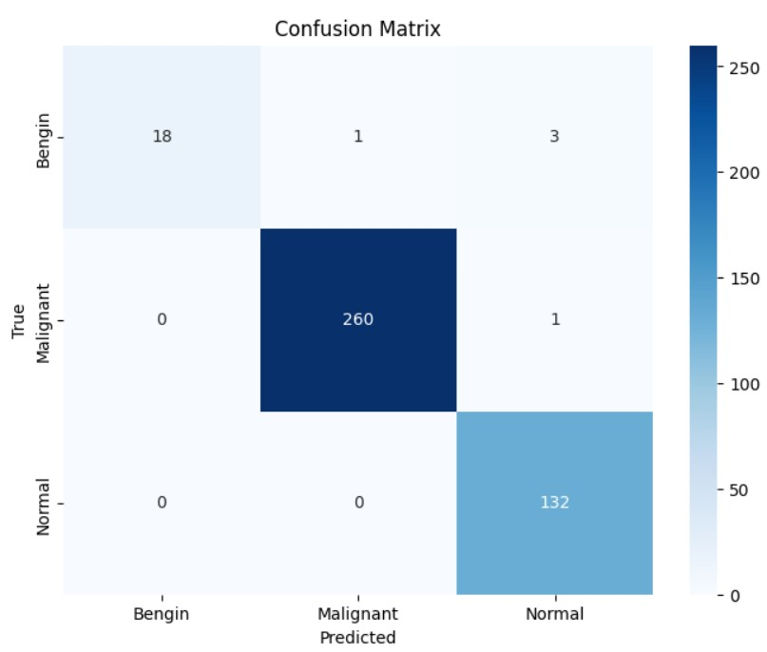

Fig. 3 Confusion Matrix for the proposed model

- Confusion matrix:
The granularity test of the confusion matrix adds some depth to the classification results. Figure 3 shows the confusion matrix classifying the samples into three categories namely ‘Benign’, ‘Malignant’, and ‘Normal’ cases. It can be observed from the diagonal components that most of the cases of Benign and True Malignant are 18 and 260, respectively. This hints to the fact that the representation of these classes is reasonably fair across the classes. On the other hand, the count of the Normal category is around 132. This implies that there is probably an imbalance among the classes. The model shows a high degree of accuracy in the identification of malignant and benign instances. The latter was evidenced by non-zero values on the diagonal for these classifications. It is exemplary in diagnosing 18 cancer-free cases and 260 cancerous cases in particular. Significantly, it produces only a single case of miss-prediction of malignancy and three miss-predictions of normalcy which emphasizes the model's shortfalls in correctly classifying benign instances. The False Malignant predicted is a case when a benign case is marked as malignant, while only three False Normal predictions refer to the situation of misclassifying normal patients as benign. An outstanding result in the model on correctly detecting malignant entities with almost no false negatives is quite noticeable. The capability of accurately diagnosing malignant lesions helps to develop the model's skill in the diagnosis.

- Conclusion
This research study investigates various machine learning and deep learning algorithms to classify lung cancer leveraging CT images from the IQ-OTH/NCCD data. We compare and contrast the conventional methods and the emerging deep learning systems to find out their strengths. In this work, we design a stacking-ensemble approach through an ensemble of models, including CNN, XG-Boost, Random Forest, and SVM for developing a single predictive tool. This integration not only reflects the positive features of the individual models but also amplified the model's authority in classifying cancer patients into benign, malignant, and normal cases. The designed ensemble emphasizes the usage of logistic regression as a meta-model. This unique combination exhibits high-level performance via improved precision (99.11%), recall (99.07%), and accuracy (99.52%).
Our future works focus on fine-tuning the CNN model leveraging attention mechanism for the efficient extraction of the hidden features from the medical imaging datasets with enhanced interpretability. Future research can be carried out by adopting advanced methods, such as domain adaptation and adversarial training, thereby making a positive impact on models by adapting to various medical imaging scenarios.

- Contribution
H Sai Karthik V – Model Development and Evaluation
A Suhas – Data collection, Data Pre-processing
D Vivek Reddy – Literature Survey, Analysis of different models
Dr K Suresh, Dr Pritam Khan - Supervisors

References
- Rahane, W., Dalvi, H., Magar, Y., Kalane, A. and Jondhale, S., 2018, March. Lung cancer detection using image processing and machine learning healthcare. In 2018 International Conference on Current Trends towards Converging Technologies (ICCTCT) (pp. 1-5). IEEE.
- Zhang L, Zhang Q, Du Member B, Huang X, Tang YY, Tao D (2016) Simultaneous spectral-spatial feature selection and extraction for Hyperspectral images. IEEE Transactions on Cybernetics
- Xie, Y., Meng, W.Y., Li, R.Z., Wang, Y.W., Qian, X., Chan, C., Yu, Z.F., Fan, X.X., Pan, H.D., Xie, C. and Wu, Q.B., 2021. Early lung cancer diagnostic biomarker discovery by machine learning methods. Translational oncology, 14(1), p.100907.
- Asuntha, A. and Srinivasan, A., 2020. Deep learning for lung Cancer detection and classification. Multimedia Tools and Applications, 79, pp.7731-7762.
- Raut, S., Patil, S. and Shelke, G., 2021. Lung cancer detection using machine learning approach. International Journal of Advance Scientific Research and Engineering Trends (IJASRET).
- Singh, G.A.P. and Gupta, P.K., 2019. Performance analysis of various machine learning-based approaches for detection and classification of lung cancer in humans. Neural Computing and Applications, 31, pp.6863-6877.
- Pawar, V.J., Kharat, K.D., Pardeshi, S.R. and Pathak, P.D., 2020. Lung cancer detection system using image processing and machine learning techniques. Cancer, 3(2020), p.4.
- Radhika, P.R., Nair, R.A. and Veena, G., 2019, February. A comparative study of lung cancer detection using machine learning algorithms. In 2019 IEEE international conference on electrical, computer and communication technologies (ICECCT) (pp. 1-4). IEEE.
- Hussain, L., Rathore, S., Abbasi, A.A. and Saeed, S., 2019, March. Automated lung cancer detection based on multimodal features extracting strategy using machine learning techniques. In Medical imaging 2019: physics of medical imaging (Vol. 10948, pp. 919-925). SPIE.
- Günaydin, Ö., Günay, M. and Şengel, Ö., 2019, April. Comparison of lung cancer detection algorithms. In 2019 Scientific Meeting on Electrical-Electronics & Biomedical Engineering and Computer Science (EBBT) (pp. 1-4). IEEE.
- Hazra, A., Bera, N. and Mandal, A., 2017. Predicting lung cancer survivability using SVM and Logistic Regression Algorithms. International Journal of Computer Applications, 174(2), pp.19-24.
- B. S, P. R and A. B, "Lung Cancer Detection using Machine Learning," 2022 International Conference on Applied Artificial Intelligence and Computing (ICAAIC), Salem, India, 2022, pp. 539-543, doi: 10.1109/ICAAIC53929.2022.9793061.

