Advertisement CAPTCHA Image Generation APIs

Features -

a) Sample Image Format Used

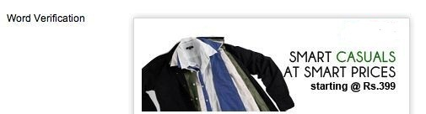

This image format is universal. There is some blank space in the left side of the image and in the top right corner of the image. It can be utilized by all the APIs. APIs which don’t need blank space in the left, crop the image accordingly to get fixed size except API – 5 which needs blank space in the left side of Advertisement image.

b)Color of the Advertisement message can be customized by advertisers by uploading a Color/Texture sample image according to their needs.

c)Challenge Text / Question to be asked to the users can be entered by advertisers.

API Descriptions

1)Quoted Text Generation API

A)Places Single Word Brand Message in Top right space in the Ad image.

a)Blue Coloured Quoted Brand Message in the Top right

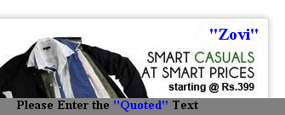

b)
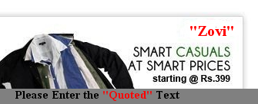

B) Places Multiple Word Brand Message in Top right space in the Ad image.
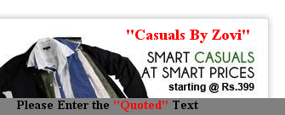

2)Underlined Brand Message API

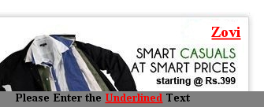

Places Underlined Brand Message in the top right space of the image.

3)Colored Brand Message API

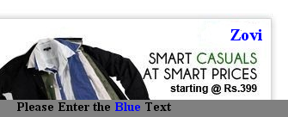

Places Brand Message in Particular Color in the Top right corner of the Ad image.

4)Italicized Brand Message API

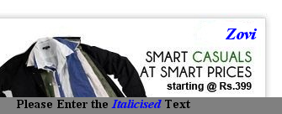

5)Quoted Text Generated in the Left side of Advertisement Image
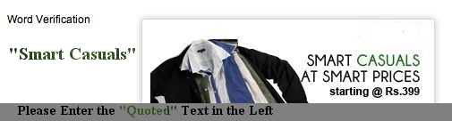

Color Sample used in this case. This is a specific texture not available in default libraries and is uploaded.

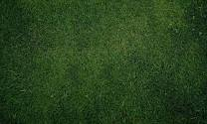

.6)TYPE-IN Captcha API Analogous to Solve Media’s Captcha

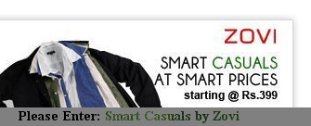

Benefit of the Design – Can Accommodate five words long Brand Messages
Sample Color Sample used is same as in API – 5.

7)Custom Question Captcha API
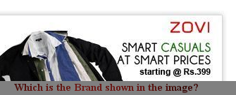

Custom Question entered by Advertiser gets displayed at the bottom of the image. Mechanism is feeded in other APIs as well, if custom question is not entered, default challenge gets displayed at the bottom of the image as shown in above images.

8)APIs for placing Quoted Text in the Top left and Bottom Left Space of the image has also been implemented as might be required in some cases.

