TIMES CAPTCHA

Protocol

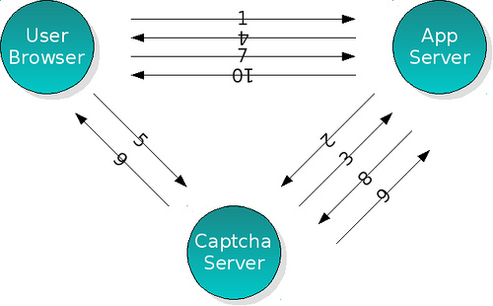

1. User requests the page which should contain captcha image.
2. Application server sends request for a captcha to captcha server.
3. Captcha server generates a captcha session id, returns captcha url, captcha session id and captcha code to application server.
4. Application sends the page contains captcha url to user, stores captcha session id to session (or writes to page as a hidden field)
5. User browser renders the page, and requests captcha image from captcha server.
6. Captcha server writes image stream to user browser, clear session.
7. User submits the form including user input captcha code.
8. Application sends captcha session id and captcha code to captcha server.
9. Captcha server checks the code with the one in session, returns validation result.
10. Application server sends the result.

All the three mechanism is supported with 3 HTTP interface.

Interfaces
This page describes the HTTP interfaces exposed by Times captcha server.

Registration for API Key -
http://localhost:8080/tcaptcha/reg?appname=app1

Sample response-
<string>6d5fc3482be490727686de4a5c1d45b8995dfe9f</string>

/ticket
Request a captcha session id and captcha url .

System Parameters:
- ip: ip addr of the user who will get the image code, optional , checkip can be enabled/disabled in properties file
- apikey: registered key for the application, optional, apikey feature can be enabled/disabled in properties file
- mode: captcha type code
- alt: response format, the value must be contained in json/xml/plain

API -
http://localhost:8080/tcaptcha/ticket?ip=127.0.0.1&apikey=6d5fc3482be490727686de4a5c1d45b8995dfe9f&alt=json&mode=3

Return:
/ticket returns you some plain text seperated by line-seperator which is aimed for easy parsing
- captcha url (which you should pass to client)
- captcha mimetype (which informs you the captcha type (a image or just plain text))
- captcha session id (which you should keep in session or pass to hidden field / cookie to client)( It is generated uniquely per ticket api call , session id/key is digested code with given keys . currentTimeMillis is also one of the parameters to make result unique)
- text hints (text hints related to the captcha, should be passed to client in many cases)

Return as plain text

http://localhost:8080/tcaptcha/captcha/512c94a2d1c17aff26e854db4496d11d36b0ab4d
image/jpeg
512c94a2d1c17aff26e854db4496d11d36b0ab4d
Zovi

Return as json

{"code":"Zovi","hint":"","key":"e70a6805a829da1bd704def46aff11261a058977","type":"image/jpeg","url":"http://localhost:8080/tcaptcha/captcha/e70a6805a829da1bd704def46aff11261a058977"}

Return as xml
<ticket>
<url>http://localhost:8080/tcaptcha/captcha/c5cd89644a35e46d379c8671bae40d5db5d25ee7</url>
<type>image/jpeg</type>
<key>c5cd89644a35e46d379c8671bae40d5db5d25ee7</key>
<code>Smart Casuals</code>
<hint/>
</ticket>

Error:
- "ERROR: Invalid Apikey, check input or contact with administrator": apikey not registered
- "ERROR: Not enough parameter": essential parameter omitted.

/captcha/[captcha_id]/
Request captcha image. if captcha_id provided, image generation will be in accord with configuration parameters passed by /ticket request. Otherwise, image will follow default rules, and a new session id will be generated and passed to user client by http cookie.

Error:
- "ERROR: Invalid Host": the host which retrieve image is not the one request to application server
- 404: the session expired or visited

Captcha Url -
http://localhost:8080/tcaptcha/captcha/c22cc4f9d7946b8383e30e1e0620d2dec407c96a

/validate
verify the user input and give out result

Parameters:
- apikey: registered key for the application, optional apikey feature can be enabled/disabled in properties file
- key: captcha session id required
- code: captcha code input by user required
- ip: client user ip optional , checkip can be enabled/disabled in properties file

API - http://localhost:8080/tcaptcha/validate?ip=127.0.0.1&apikey=6d5fc3482be490727686de4a5c1d45b8995dfe9f&code=v6RM&key=c22cc4f9d7946b8383e30e1e0620d2dec407c96a

Return:
True(plain text) if verification succeeds, else False

Error:
- "ERROR: Invalid Apikey, check input or contact with administrator": apikey not registered
- "ERROR: Not enough parameter": essential parameter omitted.

Analytics Panel -
Validation response corresponding to Captcha puzzle are recorded. <image_id> corresponding to Plain/Text,Math is 0. Hence, entries in the file with image_id – 0 can be discarded.
Captcha Analytics will be stored in PerformanceProfile.txt

Format of file is -
<image_id>#<Captcha Validation Response>#<timestamp>

Database support has been added

Demo -

There are four modes of Captcha -
0-Advertisement Captcha
1-Math Captcha
2-Advertisement Captcha with hint
3-Plain/Text Captcha

1)Mode 0 – Advertisement Captcha

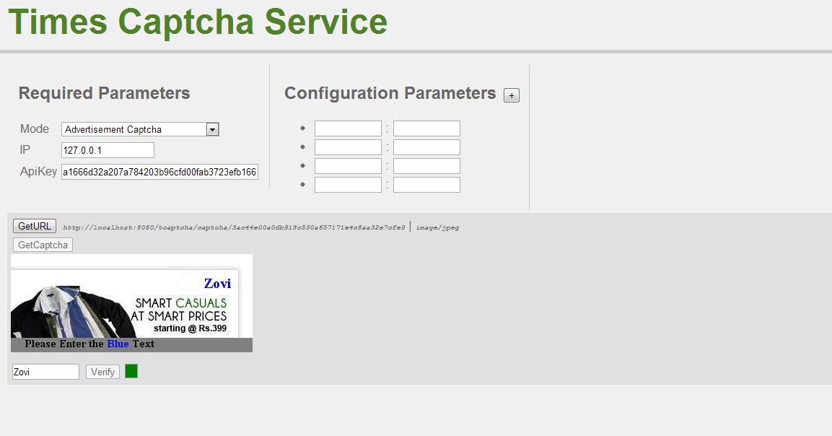

2)Mode 1 – Math Captcha

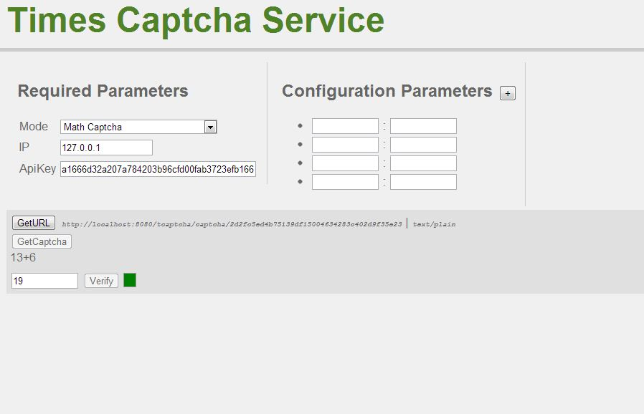

3)Mode 3 - Advertisement Captcha with Hint

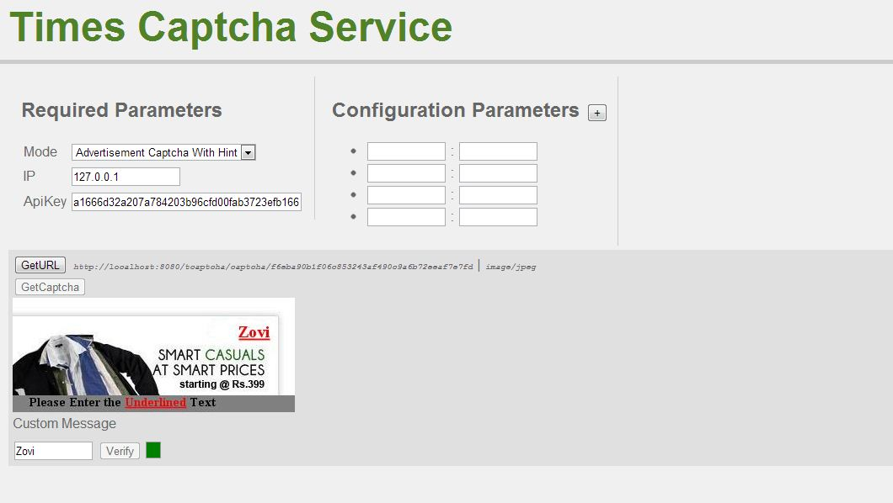

4)Mode 4 – Plain/Text Captcha

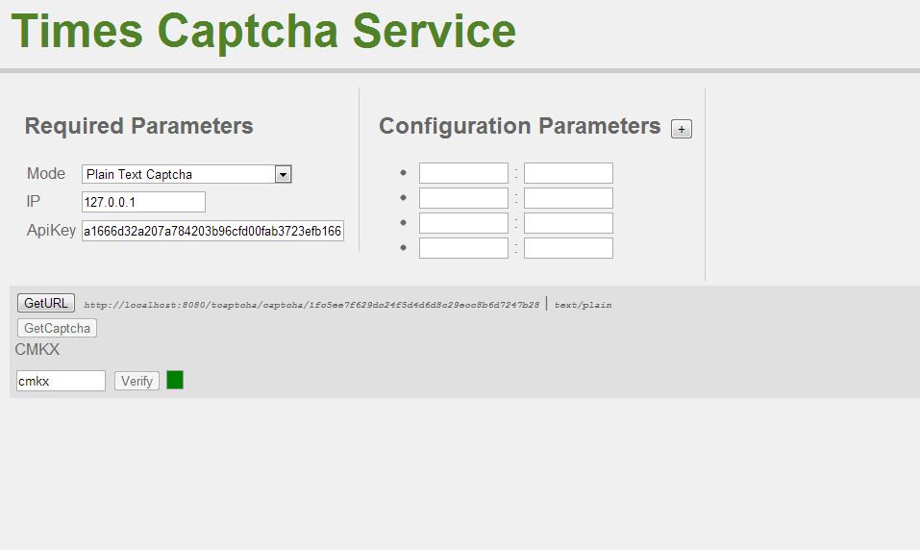

Caching

Caching operates in two contexts –

1)Images - Captcha images generated are written to outputstream. Outputstream is saved to the file which is used to generate Captcha images in later cases.

2)Captcha model generated is cached in memcached. It consists of Captcha code, session key, hint, mode, ip. Captcha model is inserted in memcached with key as session key. For validation, this captcha model is retrieved from memcached, corresponding to key supplied by validate api call. Lifetime of Captcha model object in memcached can be set by specifying expiration time of memcached object.

Set up Captcha Server Cluster -

.war deployed in different Tomcat for cluster setup should point to same memcached servers.

Ehcache support has been added.

