Security Hub Architecture
Carl A. Gunter, Sam King, Jianqing Zhang
July 2007

Elements
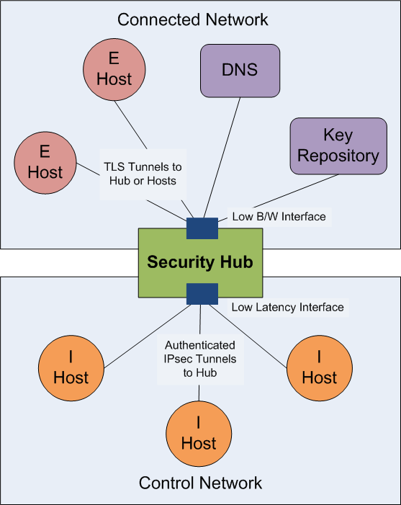
A security hub is a network element whose purpose is to provide broad access to a distinguished collection of hosts while assuring latency requirements between these distinguished hosts. The concept is illustrated in the figure. The security hub (or “hub” for short) links two networks: a connected network such as the Internet or enterprise network and a control network such as the digital communication bus in a power station or vehicle. Hosts in the connected network are said to be external hosts (ehosts) whereas hosts in the control network are called internal hosts (ihosts). The security hub mediates communication with each ihost so that a packet from an ehost to any ihost must pass through the hub and a packet from any ihost to any other ihost must pass through the hub. The security hub provides a “hub-and-spokes” network architecture for the ihosts while also acting as a gateway between the ehosts and the ihosts. It provides a low bandwidth interface to the connected network and a low latency interface to the control network.
The hub maintains IPsec-authenticated tunnels between itself and each of the ihosts and takes responsibility for checking the authenticity of the origin of any packet sent between ihosts. It routes packets from the connect network to the ihosts through these tunnels, but leaves their authentication to the ihosts, which use TLS to provide both authentication and encryption for these links. Each ihost is given a DNS name and a certificate with a private key bound to this name. These keys are managed by a key repository which is located in the connected network. The nodes use the Domain Name Server (DNS) to get IP addresses for routing, including routing within the control network. The hub provides multicast addresses and routing for use by the ihosts. An ihost can declare a new multicast address and other ihosts can subscribe to it. Finally, the hub keeps an inventory of the names of all of the ihosts attached to it in the control network and is able to provide this list to hosts authorized to receive it. The hub is also able to enforce basic partitioning of the ihosts by being configured so to allowing only some communication between the ihosts, thereby implementing an analog of a VLAN.

Design Objectives and Constraints
The main purpose of the design is to assure secure low-latency communications between ihosts while enabling access to the ihosts by ehosts. If the ehosts have an explicitly provisioned path to the hub and are all trusted, then there will be protection against DoS for the ehosts. However, the architecture envisions untrusted ehosts that may be able to overwhelm the low-bandwidth link to the hub and cause a loss of availability to the legitimate ehosts for some period of time. The key architectural aim is to assure that even a DoS attack that is this successful has no unacceptable effect on the ihosts and their communication constraints or security. In particular, each ihost must be able to sustain any attack on its integrity and availability that is bounded by the low bandwidth rate of the hub external interface. We assume a specific interval for the length of time that the system can survive a DoS attack on the connectivity to the connected network. We call this the DoS interval. In particular, it is assumed that the hub can detect a DoS attack and use policies that adapt to it. For instance, the hub may extend the length of time that DNS entries and keys are considered to be valid by the ihosts.

Key Repository
A key repository holds certificates for nodes such as the hosts and the hub itself. These certificates may be exchanged in the protocol, for example TLS does this, but the key repository could support revocation. In particular, one approach is to use domain keys and merge the key repository function with the DNS server. This requires that the DNS server is a DNSSEC server. Since the key repository is stationed in the connected network and DoS is possible between the connected network and control network, it is important that ihosts be able to continue their functions for the DoS interval.

External Hosts
External hosts are computers in the Internet or enterprise network or may even be located near the control network itself, such as a Human Machine Interface (HMI) console in a power substation. Ehosts can communicate with each other in accordance with any protocols on which they agree; they communicate with the ihosts by establishing TLS connections end-to-end and authenticating them with keys and certificates supplied by the key repository. In particular, an ehost communicates directly with an ihost and this communication is routed (not proxied) by the hub. An ihost will communicate with ehost if, and only if, the ihost policy permits this. However, any ehost, including malicious ones, may attempt to communicate with an ihost by sending packets to it. Ihosts are configured to repel malicious communications. TLS deals with threats to integrity and confidentiality, whereas the hub limits the risk of DoS threats by using a low bandwidth interface to the connected network. Ehosts are thereby given a limited bandwidth to ihosts. A DoS attack may limit this access. The goal is to minimize such threats as much as possible and assure that ehost functions are not extremely time critical. For example, SCADA ehosts may require special provisioning to assure that their timing constraints can be met even if a major DoS attack is coming from the connected network.

Internal Hosts
Ihosts are computers, typically embedded computers, operating on the control network. In the target application for the security hub architecture, ihosts perform process control functions and need to operate within potentially strenuous timing constraints governed by these physical processes. Attaching such computers directly to the Internet or enterprise networks is problematic because of these constraints. A key goal of the security hub architecture is to address malicious threats arising from this extra connectivity. An ihost has its own DNS name and globally routable IP address and may be addressed from any ehost in the connected network modulo restrictions imposed by the hub such as cutting off certain IP addresses to limit a DoS attack. An ihost may also contact any ehost using TLS. To communicate with other ihosts, a given ihost uses the hub and may unicast or multicast to other ihosts through its IPsec tunnel to the hub. Communication between ihosts will follow domain-specific protocols aimed at satisfying domain-specific functions and timing constraints. For example, a power substation network security hub may restrict communication between ihosts to GOOSE and SMV messages.

Security Hub
The security hub is the key architectural element in the architecture. It provides routing, limited access control functionality, and basic directory functions. It also provides support for DoS protection of and low-latency communications between ihosts. The state of the hub has the following components:
- IPsec tunnel association and policy for each ihost.
- Directory of ihost names and addresses.
- Policy for establishing multicast addresses.
- Routing state such as the multicast table.
- Configuration policies for tunnels.
- Policy for communications between hosts.
- Audit trails.
We organize the description of the functionality of the hub around these components of its state.

IPsec Associations and Policies
The security hub is a Virtual Private Network (VPN) hub for the ihosts, which connect to it with authenticated IPsec tunnels. It is possible to encrypt on these tunnels, but such encryption makes it harder to meet timing constraints and is often unnecessary because communications on the control network do not require confidentiality and communications to the connected network use TLS with confidentiality. The hub maintains an entry in its Security Policy Database (SPD) for each of its registered hosts so that communications to the ihost are sent into the Security Association (SA) for that ihost. If the SA does not exist then it is created using IKEv2 and the keys for the hub and ihost.

Hub Directory
The hub maintains a directory of the ihosts it connects, including their names and IP addresses. This directory has an associated access control policy that indicates which principals are allowed to query the directory. Queries are performed within a TLS tunnel (for an ehost) or an IPsec tunnel (for an ihost) and return a list of all ihosts. The principal that receives this information can use it to query individual ihosts to learn domain-specific information. For example, an ehost might get this list and then query each ihost for its description as a way to inventory the control network. If there are 100 ihosts then this would require 101 TLS connections and queries. However, a given ehost could cache this information and it could be retrieved by other ehosts using any desired query mechanism. In particular, the hub supports only a basic domain-independent directory service. More specialized and advanced mechanisms are implemented by the hosts.

Establishing Multicast Addresses
The hub maintains a table of multicast addresses that can be used to form a simple publish-subscribe system. The hub has an access control policy for hosts that can add entries to this table and modify the table. A basic approach is to allow any ihost to add a multicast address to the table or subscribe to any address that is in the table.

Routing
The hub performs basic unicast and multicast routing based on its SPD entries and multicast address table. If a packet is received by the hub from an ihost in an IPSec tunnel, the hub inspects its access rules and determines whether the packet can be transmitted to its indicated destination address. If this is permitted, it forwards it accordingly. If the destination is an ehost, then the hub forwards the packet through the hub’s low-bandwidth interface to the connected network. If it is an ihost, then it forwards it toward the destination and it is placed into the IPsec tunnel for that destination by the SPD. If it is a multicast address, then a copy of the packet is sent to each ihost on the subscription list for that multicast address. This will cause each such packet to be placed in an IPsec tunnel so the multicast is authenticated at the destinations. In particular, the hub assures that the return address on any ihost packet it receives is correct according to the IPsec tunnel from which it was received. The hub cannot authenticate traffic from ehosts to ihosts, but this task is left to the ihosts themselves.

Configuration Policy and Settings
The hub has a management policy that determines who can change the configuration and it has settings for parameters such as how long IPsec tunnels should be maintained before being reinitialized. Configuration settings include access control rules for the multicast tables and routing.

Communication Policy
The hub maintains a communication policy for the hosts. In particular, it is able to limit communications between ihosts and other nodes. For instance, a given collection of ihosts may be allowed to communicate only among themselves or to ehosts but not to other ihosts. In a power substation this could be used to restrict a group of ihosts in a given bay to communicate only with other ihosts in that bay, thus limiting the risk of unintended communications with ihosts in other bays.

Audit Trails
The hub collects practical audit trails and these are made available to authorized hosts.

