SECURITY HUB ARCHITECTURE SUPPORT FOR IEC 61850 INFORMATION EXCHANGE PROTOCOLS
© Suhas Aggarwal (suhas@iitg.ernet.in)

INFORMATION EXCHANGE SERVICES IN IEC 61850
|
------------------------------------------------------------------------
| | |
GOOSE MESSAGES SERVICE FUNCTIONS SMV MESSAGES
(TIME CRITICAL) (TIME CRITICAL)

COMMUNICATION MODELS -

GOOSE MESSAGES – PUBLISHER SUBSCRIBER MODEL.
Transmission using MULTICAST APPLICATION ASSOCIATION

SERVICE FUNCTIONS – CLIENT SERVER MODEL.
Transmission using TWO PARTY APPLICATION ASSOCIATION

SMV MESSAGES - PUBLISHER SUBSCRIBER MODEL.
Transmission using MULTICAST APPLICATION ASSOCIATION

SECURITY HUB ARCHITECTURE SUPPORT FOR PUBLISHER SUBSCRIBER
MODEL -

If a SIED wants to be a PUBLISHER it sends a message to SECURITY HUB .
SECURITY HUB broadcasts this message to all SIEDS in the control network.
Any SIED wishing to SUBSCRIBE sends a message to security hub.
Security hub check its security association policies before setting up a PUBLISHER
SUBSCRIBER relationship between them.

SECURITY HUB contains a Database* which keeps track of publisher subscriber
relationships and various publisher subscriber systems active at a given time.

*Database is compliant with the database model described in the IEC 61850 prototype version 2.0.

SECURITY HUB
|| || || ||
=====================
|| || || ||
SEID1 SEID2 SIED3 SIED4

--- subscriber request
--- publisher request
--- request granted
--- request rejected
( This also gives slight idea about chances of infection and that SIED can be isolated quickly )

ROLE of SECURITY HUB as a KEY MANAGER and DISTRIBUTOR –

Generates a group key for each publisher subscriber group and transmits it to the each group member.

GROUP JOIN OPERATION-
If any SIED wants to join an established group it receives the group key of group.

GROUP LEAVE OPERATION-
If any SIED wish to leave the group ,a new group key is generated and unicasted to each group member .

Use of group keys will save cryptographic checksum calculations as packets meant for the same group members will just have to be duplicated.

PAIRWISE KEY SETUP -

Generate pairwise session keys for members of the group. No. of keys to be generated ,^{n}C_{2,} n is no. of group members.Unicast set of keys to each group member.
This way they are aware of other group members as well.
Each group member receives ‘n’ keys in a unicast message (a group key and n-1 session keys corresponding to each group member)
In case of a group leave, leaving member sends a message to security hub and security hub multicasts this information to the group, so group members can flush the session key established with this group member from their cache.
I think it is a good idea to cache the keys in local cache of publisher-subscriber group members.
It is OK to be a bit sloppy here (in terms of security) to save some time. As these SEIDS can be mutually interdependent for the period they are part of a publisher subscriber group, if one SEID gets compromised, others will be affected naturally as they are functionally dependent on each other.
Additional Advantage-
Members which are a part of publisher subscriber system, can also be mutually dependent on each other for that period.
So, there is a very high probability that they may issue some service commands to each other as well using client – server model. As member SIEDS can communicate directly via session keys established between them ,we save some time again here.

Role of security hub* cuts down to key management to most extent and sort of decentralization is achieved with various publisher subscriber systems operating almost independently.

Any communication between SIEDS (belonging to different publisher-subscriber
systems or we can say belonging to different domains at that time)
is achieved via SECURITY HUB as an intermediate node.
This also helps in detecting suspicious behaviour and immediate security actions.

DOMAIN A
A Publisher
Subscriber system
DOMAIN B
A Publisher
Subscriber
system
DOMAIN C
A Publisher
Subscriber
system
SECURITY
HUB

Communication between members of a different domain is achieved via Hub and Spoke principles.

*Security hub may be replicated in the control network to enhance reliability, external connectivity and performance.

AN ON DEMAND GROUP GENERATION SCHEME-
Implementation of a counter in a security hub which keep tracks of interactivity between SEIDS belonging to different domains .
If the activity exceeds a certain set threshold level in some predecided time interval1 a group is established and keys can be distributed accordingly.
If the group activity reaches below threshold level in some predecided time interval2 group dissolves.

GROUP DYNAMICS – MIGHT BE PRESENT IN SUBSTATION SIEDS
(This behaviour may be observed among different publisher subscriber groups and might be periodic in nature)

DOMAIN COALESCING-

C

PS G3

( Merged group)
A

PS G1
B
PS G2

DOMAIN SPLIT-

B
PS G2
C
PS G3

A
PS G1
( Splits up)
D
PS G4

SUB DOMAIN GENERATION WITHIN A LARGE DOMAIN –

Super PS G1 A

Existing
SUB
PS G2 B

SUB
PS G3 C
Generated

Effect on key distribution-

In case of a domain merge-

A new group key is generated for new group.
Also, pairwise session keys are generated between members in domain1 and domain2 respectively. Suppose there are ‘a’ members in domain1 and ‘b’ members in domain2
So, total no. of session keys to be generated ‘ab’.
Each member in domain A receives b+1 keys ( ‘b’ pairwise session keys + 1 group key) and unicast message for domain B members contains a+1 keys ( ‘a‘ pairwise session keys + 1 group key ).
Total no. of unicasts a+b.

In absence of dynamics- No. of keys to be generated ^{a+b}C₂ pairwise session keys + a group key.

In case of a domain split-

It is not required to generate pairwise session keys among group members, as they already exist .Only new individual group keys need to be generated and invalid session keys need to be flushed from local cache of group members.

In case of a sub domain generation-

A new group key should be transmitted to each group member.

In absence of dynamics - No. of keys to be generated ^{n}C₂ pairwise session keys ,where ‘n’ is no. of group members in a newly generated sub domain + a group key.

Use Of a Key Graph for Group Communication-

Some key graphs -

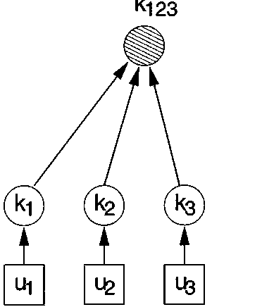

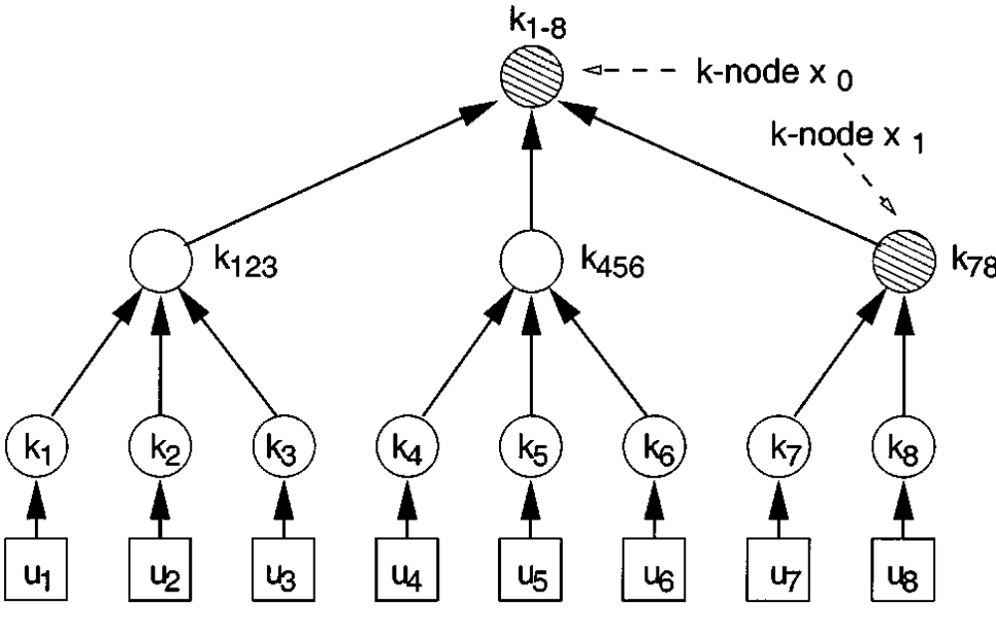

Advantages-

1)Reduction in no. of messages to distribute group key when a group leave operation is performed.

2)Enables sub-group communication via sub group keys.

Overheads-

1)Key graph generation, each time a group is created.

2) Number of keys to be changed when a group leave operation is performed.
Eg- 2 in case of above ternary tree when u3 leaves instead of 1 if we use a star key graph or just use a single group key .

Fundamental Questions/Challenges-

Which key graph to use??

A significant parameter on which choice of key graph might depend-
Order of group

Is it feasible to make the nature of key graph dynamic??Which changes upon change in these parameters.

Some Efficiency Measures to be considered -

1)Network traffic (should be in a suitable range)

2)Network latency (should satisfy the requirements,try to achieve as minimal as possible)

3)Key management and distribution overheads (should be manageable)

Future work:

Exploring behaviour of groups in a substation.Designing experiments to observe factors such as group order,group dynamics .
Study of these fundamental questions/challenges.

