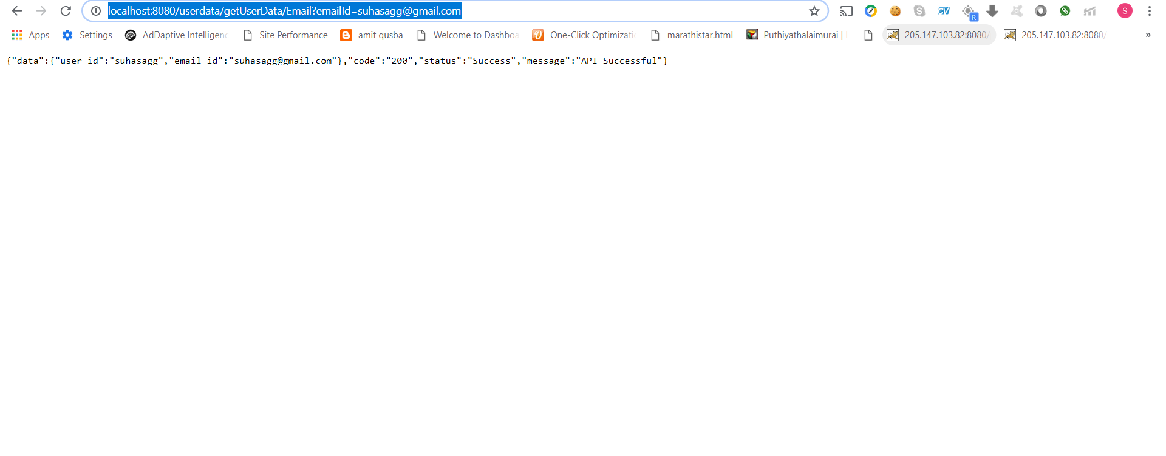

1)http://localhost:8080/userdata/getUserData/Email?emailId=suhasagg5@gmail.com

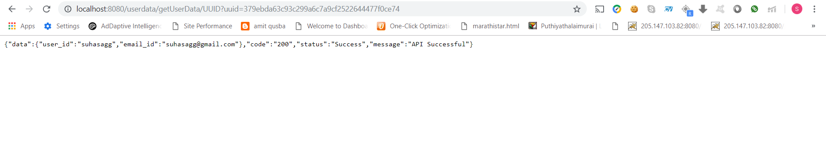

2)http://localhost:8080/userdata/getUserData/UUID?uuid=379ebda63c93c299a6c7a9cf2522644477f0ce74

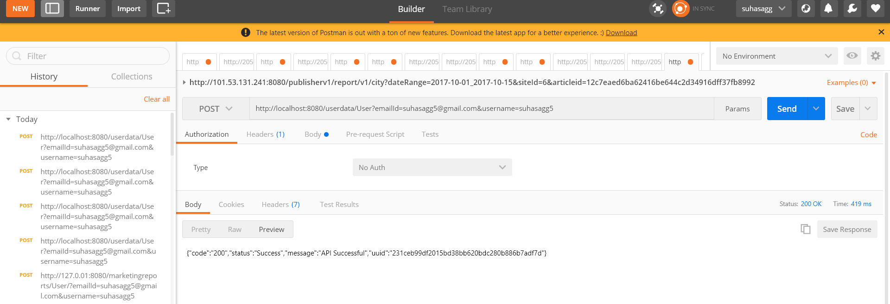

3)Insert UserData using POST as shown in POSTMAN.