ASSIGNMENT-4.5

NAME: Suhas Akshaj

Roll No: 2403A51299

SAMPLE DATA:

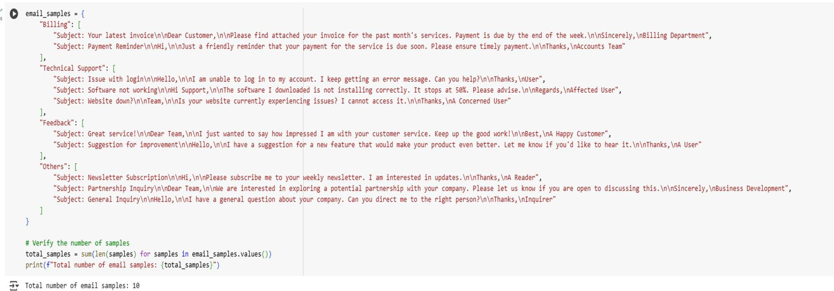

**Reasoning**: Create a dictionary with email categories as keys and lists of email samples as values, ensuring a total of 10 samples distributed across categories, and store it in the email_samples variable.

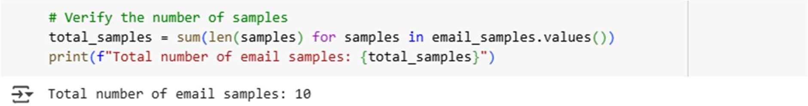output:

## Zero-shot prompting:

Subtask:

Design a prompt for zero-shot classification and test it on 5 emails.

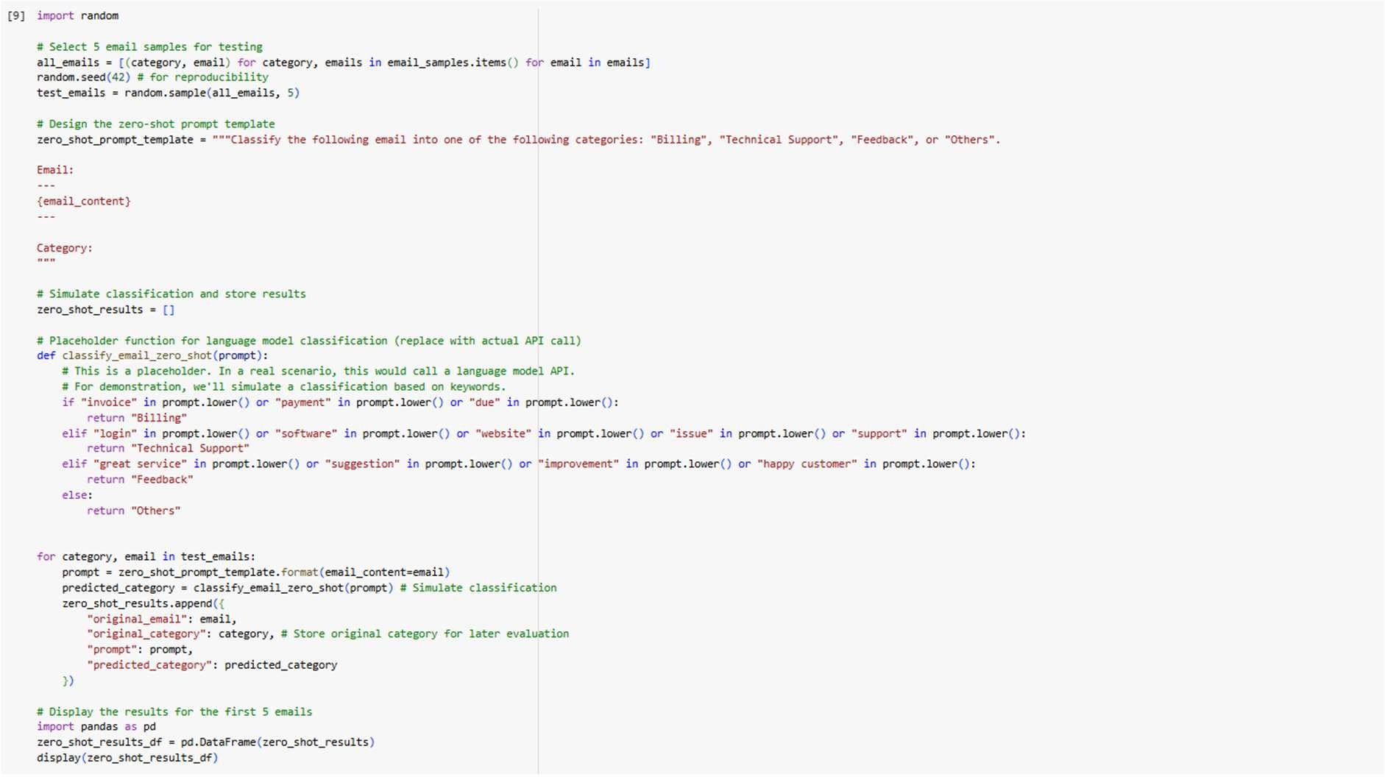

**Reasoning**: Select 5 email samples for testing, design a zero-shot prompt, and then iterate through the selected samples to construct the full prompts and simulate the classification using a placeholder function. Store the results.

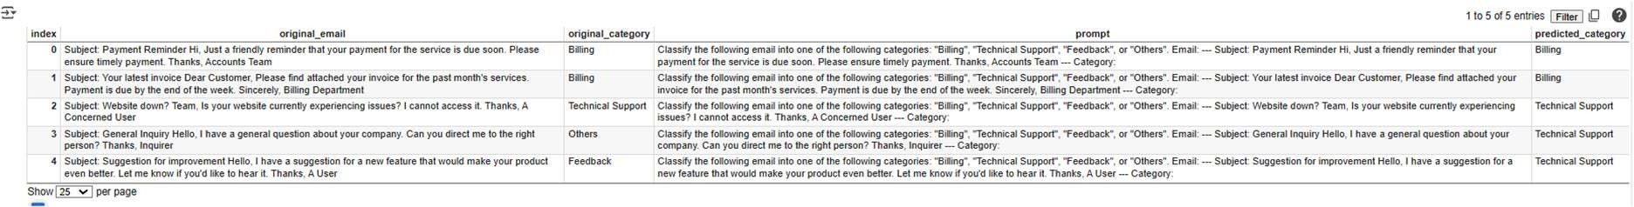Output:

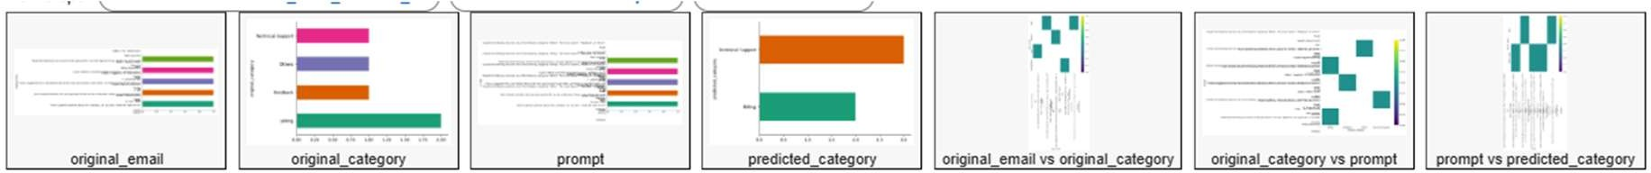recommended plots:

# One-shot prompting

Subtask:

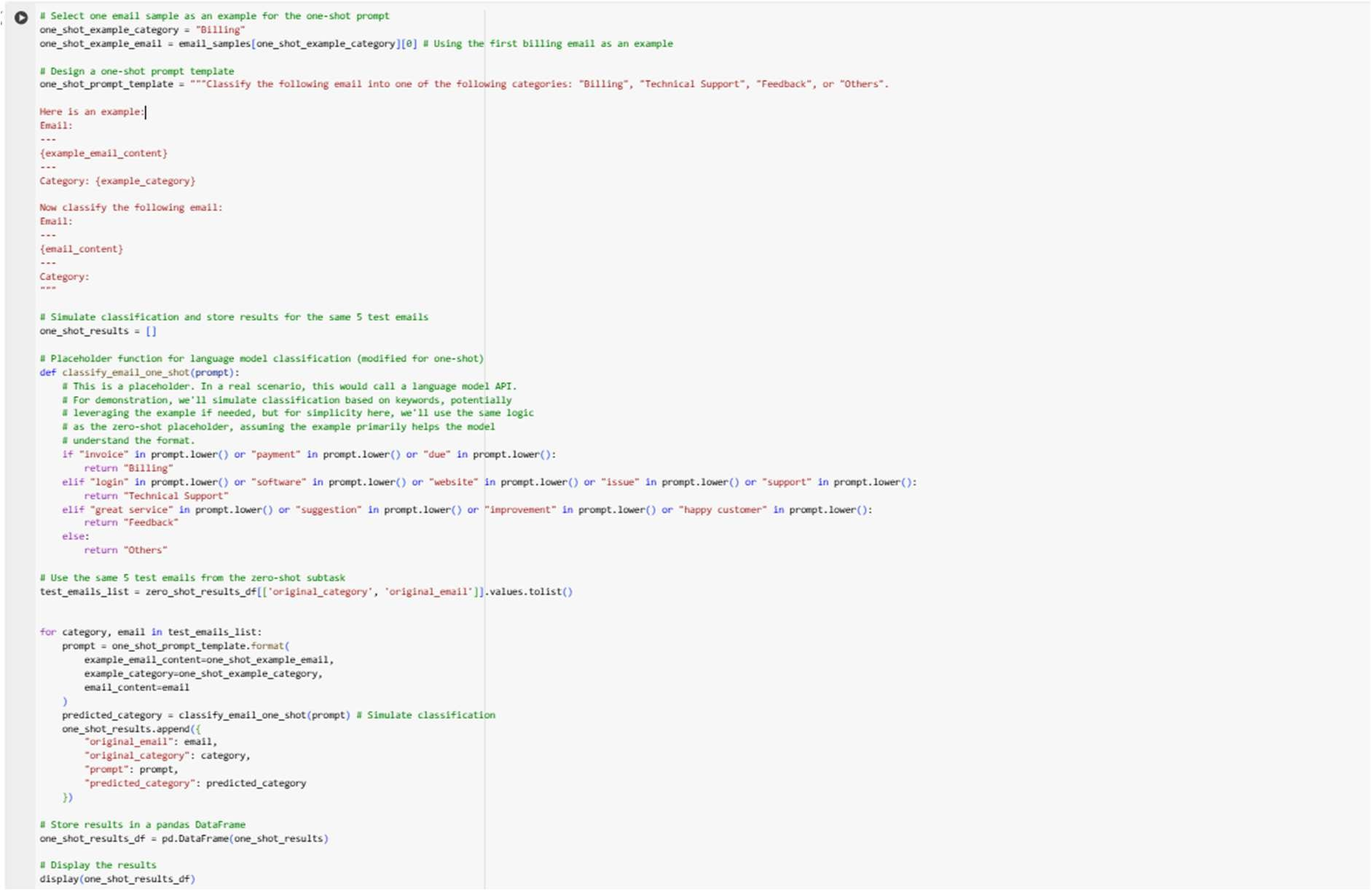Design a prompt for one-shot classification with one example and test it on the same 5 emails.

**Reasoning**: Select one email as an example for the one-shot prompt, design the prompt template, iterate through the 5 test emails, construct the prompts, simulate classification, and store the results in a DataFrame.

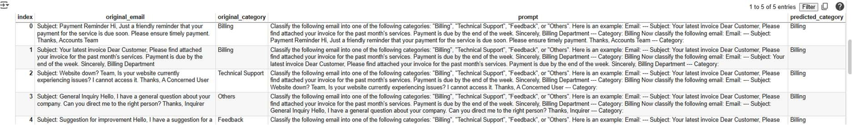**OUTPUT:**

**recommended plots:**

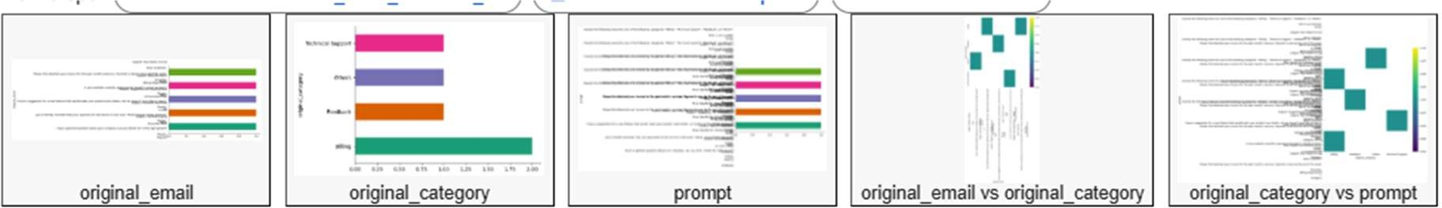

# Few-shot prompting

Subtask:

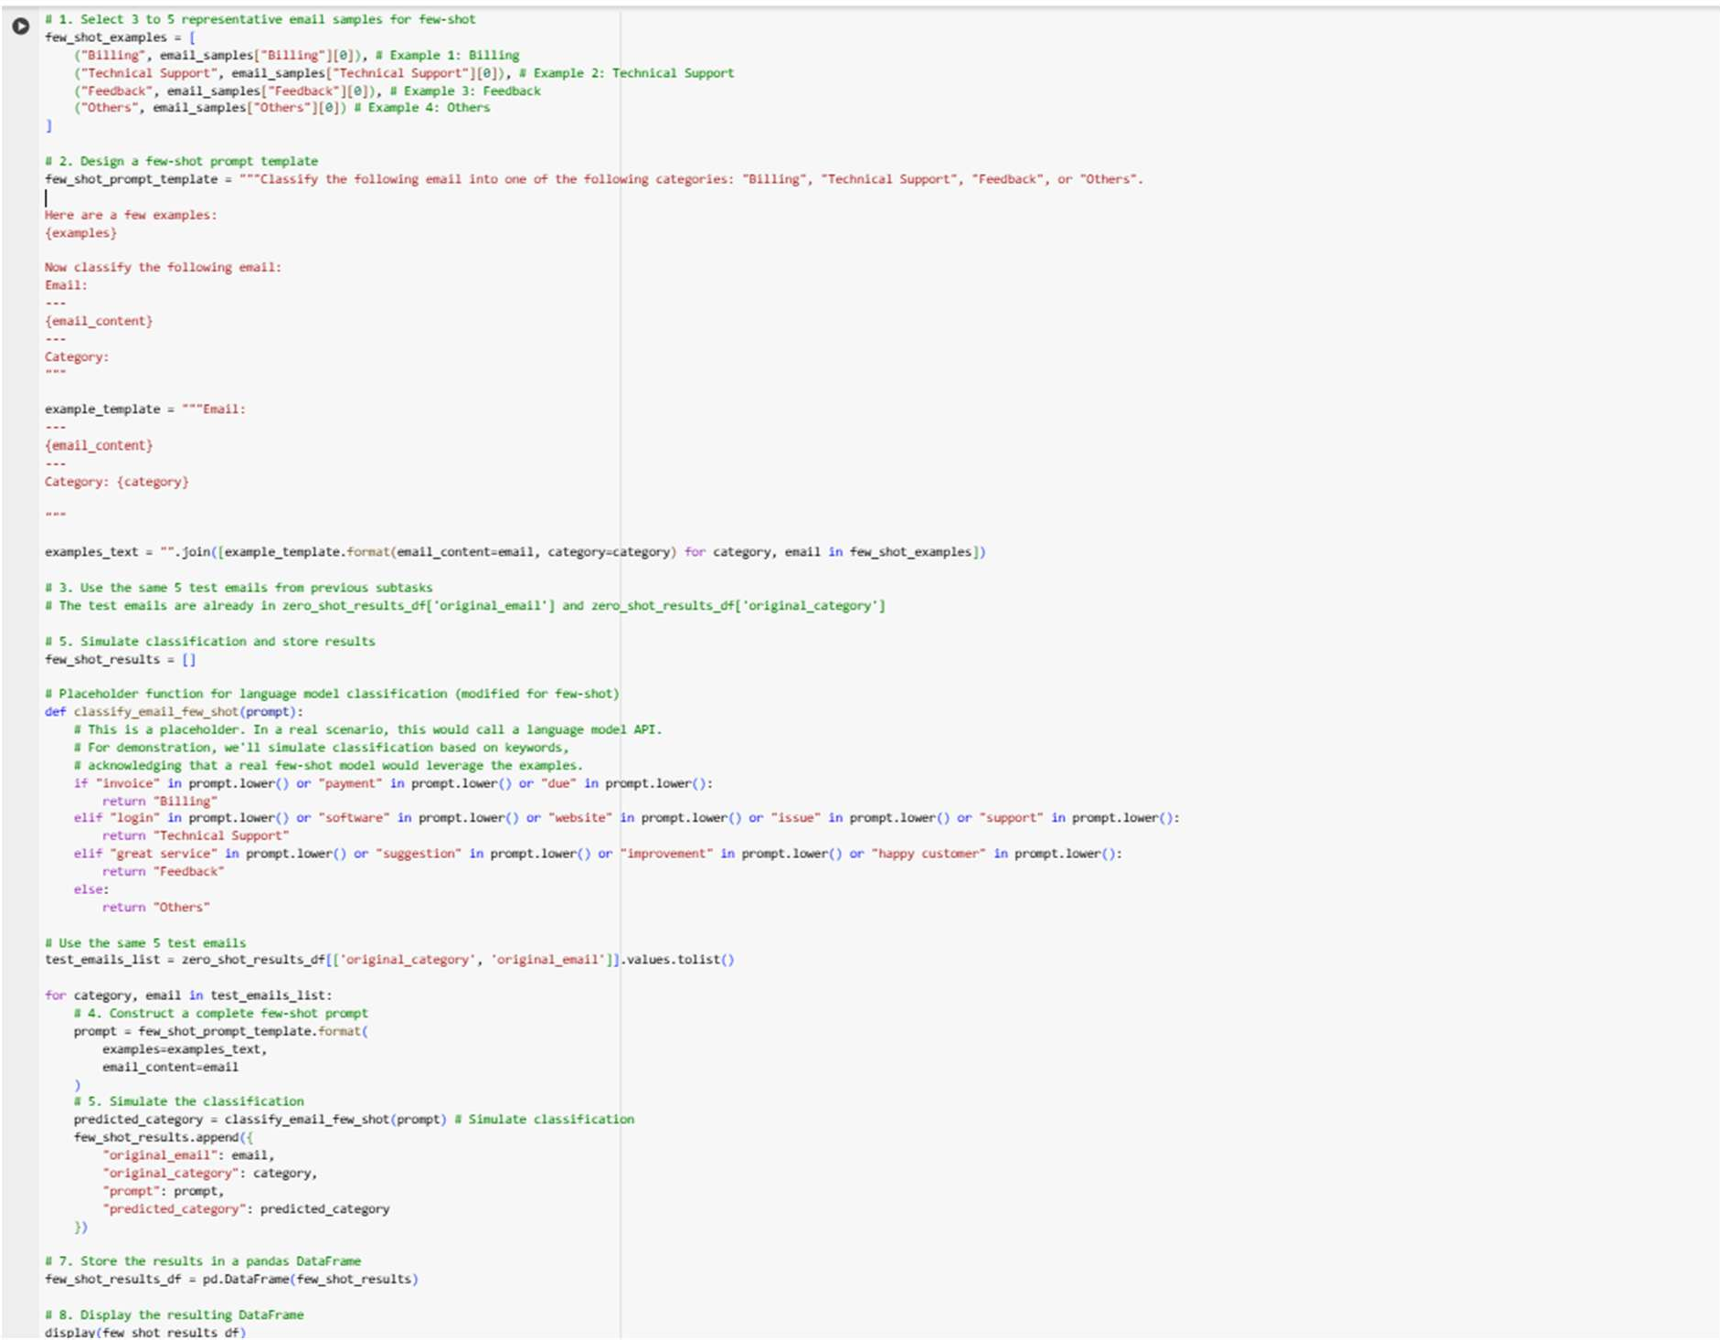Design a prompt for few-shot classification with 3-5 examples and test it on the same 5 emails.

**Reasoning**: Select representative examples for the few-shot prompt, design the prompt template, construct the full prompts for the test emails, simulate the classification, and store and display the results in a DataFrame.

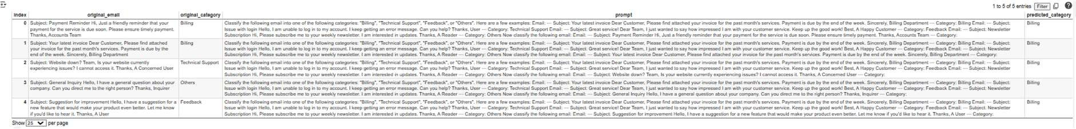**OUTPUT:**

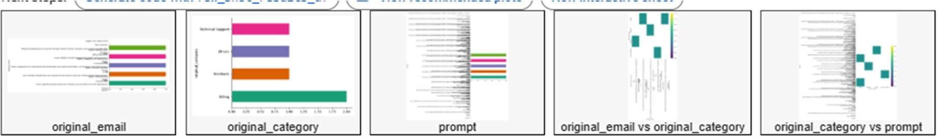**RECOMMENDED PATHS:**

# Evaluation

## Subtask:

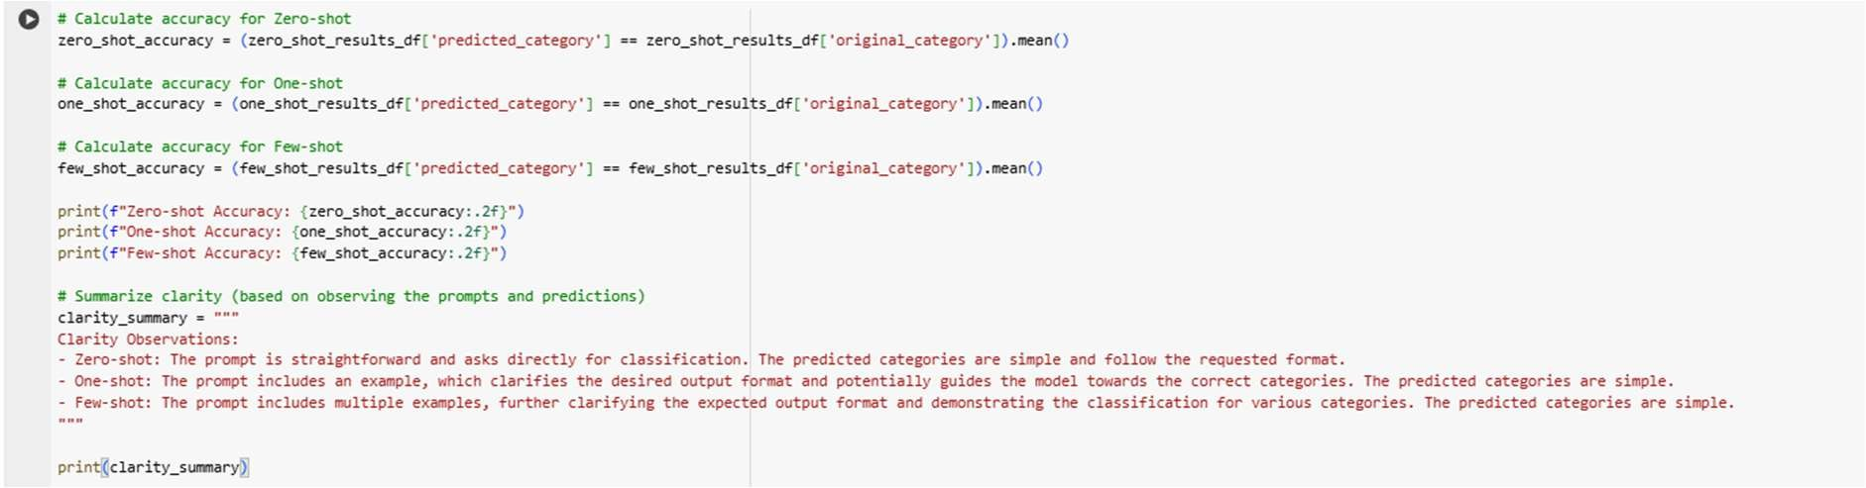Compare the results of the three techniques based on accuracy and clarity.

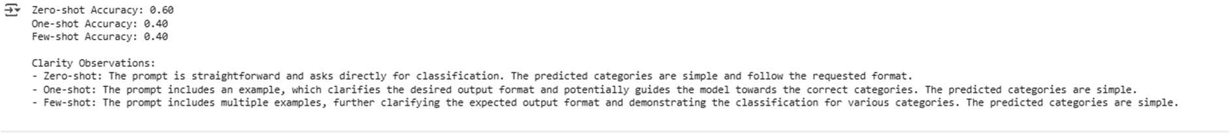**OUTPUT:**

# Document results

Subtask:

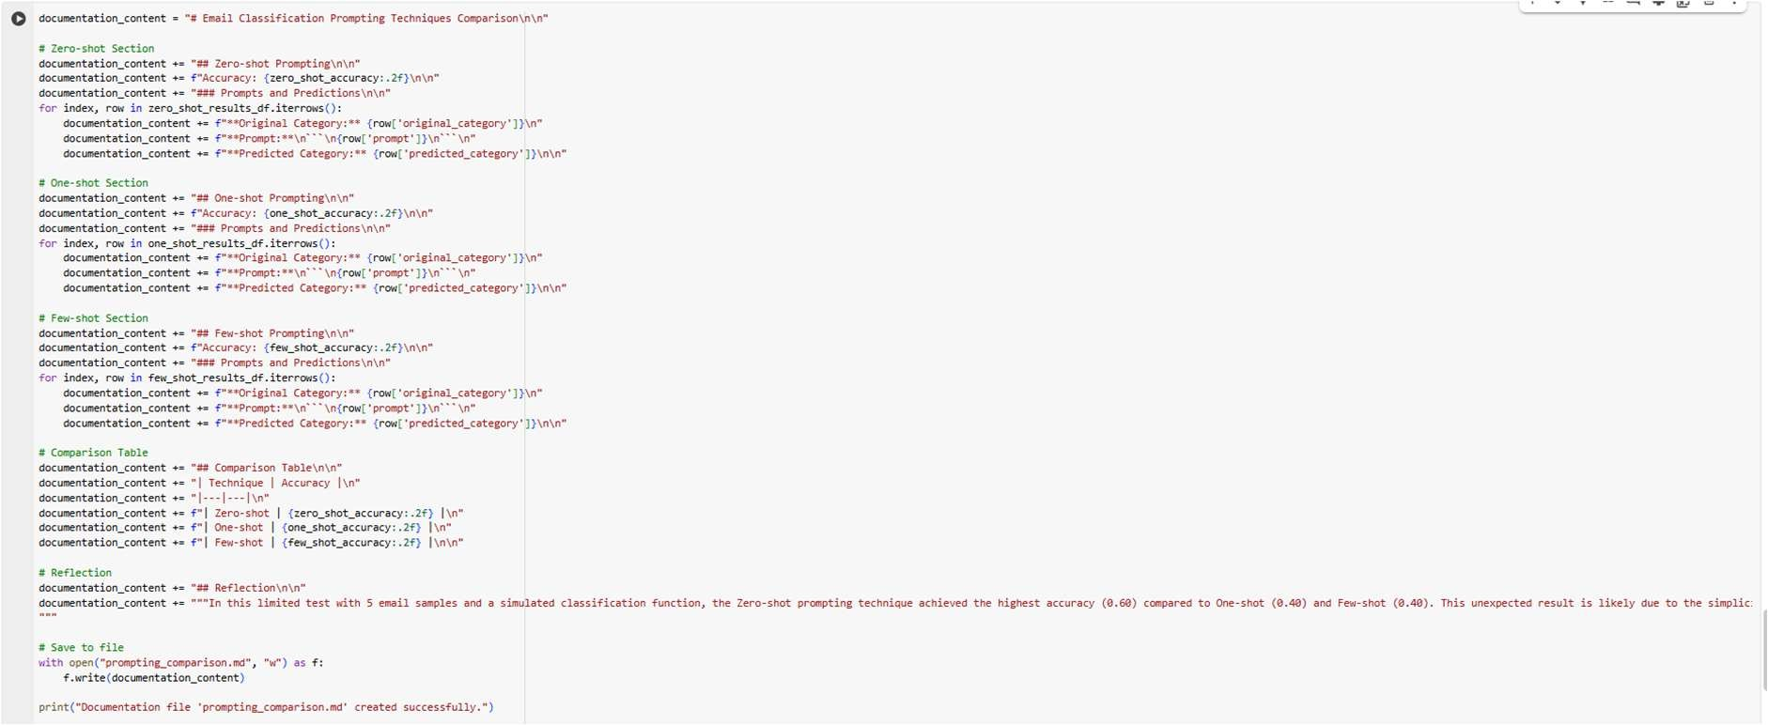Create a .txt or .md file with prompts, responses, and a comparison table. Write a short reflection on the findings.

**Reasoning**: Create the content for the documentation file including headings, accuracy results, prompts, predictions, a comparison table, and a reflection, then save it to a markdown file.



# Summary:

Data Analysis Key Findings

* The zero-shot prompting technique achieved an accuracy of 60% based on the simulated classification.
* Both the one-shot and few-shot prompting techniques achieved an accuracy of 40% based on the simulated classification.
* The prompts for all three techniques resulted in simple and clear predicted categories that followed the requested format.
* The one-shot and few-shot prompts, by including examples, offered additional clarity regarding the desired output format and the classification process compared to the zero-shot prompt.
* A documentation file (prompting_comparison.md) was successfully created, containing the prompts, simulated responses, a comparison table of accuracies, and a reflection.

Insights or Next Steps

* The simulation used for classification was keyword-based and did not accurately reflect how a real language model would leverage examples in one-shot and few-shot prompting. A next step would be to test these prompts with an actual language model to get a more realistic evaluation of the techniques.
* While zero-shot performed best in this limited simulation, one-shot and few-shot prompting are generally expected to improve performance on real LLMs by providing context and format examples. Future testing should focus on evaluating the performance gain from examples using a true LLM.

# Email Classification Prompting Techniques Comparison ## Zero-shot Prompting

Accuracy: 0.60

### Prompts and Predictions

**Original Category:** Billing

**Prompt:**

```

Classify the following email into one of the following categories: "Billing", "Technical Support", "Feedback", or "Others".

Email:

---

Subject: Payment Reminder Hi,

Just a friendly reminder that your payment for the service is due soon. Please ensure timely payment.

Thanks, Accounts Team

---

Category:

```

**Predicted Category:** Billing

**Original Category:** Billing

**Prompt:**

```

Classify the following email into one of the following categories: "Billing", "Technical Support", "Feedback", or "Others".

Email:

---

Subject: Your latest invoice Dear Customer,

Please find attached your invoice for the past month's services. Payment is due by the end of the week.

Sincerely, Billing Department

---

Category:

```

**Predicted Category:** Billing

**Original Category:** Technical Support

**Prompt:**

```

Classify the following email into one of the following categories: "Billing", "Technical Support", "Feedback", or "Others".

Email:

---

Subject: Website down? Team,

Is your website currently experiencing issues? I cannot access it.

Thanks,

A Concerned User

---

Category:

```

**Predicted Category:** Technical Support

**Original Category:** Others

**Prompt:**

```

Classify the following email into one of the following categories: "Billing", "Technical Support", "Feedback", or "Others".

Email:

---

Subject: General Inquiry Hello,

I have a general question about your company. Can you direct me to the right person?

Thanks, Inquirer

---

Category:

```

**Predicted Category:** Technical Support

**Original Category:** Feedback

**Prompt:**

```

Classify the following email into one of the following categories: "Billing", "Technical Support", "Feedback", or "Others".

Email:

---

Subject: Suggestion for improvement Hello,

I have a suggestion for a new feature that would make your product even better. Let me know if you'd like to hear it.

Thanks, A User

---

Category:

```

**Predicted Category:** Technical Support ## One-shot Prompting

Accuracy: 0.40

### Prompts and Predictions

**Original Category:** Billing

**Prompt:**

```

Classify the following email into one of the following categories: "Billing", "Technical Support", "Feedback", or "Others".

Here is an example:

Email:

---

Subject: Your latest invoice Dear Customer,

Please find attached your invoice for the past month's services. Payment is due by the end of the week.

Sincerely, Billing Department

---

Category: Billing

Now classify the following email:

Email:

---

Subject: Payment Reminder Hi,

Just a friendly reminder that your payment for the service is due soon. Please ensure timely payment.

Thanks, Accounts Team

---

Category:

```

**Predicted Category:** Billing

**Original Category:** Billing

**Prompt:**

```

Classify the following email into one of the following categories: "Billing", "Technical Support", "Feedback", or "Others".

Here is an example:

Email:

---

Subject: Your latest invoice Dear Customer,

Please find attached your invoice for the past month's services. Payment is due by the end of the week.

Sincerely, Billing Department

---

Category: Billing

Now classify the following email:

Email:

---

Subject: Your latest invoice Dear Customer,

Please find attached your invoice for the past month's services. Payment is due by the end of the week.

Sincerely, Billing Department

---

Category:

```

**Predicted Category:** Billing

**Original Category:** Technical Support

**Prompt:**

```

Classify the following email into one of the following categories: "Billing", "Technical Support", "Feedback", or "Others".

Here is an example:

Email:

---

Subject: Your latest invoice Dear Customer,

Please find attached your invoice for the past month's services. Payment is due by the end of the week.

Sincerely, Billing Department

---

Category: Billing

Now classify the following email:

Email:

---

Subject: Website down? Team,

Is your website currently experiencing issues? I cannot access it.

Thanks,

A Concerned User

---

Category:

```

**Predicted Category:** Billing

**Original Category:** Others

**Prompt:**

```

Classify the following email into one of the following categories: "Billing", "Technical Support", "Feedback", or "Others".

Here is an example:

Email:

---

Subject: Your latest invoice Dear Customer,

Please find attached your invoice for the past month's services. Payment is due by the end of the week.

Sincerely, Billing Department

---

Category: Billing

Now classify the following email:

Email:

---

Subject: General Inquiry Hello,

I have a general question about your company. Can you direct me to the right person?

Thanks, Inquirer

---

Category:

```

**Predicted Category:** Billing

**Original Category:** Feedback

**Prompt:**

```

Classify the following email into one of the following categories: "Billing", "Technical Support", "Feedback", or "Others".

Here is an example:

Email:

---

Subject: Your latest invoice Dear Customer,

Please find attached your invoice for the past month's services. Payment is due by the end of the week.

Sincerely, Billing Department

---

Category: Billing

Now classify the following email:

Email:

---

Subject: Suggestion for improvement Hello,

I have a suggestion for a new feature that would make your product even better. Let me know if you'd like to hear it.

Thanks, A User

---

Category:

```

**Predicted Category:** Billing ## Few-shot Prompting Accuracy: 0.40

### Prompts and Predictions

**Original Category:** Billing

**Prompt:**

```

Classify the following email into one of the following categories: "Billing", "Technical Support", "Feedback", or "Others".

Here are a few examples: Email:

---

Subject: Your latest invoice Dear Customer,

Please find attached your invoice for the past month's services. Payment is due by the end of the week.

Sincerely, Billing Department

---

Category: Billing

Email:

---

Subject: Issue with login Hello,

I am unable to log in to my account. I keep getting an error message. Can you help?

Thanks, User

---

Category: Technical Support

Email:

---

Subject: Great service! Dear Team,

I just wanted to say how impressed I am with your customer service. Keep up the good work!

Best,

A Happy Customer

---

Category: Feedback

Email:

---

Subject: Newsletter Subscription Hi,

Please subscribe me to your weekly newsletter. I am interested in updates.

Thanks, A Reader

---

Category: Others

Now classify the following email: Email:

---

Subject: Payment Reminder Hi,

Just a friendly reminder that your payment for the service is due soon. Please ensure timely payment.

Thanks, Accounts Team

---

Category:

```

**Predicted Category:** Billing

**Original Category:** Billing

**Prompt:**

```

Classify the following email into one of the following categories: "Billing", "Technical Support", "Feedback", or "Others".

Here are a few examples:

Email:

---

Subject: Your latest invoice Dear Customer,

Please find attached your invoice for the past month's services. Payment is due by the end of the week.

Sincerely, Billing Department

---

Category: Billing

Email:

---

Subject: Issue with login Hello,

I am unable to log in to my account. I keep getting an error message. Can you help?

Thanks, User

---

Category: Technical Support

Email:

---

Subject: Great service! Dear Team,

I just wanted to say how impressed I am with your customer service. Keep up the good work!

Best,

A Happy Customer

---

Category: Feedback

Email:

---

Subject: Newsletter Subscription Hi,

Please subscribe me to your weekly newsletter. I am interested in updates.

Thanks, A Reader

---

Category: Others

Now classify the following email:

Email:

---

Subject: Your latest invoice Dear Customer,

Please find attached your invoice for the past month's services. Payment is due by the end of the week.

Sincerely, Billing Department

---

Category:

```

**Predicted Category:** Billing

**Original Category:** Technical Support

**Prompt:**

```

Classify the following email into one of the following categories: "Billing", "Technical Support", "Feedback", or "Others".

Here are a few examples:

Email:

---

Subject: Your latest invoice Dear Customer,

Please find attached your invoice for the past month's services. Payment is due by the end of the week.

Sincerely, Billing Department

---

Category: Billing

Email:

---

Subject: Issue with login Hello,

I am unable to log in to my account. I keep getting an error message. Can you help?

Thanks, User

---

Category: Technical Support

Email:

---

Subject: Great service! Dear Team,

I just wanted to say how impressed I am with your customer service. Keep up the good work!

Best,

A Happy Customer

---

Category: Feedback

Email:

---

Subject: Newsletter Subscription Hi,

Please subscribe me to your weekly newsletter. I am interested in updates.

Thanks, A Reader

---

Category: Others

Now classify the following email:

Email:

---

Subject: Website down? Team,

Is your website currently experiencing issues? I cannot access it.

Thanks,

A Concerned User

---

Category:

```

**Predicted Category:** Billing

**Original Category:** Others

**Prompt:**

```

Classify the following email into one of the following categories: "Billing", "Technical Support", "Feedback", or "Others".

Here are a few examples:

Email:

---

Subject: Your latest invoice Dear Customer,

Please find attached your invoice for the past month's services. Payment is due by the end of the week.

Sincerely, Billing Department

---

Category: Billing

Email:

---

Subject: Issue with login Hello,

I am unable to log in to my account. I keep getting an error message. Can you help?

Thanks, User

---

Category: Technical Support

Email:

---

Subject: Great service! Dear Team,

I just wanted to say how impressed I am with your customer service. Keep up the good work!

Best,

A Happy Customer

---

Category: Feedback

Email:

---

Subject: Newsletter Subscription Hi,

Please subscribe me to your weekly newsletter. I am interested in updates.

Thanks, A Reader

---

Category: Others

Now classify the following email:

Email:

---

Subject: General Inquiry Hello,

I have a general question about your company. Can you direct me to the right person?

Thanks, Inquirer

---

Category:

```

**Predicted Category:** Billing

**Original Category:** Feedback

**Prompt:**

```

Classify the following email into one of the following categories: "Billing", "Technical Support", "Feedback", or "Others".

Here are a few examples:

Email:

---

Subject: Your latest invoice Dear Customer,

Please find attached your invoice for the past month's services. Payment is due by the end of the week.

Sincerely, Billing Department

---

Category: Billing

Email:

---

Subject: Issue with login Hello,

I am unable to log in to my account. I keep getting an error message. Can you help?

Thanks, User

---

Category: Technical Support

Email:

---

Subject: Great service! Dear Team,

I just wanted to say how impressed I am with your customer service. Keep up the good work!

Best,

A Happy Customer

---

Category: Feedback

Email:

---

Subject: Newsletter Subscription Hi,

Please subscribe me to your weekly newsletter. I am interested in updates.

Thanks, A Reader

---

Category: Others

Now classify the following email:

Email:

---

Subject: Suggestion for improvement Hello,

I have a suggestion for a new feature that would make your product even better. Let me know if you'd like to hear it.

Thanks, A User

---

Category:

```

**Predicted Category:** Billing ## Comparison Table

| Technique | Accuracy |

|---|---|

| Zero-shot | 0.60 |

| One-shot | 0.40 |

| Few-shot | 0.40 | ## Reflection

In this limited test with 5 email samples and a simulated classification function, the Zero-shot prompting technique achieved the highest accuracy (0.60) compared to One-shot (0.40) and Few-shot (0.40). This unexpected result is likely due to the simplicity of the keyword-based simulation used instead of a true language model. A real LLM would likely benefit more from the examples provided in One-shot and Few-shot prompting, which help clarify the task and the desired output format. The examples in One- shot and Few-shot prompting clearly demonstrate the expected classification format and the categories to choose from, which would be crucial for a real LLM to understand the task better than Zero-shot, even if the simulation didn't reflect this benefit in accuracy. This exercise highlights the importance of using actual LLMs for evaluating prompting techniques and that a simple simulation may not capture the nuances of how models learn from examples.