***===================================================***

***ASSIGNMENT 8.1***

***==================================***

***NAME : SREERAMOJU SUHAS AKSHAJ***

***HALL TICKECT NO : 2403A51299***

***BATCH NO : 12***

***Assignment 8.1:***

***Task Description #1 (Password Strength Validator – Apply AI in Security Context)***

***Prompt:*** ***Write a Python function is_strong_password(password) and use AI to first generate at least 3 assert test cases based on password rules (length, uppercase, lowercase, digit, special character, no spaces). Then implement the function so it passes all test cases***

***Output:***

***Code:***

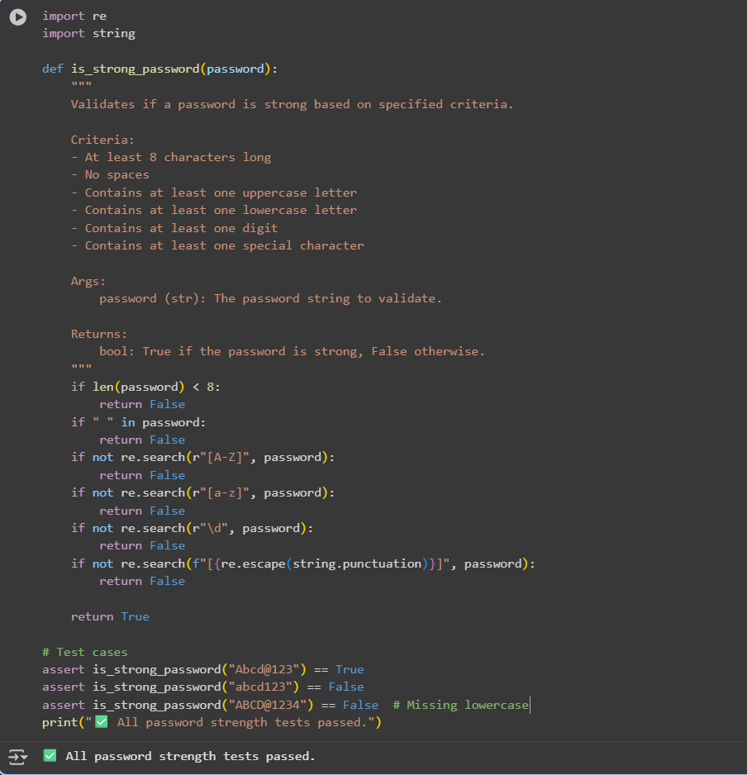

***Task Description #2 (Number Classification with Loops Apply AI for Edge Case Handling)***

***Prompt: Create a Python function classify_number(n) and ask AI to generate at least 3 assert test cases, including edge cases (negative, zero, positive, invalid input). Implement the function using loops to classify inputs as Positive, Negative, or Zero while handling invalid cases***

***Output:***

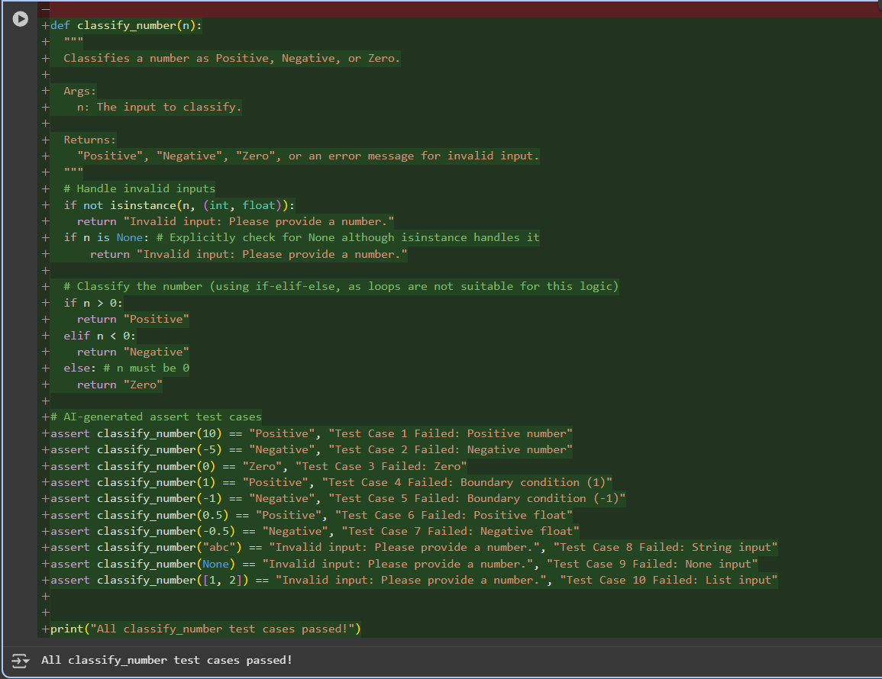

***Task Description #3 (Anagram Checker – Apply AI for String Analysis)***

***Prompt: Ask AI to generate at least 3 assert test cases for a Python function is_anagram(str1, str2) that checks if two strings are anagrams. Implement the function so it ignores case, spaces, and punctuation, and passes all test cases, including edge conditions***

***Output:***

***Task Description #4 (Inventory Class – Apply AI to Simulate Real-  
World Inventory System)***

***Prompt:*** ***Ask AI to generate at least 3 assert test cases for an Inventory class in Python that manages stock. Implement methods add_item(name, quantity), remove_item(name, quantity), and get_stock(name). Ensure the class passes all AI-generated test cases and works correctly in real-world inventory simulation.***

***Output:***

***Task Description #5 (Date Validation & Formatting – Apply AI for  
Data Validation)***

***Prompt:*** ***Ask AI to generate at least 3 assert test cases for a function validate_and_format_date(date_str) that validates dates in 'MM/DD/YYYY' format. The function should return dates in 'YYYY-MM-DD' format if valid or 'Invalid Date' if not. Implement the function so it passes all test cases, including edge cases***

***Output:***

