***=============================================***

***ASSIGNMENT 9.1***

***==================================***

***NAME : SREERAMOJU SUHAS AKSHAJ***

***HALL TICKECT NO : 2403A51299***

***BATCH NO : 12***

Prompt 1: Add Google-style docstrings to all functions in this Python script.

Include: description, parameters with types, return type, and example usage (no I/O examples).

Preserve code logic, ensure proper indentation, and follow Google-style formatting strictly

Code:

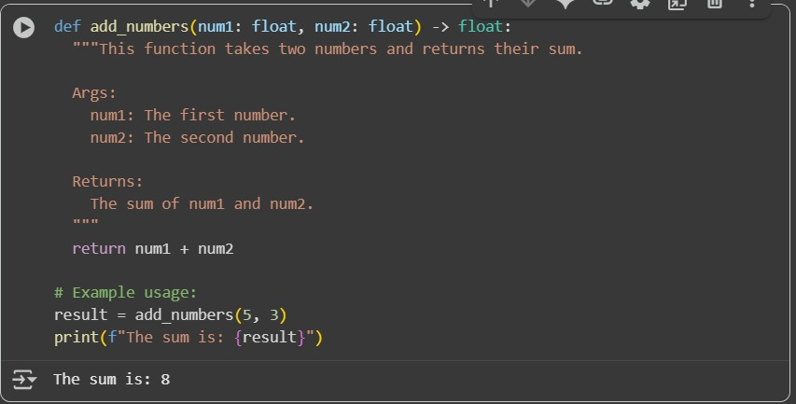

Prompt 2: Add inline comments only for complex or non-obvious logic in this Python script.

Skip obvious syntax. Keep comments concise and context-aware.

Do not change the code.

Code:

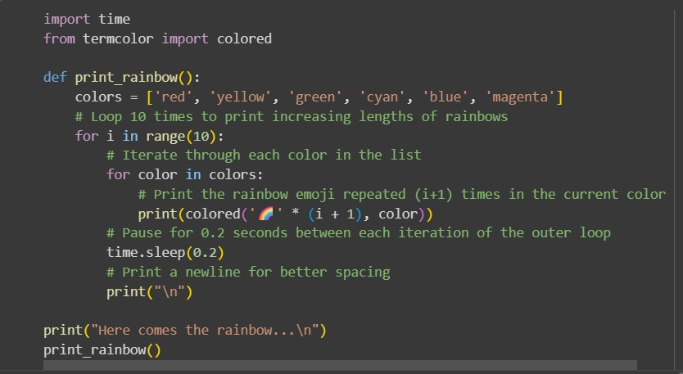

Output:

Prompt 3 : Add a module-level docstring at the top of this Python file. Summarize purpose, dependencies, and main functions/classes.

Keep it concise, clear, and multi-line.

Do not alter the code.

Code:

Python file:

Output:

Prompt 4 : Convert inline comments in this Python code into structured Google-style docstrings.

Keep meaning intact, improve clarity, and remove the old comments.

Do not change code logic

Output:

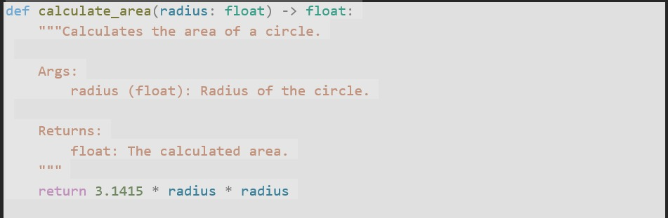

Prompt 5 : Review all docstrings in this Python file.

Fix inaccuracies so they match current code behavior.

Ensure Google-style format with description, parameters, return type, and example.

Output:

Before:

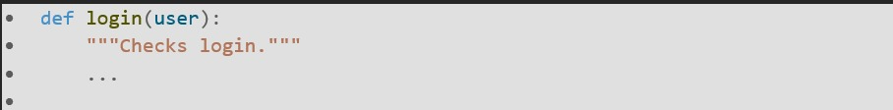

After:

Prompt 6 : Compare AI documentation for one Python function using two prompts:

1) "Add comments to this function"

2) "Add Google-style docstring with description, parameters, return type, and example"

Create a table showing prompt type, output, and observations.

Output:

