**AI ASSISTED LAB TEST -1**

***NAME: S.suhas akshaj***

***Batch number :* 12**

***Hall no: 2403a51299***

1. Create a Python function that converts an amount from one currency to another using exchange rates stored in a dictionary. Use GitHub Copilot along with VS Code. Use Few shot prompting.

Prompt:

Using python functions write a code that generaterr the currency exchange rates from one currency to another using exchange rates stored In a dictionary , ask for input for the amount of money then from which currency to which one

Code:

Output:

2. Write a Python program to extract all email addresses from a block of text using regular expressions. GitHub Copilot along with VS Code. Use zero shot prompting.

Prompt:

Using python write a code that extracts all email addresses in a user given text and has to print them

Code:

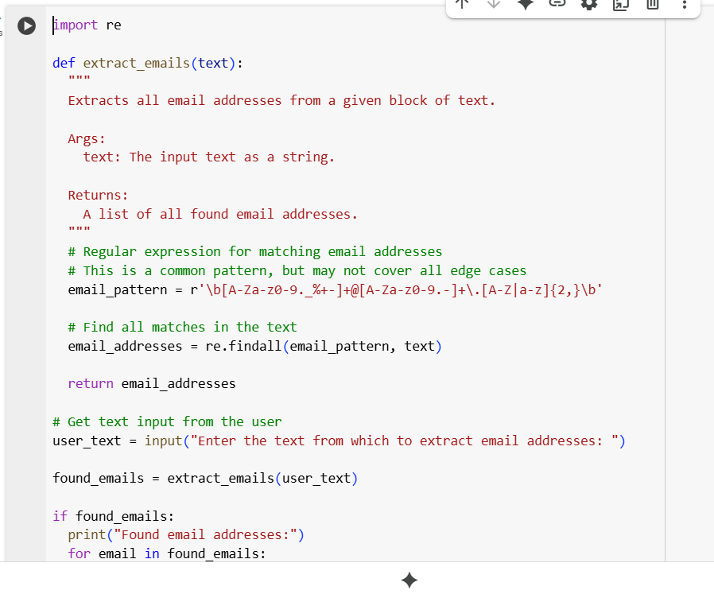

Output:

3. Given a list of movies with their genres, Write a Python function that recommends movies based on a user's preferred genre. Use the Cursor AI tool. Use few shot prompting.

Prompt: using python write a code which has multiple movies grouped according to their genre, and ask the user to select amoung those genre and suggest movies in that group of genre

Code:

Output:

4. Write Python code that reads a CSV file containing student names and marks in 3 subjects. Calculate the total and average marks for each student. Use the Cursor AI tool.

Prompt: write a python program that reads cvs file which contains student names and marks in 3 subjects, now calculate total and average marks

Code:

Output:

