**Parking and ticketing system**

**STUDENT NAME: SUHASA R K**

**STUDENT BITS ID: 2023MT12033**

| **Version Number** | **Date** | **Author/Owner** | **Description of Change** |
| --- | --- | --- | --- |
| Draft | 30-07-2023 | Suhasa R K | Initial Version with Chapters 1a - 1c |
| 0.1 | 14-08-2023 | Suhasa R K | Reformatting as per new format & adding the Gantt chart (chapter 1d) |
| 0.2 | 30-08-2023 | Suhasa R K | Added content for chapters 2a and 2b |
| 0.3 | 16-09-2023 | Suhasa R K | Minor changes to earlier added images. Primarily conventions to make entity names all uppercase |
| 0.4 | 16-09-2023 | Suhasa R K | Added Logical Design chapter |

# 

# REQUIREMENT SPECIFICATION

## Problem Statement & Requirements Definition

***PARKING & TICKETING SYSTEM:***

***We decided to automate the Parking & Ticketing process in a multi-tenant vehicle parking system. The parking space allows two-wheeler and four-wheeler LMV (Light Motor Vehicle) to be parked on a tenant basis for a minimum duration of 1 minute and a maximum duration of 24 hours. We decided to maintain the information on vehicle check-in(entry) and check out(exit), the charges including taxes for the duration of parking and bill generation in a database which will help organize the parking space. It would be ideal for a parking space upgrading from a manual token system where they have a token given by a parking attendant with entry time recorded for each vehicle checking in. The system also helps in effectively managing the slots by optimizing on the available slots & providing a simple bookkeeping system to record all the monetary transactions including taxation.***

The purpose of this database is to automate and replace the current manual token system. All tasks previously recorded on paper tokens & book records will be integrated into the new system. For example, if there are any vehicles that have not moved out even after 24 hours, sufficient alerting is built into the system to alert the concerned authorities that own the parking space.

The users of the Parking will have a faster & efficient check-in and check-out process with an automated system calculating the charges thus removing any errors that may creep in when manually done. Details of the vehicle viz. Registration number, vehicle type, Brand/Model/Color,Owner’s name & contact number are captured for the first time vehicle enters the parking lot. For any subsequent entries of the vehicle, these details can be captured from master information.

Payment is accepted in cash and also digital formats like wallets & cards. This information including the amount to be charged, payment type & audit details are recorded in the system for any future reconciliation with wallet and card partners.

The accounting department that manages the accounts i.e. book keeping of the parking space, can generate reports on an ad-hoc basis to see the revenue, the taxes due to governmental bodies and make any process changes as required.

The system integration with employee related data which can be done using off-the shelf ERP systems more effectively is **not in scope** for this project. Integration with automated gate management systems that will open or close the gate is **not in scope** for this implementation.

The system will be more reliable and user friendly to everyone including customers. While it will require some training for employees, once the system is in place, the benefits will outweigh the costs of implementing the system since automation daily manual tasks will be much faster than a paper-based token system.

## Project features identified

|  |  |  |
| --- | --- | --- |
| **Feature ID** | **Feature name** | **Description** |
| **PT 01** | **Login** | **Authentication and on success takes you to the dashboard which has a different view based on role. For an “attendant” role which is for the parking attendant, it is covered in PT 02 below. For an “accountant”, it is covered in PT 03 below** |
| **PT 02** | **Attendant Dashboard** | **Shows a screen with the current status of the parking space with aggregated information including number of occupied parking slots, number of free parking slots and number of unusable slots (due to some issues).**   * **Additionally, the user can record the entry of a vehicle by searching its registration number or creating a new one. Once vehicle details are available, the attendant can search for a free parking slot and allot the same.** * **If a vehicle is exiting, the user can fetch the parking details and generate a bill for payment. Once payment is realized, the slot is freed up and payment is recorded in the system and a bill is generated** |
| **PT 03** | **Accountant Dashboard** | **Shows a screen with a bunch of input fields which allows the user to run a transaction report or a revenue report. The report can be exported as a PDF as well.**   * **The transaction report shows the raw transaction for the eligible time period selected as input.** * **The revenue report shows the aggregated amount collected, the tax to be remitted to the government treasury & it is grouped by the payment type i.e cash, card or wallet.** |

## 

## Software and hardware details

|  |  |
| --- | --- |
| **Platform** | [**Spring**](https://spring.io/) **running on JRE (Java 17)** |
| **Frontend/console** | **HTML using a web framework named** [**Vaadin**](https://vaadin.com/) |
| **Backend/server** | **Spring Boot (uses Tomcat or Jetty)** |
| **Database** | * [**H2**](https://www.h2database.com/html/main.html) **database for demo purposes but can be extended to any RDBMS** * **JDBC for connectivity between application & database** |
| **Programming Language** | **Java - for both server side(backend) and client side(frontend)** |

## Project Plan

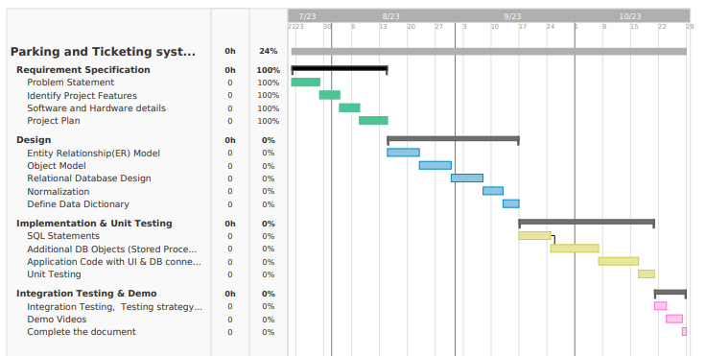

# Conceptual Design

## Entity Relationship Model

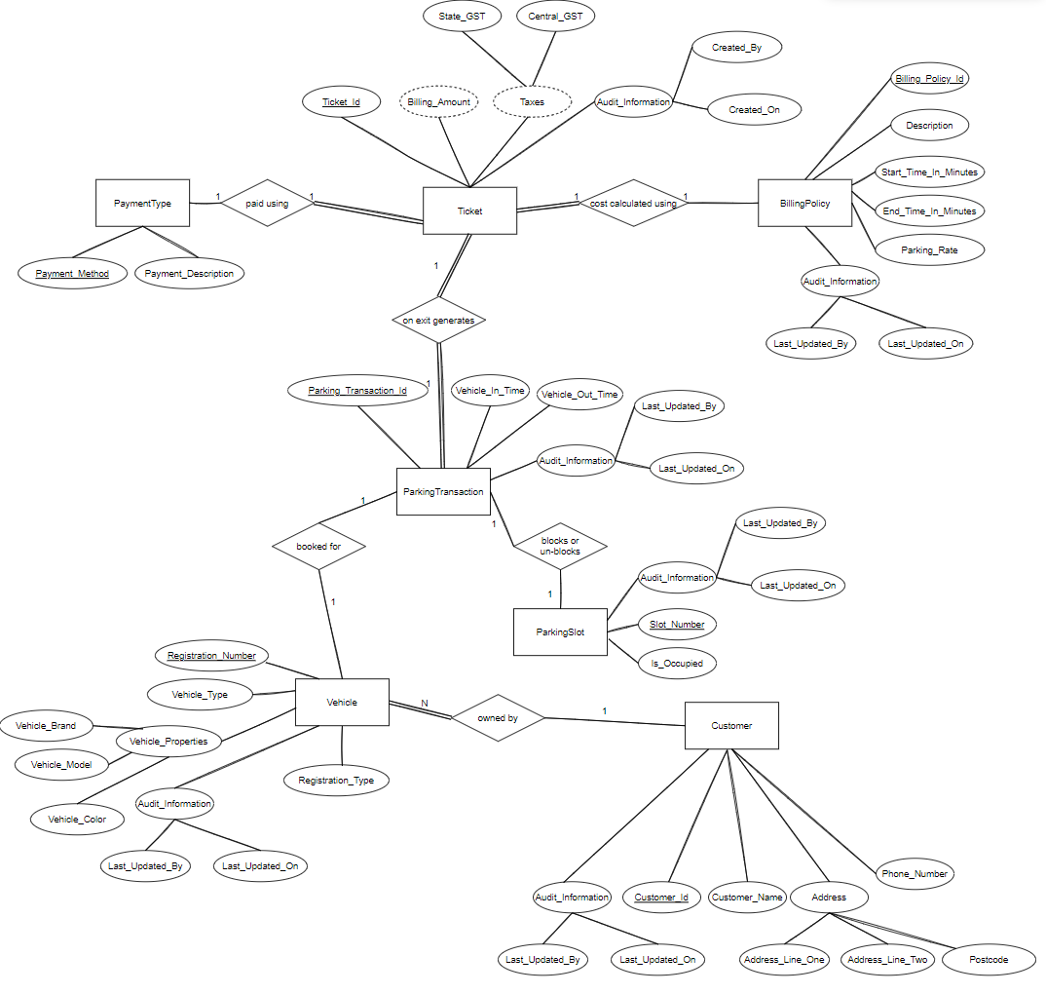

## Object Model

## 

## 

# Logical Design

# Relational Database Schema

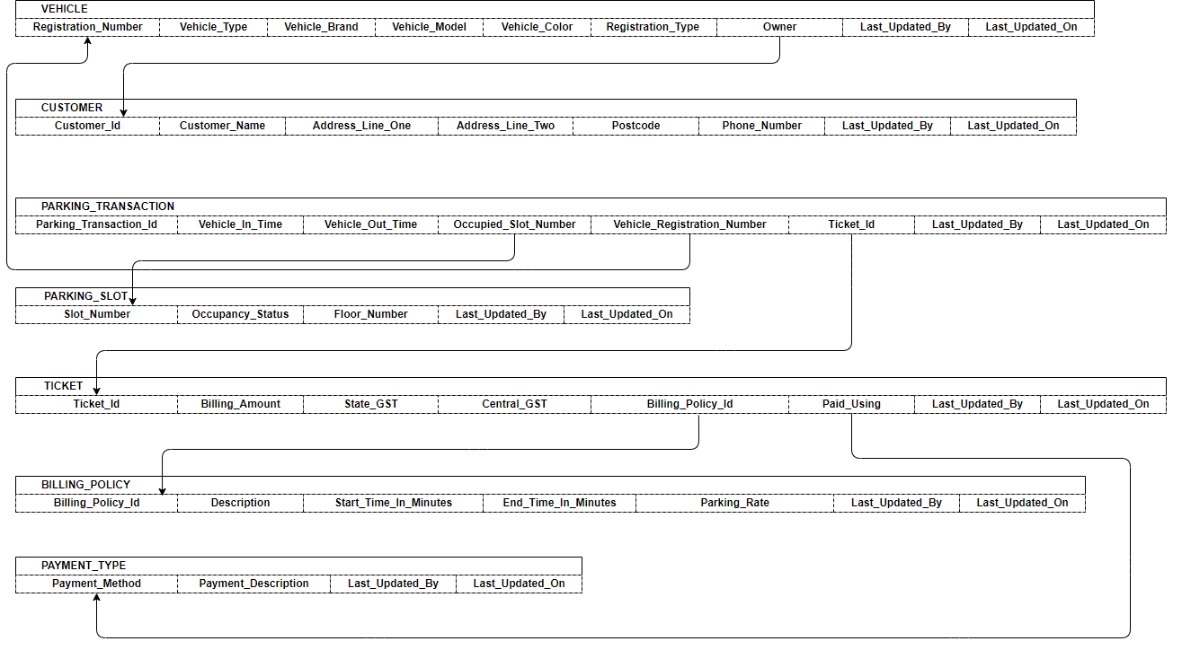

# 

# Normalization

|  |  |  |
| --- | --- | --- |
| **Table Name** | **State** | **Reason** |
| **VEHICLE** | 3rd Normal Form | No Multivalued Attributes, No Partial or Transitive Dependencies |
| **CUSTOMER** | 3rd Normal Form | No Multivalued Attributes, No Partial or Transitive Dependencies |
| **PARKING_TRANSACTION** | 3rd Normal Form | No Multivalued Attributes, No Partial or Transitive Dependencies |
| **PARKING_SLOT** | 3rd Normal Form | No Multivalued Attributes, No Partial or Transitive Dependencies |
| **TICKET** | 3rd Normal Form | No Multivalued Attributes, No Partial or Transitive Dependencies |
| **BILLING_POLICY** | 3rd Normal Form | No Multivalued Attributes, No Partial or Transitive Dependencies |
| **PAYMENT_TYPE** | 3rd Normal Form | No Multivalued Attributes, No Partial or Transitive Dependencies |

# Data Dictionary













