**Ansible assignment:**

Step 1: Setup ssh connection to workstation using openstack.pem openstack.pub key.

Download and place the keys in appropriate folders.

Step 2: run the set up file ‘site-setup-workstation.yml’ to create the environment

Step 3: make workstation as isolated node:

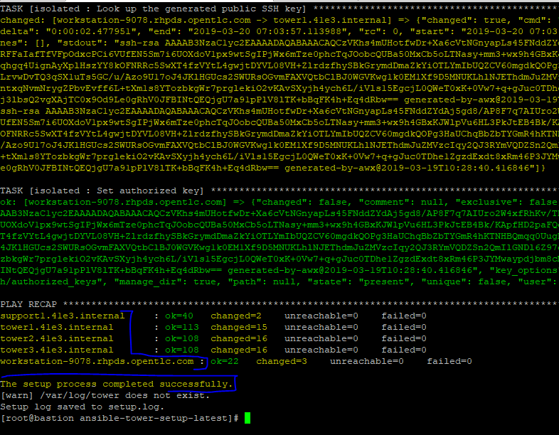

Isolated tower set up done.

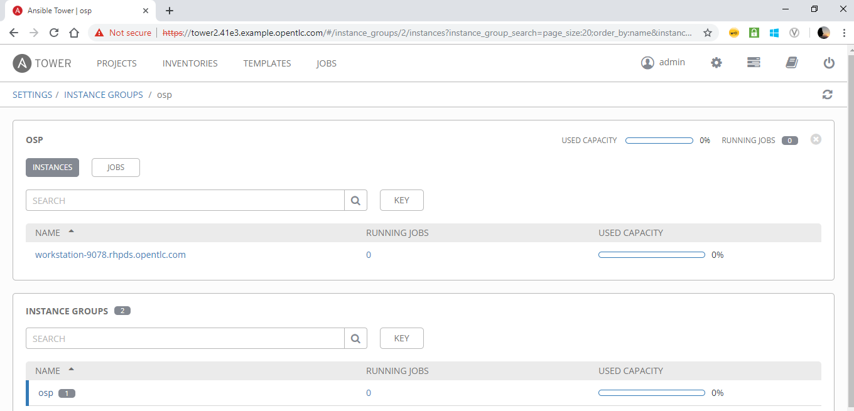

Isolated node OSP verification in web portal.

Step 4: Create the systems for 3 trier application set up:

Machine generated alternative text:
u'polt range min': 443, u 'location' 
06a2fg4eg3bb328f6bebe8bY6S'}, u' zone': None, 
u' 0.0.0.0/0', u ' group': { 
oce ip prefix' 
one, u 'direction': 
u' Ingress ' 
u 'protocol ' • 
-4bea-b2b2-b27f2436218f' , 
u'Cenant id': u' 
{u 'project' • 
{u' domain name' : 
u'regzon name' • 
u 'RegionOne' , 
None , u domain 
u' cloud': u' 
u'projecC id': u' 
u'id': u'S4SOd70e-7S3c-4S• 
u' Ccp', u' ethertype': u' IPv4', u 'port range 
u'polt range min': 80, u' location' 
u' name' • 
u ' admin ' 
u' id': u'Ie3aa106a2fg4eg3bb328f6bebe8bY6S'}, u' zone': None, 
u' 0.0.0.0/0', u ' group': { 
u 'properties' 
{u' group': { } } , u ' remote ip prefix' 
4ad7aIaa71'}, {u' remote group id': None, u 'direction' 
u' Ingress ' 
u 'protocol ' • 
' secmlity group id': 
u'Cenant id': u' 
u' region 
u proj ect 
u' port 
main name': None, u 'domain id': None, u 'name': 
u ' admin ' 
u' id': u'1e3aa106a2fg4eg3bb328f61 
RegionOne , 
u' cloud': u' ospcloud'}, u 'properties' 
{u'group': { } } , u ' remote ip prefix' 
name' • 
none ' 
u' 72fdc2se-egea-4scb-bsc1-32gf8gead3sc• u' id': u'd42a1cS2-S1ea-4bea-b2b2-b27f2• 
None, u 'domain id': None, u 'name': 
u ' admin ' 
u' id': u'1e3aa106a2fg4eg3bb328f6bebe81 
u' cloud': u' ospcloud'}, u 'project id': u'Ie3aa106a2fY4eg3bb328f6bebe8bY6S', u 'propt 
scheduler hints': None, u' attached': [l, u 'user id': u' g 7656( 
u'MANUAL', u'MANUAL', 
K}, u'access1Pv4': '&'20.20.20.3', 
{u' u'Ie3aa106a2fY4eg3bb328f6bebe8bY6S', u 'domain name' : None, u 'name' : 
u RegionOne ' 
u' cloud': u' ospcloud'}, u 'power state' • 
I, u 'key name' • 
I, u' interface i p': u'20.20.20.3', u' instance name' • 
u' instance—OOOOOOOI ' 
{u' group': u' flontends', 
u' deployment name' • 
u'dev'}, u 'status': 
u ' admin ' 
u' ansible s: 
u' launched al 
u 'updated' 
806gc188c8861agadd78f3dese78dS181e211b801841Sdd80', at' : None, 
0.20. 20.3', u'public v6': u", 
u 'hypervisor hostname' 
u' compOI . example . com' , 
u 'private 
-scH-HNT:schedu1el hints' : None, u'host : u'b3aa706806gc188c8861agadd78f3dese78dS181e21 
ties': 
{u'OS-EXT-STS:task : None, hostname' • 
u ' compOI 
u' instance-oooooool', u'MANUAL', data': No: 
u' active 
u scheduler hints' : 
os-EXT-STs:power state' • 
I, u zone' • 
u nova 
None, u 'OS-SRV-USG:1i 
u OS-SRV-USG: terminal 
ability zone' 
u nova 
u' hostname' • 
u' compOI . example . com' , 
54' , u' tenant id': u' le3aa106a2fY4eg3bb328f6bebe8bY6S', u' created at' : 
has config drive' • 
False, u 'project id': u' , u 'l.mlumes' 
u' region' • 
u 'RegionOne'}}" public I P] 
ok: [workstation] { 
floating ± p. floating address 
" : "20.20.20.22 
TASK 
[osp—inscances 
Wai C for 
" f ronCend " 
Co be available] 

Frontend system got created

IP : 10.10.10.12

Machine generated alternative text:
None , 
u'flavor• . 
u' active 
u os-EXT 
{u' id': u'dfcOb7bf 
—SRV—ATTR: instance name' : 
-esfe-4f0b-g214-f822fa10c0fa• , 
u'm2.smaII'}, u 'az': 
u 'ncva', 
a-bd4e-4243-80 
ff—8821fg43ebdI' , u' security groups' • 
[ {u description ' 
u' ports open', 
u' tenant id': u' le3aa106a2fg4eg3bI 
u' security group rules' 
[ {u' remote grcup id': None, u 'direction' 
u' Ingress' 
u' protocol': u 'Ccp', u' ether type' 
e max': 8080, u' security group id': u' u'Cenant id': u' ' , 
u' port range min': 8081 
u'projecc': {u' domain name': None, u 'domain id': None, u 'name' • 
u ' admin ' 
u' u' le3aa106a2fg4eg3bb328f6bebe8bg6S 
u•o.o.o.o/o•, 
'legion name' • 
u RegionOne ' 
u' cloud': u' ospcloud'}, u 'properties' 
{u'group': { } } , u ' remote ip prefix' 
project id': u' 
u' id': u' {u' remote group id': None, u 'direction' 
u' Ingress ' 
Ccp', u'eCherCype': u' IPv4', u 'port range max': 22, u' security group id': u' u 'C' 
'port range min': 22, u' location': {u'project' 
{u' domain name': None, u 'domain id': None, u 'name': 
u ' admin ' 
bb328f6bebe8bY6S'}, u' zone': None, u' region name' 
u RegionOne ' 
u' cloud': u' ospcloud'}, u 'properties' 
{u' group': { } } 
u' 0.0.0.0/0', u 'group'. 
fix' : 
9—818247fcgfa4', u' location' . 
f6bebe8bY6S'}, u' zone': None, 
{ u'project id': u", 
{u 'project' • 
{u' domain name' : 
u'regzon name' • 
u RegionOne ' 
u' 736gcb13-c1g1-4a8f-gsoa-70e07e660S62'}], u'id': u'883ff• 
None, u 'domain id': None, u 'name': 
u ' admin ' 
u' id': u'Ie3a, 
u' cloud': u' ospcloud'}, u 'project id': u' le3aa106a2fg4eg3bI 
u'propelties'• 
{ } , u 'name': 
u'app servers' u' scheduler hints': None, u' attached': [l 
s6d0787sc40b3880ss82g46Y8ge4g•, u'disk config': u'MANUAL', u'OS-DCF:diskConfig•: u'MANUAL', 
{Y, u 'accessl: 
7', u' accessIPv6': u" 
u' domain id': None}, 
ssh', u 'progress' 
u • 2019-03-22T07 
2019-03-22T07 : 10: ssz•, 
u' location': {u'projecc': {u' id': u' le3aa106a2fY4eg3bb328f6bebe8bY6S', u 'domain name': None, u 
u' zone' • 
u nova 
u ' region name ' • 
u RegionOne ' 
state' • 
I, u' interface i p' • 
: 10:56. 000000', u 'metadata': 
{u'group': u 'apps', 
u' cloud': u' ospcloud'}, u 'power state' • 
I, u 'key 
u' 20.20.20.7', u 'instance name': 
u' instance—OOOOi 
u ' deployment name' • 
u'dev'}, u' status': 
Ck device mapping' : None, 
'&'20.20.20.7', u'cloud': 
: u' sgbgf8bf3d22d1ecfa16eS2e12ed870badgag6c862g8184f00241esa• , 
u ' : terminated 
u'public VA': u' 20.20.20.7', u'public v6': u", 
u 'hypervisor hostname' 
u compOO . example . com 
u' ospcloud', hints' : None, u 'host id': u' SYbgf8bf3d22dIecfa16eS2e12ed: 
84f00241esa•, 
u'Cask state': None, u 'properties' 
{u'OS-EXT-STS: task : None, 
mpIe . com' , 
name' : 
u' instance-00000002', u'OS-DCF:diskConfig•: u'MANUAL', u•os-EXT-SRV-ATTR: 
u' : volumes attached': [l, u state' • 
u' active' 
u scheduler hints' : 
ched at' : 
I, u zone' • 
u nova 
None , 
u os-sl 
at': None}, u 'Cags'• 
[l, zone' • 
u' appl' , u' 
u' g8euLn14qoZv' , 
u' tenant id' : 
u nova 
u hostname' • 
u' compOO . ex, 
u' le3aa106a2fg4eg3bb328f6bebe8bY6S' , u' created at : 
u' 2019-0: 
u' created': 
personality': None, u' config drive' • 
ok: [workstation] { 
u' has config drive' • 
False, 
u 'project id': u' le3aa106a2fg4eg3bb328f6bebe8bY6S' , u 
u'reglon'• 
u 'RegionOne'}}" public I P] 
floating ± p. floating address 
TASK 
[osp—inscances 
Wai C for 
"appl" Co be available] 

App1 system got created

IP: 10.10.10.3

Machine generated alternative text:
Puny sessions 
HomeWork (suhas.m. I. bhatt-accent 
PreReqLab (suhas.m.l. bhatt-accent 
Redhatl (ec2-user@13.233.o.gg) 
ubu2 (ubuntu@13.233.154138) 
Windows int lab (suhas.m.l.bhatt-ac 
vvorkstaton (suhas. m bhatt-accen 
ata': None, 
u'flavor• . 
u' active', 
u os-EXT 
{u' id': u'dfcOb7bf 
—SRV—ATTR: instance name' : 
u' instance—00000003', at' : 
u'201 
, u' security groups' • 
-esfe-4f0b-g214-f822fa10c0fa• , 
[ {u description ' 
u'ports open', 
u'm2.smaII'}, u 'az': 
u 'ncva', 
u 'tenant id': u'Ie3aa106a2fY4eg3bb328f6bebe8 
EY6s•, u' security group rules' 
[ {u' remote grcup id': None, u 'direction' 
u' Ingress ' 
u' protocol': u 'Ccp', u 'ether type' 
u' IPv4', u 'poi 
t range max': 8080, u' security group id': u' u'Cenant id': u' ' , 
u'porC range min': 8080, u 'locati 
one , 
{u 'project': {u' domain name': None, u 'domain id': None, u 'name' • 
u ' admin ' 
u' id': u'1e3aa106a2fg4eg3bb328f6bebe8bY6S'}, u' zone': N 
u' 0.0.0.0/0', u 'group'. 
u'regzon name' • 
u RegionOne , 
u' cloud': u' ospcloud'}, u 'properties' 
{u' group': { } } , u ' remote ip prefix' 
u'project id': u' 
u' id': u' {u' remote group id': None, u 'direction' 
u' Ingress ' 
u ' protoco 
u' Ccp', u' ethercype': u' IPv4', u'p01C range max': 22, u' security group id': u' u'Cenant id' 
u'port range min': 22, u 'location': {u'project': {u'domain name': None, u 'domain id': None, u 'name' 
u ' admin ' 
u' id': u'Ie3aa106a2 
fY4eg3bb328f6bebe8bY6S'}, u' zone': None, u' region name' 
u RegionOne , 
u' cloud': u' ospcloud'}, u 'properties' 
{u' group': u' lemote 
u' 0.0.0.0/0', u 'group'. 
ip prefix' 
10-aS3g-818247fcgfa4', u'location• . 
Sbb328f6bebe8bY6S'}, u' zone': None, 
{ u'project id': u", 
{u'project': {u'domain name' • 
u'regzon name' • 
u RegionOne ' 
EY6s•, u 'properties' • 
{ } , u 'name': 
u' app servers' } l, u' scheduler 
u•g76s6d0787sc40b3880ss82g46Y8ge4g•, u'disk config': u 
' MANUAL ' , 
20.20 .14', u' accessIPv6': u", 
u' location': {u' project' • 
u' 736gcb13-c1g1-4a8f-gsoa-70e07e660S62'}], u'id': u'883ffgf1-ffdc-4f 
None, u 'domain id': None, u 'name': 
u ' admin ' 
u' id': u'Ie3aa106a2fY4eg 
u' cloud': u' ospcloud'}, u 'project id': u'Ie3aa106a2fY4eg3bb328f6bebe8 
hints': None, u' : volumes attached': [l, u 'user id' • 
u' u 'MANUAL', u 'networks' 
{Y, u 'accessIPv4': u '20 
u'Ie3aa106a2fY4eg3bb328f6bebe8bY6S' , u 'domain name' : None, u 'name' : 
admin' , 
u'domain id': None}, u 'zone': 
u nova 
u' region 
ansible ssh', u 'progress' 
O, state' • 
launched at ' : 
name ' • 
u 'RegionOne' , 
I, u' interface i p' • 
{u' group': u 'apps', 
u' cloud': u 'ospcloud'}, u 'power state' 
I, u 'key name' • 
u'20.20.20.14', u' instance name': 
u' instance—00000003', u' 
u' deployment name' • 
u'dev'}, u' status': 
u' ACTIVE', u •upda 
ted': u'hostld': u'b3aa706806gc188c8861agadd78f3dese78dS181e211b801841Sdd80', at': Non 
e, u 'block device mapping': None, u 'public VA': u'20.20.20.14', u 'public v6': u' ' , 
u 'hypervisor hostname' 
u' compOI . example . com' , 
vate VA': u' 20.20. 20.14', u' cloud': u'ospcloud', hints': None, u'host id': u'b3aa706806gc188c8861agadd78f3deSe78 
dS181e211b801841Sdd80', u'Cask state': None, u 'properties' 
{u'OS-EXT-STS: task : None, hostname' • 
compOI . example . com' , 
name' : 
u' instance-ooooooos•, u'OS-DCF:diskConfig•: u'MANUAL', da 
ta' : None, :volumes attached': [l, u state' • 
u' active 
hints' : 
IT—USG: launched at : 
I, u zone' • 
u ' nova ' 
None, u •os-SR 
u OS-SRV-USG: 
terminated at': None}, u' tags' • 
[l, zone' • 
u 'app2 ' , u 
u' YAiXAt73EkQ8', u' tenant id' : 
u' created': u' u'has config drive' • 
u nova 
u hostname • 
u ' compOI . example . c 
u' le3aa106a2fg4eg3bb328f6bebe8bY6S' , u' created at : 
u • 2019-03-22T07 
False, u 'project id': u' le3aa106a2fg4eg3bb328f6bebe8bY6S' , u 'l.mlume 
[l, u 'personality': None, u' config drive' • 
[workstation] { 
u' region' 
floating ± p. floating address 
u 'RegionOne'}}" public I P] 
" : "20.20.20.24" 
r ASK 
[osp—inscances 
Wai C for 
"app2" Co be available] 

App1 system got created

IP : 10.10.10.14

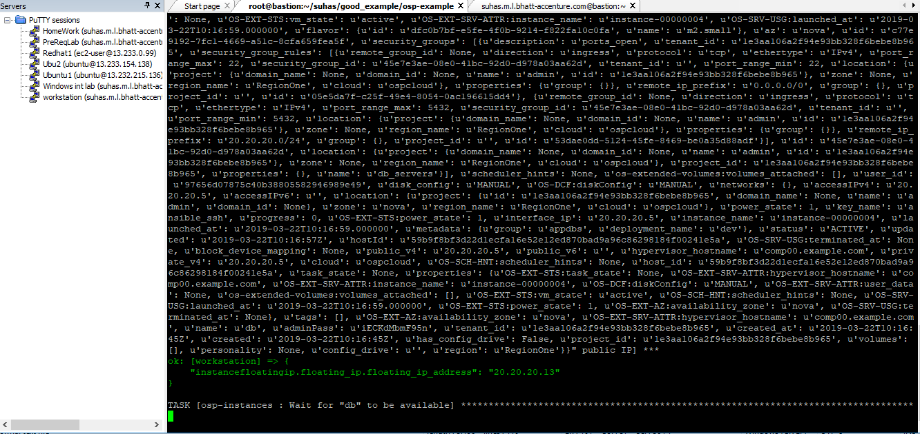

DB system got created

IP : 20.20.20.13