Software Requirements Specification
for
Hostel Management System

Version 1.0 approved
Prepared by B S Suhas [15IT110]
NITK, Surathkal
9th January, 2018

Table of Contents
Table of Contents ii
Revision History ii
1. Introduction 1
1.1 Purpose 1
1.2 Document Conventions 1
1.3 Intended Audience and Reading Suggestions 1
1.4 Product Scope 1
1.5 References 1
2. Overall Description 2
2.1 Product Perspective 2
2.2 Product Functions 2
2.3 User Classes and Characteristics 2
2.4 Operating Environment 3
2.5 Design and Implementation Constraints 3
2.6 User Documentation 3
2.7 Assumptions and Dependencies 3
3. External Interface Requirements 3
3.1 User Interfaces 3
3.2 Hardware Interfaces 3
3.3 Software Interfaces 3
3.4 Communications Interfaces 4
4. System Features 4
4.1 Login 4
4.2 Room Allotment 4
4.3 Download allotment letter / See status of application 5
4.4 Hostel Complaints 5
4.5 Hostel Notice Board 6
5. Other Nonfunctional Requirements 6
5.1 Performance Requirements 6
5.2 Safety Requirements 6
5.3 Security Requirements 7
5.4 Software Quality Attributes 7
5.5 Business Rules 7
6. Other Requirements 7
Appendix A: Glossary 7
Appendix B: Analysis Models 8
Appendix C: To Be Determined List 8

Revision History
Name | Date | Reason For Changes | Version

Introduction

Purpose
The purpose of this document is to present a detailed description of the Hostel Management System. It will explain the purpose and features of the system, what the system will do, the constraints under which it must operate and how the system will react to external stimuli. This document is intended for both the concerned authorities and the developers of the system.

Document Conventions
This Document was created based on the IEEE template for System Requirement Specification Documents. This document uses the Times font size 12.

Intended Audience and Reading Suggestions
This document is intended for different users:
- The developers, who will be developing this system and those who might wish to implement new features
- Testers who can run and test the software. They can check if the software follows specific requirements and if it meets developer’s goals and user’s expectations. Testers can also search for bugs or unexpected behaviors and report them.
- Other users who wish to learn about the software.

Product Scope
Hostel Management System is a web-based portal for the students and hostel administrators for hostel room allocation, mess allotment and help manage the hostels. The hostel information can be setup by the staff/admin, and the students can be allocated rooms based on their preference. On the whole, this system would help discard the manual system followed, and would replace the existing system.

References
[1] IEEE Software Engineering Standards Committee, “IEEE Std 830-1998, IEEE Recommended Practice for Software Requirements Specifications”, October 20, 1998.

Overall Description

Product Perspective
Hostel Management System(HMS) is an online portal which intends to roll out the current manual process of room allocation in colleges. The manual process which is currently being followed is definitely tedious and prone to errors. This online system proposes a robust alternative to the current methodologies used for the required functions. The advantages are many :
- Ease of use
- Ease of maintenance
- No need of bookkeeping
- Fast and does not require the physical presence of student

Product Functions
Functions for the student are:
- Login to the system using the given credentials
- Request for hostel room allocation by filling a form
- See the status of the application for room allotment
- Lodge a complaint regarding hostels
- View the hostel notice board

Functions for hostel admin are:
- View all applications for room allotment
- Allot/approve rooms to students based on preference
- Deallocate rooms of vacated students
- Update the hostel notice board
- View complaints

User Classes and Characteristics
This system will be used primarily by two users:
- Students
- Hostel Administrators
Each of their functions have been summarized in the 2.2.
Each user is expected to be an internet literate.

Operating Environment
The application being web-based, will be able to run on all modern browsers like:
- Google Chrome
- Mozilla Firefox
- IE 8 etc
The application can work in all operating system having a modern browser such as the ones mentioned above.

Design and Implementation Constraints
The web application will be constrained by the capacity of the DB. The DB may in some cases be forced to queue incoming requests and therefore increase the time it takes to fetch data.

User Documentation
TBD

Assumptions and Dependencies
It has been assumed that the user is using a modern browser with enabled JavaScript. This is required for the normal functioning of the system.

External Interface Requirements

User Interfaces
TBD

Hardware Interfaces
TBD

Software Interfaces
- A web framework like Django 1.11 or Ruby on Rails 5 will be used to develop this application. A suitable framework will be chosen later in the development cycle.
- MySQL 5 DBMS will be used for this project, as it is a robust and easy to use database and can easily be integrated with the framework.

Communications Interfaces
The application being web based, will require a web browser for all communication. All messages will be sent over HTTP, as it is the standard protocol used for communication over the internet.

System Features

Login
4.1.1 Description and Priority
This feature helps the users authenticate themselves into the system. Authentication is one of the most important features in any system, thus this becomes a high priority functionality.
4.1.2 Stimulus/Response Sequences
When the user enters the system for the first time, he will be redirected to the login page, where he will have to enter his login credentials.
4.1.3 Functional Requirements
REQ-1: A login page, with a form having the fields ‘Username’ and ‘Password’ and a submit button. When the submit button is clicked, the credentials should be ‘POST’ed to the server. If the credentials are correct, the user is allowed into the system, else an appropriate message is displayed on the screen.
REQ-2: No two accounts should have the same username.

Room Allotment
4.2.1 Description and Priority
This feature allows the student to give his preference for the hostel room and request allotment and also the hostel admin to allot/assign rooms to students based on their preference.

4.2.2 Stimulus/Response Sequences
The user needs to login successfully before he can perform this function. If the user is student, he can choose hostel preference and submit the application for room allotment.
If the user is hostel admin, he can view all applications and allot rooms based on student preference and room availability.

4.2.3 Functional Requirements
REQ-1: For a student, on clicking a link to the hostel allotment, should be redirected to a page where he can fill his preference. A form with fields like hostel block preference, occupancy etc should be present, and on submit, a message saying hostel allotment form submitted should be displayed.
REQ-2: For hostel admin, an option to view all applications should be present, clicking on which will be redirected to a page with links to all applications submitted for room allotment. He will be able to approve the application.
REQ-3: The hostel admin should also be able to deallocate rooms of vacated students

Download allotment letter / See status of application
4.3.1 Description and Priority
This feature allows the student to see the status of his application or download the hostel allotment letter if approved by the admin. This is one of the main features of the system.
4.3.2 Stimulus/Response Sequences
This feature would be available only after the student has submitted the application for room allotment.
4.3.3 Functional Requirements
REQ-1: Before approval, a message like ‘Approval Pending’ should be displayed. On approval, a link to download the PDF of the hostel allotment letter should be made available. On clicking the download button, a PDF copy of the hostel allotment letter will get downloaded on the user’s machine.

Hostel Complaints
4.4.1 Description and Priority
A student, during his stay at the hostel might face a lot of issues such as broken
furniture, a burnt bulb etc. This feature allows him to lodge a complaint regarding furniture, lighting or any other issue related to hostels. Also, the hostel admin will be able to view all the complaints and can address them accordingly.
4.4.2 Stimulus/Response Sequences
The student needs to login to use this functionality. After successful login, he will be able to go to the complaints page by clicking on the Complaints Link.
4.4.3 Functional Requirements
REQ-1: The student should be able to effectively explain the complaint, so that appropriate action can be taken. A form with fields such as nature of complaint, room number, hostel block number and a description should be provided. On submit, a message saying complaint lodged should be displayed.
REQ-2: The hostel admin should be able to view all the complaints from the students and based on nature of complaint, required action can be taken. Another option to mark the complaint as ‘Finished’ should be provided.

Hostel Notice Board
4.5.1 Description and Priority
This feature allows the hostel admin to post any important information, that needs to be conveyed to the hostelites. This could act as a virtual notice board. This again is an important feature of the system. The students will have to check the ‘notice board’ from time to time to see if anything has been posted.
4.5.2 Stimulus/Response Sequences
The hostel admin after logging in, will be able to post notices on the notice board by clicking on the Notice Board icon on his index page, and then clicking the ‘Post to Notice Board’ button.
The student, similarly after logging in, will be able to view the notice board by clicking on the notice board icon.
4.5.3 Functional Requirements
REQ-1: For the hostel admin, when he clicks the post to notice board button, should be redirected to a form. The form should contain fields for date, and the notice message, and a Post button. On clicking the Post button, the notice should be posted to the notice board. If the notice message is empty, the system should not allow the notice to be posted.
REQ-2: For the student, when he clicks on the notice board link, he should be redirected to a page containing all the notices sent by the hostel admin, latest first.

Other Nonfunctional Requirements

Performance Requirements
The Hostel Management System requires a good internet connection, with a modern browser such as Google Chrome, Mozilla Firefox or IE8. It also requires JavaScript to be enabled in the browser.
The performance depends on server load at any given instant and the efficiency and number of database queries. The queries must be optimised and should be kept minimal.

Safety Requirements
There is a possibility that the user’s login credentials might get compromised. So it is important to have a strong password, which needs to be enforced by the system.

Security Requirements
The database is of utmost importance for this system, so it must be made sure that the database is safe at all times. Backups of the database must be made at regular intervals. Also, passwords must not be stored as raw text. They must be hashed with a good encryption algorithm and stored in the database. CSRF tokens must be used while POSTing to the server, to authenticate the client and prevent cross site requests.

Software Quality Attributes
- Correctness : The hostel information displayed should be consistent with the actual information
- Availability : The availability of rooms must be correctly displayed, so that errors in allotment must not occur.
- Maintainability : The hostel admins should be able to maintain information and make changes if required.
- Portability : The software should be easily portable and be accessible on all kinds of devices.
- Usability : The interface should be user-friendly.

Business Rules
- Hostel Admin user : Room allotment/approval, update/post to notice board and view complaints only after login.
- Student User:
  - Only show hostel blocks with availability while filling preference
  - He should be able to lodge complaints only if he has been allotted a room.

Other Requirements
TBD

Appendix A: Glossary
- GUI: Graphical User Interface

- HMS: Hostel Management System

- SRS: Software Requirements Specification

- Hostel Admin: This comprises of employees of Department of Hostel Affairs who are in charge of hostels.

- Students: This refers to the 2nd, 3rd and 4th year B.Tech (Bachelor Of Technology) students who will be enrolling for the hostels.

- User : This term is used to refer to all the faculty and students who will use the application.

- TBD: To be determined.

- CSRF: Cross Site Request Forgery

- DBMS: Database Management System

Appendix B: Analysis Models
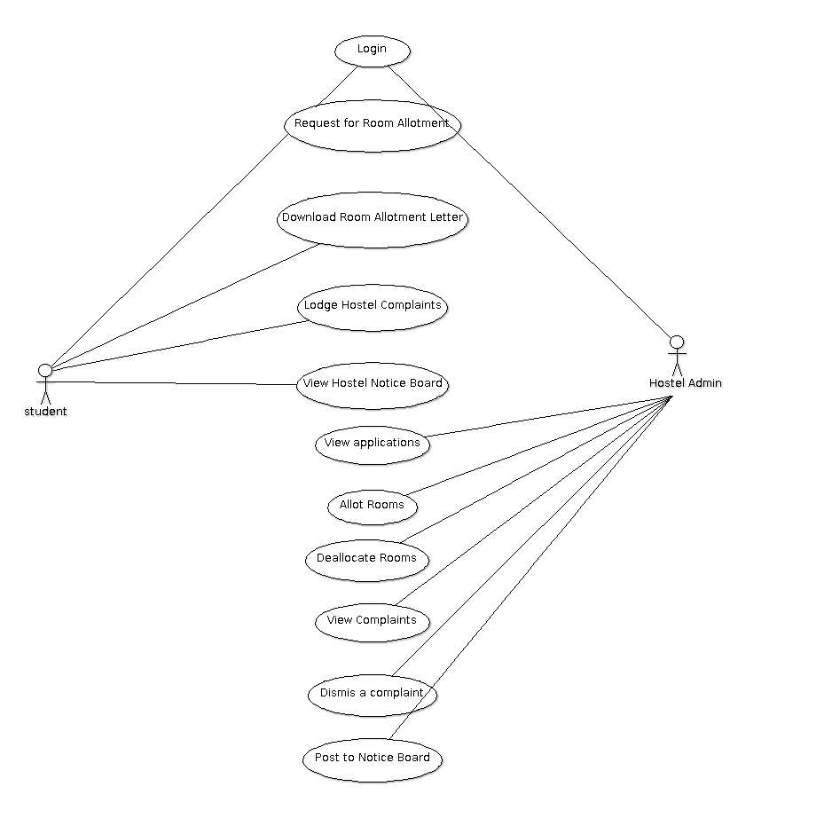
Use Case Diagram

Appendix C: To Be Determined List
- 2.6 User Documentation
- 3.1 User Interfaces
- 3.2 Hardware Interfaces
- 6 Other Requirements
- Appendix B

