### 1. **Stored Procedure: `add_user`**

-- **Description**: Adds a new user to the `Users` table with validation for the subscription type.

-- Query 1: Add a user with a valid subscription type.

CALL add_user('USR033', 'John Doe', 'john.doe@example.com', '9876543210', 'Active', 'Basic', 'Engineer');

SELECT * FROM Users WHERE user_id = 'USR033';

-- Query 2: Attempt to add a user with an invalid subscription type (this will trigger an error).

CALL add_user('USR034', 'Jane Smith', 'jane.smith@example.com', '0123456789', 'Inactive', 'Gold', 'Scientist');

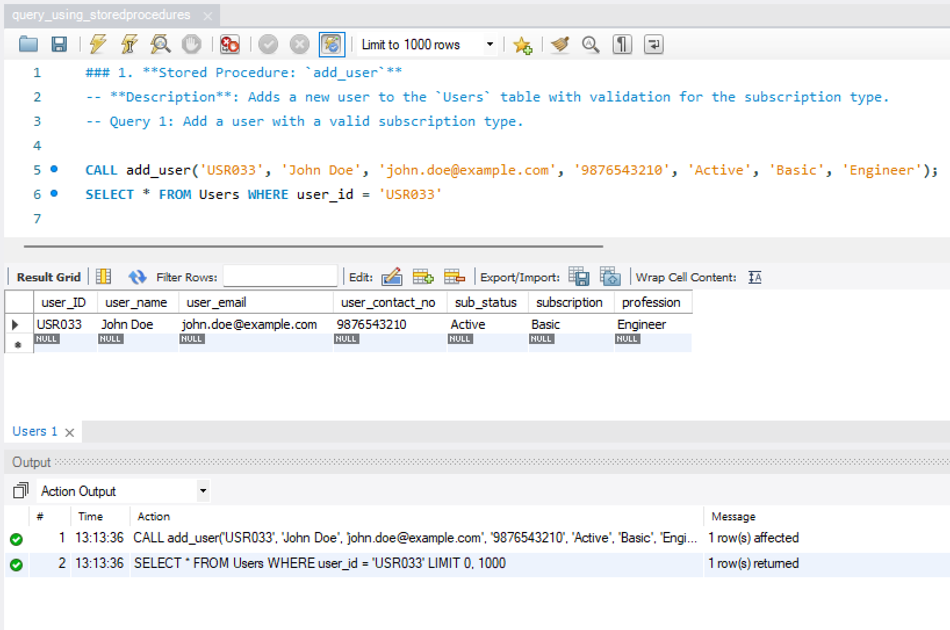

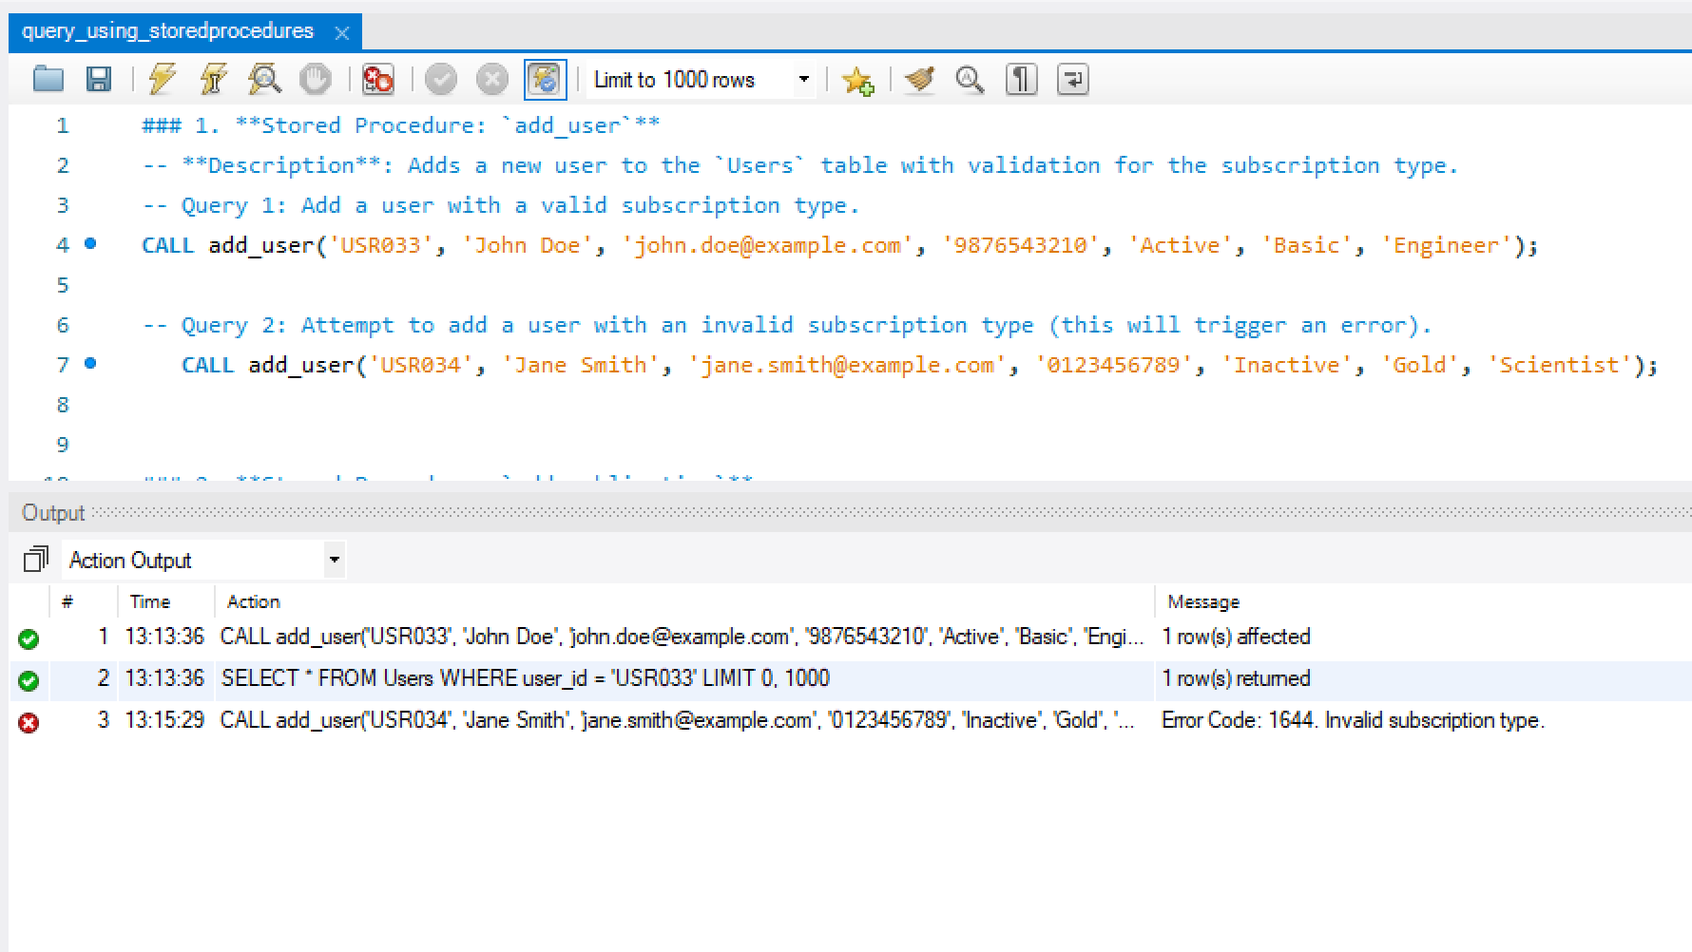

### 2. **Stored Procedure: `add_publication`**

-- **Description**: Adds a new publication to the `Publications` table and handles missing publication date by setting it to the current date.

-- Query 1: Add a publication with a specified publication date.

CALL add_publication('PUB039', 'Quantum Computing Advances', 'IEEE', '10.456/789', '5678-1234', '978-1-234567-8-9', 'CONF003', '2023-09-15');

SELECT * FROM publications WHERE publication_id = 'PUB039';

-- **Query 2**: Add a publication without specifying the publication date (current date will be used).

CALL add_publication('PUB040', 'Artificial Intelligence in Healthcare', 'Elsevier', '10.789/456', '5678-9101', '978-1-123456-7-8', 'CONF004', NULL);

SELECT * FROM publications WHERE publication_id = 'PUB040';

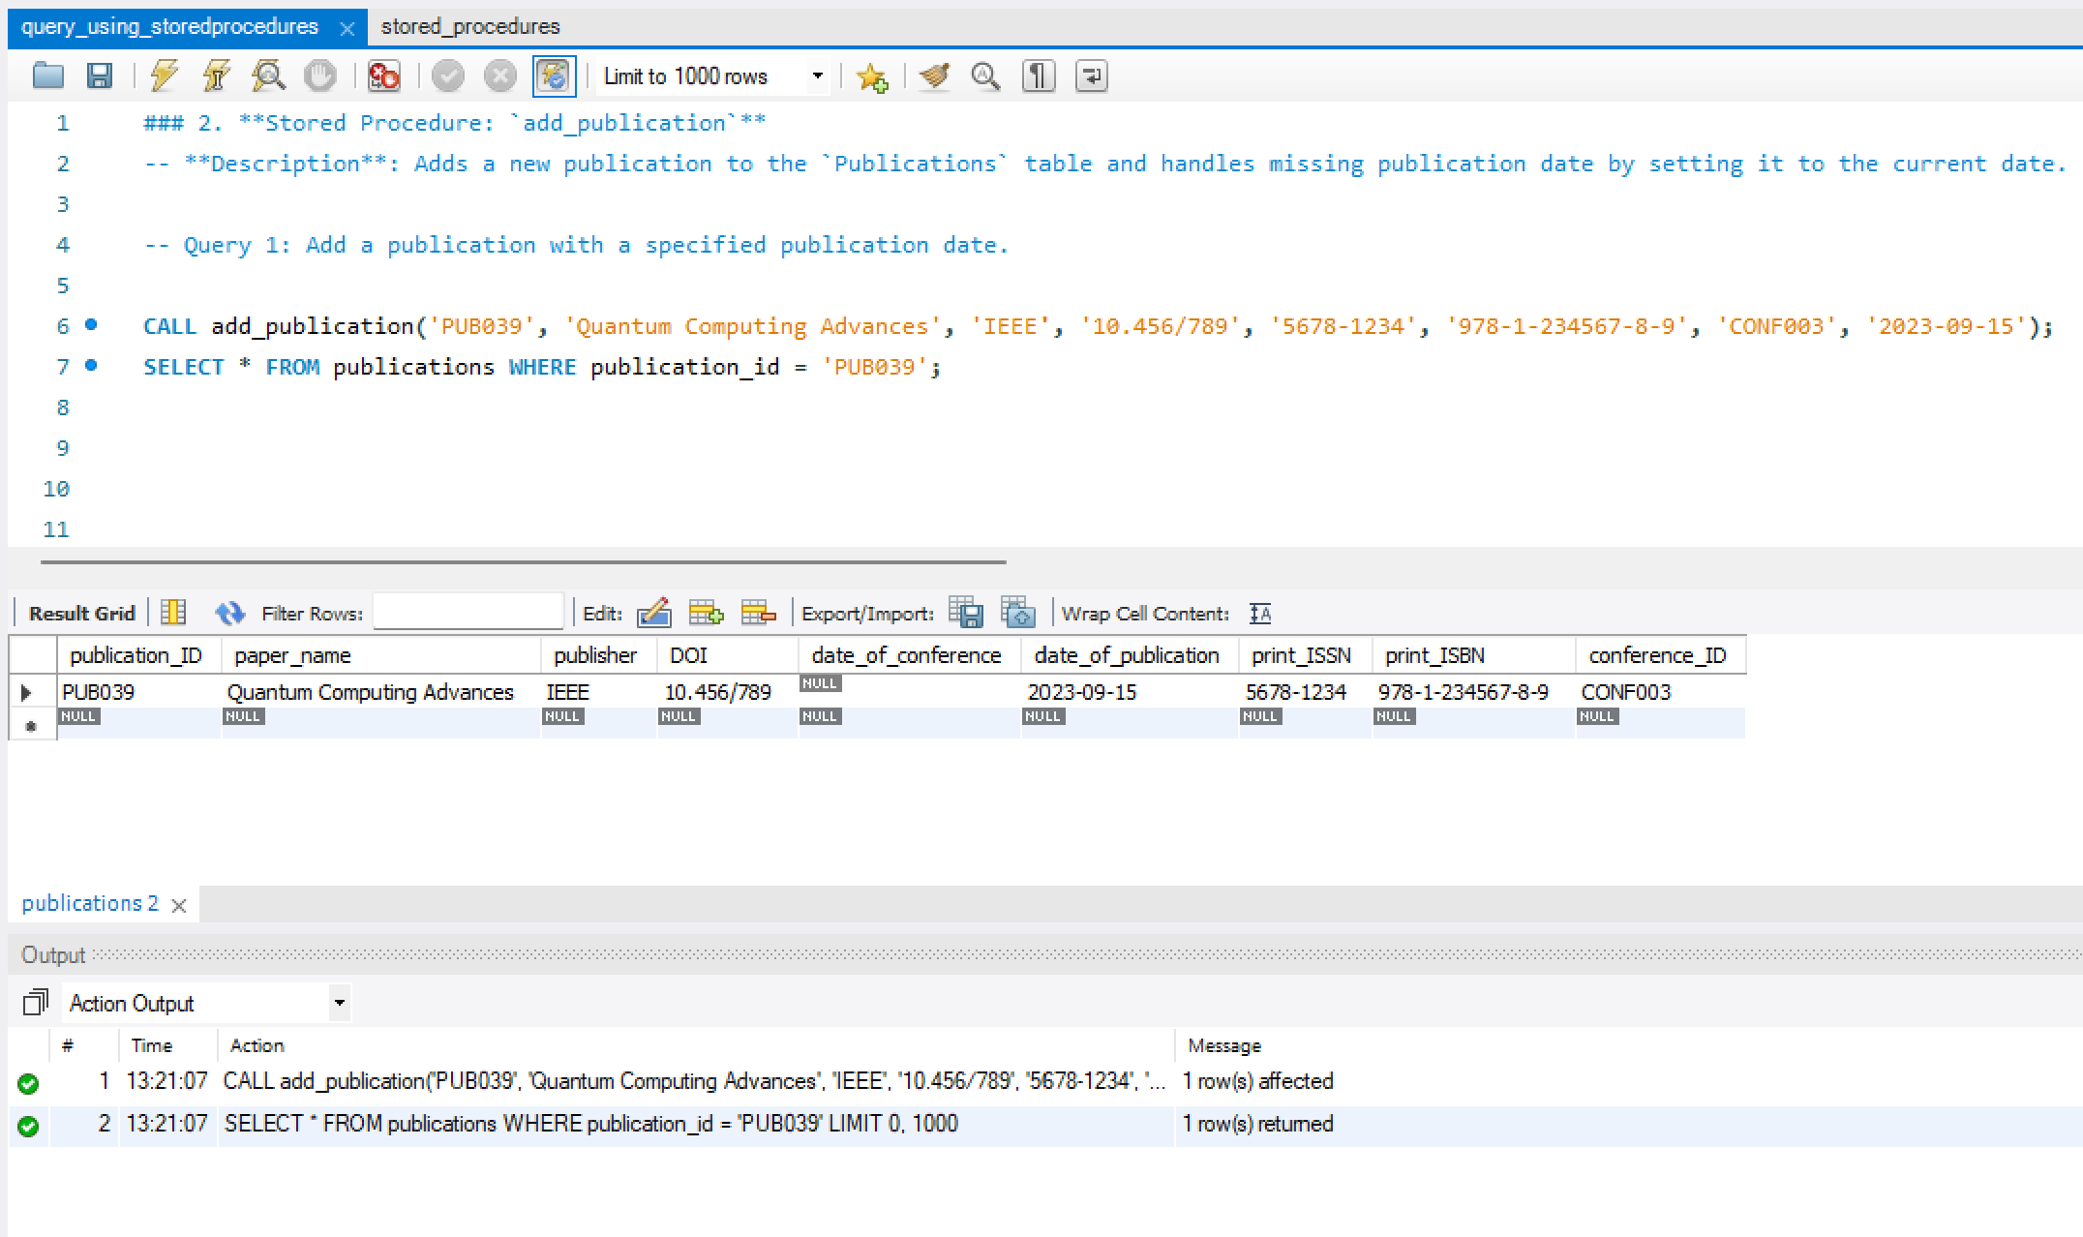

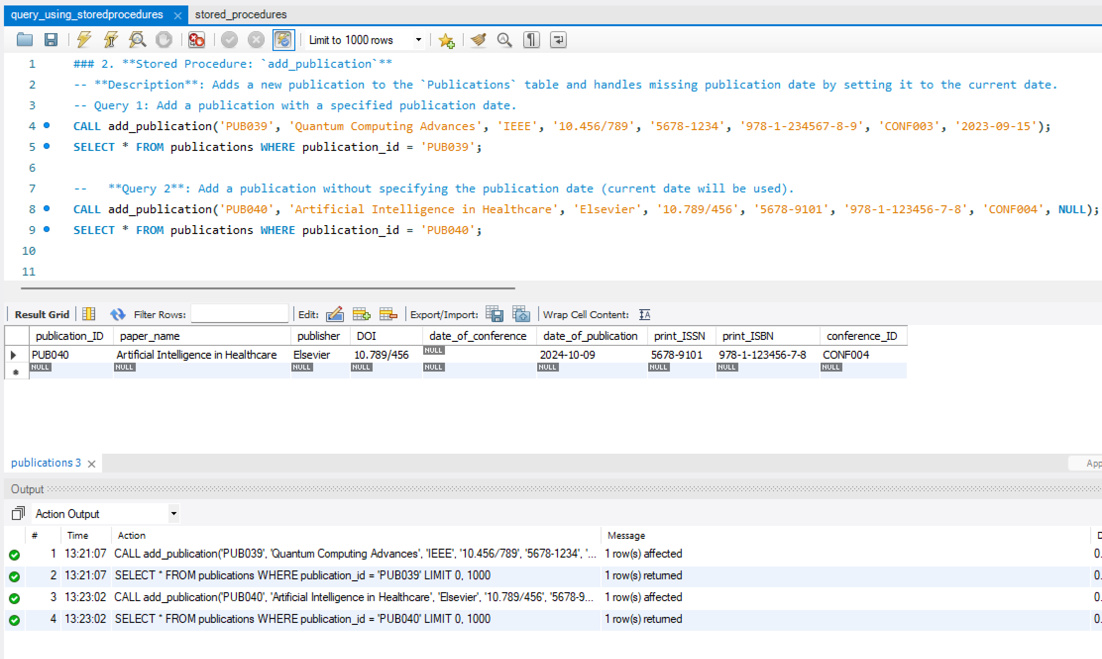

### 3. **Stored Procedure: `get_popular_keywords`**

-- **Description**: Retrieves keywords that have been associated with more than a certain number of publications.

-- **Query 1**: Get keywords associated with more than 3 publications.

CALL get_popular_keywords(2);

### 4. **Stored Procedure: `get_conference_publications`**

-- **Description**: Retrieves all publications for a specified conference.

-- Query: Get publications for a specific conference.

CALL get_conference_publications('CONF001');

