### 1. **Query: Find Publications by Conference**

-- **Description**: This query searches for all publications associated with a specific conference.

EXPLAIN SELECT * FROM Publications WHERE conference_ID = 'CONF001';

-- **Index Used**: `idx_publications_conference_id`

### 2. **Query: Find Recent Publications**

-- Description**: This query finds all publications that were published after January 1, 2020.

EXPLAIN SELECT * FROM Publications WHERE date_of_publication > '2020-01-01';

-- **Index Used**: `idx_publications_date_of_publication`

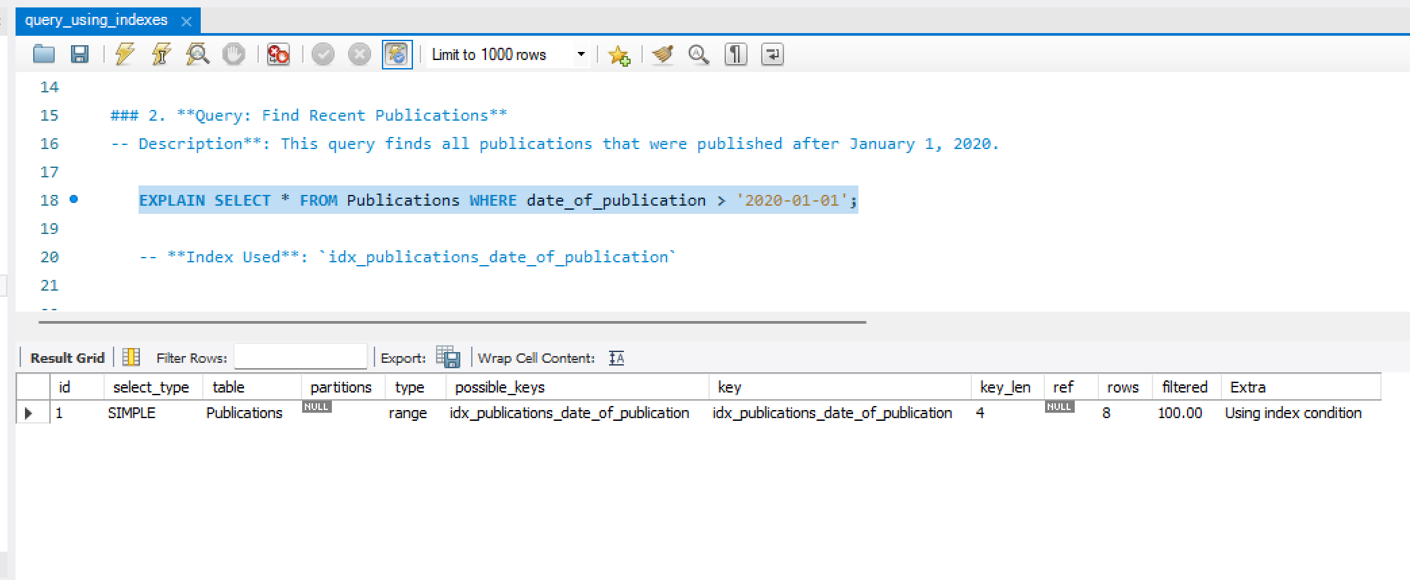

### 3. **Query: Find Authors by Institution**

-- **Description**: This query searches for authors affiliated with a specific institution.

EXPLAIN SELECT * FROM Authors WHERE institution_ID = 'INST001';

-- **Index Used**: `idx_authors_institution_id`

### 4. **Query: Find Authors by Institution and Topic**

-- **Description**: This query finds authors based on both their institution and research topic.

EXPLAIN SELECT * FROM Authors WHERE institution_ID = 'INST001' AND topic_ID = 'TOP001';

-- **Index Used**: `idx_authors_institution_topic`

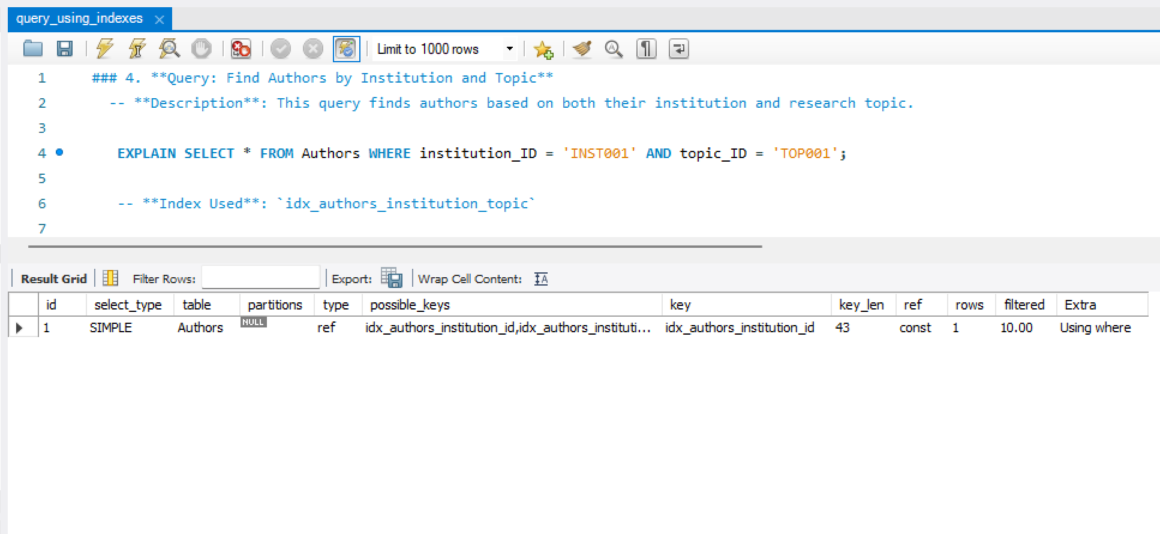

### 5. **Query: Find Authors by Topic**

-- **Description**: This query finds all authors working in a specific research topic.

EXPLAIN SELECT * FROM Authors WHERE topic_ID = 'TOP001';

-- **Index Used**: `idx_authors_topic_id`

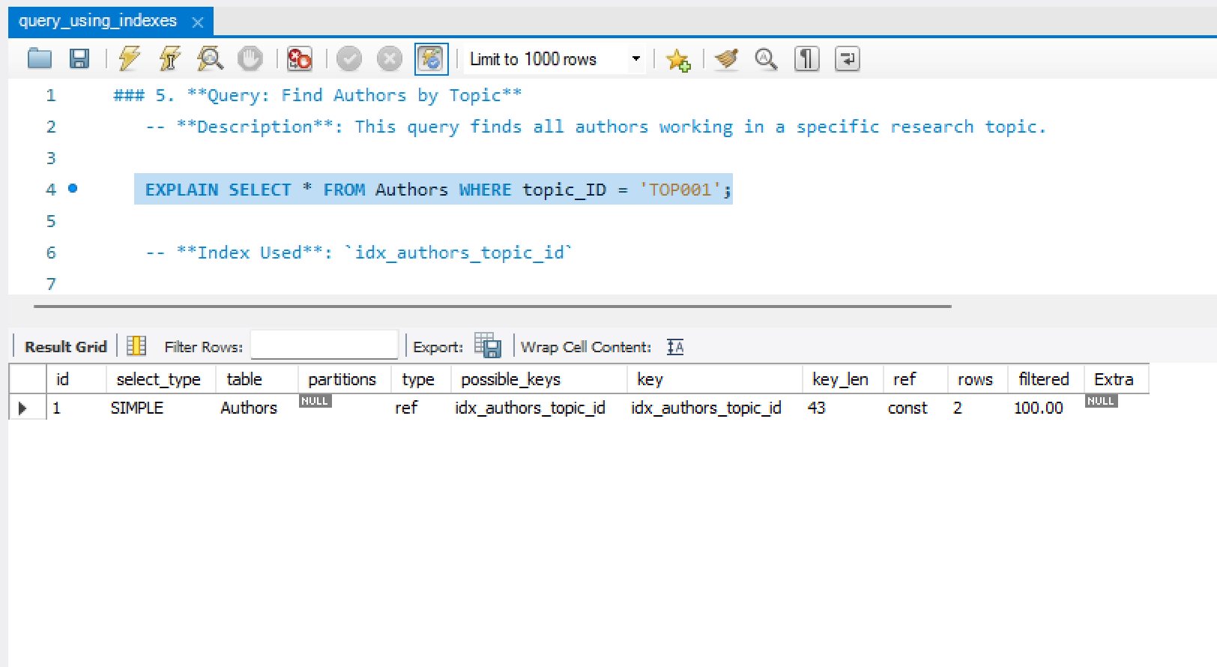

### 6. **Query: Find Publications by Author**

-- **Description**: This query retrieves publications authored by a specific author.

EXPLAIN SELECT * FROM Pub_Author WHERE author_ID = 'AUTH001';

-- **Index Used**: `idx_pub_author_author_id`

### 7. **Query: Find Authors by Publication**

-- **Description**: This query finds all authors of a particular publication.

EXPLAIN SELECT * FROM Pub_Author WHERE publication_ID = 'PUB001';

-- **Index Used**: `idx_pub_author_publication_id`

### 8. **Query: Find Keywords Associated with a Publication**

-- **Description**: This query retrieves keywords linked to a particular publication.

EXPLAIN SELECT * FROM Pub_Key WHERE publication_ID = 'PUB001';

-- **Index Used**: `idx_pub_key_publication_id`

### 9. **Query: Find Publications Associated with a Keyword**

-- **Description**: This query finds publications tagged with a specific keyword.

EXPLAIN SELECT * FROM Pub_Key WHERE keyword_ID = 'KW001';

-- **Index Used**: `idx_pub_key_keyword_id`

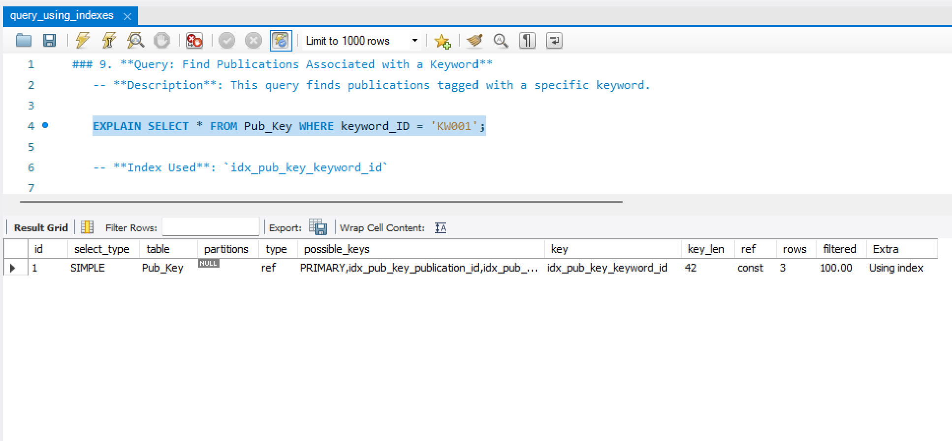

### 10. **Query: Find Publications by Citation Count**

-- **Description**: This query searches for publications with more than 5 citations.

EXPLAIN SELECT * FROM Citations WHERE citation_count > 5;

-- **Index Used**: `idx_citations_citation_count`

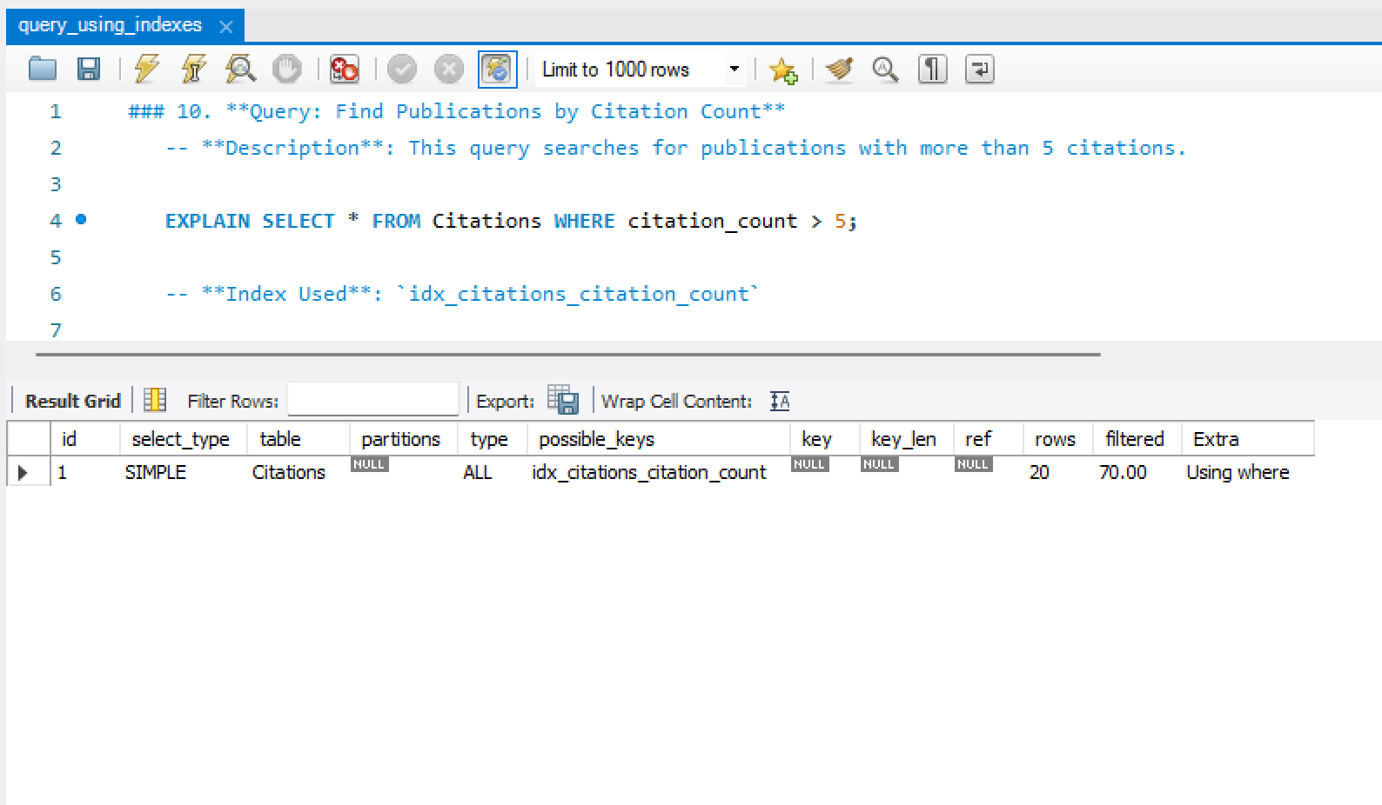

### 11. **Query: Find Citations for a Specific Publication**

-- **Description**: This query finds all citations of a specific publication.

EXPLAIN SELECT * FROM Pub_Cite WHERE publication_ID = 'PUB001';

-- **Index Used**: `idx_pub_key_publication_id`

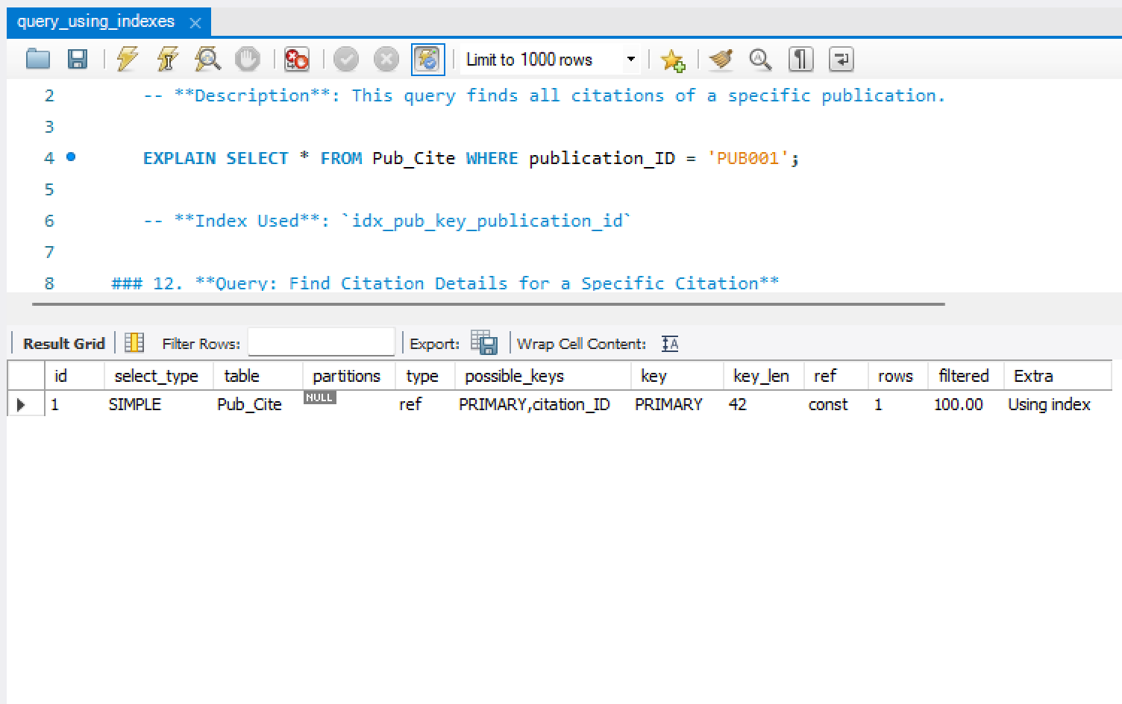

### 12. **Query: Find Citation Details for a Specific Citation**

-- **Description**: This query retrieves details for a specific citation by its ID.

EXPLAIN SELECT * FROM Pub_Cite WHERE citation_ID = 'CIT001';

-- **Index Used**: Citation indexes on `citation_ID`

